State of Alabama
Office of Water Resources

Risk MAP Program Business Plan

Increasing Risk Awareness, Resilience, and Sustainable Mitigation Actions in Alabama
Fiscal Funding Years 2017 to 2021

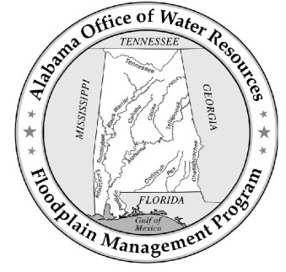
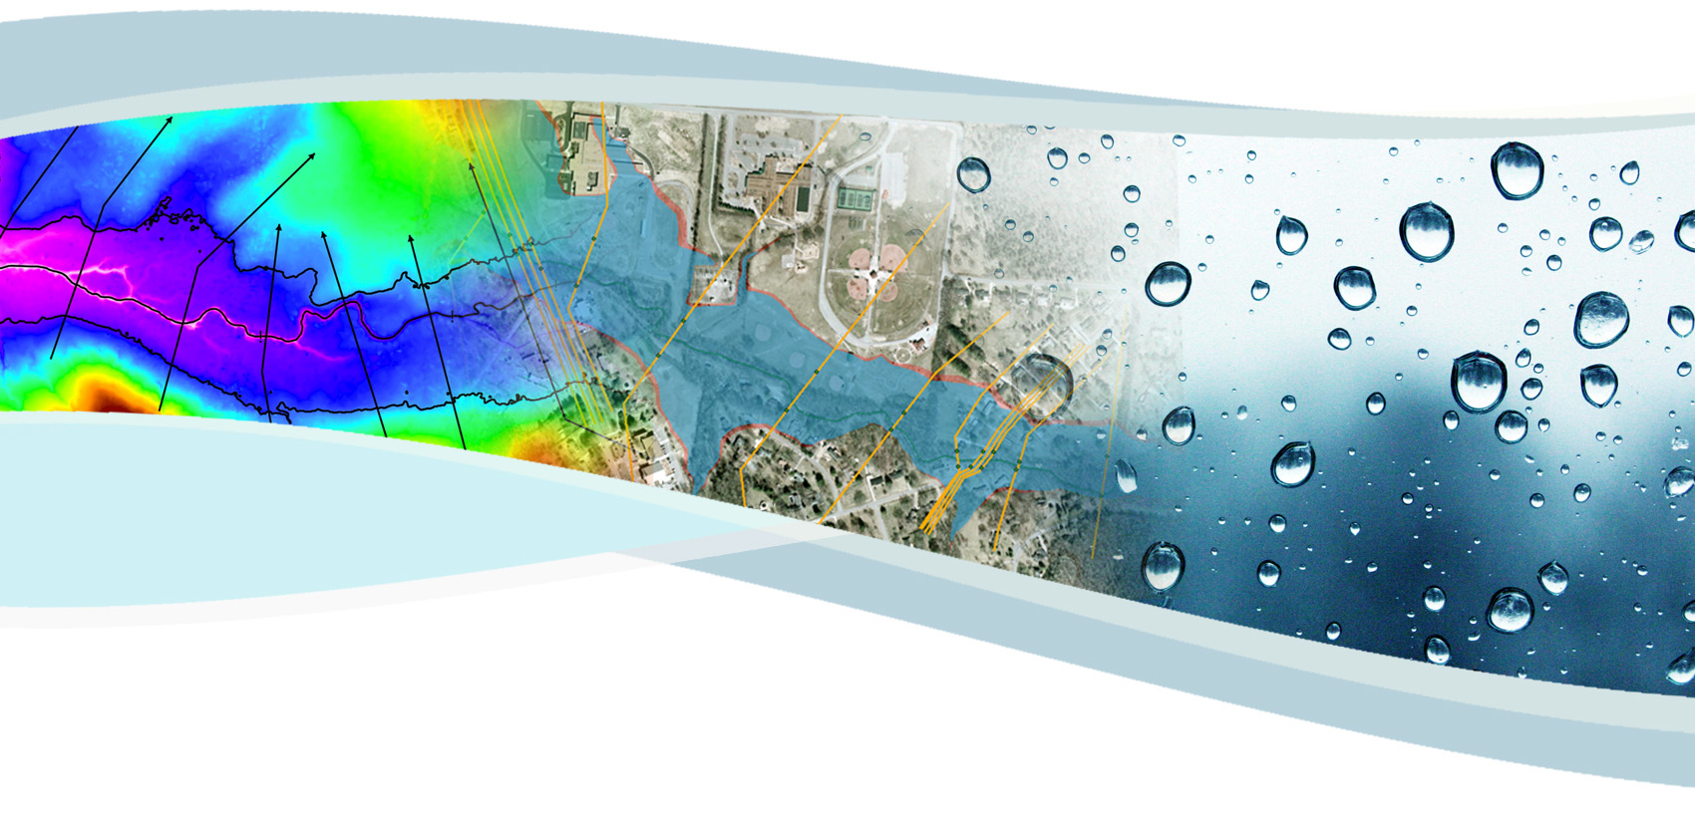

Table of Contents
Page No.
List of Acronyms iv
Executive Summary 1
I. Introduction 2
A. Purpose and Need 2
B. Vision, Mission, and Goals 3
1. Vision and Mission Statements 3
2. Program Goals 3
C. Program Organization 4
D. Past Program Accomplishments 4
1. Risk MAP Management Support and Program Management Activities 5
2. LOMR Review Partner 7
3. Earned Value Management 7
II. Risk MAP Program Overview 7
A. Program Management 7
1. Community Engagement and Risk Communication 7
a) Targeted Educational Topics and Forums 8
(1) Target Message: The Importance of Floodplain Management 8
(2) Target Message: Floodplain Management Best Management Practices 8
(3) Target Message: Effectively Utilizing Risk MAP Tools 8
(4) Target Message: The Importance of Building Partnerships and Investing in Floodplain Management 9
(5) Target Message: Identifying and Implementing Sustainable Mitigation Actions 9
b) Riverine Risk MAP Project Outreach 9
c) Coastal Risk MAP Project Outreach 10
d) Alabama Floodplain Management Program Website 11
e) Mitigation Support 11
(1) Action Identification and Advancement 11
(2) Flood Mitigation Opportunities 12
2. Technical Trainings 12
a) Advanced LOMR Training 13
b) Risk MAP Tools Training 13
c) Risk MAP Video Training 13
3. Data Management 13
a) Topography 14
b) Orthophotography 14
c) Parcel Data 14
d) Building Footprints 15
e) First Floor Elevations 15
f) Value of Partner Contributions 15
4. Hazard Mitigation Planning Coordination 16
a) State Coordination 16
b) Local Coordination 16
5. State National Flood Insurance Program 17
6. Letter of Map Revision Review Partner 18
a) Connection to the Alabama Department of Economic and Community Affairs 19
b) Connection to the National Flood Insurance Program 19
c) Connection to Local Communities 20
B. Digital Vision 20
C. Project Management 20
D. Program Management Activity Performance vs. Risk MAP Goals 21
III. Five-Year Plan 22
A. Watershed Sequencing FY 2017 through FY 2021 24
B. Levee Strategies 28
C. Coastal Needs 28
D. Statewide Base Level Engineering Update 28
IV. Current Risk MAP Performance Measures Targets 28
V. Summary and Program Funding Required 31

List of Tables

Table 1. Types of Local Partner Contributions 15
Table 2. AFPMP Program Management Activities and Specific MAP Goals by Activity 22
Table 3. Watershed Sequencing for Fiscal Funding Years 2017 to 2021 25
Table 4. Flood Risk Project Performance Measures Targets 29
Table 5. Program Management Performance Measures Targets 29
Table 6. CERC Performance Measures Targets 30
Table 7. Program Funding for Fiscal Funding Years 2017 to 2021 31

List of Figures

Figure 1. Alabama HUC 8 Watersheds 26
Figure 2. Current Alabama LiDAR Coverage 27

Appendices

Appendix A Alabama’s Cooperating Technical Partner Agreement

List of Acronyms
A
AAFM Alabama Association of Floodplain Managers
AAL Average Annualized Loss
ADCIRC Advanced Circulation Model
ADECA Alabama Department of Economic and Community Affairs
AEMA Alabama Emergency Management Agency
AFPMP Alabama Floodplain Management Program
ALDOT Alabama Department of Transportation
AL FRIS Alabama Flood Risk Information System
AoMI Areas of Mitigation Interest

B
BLE Base Level Engineering
BMP Best Management Practices

C
CAC Community Assistance Contact
CAP Community Assistance Program
CAV Community Assistance Visit
CERC Community Engagement and Risk Communication
CFR Code of Federal Regulations
CLOMR Conditional Letter of Map Revision
CNMS Coordinated Needs Management Strategy
CPI Cost Performance Indicator
CSLF Changes Since Last FIRM
CTP Cooperating Technical Partner

D
DEM Digital Elevation Model
DFIRM Digital Flood Insurance Rate Map

E
EV Earned Value

F
FBS Floodplain Boundary Standard
FEMA Federal Emergency Management Agency
FIRM Flood Insurance Rate Map
FIS Flood Insurance Study
FLIS FEMA Levee Inventory System
F (cont.)
FRD Flood Risk Database
FRIS Flood Risk Information System
FRM Flood Risk Map
FRR Flood Risk Report
FY Fiscal Year

G
G&S FEMA Guidelines and Standards
GIS Geographic Information System

H
HAZUS Hazards-United States
HUC Hydrologic Unit Code

K
KPI Key Performance Indicator

L
LAMP Levee Analysis and Mapping Procedures
LFD Letter of Final Determination
LiDAR Light Detection and Ranging
LOMC Letter of Map Change
LOMR Letter of Map Revision

M
MAS Mapping Activity Statement
Map Mod Flood Map Modernization Program
MIP Mapping Information Platform
MMMS Map Modernization Management Support
MNUSS Mapping Needs Update Support System
MOU Memorandum of Understanding

N
NDI National Dam Inventory
NFIP National Flood Insurance Program
NRCS Natural Resources Conservation Service
NVUE New, Validated or Updated Engineering
NWS National Weather Service

O
OWR Alabama Office of Water Resources
P
PAL Provisionally Accredited Levee
PDCC Preliminary DFIRM Community Coordination
PM Program Management
PMR Physical Map Revision

Q
QA/QC Quality Assurance/Quality Control

R
Risk MAP Risk Mapping, Assessment, and Planning
RSC Regional Support Center

S
SFHA Special Flood Hazard Area
SHMO State Hazard Mitigation Officer
SPI Schedule Performance Indicator
SWAN Simulating Waves Nearshore

T
TMAC Technical Mapping Advisory Council
TVA Tennessee Valley Authority

U
UDF User Defined Facility
USACE U.S. Army Corps of Engineers
USDA U.S. Department of Agriculture
USGS U.S. Geological Survey

W
WSEL Water-Surface Elevation

Executive Summary
The Office of Water Resources (OWR) is responsible for water resources and all aspects of floodplain management, including protection and planning, within the State of Alabama. Through a Cooperating Technical Partner (CTP) agreement with the Federal Emergency Management Agency (FEMA), Alabama has assumed responsibility for the technical accuracy of Flood Insurance Rate Maps (FIRMs) across the State. OWR has worked closely with FEMA for the past 14 years on various aspects of floodplain management, including Map Mod, Risk MAP, activities associated with the National Flood Insurance Program (NFIP), and the Letter of Map Revision (LOMR) Review Partnership. Program accomplishments include replacing the State’s paper flood maps with a more accurate, updated digital product and creation of a comprehensive floodplain management website, along with informational videos and interactive mapping application, to disseminate information to local floodplain managers, elected officials, emergency management personnel, and the general public. Since 2010, OWR has been a key partner in implementing FEMA’s Risk MAP Program throughout the State, which has focused on increasing flood risk awareness and resilience at the local level through effective community engagement and sustainable mitigation actions, and OWR has processed 170 LOMC cases consistently exceeding regulatory and internal processing times. OWR is proud of the federal/state partnership that has been developed through the implementation of Map Mod and Risk MAP, and the result is a successful and robust floodplain management program within the State of Alabama.

OWR has taken advantage of its ability to integrate the Map Mod and Risk MAP Programs with other floodplain management functions to create the comprehensive Alabama Floodplain Management Program (AFPMP). The primary goals of the AFPMP are to reduce the loss of life and property, minimize suffering and disruption caused by disaster, and better prepare for the consequences of flooding and other hazards. Similarly, FEMA’s goals for Risk MAP are to identify and assess flood risk, communicate flood risk, and ultimately mitigate flood risk through measurable community actions. OWR, through the AFPMP, will accomplish these goals through effective leadership, interagency coordination and community involvement, and by providing communities with the tools and resources they need to effectively manage, assess, and plan for development in flood prone areas; to save lives; and to protect property.

In accordance with FEMA guidance, all watersheds within the State have been prioritized for study based on current flooding risk, the need for engineering updates, and the availability of quality topographic data, parcel data and building footprints. Alabama estimates that approximately 47% (2,378 miles) of existing AE Zones (detailed) studies are still in need of updated engineering in order to meet FEMA’s New, Validated or Updated (NVUE) goals. In order to meet these NVUE requirements and the additional program goals and performance measures outlined in this Business Plan, OWR estimates that approximately $5,100,000 will be needed each year over the next five years, and the total program funding level required for FY 2017 to FY 2021 is estimated to be approximately $25,500,000.

Introduction

Purpose and Need
Recognizing the connection between reliable flood maps and effective flood damage reduction, the FEMA provided funding for Map Mod starting in Fiscal Year (FY) 2003 and continuing through FY 2008. Map Mod focused on updating existing Special Flood Hazard Areas (SFHAs) and converting paper flood maps to a digital platform. Through Map Mod, FEMA created an opportunity for CTPs to manage flood map development at the local level, realizing that local involvement leads to increased flood risk awareness and product acceptance. The Alabama OWR entered into a CTP agreement with FEMA on September 30, 2002, assuming responsibility for the technical accuracy of the FIRMs across the State. A copy of the current CTP agreement between Alabama and FEMA is attached in Appendix A.

In order to effectively and efficiently deliver the Map Mod program within the State of Alabama, OWR created the comprehensive Alabama Floodplain Management Program (AFPMP). Since its conception during the implementation of Map Mod, the AFPMP has grown to include a variety of floodplain management activities including flood hazard mapping, community engagement and risk communication, outreach, community trainings, data management, program management, project planning, project management, Letter of Map Revision (LOMR) review partnership, and state coordination of the National Flood Insurance Program (NFIP). In FY 2010, FEMA transitioned beyond Map Mod into the Risk MAP Program. To allow for the successful implementation of the Risk MAP vision within the State of Alabama, OWR further expanded the AFPMP to include a Risk MAP Coordinator role, the production of flood risk assessment data, hazard mitigation planning coordination activities, and mitigation action tracking at the local level.

This Business Plan describes how the AFPMP will continue to successfully execute the Risk MAP vision and meet FEMA’s program goals within the State of Alabama through FY 2021. Included in this Business Plan is an overview of past program accomplishments; current program organization; the program vision, mission and goals; program metrics, program management and community engagement activities; project sequencing and prioritization; and a description of the funding needed to properly support the AFPMP.

OWR is excited about the opportunity to continue its partnership with FEMA and is committed to the success of the AFPMP and the Risk MAP Program. This Business Plan clearly outlines the objectives, sequencing, and funding requirements that will continue to make the AFPMP a success.

Vision, Mission, and Goals

Vision and Mission Statements
The vision of the AFPMP is to create a proactive, continuously improving, and evolving process of floodplain management, including flood hazard mapping, risk assessment and risk communication through effective leadership, interagency coordination, and community involvement.

The mission of the AFPMP is to make Alabama and its citizens less vulnerable to the impact of flooding through the effective administration of statewide floodplain management and to provide local communities with the tools and resources for managing, assessing, and planning for development in flood prone areas; to save lives; and to protect property.

FEMA’s vision for Risk MAP is that through collaboration with state, local and tribal entities, Risk MAP will deliver quality data that increases public awareness and leads to action that reduces risk to life and property.

Program Goals
The primary goals of the AFPMP are to reduce the loss of life and property, minimize suffering and disruption caused by disaster, and better prepare for the consequences of flooding and other hazards.

To achieve the Risk MAP vision, FEMA has expanded on flood hazard identification and mapping to include a more integrated process involving identifying, assessing, communicating, planning, and mitigating flood risk. FEMA’s goals for Risk MAP are as follows:

- Goal 1: Data Gaps
  - Address gaps in flood hazard data to form a solid foundation for flood risk assessments, floodplain management, and actuarial soundness of the NFIP.

- Goal 2: Awareness and Understanding
  - Ensure that a measurable increase of public awareness and understanding of risk management results in a measurable reduction of current and future vulnerability to flooding.

- Goal 3: Mitigation Planning
  - Lead and support states, communities, and Tribes to effectively engage in risk-based mitigation planning resulting in sustainable actions that reduce or eliminate risks to life and property from natural hazards.

- Goal 4: Digital Platform
  - Provide an enhanced digital platform that improves management of limited Risk MAP resources, stewards information produced by Risk MAP, and improves communication and sharing of risk data and related products to all levels of government and the public.

- Goal 5: Synergize Programs
  - Align Risk Analysis programs and develop synergies to enhance decision-making capabilities through effective risk communication and management.

Ultimately, through collaboration with FEMA and strong partnerships with state, local, and tribal entities, the AFPMP will reduce losses of life and property throughout the State of Alabama through local, sustainable mitigation actions based on quality flood hazard data, flood risk assessments, and effective hazard mitigation planning coordination.

Program Organization
The Office of Water Resources is a division within the Alabama Department of Economic and Community Affairs (ADECA). OWR administers programs for river basin management, river assessment, drought planning, floodplain management and mapping, and the NFIP. OWR is comprised of engineers and planners with expertise in hydrology and water resources. In addition to floodplain management functions, OWR performs several water resources-related tasks and analyses such as surface water modeling, drought planning and management, water use management, and water policy review and implementation. The OWR staff clearly has the technical and program knowledge and capabilities to perform all functions associated with the AFPMP.

The AFPMP, including the State NFIP Coordinator as well as the State hydrologic engineering and floodplain mapping and flood risk communication groups, are housed within one facility and overseen by one unit chief. This advantageous organization of offices gives OWR the ability to coordinate and leverage floodplain management activities with other water resources programs within the State. This organization is a key factor in the successful implementation of Risk MAP as coordination between state agencies is vital to the integration of risk assessments and mitigation planning in Alabama.

Past Program Accomplishments
OWR has established a proactive environment for managing flood-related issues within the State by developing strong partnerships with local communities and other state and federal agencies, increasing public awareness and education of flood hazards through various outreach channels, and utilizing modern mapping technologies to increase the reliability and accuracy of flood hazard delineations. OWR has also been instrumental in several pilot and early demonstration projects in partnership with FEMA to help develop new methodologies and guidance for emerging FEMA programs. The following is a list of notable AFPMP accomplishments to date.

Risk MAP Management Support and Program Management Activities
- Early demonstration projects for Madison County and Upper Alabama watersheds that aligned with the overall vision of Risk MAP to provide clear communication regarding dam failure risks within the watershed.
- Successful pilot projects for FY 2008 Map Maintenance Counties to collect unmet engineering needs and populate a draft data structure and for a Level 2 Hazards-United States (HAZUS) analysis for the City of Prattville. Based on the success of the City of Prattville pilot project, all standard Risk MAP projects in Alabama incorporate a Level 2 HAZUS analysis.
- Digital base map inventory for the entire state.
- Continuous outreach to educate state and federal agencies about the benefits of base map data sharing.
- Yearly, updated Program Management and QA/QC Plans for the program.
- Implementation and regular updates of FEMA’s Coordinated Needs Management Strategy (CNMS) database.
- Development of a strategy for levee certification for the State of Alabama.
- Creation of and continual updates to the AFPMP website, which provides access to the most current flood hazard data and an extensive toolset to users for the management of flood mapping data.
- Development and execution of various trainings for state and local officials, community officials, frequent requestors, and stakeholders such as use of the AFPMP website and the various tools and floodplain data available, comprehensive digital tools trainings for the basic user as well as the more advanced user, and LOMR and MT-2 Letter of Map Change (LOMC) trainings in order to provide a working understanding of the LOMR application process to examine the application process step-by-step in detail.
- Creation of and continual updates to the AFPMP Business Plan to reflect program status, goals, objectives, and performance metrics.
- Management of technical mapping activities through bi-monthly planning meetings to discuss project schedules, project budgets, and resources needed to successfully execute the activities outlined in the Mapping Activity Statements (MAS).
- Outreach and engagement activities that enhance the understanding of the flood mapping program and ownership of the mapping process at state and local levels, which included specialized coastal outreach meetings and development of a coastal outreach plan, plus specialized LOMR outreach regarding the LOMR processing responsibilities to the State.
- Creation of the Alabama Flood Risk Data Management System (AL FRD) to display statewide flood hazard information, flood risk information, modeling data, and Flood Insurance Study data at the structure level.
- Ongoing Mitigation Planning and Technical Assistance Training focused on building a community’s capability to plan for and reduce risk.
- Ongoing Global Program Management to ensure the successful execution of Risk MAP projects in the areas of scope, schedule, cost, and quality, as well as the accomplishment of Risk MAP program goals in the areas of integration, risk assessment, and communication.
- Completion of the validation evaluation in CNMS for the remaining miles that have exceeded their study lifespan. Assessment of these expiring miles through engineering and GIS will promote prioritization of streams to be targeted for future studies.
- Completion of dam inventories with all counties in a singular database to ensure it is compatible with current National Inventory of Dams (NID) shapefile formatting. This aids in recommendations for adding to the current NID.
- Development of training videos to promote the use and understanding of Non-Regulatory datasets including Changes Since Last FIRM, Flood Depth & Analysis Grids, and Flood Risk Assessments, as well as updates to the Regulatory Database. By enabling both a visual and verbal component to communicate processes and best practices for using these datasets, communities are able to maximize their understanding of local flood risks. These videos can be found on the OWR Floodplain Management YouTube Channel.
- Service by an OWR representative on FEMA’s Technical Mapping Advisory Council (TMAC), a federal advisory committee established to review and make recommendations to FEMA on matters related to the national flood mapping program. Only 20 representatives from across the U.S. are selected to participate on TMAC.
- Coordination with and Participation in a Pilot Phase of the National Water Center’s National Water Model using local LiDAR data for flood inundation mapping.
- Development of a statewide mapping website (alabamaflood.com) to communicate Flood Risk Products to community officials and residents. The website displays all Effective Regulatory map data and Preliminary Regulatory map data to raise awareness of flood risk. Ongoing enhancements to the website include adding water surface elevation grids, building footprints, and HAZUS Level 2 data.
- Development of Flood Mitigation Opportunities reports to deliver to communities at the conclusion of Flood Risk Projects that define mitigation opportunity areas at the neighborhood level. Identified areas are compiled into a report and presented to communities as an outreach tool and starter for mitigation actions. The Middle Coosa watershed was the first watershed to receive a Flood Mitigation Opportunities report and training.
- Maintaining a dam inventory database for the State of Alabama as dam failure risk awareness and dam failure communication are potential major components of Risk MAP in the future. Inventory development for a seamless statewide database was fully funded as of FY 2016, and the inventory has been completed for approximately 90% of the counties in the State. The remaining approximately 10% is scheduled for completion in 2017.

LOMR Review Partner
FEMA clearly recognizes the need for advantageous and effective partnerships in producing accurate mapping products by continuing to offer the opportunity for CTPs to process LOMRs within their jurisdiction. OWR gladly accepted this opportunity and has been responsible for the review and processing of all LOMR requests within the State since July 2010.

Earned Value Management
OWR has successfully used the Mapping Information Platform (MIP) to provide monthly updates on the earned value (EV) of mapping projects, which represents performance standards through a cost performance index (CPI) and a schedule performance index (SPI). The CPI and SPI are calculated using the actual cost and schedule of work performed and comparing them to the expected cost and schedule of work performed, or “baseline”. Alabama’s SPI and CPI values currently average 0.99 and 1.00, respectively.

Risk MAP Program Overview

Program Management
The State of Alabama has taken a holistic approach to floodplain management by combining several FEMA and State programs to create a robust floodplain management program. With the transition of the NFIP program from the Alabama Emergency Management Agency (AEMA) to OWR in June 2002, Alabama established a proactive environment for managing flood related issues and concerns through the creation of the AFPMP, which is a multi-faceted and comprehensive plan for program management essential to success execution of the Risk MAP vision in Alabama. The following is a summary of the program management activities that are planned for FY 2017 and beyond.

Community Engagement and Risk Communication
OWR has developed an education and community engagement strategy that aims to build risk awareness and understanding at the local level, increase a community’s ability to communicate risk at the local level, support local efforts to reduce natural hazard risk within a community or watershed, and keep communities and other stakeholders engaged through the Risk MAP process. This Community Engagement and Risk Communication (CERC) strategy will increase community awareness and understanding of flood risk as well as the overall understanding of the NFIP. The education and outreach activities help to create a better understanding of the floodplain mapping process and facilitate early project buy-in at state and local levels, which leads to effective flood risk reduction at the completion of a Risk MAP project. Ultimately, the community engagement activities will increase flood risk awareness that leads to sustainable mitigation actions that reduce flood risk. The program management community engagement activities that are currently planned or underway for the AFPMP are outlined below.

Targeted Educational Topics and Forums
OWR has prepared a series of educational presentations that will cover a range of topics from why proper floodplain management is essential to how Risk MAP datasets can be used for effective floodplain management at the local level. Together, the series of presentations will form a clear picture of the necessity for a strong floodplain management program, the floodplain management and mapping process itself, data requirements, data availability, the organization and value of the AFPMP itself, and the potential for partnerships across local, state, and federal organizations. The goal of the stakeholder engagement effort is to increase the strength and effectiveness of the AFPMP by educating local, state, and federal officials, establish best management practices (BMPs) for daily floodplain management, and develop or strengthen partnerships across agencies and with local communities. These presentations are continually updated and refreshed as lessons are learned, new guidance is issued, or as Risk MAP program requirements change. Additionally, community feedback on the Risk MAP process is incorporated for consideration.

The educational outreach topics, targeted stakeholders, and potential forums are as follows:

Target Message: The Importance of Floodplain Management
- Education Topic: Educate state and local stakeholders about the mission and goals of the AFPMP; include local case studies as to why floodplain management is important and how it affects each citizen. The goal is to stress the impacts of proper and improper floodplain management and to motivate stakeholders to be proactive about developing strong floodplain management programs.
- Target Audience: Floodplain administrators, community elected officials, emergency management personnel, and regional planning commissions.
- Potential Forum: Annual AEMA conference and annual Alabama Association of Floodplain Managers (AAFM) conference.

Target Message: Floodplain Management Best Management Practices
- Education Topic: Provide a general overview of federal regulations regarding floodplain management; discuss a model ordinance and floodplain management BMPs; partner with a local community to showcase the practices of effective floodplain administrator.
- Target Audience: Floodplain administrators and community elected officials.
- Potential Forum: Floodplain Management 101 Course administered by AFPMP staff.

Target Message: Effectively Utilizing Risk MAP Tools
- Education Topic: Provide an overview of the new non-regulatory flood risk datasets that are produced as a result of a Risk MAP project; discuss the potential use of each product during daily floodplain management and/or hazard mitigation planning activities; discuss available grant funding; showcase known success stories.
- Target Audience: Floodplain administrators, community elected officials, emergency management personnel, and regional planning commissions.
- Potential Forum: Annual AEMA conference and annual AAFM conference.

Target Message: The Importance of Building Partnerships and Investing in Floodplain Management
- Education Topic: Discuss the importance of building state and local partnerships in order to successfully obtain FEMA funding for a Risk MAP project; identify data requirements and discuss cash match opportunities.
- Target Audience: Revenue commissioners, floodplain administrators, community elected officials, county engineers, emergency management personnel, and regional planning commissions.
- Potential Forum: Annual AEMA conference and annual AAFM conference.

Target Message: Identifying and Implementing Sustainable Mitigation Actions
- Education Topic: Discuss the importance of identifying sustainable mitigation projects within the community in order to reduce risk and prevent loss of life and property in the future; discuss opportunities for grant funding for project implementation; create a working plan for identifying and advancing mitigation actions.
- Target Audience: Floodplain administrators, community elected officials, county engineers, emergency management personnel, and regional planning commissions.
- Potential Forum: Annual AEMA conference, annual AAFM conference, Hazard Mitigation Planning and Technical Assistance trainings.

Riverine Risk MAP Project Outreach
OWR has developed a Risk MAP Project Engagement Strategy Plan (previously Outreach Plan) to be implemented throughout the life of a typical Risk MAP project. The plan aligns with FEMA’s Risk MAP project life cycle and the project milestones for CERC and outreach that are identified in a typical Risk MAP Flood Study MAS. The Risk MAP Project Engagement Strategy Plan incorporates the integration planning, action strategy, community prioritization, Watershed and Community Assessment, Relationship Management and Action Plan, and Communication and Outreach Strategy that are required by FEMA and developed on the watershed level prior to and during the Discovery process.

To date, the Risk MAP Project Outreach Plan has been completed for the Houston County project and within the Upper Alabama, Middle Coosa, and Upper Choctawhatchee watersheds, is nearing completion for the Wheeler Lake and Locust Fork watersheds, is ongoing for the Cahaba watershed, and is in process for the Guntersville Lake and Upper Black Warrior watersheds. The communication, outreach, and engagement plans have enabled OWR to focus community involvement efforts in these local communities pursuant to the individual community’s needs, structure, and Risk MAP project emphasis and will continue to be implemented during the beginning stages of future projects at the earliest opportunity for initializing stakeholder engagement and throughout the life of the project.

Coastal Risk MAP Project Outreach
OWR has developed a specialized Coastal Outreach Plan to engage, educate, and inform the coastal communities within Baldwin and Mobile Counties of the benefits of the new coastal flood maps and the potential effects of the on-going coastal mapping update project. The Coastal Outreach Plan identifies target audiences, key messages, milestone dates, and specific outreach materials such as fact sheets, press releases, and information to be displayed on the AFPMP website throughout the life of the mapping project. OWR will also conduct additional community meetings to supplement the typical project outreach performed under the mapping project’s MAS. To date, the coastal outreach plan has been implemented or is planned as follows:

- Outreach Flyer #1, Scoping – distributed July 2012
- Introductory meeting with local media – held November 2012
- Outreach Flyer #1 Version 2, Scoping – distributed April 2014 with updated project timelines
- Storm Surge Analysis Update meeting – held May 2014
- Outreach Flyer #2, Map Production – distributed August 2014
- Outreach Email, Status Update – distributed January 2015
- Discovery Meeting – held May 2015
- Outreach Email, Status Update – October 2015
- Discovery Report, finalized and approved by FEMA – March 2016
- PDCC and Resilience Meetings and associated Outreach Flyers – planned for 2017 to 2018
- Baldwin County Flood Study Update Meeting – held November 2016
- Mobile County Flood Study Update Meeting – planned for Spring 2017
- Baldwin County Preliminary – planned for July 2017
- Baldwin County Open House – planned for October 2017
- Baldwin County Public Comment Period – planned for October 2017 to January 2018
- Mobile County Preliminary – planned for November 2017
- Mobile County Open House – planned for January 2018
- Mobile County Public Comment Period – planned for January to April 2018
- Baldwin County Effective – planned for Fall 2018
- Mobile County Effective – planned for Winter 2019

Alabama Floodplain Management Program Website
To disseminate information to local floodplain managers, elected officials, emergency management personnel, and the general public, OWR has developed a comprehensive floodplain management website (adeca.alabama.gov/Divisions/owr/floodplain). The website includes an overview of Risk MAP including new flood risk datasets and products as well as critical fact sheets to promote understanding of the goals of a Risk MAP project along with a self-guided comprehensive training program on floodplain management that targets OWR employees, other state agency employees, and local officials. The training orients Alabama officials to flooding, the NFIP, and basic skills such as reading a digital FIRM (FIRM) and FIS. The website also provides a County Status link under which Preliminary or Effective FIRMs are available for each county along with the FIS Report, Summary of Map Actions, and all community correspondence. Finally, the website provides a forum for posting the AFPMP Business Plan in order to share the goals and vision of the AFPMP with other federal and state agencies as well as the local communities.

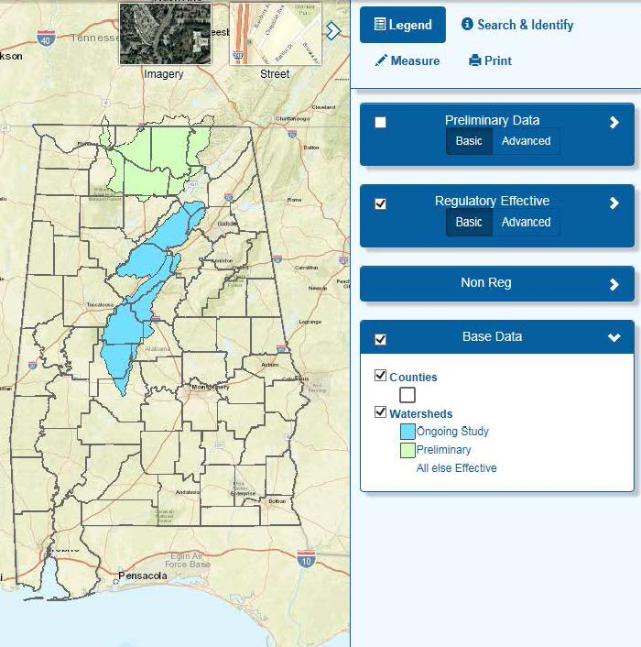
OWR has also developed a floodplain mapping website (alabamaflood.com) for the State of Alabama to visually communicate Flood Risk Products to community officials and residents. The website is used to raise awareness of flood risk and flood risk changes by displaying Effective Regulatory map data, Preliminary Regulatory map data, CSLF data, and Flood Risk data for communities studied by the Risk MAP Program. The website was used to disseminate preliminary maps following the Preliminary DFIRM Community Coordination (PDCC) meeting for the Wheeler Lake watershed in June 2016. In November 2016, the website was used as a visual tool during the Baldwin County Flood Study Update meeting, and attendees were also provided guidance for using the website. Ongoing enhancements to the website include adding water surface elevation grids, building footprints, and HAZUS Level 2 data, which will allow communities to see the range of flood risks beyond the floodplain by providing elevation, depth, and damage loss estimates at a building footprint level. The website is introduced as a community resource during all community meetings.

Mitigation Support

Action Identification and Advancement
OWR plans to leverage Risk MAP data, decision support analyses, and related products and processes to support communities in advancing mitigation actions. Through development of an Action Identification and Advancement Plan, OWR will work closely with the AEMA throughout the lifecycle of a Risk MAP project to collect and quantify actions as part of a project-specific MAS. The following activities are included in this task:

- Actions Identified – Support for communities to identify mitigation opportunities and/or select amongst alternatives by providing data and/or analysis.
- Actions Advanced – Support for communities to advance mitigation opportunities including scoping/design, budgeting, obtaining funding, project planning, technical support for zoning and ordinance development, and outreach strategies for project support.
- Evaluation and Valuation – Support provided to the community to evaluate and demonstrate the value of mitigation investment, including the calculation of economic, environmental, and/or social benefits or the losses avoided from natural hazard events.

Actions will be collected for up to two years after the closeout of a Risk MAP project to provide for the coordinated effort with AEMA for communicating with communities outside of the lifecycle of the Risk MAP project. All watersheds that are within two years beyond project lifecycle fall within the scope of work for FY 2017.

Flood Mitigation Opportunities
As part of the FY 2011 Middle Coosa Watershed project, 427 Areas of Mitigation Interest (AoMIs) were identified. While this information was useful to the local community, it was an overwhelming task for community officials to extract meaningful mitigation actions from the AoMI file. In an effort to assist the watershed and provide a linkage to data that could be utilized for FEMA’s Mitigation Action Tracker, OWR worked to create a Flood Mitigation Opportunity report using the AoMI database. The 427 identified AoMIs were screened using geospatial analysis and engineering judgement to develop a list of eight Mitigation Opportunities in high average annualized loss (AAL) locations. Each Mitigation Opportunity was described in three parts: 1) the location was shown on a map and described in text to identify the Mitigation Opportunity, 2) loss value estimates were provided as a guide to establishing the cost of the problem, and 3) a potential mitigation action was presented.

The mitigation actions presented can be input directly into FEMA’s Mitigation Action Tracker, and OWR can provide support to the communities to advance these opportunities. Additionally, the Mitigation Opportunities can be utilized to assist in mitigation planning in the form of grant applications for action advancement funding. OWR plans to produce a similar report for future watersheds as part of the Risk MAP program.

Technical Trainings
OWR believes in a strong culture of open communication, information sharing, and comprehensive stakeholder trainings. OWR has executed many successful trainings and workshops in the past as previously noted and will continue to do so through current and future program management activities. The program management training activities that are currently planned for the AFPMP are outlined below.

Advanced LOMR Training
OWR continues to conduct advanced LOMR training sessions that target frequent requestors and community officials throughout the State in an effort to provide them with a comprehensive understanding of the LOMR application process and best practices. This training examines a typical LOMR application step-by-step in greater detail than the previous LOMR application trainings. The goal of this training is to reduce the time and cost of processing LOMR applications by improving the quality of the initial applications and providing frequent requestors with the latest requirements and lessons learned.

Risk MAP Tools Training
OWR understands that flood risk awareness leads to action that reduces that flood risk, and that those who are more aware of their flood risk are more likely to take sustainable mitigation action. Building on this fundamental principle, OWR will continue to execute project-specific Risk MAP Tools Training workshops throughout the State that will focus on the non-regulatory Flood Risk Database (FRD) and the flood risk datasets contained therein. These workshops educate the everyday user on the attributes contained within each dataset and the various uses of the datasets that can be applied during daily floodplain management and hazard mitigation activities. The goal of this project-specific workshop is to leave local officials empowered, informed, ready to take action, and armed with the tools they need to provide effective outreach to citizens within their own communities. These workshops also help OWR to understand the products and datasets that will allow local officials to communicate most effectively and will help shape project deliverables for future Risk MAP projects.

Risk MAP Video Training
OWR has developed a program to produce a series of short training videos on a variety of Risk MAP topics and has created a YouTube Channel to share these videos. Video topics include the updated regulatory database; Risk MAP products including CSLF, Depth & Analysis Grids, Flood Risk Assessment; and an in-depth 4-part Risk MAP Tools Training. The videos are targeted to local community data users and are generally 10 to 15 minutes in length.

Data Management
OWR continuously collects statewide geospatial information, which contributes to the State’s goal of creating accurate floodplain maps based on the best available data. Below is a summary of the types of data included as well as a plan for data collection, continuous database updates, and the leverage value of the data that is to be considered for future Risk MAP projects.

Topography
OWR recognizes the need for quality elevation data to perform new or updated flood studies. OWR will continue to leverage all local topographic data that meets FEMA’s floodplain mapping standards. Furthermore, OWR has developed partnerships with ALDOT, USGS, the Natural Resource Conservation Service (NRCS), and various cities and counties within the State to cost-share the development of LiDAR data for use in current and future flood studies. OWR will focus the development of these partnerships and the acquisition of new data in watersheds where high risk and high need has been demonstrated and a local contribution has been committed. OWR will gather information regarding best available topographic data, parcel data and building footprints through annual Revenue Commission surveys, the Discovery process, and functions of the Risk MAP Coordinator.

In late August 2015, OWR submitted a proposal to the USGS for the 3D Elevation Program (3DEP). Titled the “Alabama LiDAR Acquisition Project,” the proposal identified FY 2016 priorities for ADECA-OWR and United States Department of Agriculture (USDA)-NRCS for LiDAR acquisition for 12 counties in Alabama: Bibb, Perry, Dallas, Chilton, Hale, Coosa, Franklin, Marion, Fayette, Pickens, Greene, and Sumter. The proposal was fully funded, and LiDAR will be acquired for those 12 counties in FY 2016. Additionally, in FY 2016 for implementation in FY 2017, FEMA funded the collection of LiDAR data in an additional 25 counties: Autauga, Baldwin, Barbour, Bullock, Butler, Chambers, Cherokee, Clarke, Conecuh, Covington, Crenshaw, Elmore, Etowah, Henry, Houston, Lamar, Limestone, Macon, Monroe, Pike, Randolph, Russell, Shelby, Tallapoosa and Winston. With the completion of this acquisition, Alabama will have statewide LiDAR coverage. This partnership with the USGS 3DEP program provides the opportunity to complement and enlarge previous LiDAR collection efforts in the state. The project will enhance the well-being of the citizens of Alabama through improvement in infrastructure and preservation and conservation efforts.

Orthophotography
Up-to-date orthophotography is necessary to produce quality flood hazard data as well as raster based flood maps. OWR will continue to leverage all local orthophotography for use in engineering analysis and flood map panel production. OWR will gather information regarding the best available orthophotography through annual Revenue Commission surveys, the Discovery process, and functions of the Risk MAP Coordinator.

Parcel Data
OWR utilizes parcel data to attribute user defined facility (UDF) points for Level 2 HAZUS analysis in estimating flood damage. The parcel data provides specific parcel and structure based economic data that enables an accurate assessment of individual property values subject to flooding. Statewide parcel data is paid for by the Alabama Revenue Commission, but the data is updated regularly by the local communities. OWR has developed a standard request that is communicated to each community in the watershed to be studied to ensure the most up to date data is being used for the HAZUS analysis.

Building Footprints
The parcel data is combined with building footprints to fully define the attributes of the UDF points for the Level 2 HAZUS analysis. The parcel data is assigned to the buildings on the parcel to facilitate analysis of whether the actual building on the parcel is inundated by flood waters for the various frequency events. Building footprints are generally collected during the collection of orthophotography and are available from either ALDOT or the local community.

First Floor Elevations
OWR uses the best available topographic data, the foundation type (if available), and HAZUS standard values for first floor height based on the foundation type for the first floor elevation required for the Level 2 HAZUS analysis. The process allows a very cost effective way to estimate first floor elevation when this building specific attribute is not available. Where elevation certificates are readily available, actual elevation data is used.

Value of Partner Contributions
It is essential to quantify the leverage value of the local data obtained as it is OWR’s goal that 25% of the federal funding received for a mapping project is matched by local contributions. OWR uses the data reflected in the master geodatabase to calculate the local contributions available within each watershed. These local contributions are taken into consideration when sequencing watersheds for study and are used to assess the need for partnerships for data development within those watersheds with the greatest risk and need.

FEMA has established leverage values for the various types of data typically utilized in a flood map production project. However, Risk MAP projects require a larger set of data for which FEMA has not yet assigned leverage values. OWR is confident that the updated Blue Book currently being developed will allow for these additional types of leverage data.

A list of local data sets typically leveraged by the OWR for use in a Risk MAP Project is outlined in Table 1 below. OWR will work with state and local revenue commissions to determine a leverage value for these Risk MAP data sets. An actual cost may also be used in place of the assigned unit value when calculating the total partner contribution to a project.

Table 1. Types of Local Partner Contributions
Data Type | Unit | Leverage Value  ($/unit)
Discovery | Community | 4,000
Outreach | Community | 2,500
Topography | Square Mile | 250
Base Map Preparation | Project | 15,000
Orthophotography | Square Mile | 100
Hydrologic Analysis | Linear Mile | 3,000
Hydrologic Analysis Independent QA/QC | Linear Mile | 300
Hydraulic Analysis | Linear Mile | 4,000
Hydraulic Analysis Independent QA/QC | Linear Mile | 650
Preliminary DFIRM Production | Panel | 1,300
Preliminary DFIRM Production QA/QC | Panel | 190
Post-Preliminary DFIRM Production | Panel | 1,700
Parcel Data | County | TBD
Building Footprints | County | $45,000*
First Floor Elevations | Building | $300 *
Changes Since Last FIRM | Linear Mile | 90
Flood Depth and Analysis Rasters | Linear Mile | 150
Flood Risk Assessment | Linear Mile | 1,000
Areas of Mitigation Interest | Community | 1,800
Flood Risk Report, Database, and Map | Project | 15,000
Source: FEMA, Estimating the Value of Partner Contributions to Flood Mapping Projects, “Blue Book”, Version 3.0, September 2011
* Based on estimated/actual cost of data in Alabama

Hazard Mitigation Planning Coordination
FEMA’s ultimate goal for Risk MAP is to reduce loss of life and property through effective local mitigation activities based on quality flood hazard data, risk assessment and mitigation planning. Therefore, it is critical that coordination with state and local hazard mitigation planning staff be incorporated into the Risk MAP project life cycle in order to meet this goal. OWR plans to address this critical element by addressing hazard mitigation planning coordination on the state and local levels as outlined below.

State Coordination
OWR has an existing partnership and a strong working relationship with the AEMA. Both agencies share a common vision and goals for the daily operations, community coordination, and federal coordination efforts required to successfully implement a Risk MAP program. OWR will continue coordination efforts with the AEMA to develop the most effective strategy for hazard mitigation planning coordination. See Section III for additional information regarding OWR’s clear and steady progress towards meeting FEMA’s Risk MAP Program metrics.

Local Coordination
OWR is committed to the robust and reciprocal engagement of local communities. Local coordination activities may include the creation of Flood Mitigation Opportunities reports and/or a series of Hazard Mitigation Planning Technical Assistance Trainings. Communities to be targeted in FY 2017 include communities within the Wheeler Lake watershed. Communities within the Locust Fork, Cahaba, Guntersville Lake, and Upper Black Warrior watersheds will be targeted in subsequent funding years.

The Flood Mitigation Opportunity reports will provide potential mitigation actions that can be input directly into FEMA’s Mitigation Action Tracker, and OWR can provide support to the communities to advance these opportunities. Additionally, the Mitigation Opportunities can be utilized to assist in mitigation planning in the form of grant applications for action advancement funding. OWR utilizes building footprint and parcel data to perform Level 2 HAZUS analysis at the individual structure level. The structure level flood risk information, AoMIs, and the hydraulic analyses are used to define mitigation opportunity areas at the neighborhood level. Identified areas are compiled into a report and presented to communities with a description of the Mitigation Opportunity, estimated flood damage loss costs, and potential mitigation actions. The reports are used as an outreach tool and as a starter for mitigation actions. The Flood Mitigation Opportunity reports are delivered to communities at a meeting, which includes a presentation, open discussion of the opportunities, and guidance for available resources with support from the AEMA. This process and the associated reports are part of the Alabama Floodplain Management Program’s vision to build relationships with communities to strengthen mitigation plans and promote mitigation actions to reduce flood risk. Middle Coosa watershed was the first watershed to receive a Flood Mitigation Opportunities report and training during November 2016.

The Hazard Mitigation Planning Technical Assistance trainings will focus on building the local communities’ capabilities to plan for and reduce risk and may include the education, use and incorporation of the new flood hazard and risk information available to them; updating and refining mitigation strategies based on the new flood hazard and flood risk information; training mitigation planning teams; and incorporating mitigation into existing community plans, programs, and policies. Ultimately, the trainings will ensure that once the quality flood hazard data and flood risk assessments have been produced, the data will be carried forward and incorporated into hazard mitigation plan updates. These coordination actions will complete FEMA’s vision of the Risk MAP life cycle shown below.

State National Flood Insurance Program
The State has enhanced its technical capabilities by adding staff members who provide assistance to the State NFIP Coordinator’s office. The AFPMP staff consists of engineers, planners, and administrative support personnel. OWR, through FEMA’s Community Assistance Program funding process, provides technical assistance to communities in order to achieve and maintain compliance and good standing in the NFIP program. The primary objectives of the NFIP are: 1) reducing flood losses in participating communities through adherence to participating communities’ Flood Damage Prevention Ordinance, NFIP regulations, mitigation planning, education, and awareness; 2) working with communities during post disaster operations to provide needed technical assistance to address NFIP issues; and 3) recruiting nonparticipating communities into the NFIP program.

Currently, more than 430 Alabama communities participate in the NFIP with more than 54,800 flood insurance policies in force. In partnership with FEMA, federal and state funds are used to meet the overall objective of reducing flood hazards in communities participating in the NFIP. Each year, the NFIP staff conducts approximately 20 in-depth Community Assistance Visits (CAV) and 65 Community Assistance Contacts (CAC) through telephone contact or a brief visit. The outreach efforts of this program include technical consultations with public officials, telephone contact providing published material to the public, and presenting seminars and conferences on floodplain management and mitigation. The State NFIP Coordinator also conducts floodplain and NFIP training courses such as Floodplain Management 101 and L273: Managing Floodplain Development through the NFIP. These courses target floodplain administrators throughout the State to provide them with a working understanding of their position and responsibilities and the tools available to them to perform their duties.

In June 2013, OWR prepared a Strategic Plan for NFIP State Coordination to evaluate the current role of the State NFIP Coordinator within the comprehensive AFPMP and to form recommendations so this role may be improved and/or expanded to ensure coordination efforts of the NFIP are effective and best serve the citizens, property, and resources within the State. The NFIP coordination efforts were reviewed and evaluated per the elements of the Community Assistance Program – State Support Services Element (CAP-SSSE) methodology, and both long-term and short-term strategies are identified including defining the overall goals of the Alabama program, while identifying specific actions and implementation schedules, deliverables, budget, staffing, and support monitoring and evaluating tasks, as necessary.

In January 2015, OWR developed an automated process for performing CACs in order to obtain and/or confirm floodplain management statistics and practices for NFIP communities within Alabama. The process also provides the local floodplain administrators with educational resources and updated information on the National Flood Insurance Program. The Alabama CAC survey system streamlines the interview process for communities identified as Tier 2 by FEMA’s CAV Tier 1 Prioritization Tool; increases the number of communities reached each year; and allows OWR to maintain a good understanding of the current status of compliance for rural and smaller communities in Alabama. In 2016, OWR continued to update the functionality of the CAC survey system improving upon management and filtering of community contact and response information; streamlining email communication and storage; and enhancing capabilities for reporting community metrics.

Letter of Map Revision Review Partner
As a CTP with FEMA, OWR has assumed responsibility for the technical accuracy of the FIRMs within the State and the associated political implications. Building on this commitment, OWR gladly accepted a CLOMR and LOMR Review Partner opportunity from FEMA and has been responsible for reviewing and processing all LOMR requests within the State since July 2010. At present, 170 total cases have been received, 129 cases have been approved by FEMA with a final determination issued, 23 cases have been suspended, and there are 18 cases on schedule for approval. FEMA maintains strict guidelines for the time allowed for the completion of case reviews, and the Alabama program is currently bettering the time allowance by more than a 30% margin.

OWR is confident that the LOMR review responsibilities will continue to contribute to the success of the AFPMP. The following strategy points outline the program management aspects and operating advantages that have made and will continue to make this effort a success.

Connection to the Alabama Department of Economic and Community Affairs
ADECA is the State agency charged with providing resources to meet critical economic, community development, job growth, community enhancement, and public safety needs to Alabamians in all 67 counties as they work to build better communities and a better life for themselves. This work is accomplished, in part, by administering grants worth hundreds of millions of dollars annually to provide staff, equipment, services, and infrastructure to meet these needs while encouraging the wise use and conservation of the State’s natural resources. With OWR being housed within one of the key departments responsible for new development and improving communities, it is an ideal agency for the processing of LOMRs within the State.

OWR will create partnerships that will allow for outreach in the development community regarding best management practices and regulatory requirements. OWR will continue outreach efforts and the development of partnerships to ensure compliance at the state level by developing a state project tracking program for projects that affect SFHAs.

Connection to the National Flood Insurance Program
In partnership with FEMA, federal and state funds are used to meet the overall objective of reducing flood hazards in communities participating in the NFIP. OWR, through the State NFIP Coordinator, works to assure that the communities within Alabama maintain the legal ability to enforce the NFIP development requirements, and that the State Model Ordinance is consistent with federal and State Law. Ordinance reviews are routinely a part of the above mentioned CAVs and CACs. Assistance is provided to communities required to adopt and amend ordinances as a result of map revisions. OWR coordinates with the FEMA Regional Office for any instances of non-compliant ordinances.

The State NFIP Coordinator also plays an integral role in the AAFM. The State NFIP Coordinator regularly disseminates information to members of the AAFM regarding the various aspects of floodplain management and ordinance enforcement. This in-house NFIP connection provides OWR with the ability to coordinate floodplain management efforts with the State NFIP Coordinator and provides a channel to provide LOMR outreach efforts to the local communities.

Connection to Local Communities
OWR maintains an open line of communication with all LOMR requesters and numerous community officials. OWR often coordinates with local communities in advance of application submittals to help ensure a quick and smooth LOMR review process. OWR also coordinates with local engineers who request data or have processing or review questions prior to data submittal in order to streamline the review process. Furthermore, requesters frequently hand-deliver data and request in-house meetings with OWR staff to discuss key issues. Recently, OWR has coordinated with FEMA regarding the processing of two potential PMRs on the Black Warrior River impacting the City of Tuscaloosa, City of Northport, and Tuscaloosa County. The Tuscaloosa County FIRMs were issued effective in January 2014; however, two FIRMs were not updated due to an accreditation issue with the Northport Levee that runs along the Black Warrior River. Just recently two LOMR/PMR cases were submitted impacting these two FIRMs. OWR makes every effort to ensure that every case is processed efficiently and in a way that will provide communities the greatest benefit. With coordination with FEMA, OWR was able to issue these two cases as LOMRs while updating the portion of the FIRMs that were not impacted by the levee. This effort provided the communities with more accurate data for floodplain management in the area. Within the last year, OWR has provided guidance to many other communities, such as the City of Attalla, City of Gadsden, and City of Muscle Shoals, to ensure their FIRMs are updated with the most accurate flood information. These are just a couple of examples of the value and effectiveness of the State LOMR Review Partnership.

Digital Vision
One of FEMA’s Risk MAP goals is to provide an enhanced digital platform that improves management of the Risk MAP Program, stewards the information produced by a Risk MAP project, and improves the communication and sharing of risk data and regulated products with all levels of government and the public. OWR currently maintains the digital Flood Hazard Layer for the State of Alabama on its website. OWR uses this data to provide state and local officials as well as the general public access to flood risk information, and Alabama’s Flood Hazard Layer is available to all stakeholders through this geospatial information system. Users can view effective flood hazard data through an address look-up tool or through zoom and pan functions. OWR is currently improving the website to contain all map-based Flood Risk Products and is considering the addition of a model data download feature.

Project Management
OWR has increased the effectiveness of the State to deliver flood mapping products by establishing a strong Program and Project Management structure as well as thorough QA/QC procedures. Through a team approach of NFIP staff and floodplain management staff, OWR remains the main point of contact with all Alabama communities in an effort to streamline requests for data and dissemination of information.

Program Components include:

- OWR Program Management: A dedicated manager at OWR who oversees overall program schedule and OWR project managers.
- OWR Project Management: Each individual mapping project is assigned a dedicated OWR Project Manager that manages project schedules and ensures the Contractor is on schedule and within budget.
- Contractors: OWR has two contractors, Amec Foster Wheeler and Atkins Global, Inc. (Atkins). Individual task orders are issued for each project. Each Contractor has a Program Manager to oversee multiple projects and project managers.
- Map Production: Contractors are assigned production tasks to produce the mapping product within the schedules outlined in the MAS and MIP. OWR holds each contractor responsible for MAS deliverables and schedules.
- QA/QC: In accordance with the QA/QC plan, independent QA/QC is performed at specified intervals in the schedules with OWR auditing the submittals and reviewing checklists. In general, each contractor reviews the other’s work such that Amec Foster Wheeler will review Atkins’ submittals and vice versa. Each contractor utilizes standard OWR QC checklists. By utilizing contractors for review, OWR Project Managers can concentrate on project schedules, deliverables, specific outreach activities for projects, and special problems. The OWR Project Manager oversees the review process and resolves, with Amec Foster Wheeler and Atkins, any discrepancies or disagreements on mapping products.

Utilizing this team approach, OWR’s flood mapping team has the capability to perform all work associated with the flood mapping program from Discovery through the development of the preliminary maps, plus the post preliminary processing. OWR will be able to ensure consistent, thorough communication between everyone involved in a Risk MAP project such as the contractor, OWR, the communities, the Regional Support Center (RSC) IV, and FEMA Region IV. This management system will result in quality mapping products that are on time and within budget.

OWR will add staff and provide training as needed to assist with project management and provide technical review for the consultants’ work. By utilizing the two main contractors and their subcontractors, OWR can maximize flood map production capabilities while focusing on meeting FEMA’s Risk MAP Program performance metrics and the overall goals of the AFPMP.

Program Management Activity Performance vs. Risk MAP Goals
The matrix in Table 2 on the following page summarizes the current AFPMP program management activities as detailed herein and the specific Risk MAP goals that are being met and addressed by each activity.

Table 2. AFPMP Program Management Activities and Specific MAP Goals by Activity
Program Management Activity | Data Gaps | Awareness  & Understanding | Mitigation  Planning | Digital Platform | Synergize  Programs
Education and Outreach
Targeted Educational Topics & Forums |  | √ | √ | √
Riverine Risk MAP Project Outreach | √ | √ | √ | √ | √
Coastal Risk MAP Project Outreach | √ | √ | √ | √ | √
AFPMP Websites | √ | √ | √ | √
Mitigation Support |  | √ | √ | √ | √
Technical Trainings
Advanced LOMR Training |  | √ |  | √ | √
Risk MAP Tools Workshop |  | √ | √ | √ | √
Hazard Mitigation Training |  | √ | √ | √ | √
Data Management | √ | √ | √ | √ | √
Hazard Mitigation Planning Coordination
State Coordination | √ | √ | √ | √ | √
Local Coordination/Mitigation Training | √ | √ | √ | √ | √
Risk MAP Coordinator Role
Risk MAP Partnership Building | √ | √ | √ | √ | √
Best Available Data Coordination | √ |  | √ | √ | √
Risk Communication Development |  | √ | √ | √ | √
Participation in FEMA’s Program Development |  | √ | √ | √ | √
State National Flood Insurance Program | √ | √ | √ | √ | √
Letter of Map Revision Review | √ | √ |  | √ | √
Digital Vision | √ | √ | √ | √ | √
Project Management | √ | √ | √ | √ | √

Five-Year Plan
OWR remains committed to providing the citizens of Alabama with the highest quality flood risk data. As with any data set, a strong plan for updates and maintenance is needed to maintain the value of the initial investment and to utilize the best available data. To this end and to support the first goal of Risk MAP, address gaps in flood hazard data, OWR uses a watershed-based approach when planning for future map updates with watersheds prioritized based on risk in the watershed, need in the watershed, and the availability of quality topographic data as defined below.

Risk is defined at the watershed level based on HAZUS loss estimate studies – a quantification of risk to people and property – as well as a review of the population and the rate of land development and change within the watershed. For current and future Risk MAP projects, OWR will provide flood depth grids for multiple flood frequencies on all NVUE studies in watersheds scheduled for hydraulic analyses updates. These flood depth grids will then be used for a Level 2 HAZUS analyses, and the results will be provided to state and local authorities responsible for hazard mitigation planning for use in local risk assessments. Local officials and local emergency planners can use this information to develop mitigation strategies and evacuation plans and to increase public awareness. As defined by the Risk MAP Coordinator Role, regular updates of flood hazard data should result in regular updates of a jurisdiction’s hazard mitigation plan. Today’s flood maps identify risk for specific areas and properties but do not assess or quantify the risk to people and property. Sound flood hazard data will allow for accurate flood risk assessments that quantify potential physical, social, and economic losses from flood hazards.

The Need for updated flood hazard analyses is driven by three principle factors:

- Physical changes: Man-made influences that may include new and/or removed bridges, culverts, and levees in the floodplain as well as development that may influence watershed characteristics as well as natural changes, which may include erosion and wildfires.
- Climate changes: Changing rainfall data, hurricane patterns, and intensities.
- Engineering methodology changes: Improved computer models and better understanding of the physics governing storm surges and major flooding events.

Under Risk MAP, these factors emphasize the need to create accurate maps using accurate topographic data. The goal for Risk MAP is to increase NVUE metrics to 80% for effective flood studies, and FEMA’s NVUE protocols have heightened the focus on ensuring that the quality of mapping products meet floodplain mapping and engineering standards for FY 2006 projects and later. Projects funded prior to FY 2006 did not include these metrics as a requirement, which accounts for over 73% of Alabama’s population and 31% of the stream miles in the State. There are approximately 39,011 total mapped stream miles within Alabama. Of these mapped stream miles, only 5,106 miles are mapped as AE and have BFEs available. Only 53% of those existing Zone AE stream miles are considered Valid by FEMA’s NVUE criteria. Alabama estimates that approximately 47% (2,378 miles) of existing AE studies are still in need of updated engineering in order to meet needs dictated by FEMA’s NVUE performance measure factors. There is also a need within the State to reduce the number of stream miles with mapped floodplain that do not have BFEs available (34,000) for planning and risk mitigation. OWR’s plan includes increasing AE miles where the risk or potential risk is the highest and providing advisory or draft BFEs in areas with model-backed Zone As.

The Availability of Quality Topographic Data in critical to the success of Risk MAP project in watersheds where high risk and high need have been demonstrated. OWR has focused on the continual development of LiDAR across the State and has developed partnerships with ALDOT, USACE, USGS, NRCS, and various cities and counties to cost-share the development of countywide LiDAR data for use in current and future flood studies. As part of this focus, OWR submitted a proposal in 2015 to the USGS for the 3D Elevation Program (3DEP). Titled the “Alabama LiDAR Acquisition Project,” the proposal identified FY 2016 priorities for ADECA-OWR and United States Department of Agriculture (USDA)-NRCS for LiDAR acquisition for 12 counties in Alabama: Bibb, Perry, Dallas, Chilton, Hale, Coosa, Franklin, Marion, Fayette, Pickens, Greene, and Sumter. The proposal was fully funded, and LiDAR will be acquired for those 12 counties in FY 2016. Additionally, in FY 2016 for implementation in FY 2017, FEMA funded the collection of LiDAR data in Autauga, Baldwin, Barbour, Bullock, Butler, Chambers, Cherokee, Clarke, Conecuh, Covington, Crenshaw, Elmore, Etowah, Henry, Houston, Lamar, Limestone, Macon, Monroe, Pike, Randolph, Russell, Shelby, Tallapoosa and Winston Counties. OWR has proposed to acquire future LiDAR data ahead of the Risk MAP funding for the applicable watershed in order to more efficiently implement the Risk MAP projects. This partnership with the USGS 3DEP program provides the opportunity to complement and enlarge previous LiDAR collection efforts in the state. The project will enhance the well-being of the citizens of Alabama through improvement in infrastructure and preservation and conservation efforts.

Additionally in FY 2017, considering the National Geodetic Survey’s plan to replace the NAD 83 and NAVD 88 datums in 2022, OWR will begin to proactively prepare for how that replacement may impact the State of Alabama.

Watershed Sequencing FY 2017 through FY 2021
OWR will continue to maintain the high quality of the flood hazard data in Alabama to ensure a solid foundation for flood risk assessments. Therefore, engineering and mapping products must be developed to effectively interface with risk assessments and mitigation planning, align with natural flood risk boundaries, and facilitate the sharing of data. To accomplish this goal, OWR will:

- Initiate Risk MAP projects to address needs in high risk areas;
- Develop flood depth grids for multiple flood frequencies based on updated or validated engineering studies for use in risk assessments and risk communication outreach;
- Update existing approximate studies when new elevation data is obtained as, currently, all updated approximate studies are and will continue to be model based with the ability to produce profiles for multiple frequencies;
- Evaluate levee status information to ensure accurate risk zone depiction for counties impacted by levees (subsection F below);
- Improve the accuracy of coastal flood maps using effective computer techniques for storm surge modeling, together with twenty additional years of storm data (subsection G below); and
- Complete a statewide Base Level Engineering update of Zone A flood areas.

Hydrologic and hydraulic analyses for these watersheds will be performed at the Hydrologic Unit Code (HUC) 8 (or smaller) level, and mapping updates will be physical map revisions rather than countywide revisions, when appropriate. OWR and its contractors have the capability to perform studies on multiple watersheds simultaneously. Should funding levels dictate the execution of Risk MAP studies for only one Alabama watershed per year, sequencing and priority will be adjusted accordingly. The watersheds sequenced for hydraulic updates starting in FY 2017 through FY 2021 are shown in Table 3 below. This sequencing is also demonstrated further below in Figure 1 in a visual depiction of the HUC 8 level watersheds within Alabama.

Table 3. Watershed Sequencing for Fiscal Funding Years 2017 to 2021
Funding Year | Watershed | Counties
2017 | Pickwick Lake | Colbert, Franklin, Lawrence, Lauderdale
2017 | Lower Coosa | Autauga, Chilton, Clay, Coosa, Elmore, Montgomery, Shelby, Talladega, Tallapoosa
2017 | Upper Coosa | Calhoun, Cherokee,  Cleburne, DeKalb, Etowah
2018 | Lower Tallapoosa | Bullock, Chambers, Elmore, Lee, Macon, Montgomery, Pike, Russell, Tallapoosa
2018 | Mulberry | Blount, Cullman, Fayette, Walker, Winston
2019 | Middle Chattahoochee – Walter F. George | Barbour, Bullock, Henry, Lee, Macon, Russell
2019 | Middle Chattahoochee – Lake Harding | Chambers, Lee, Randolph, Russell
2019 | Lower Black Warrior | Bibb, Fayette, Jefferson, Tuscaloosa, Walker
2020 | Middle Tallapoosa | Chambers, Clay, Coosa, Elmore, Lee, Randolph, Tallapoosa
2020 | Pea | Barbour, Bullock, Coffee, Covington, Crenshaw, Dale, Geneva, Pike
2021 | Sipsey Fork | Cullman, Lawrence, Walker, and Winston
2021 | Bear | Colbert, Franklin, Marion, Lawrence, Winston

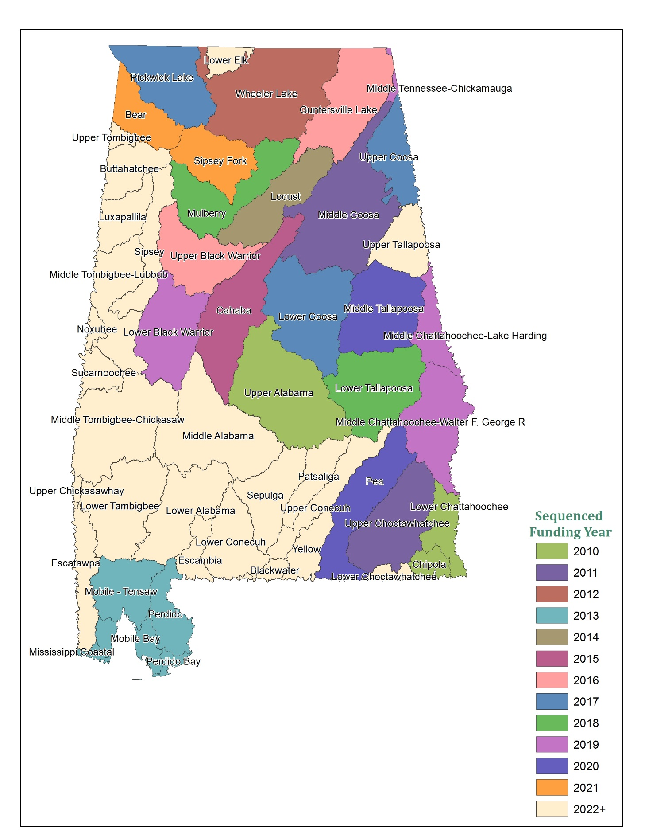
Figure 1. Alabama HUC 8 Watersheds
Figure 2 below demonstrates the current LiDAR coverage across the State including the date of the topographic data collection.
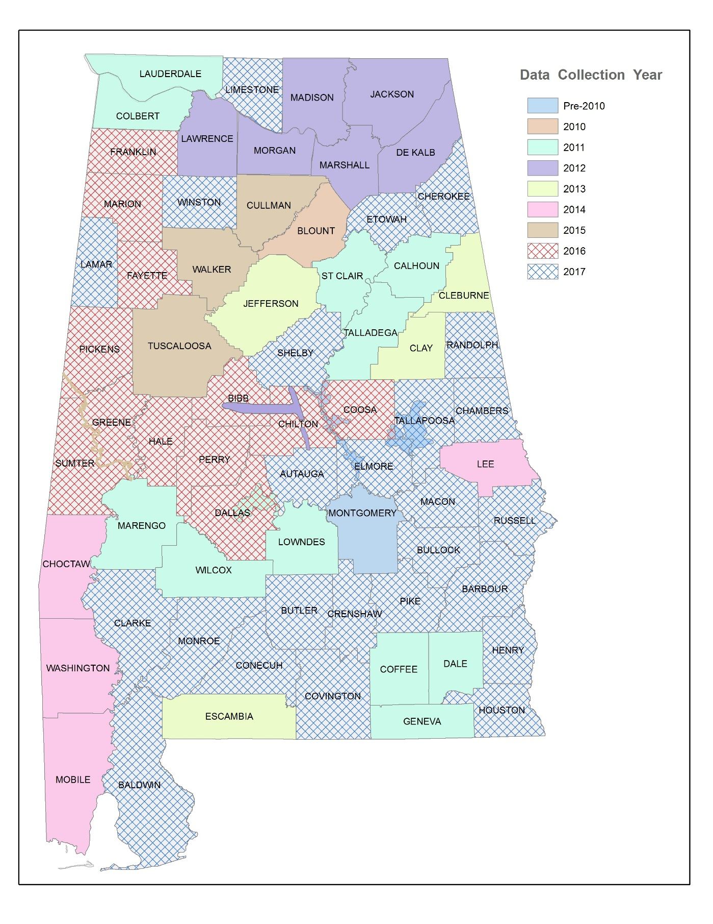
Figure 2. Current Alabama LiDAR Coverage

Levee Strategies
The extent of floodplain mapping that is impacted by levee systems in Alabama is limited. OWR has identified five levees that are shown to provide some level of protection from flood events. There is one levee in Tuscaloosa County that will be evaluated as part of the Upper Black Warrior Watershed study. The other levees are not in watersheds that are planned for projects in the next 5 years.

Coastal Needs
There are approximately 211 coastal miles that are currently being updated in Alabama; 111 miles in Baldwin County and 100 miles in Mobile County. The coastal remapping study that is currently underway includes storm surge analysis and overland wave height analysis for Baldwin and Mobile Counties. This study involves new and existing methodologies such as LiDAR-based topography, new digital orthophotography, statistical analyses using appropriate Joint Probability Methods for storm analyses, Simulating Waves Nearshore (SWAN) 2-D wave model, and Advanced Circulation model (ADCIRC) 2-D hydrodynamic modeling. The coastal flood maps for Baldwin County are anticipated to be issued Preliminary in the July 2017; and the maps for Mobile County in November 2017.

Statewide Base Level Engineering Update
Additionally, furthering the Risk MAP goal to address data gaps, OWR plans to update the State's Zone A modeling to Base Level Engineering (BLE) level by creating water-surface elevation (WSEL) and depth grids for all of the Zone A models, and by conducting HAZUS Level 2 analyses on the building-level analysis for 20% of the counties based on population. The WSEL and depth grids would be loaded into a web-based mapping tool to allow for point and click access to the estimated 100-year elevation and depth depicted by the Zone A. The State has 33,905 miles of Zone A mapping, which constitutes approximately 87% of all SFHA in the State. This project will allow floodplain administrators, homeowners, and local developers access to the best available flood elevation data. This project will increase technical credibility for the flood information, raise risk awareness, and reduce flood risk.

Current Risk MAP Performance Measures Targets
FEMA’s vision for the Risk MAP Program is to deliver quality data that increases public awareness and leads to action that reduces risk to life and property. FEMA has selected key performance measures or program metrics that can be used to determine whether desired program outcomes are being achieved so that Risk MAP performance is aligned across FEMA Headquarters and Regional offices. Performance Measure Targets for the FY16 projects are presented in the tables below.

Table 4. Flood Risk Project Performance Measures Targets
Performance Measure | Method for Achieving Target
Deploy Risk MAP in the Upper Black Warrior and Guntersville Lake Watersheds | Achieve deployment for the following watershed populations: Upper Black Warrior – 280,203 and Guntersville Lake – 134,657
Provide updated engineering for certain mileages in the Upper Black Warrior and Guntersville Lake Watersheds | Update the following number of miles: Upper Black Warrior – 134 miles and Guntersville Lake – 122 miles
Meet planned leverage amounts for Upper Black Warrior and Guntersville Lake Watersheds | Achieve the following leverage amounts: Upper Black Warrior – $498,000 and Guntersville Lake – $639,000
Meet the CPI/SPI threshold | Maintain SPI and CPI between 0.92 and 1.08
Continued maintenance, through non-federal funds, of the processes or systems in place to support the collection, development, evaluation, dissemination and communication of flood hazard and risk assessment data and mapping | Achieve the following requirements for leveraging: Upper Black Warrior – $498,000 or 26%; Guntersville Lake – $639,000 or 28%; Pickwick Lake, Upper Coosa, and Lower Coosa – $10,000 or 12%, and City of Atmore PMR – $23,600 or 19%
Evaluate partnerships on a quarterly basis and incorporate results in the quarterly reporting requirement | Achieve a rating of “Good.”
Meet recycle rate requirements for QR3, a review of 10% of the map panels prior to Preliminary Release | Achieve a recycle rate as defined of less than or equal to 3 (“Good” rating)
Meet recycle rate requirements for QR5, a review of final data preparing for the LFD | Achieve a recycle rate as defined of less than or equal to 3 (“Good” rating)
Meet minimum issue requirements for QR6 | Complete QR6 with 3 issues or less (“Good” rating)
Meet minimum issue requirements for revised preliminaries or other post-preliminary rework | Complete revised preliminaries or post-preliminary rework with 3 issues or less (“Good” rating)
Complete timely updates of the MIP | Update the MIP monthly

In conjunction with efforts to meet the above targets, OWR will communicate with communities throughout the life of each project. Continued engagement is necessary and appropriate to build upon the relationships established or enhanced during Discovery and to provide transparency into the Risk MAP process. This communication may occur through monthly or quarterly updates or project status calls with community leaders, updates to project websites including at milestones or along a specific timeline, or other methods.

Table 5. Program Management Performance Measures Targets
Performance Measure | Method for Achieving Target
Update CNMS for expiring miles in FY 2017 | Complete updates of the CNMS database for Alabama to include 232 expiring miles in FY 2017 and achieve an adequate rating of the CNMS roll-up data.
Evaluate partnerships on a quarterly basis and incorporate results in the quarterly reporting requirement. This will be conducted in conjunction with those efforts detailed in Table 4 above. | Achieve a rating of “Good.”
Submit a Business Plan highlighting areas of priority and OWR’s plan to address need | Complete and submit an annual Business Plan in accordance with the schedule approved by FEMA.

Table 6. CERC Performance Measures Targets
Performance Measure | Method for Achieving Target
Identify the planned number of communities to be assisted in identifying and advancing actions and then issue a report on success of action advancement. | Conduct mitigation action assistance in 3 communities each for Upper Black Warrior and Guntersville Lake Guntersville watersheds. The initial screening of mitigation locations/projects will be prepared based on AoMIs, repetitive loss, parcel specific flood risk calculations, and flood profiles to determine potential projects in each watershed. Action targets include the identification of a minimum of 1 but up to 5 actions per community.
Add Training videos and/or flood risk information to OWR’s website and YouTube channel | Add at least 3 new items (videos or risk information) to the website and publicized through the Alabama Association of Floodplain Managers conferences and email distribution to floodplain managers in the State. All website additions will be reviewed by FEMA and should require minimal corrections.
Continued maintenance, through non-Federal funds, of the processes or systems in place to support the collection, development, evaluation, dissemination and communication of flood hazard and risk assessment data and mapping | Identify the level of non-Federal support provided during the previous quarter and show cumulative totals for the project
Incentivize building local/federal/state partnerships. Document where OWR builds partnerships in the mapping projects with a local champion to outreach or engage a broader audience in a more efficient manner | Establish one private and one public partnership per watershed and more efficiently engage a broader audience during the Risk MAP project
Distribute quarterly emails with communities in watershed stakeholder groups to keep them up to date on the status of the projects and to document the completion of activities | Submit documentation of quarterly emails to communities and FEMA

To support action advancement, FEMA has developed a Mitigation Action Tracker. In addition to watershed project entries, OWR will enter mitigation actions as identified during Risk MAP project for Upper Black Warrior and Guntersville Lake projects. Approximately 160 mitigation actions have been identified to date. OWR will continue to coordinate with local emergency management partners to ensure mitigation actions as identified during the mitigation planning process are entered and tracked in FEMA’s Mitigation Action Tracker for the State of Alabama.

Summary and Program Funding Required
OWR is committed to providing the citizens of Alabama with accurate up-to-date flood maps. OWR will utilize the foundation and partnerships and the very successful development and implementation of the AFPMP to meet and exceed the goals established for Risk MAP in the State of Alabama.

Alabama estimates that approximately 47% (2,378 miles) of existing AE (detailed) studies are still in need of updated engineering in order to meet FEMA’s New, Validated or Updated (NVUE) goals. In order to meet these NVUE requirements and the additional program goals and performance measures outlined in this Business Plan, OWR estimates that approximately $5,100,000 will be needed each year over the next five years, and the total program funding level required for FY 2017 to FY 2021 is estimated to be approximately $25,500,000.

Table 7. Program Funding for Fiscal Funding Years 2017 to 2021
Fiscal Year | Engineering & Mapping Funding | Non-Regulatory Product Funding | Program Management Funding | CERC Funding | LOMR Review Funding | Total FEMA Funding Required
2017 | $6,820,000 | $682,000 | $125,000 | $125,000 | $210,000 | $7,962,000
2018 | $3,250,000 | $300,000 | $150,000 | $175,000 | $210,000 | $4,085,000
2019 | $3,412,500 | $315,000 | $157,500 | $183,750 | $220,500 | $4,289,250
2020 | $3,583,125 | $330,750 | $165,375 | $192,938 | $231,525 | $4,503,713
2021 | $3,762,281 | $347,288 | $173,644 | $202,584 | $243,101 | $4,728,898
Totals | $20,827,906 | $1,975,038 | $771,519 | $879,272 | $1,115,126 | $25,568,861

OWR has developed an approach that will meet all the goals and objectives of the Risk MAP Program. The costs identified in Table 7 above demonstrate the dollars needed to accomplish this plan within the established timeline. The AFPMP includes costs associated with technical studies, mapping, outreach, development of non-regulatory products, post preliminary processing, program management, community engagement and risk communication, and LOMR Review Partnership.

APPENDIX A
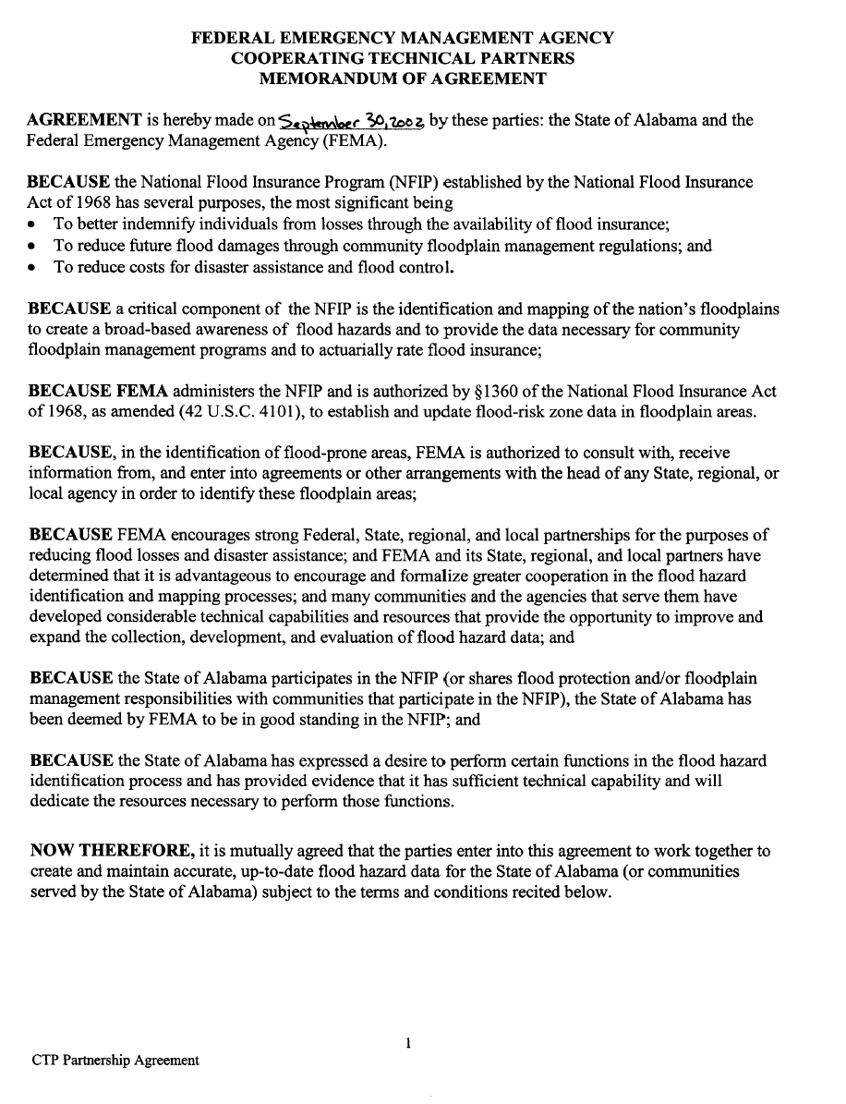

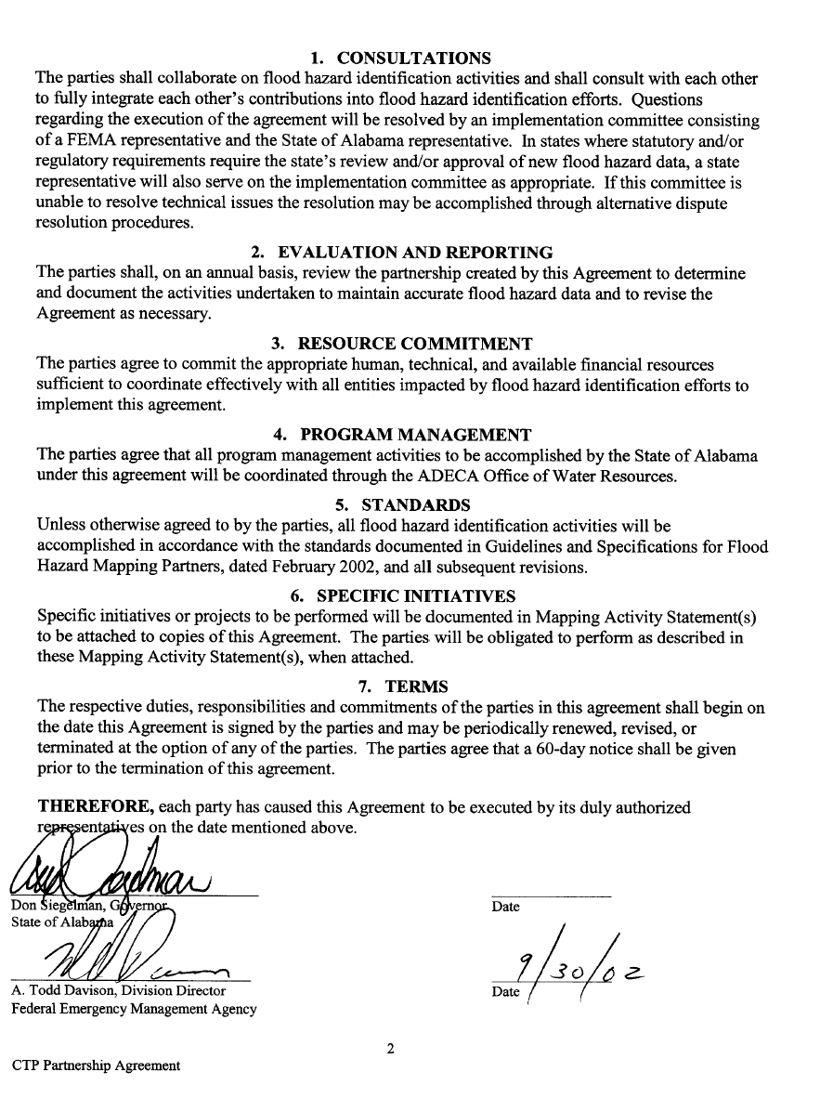

The recycle rate measures the ability to resolve comments and attain a high quality submission during the first cycle of review and comment resolution and reflects the number of times this process is repeated or recycled based on a quality-induced error, not just a program or process change induced correction.

