State of Alabama
Office of Water Resources

Risk MAP Program Business Plan

Increasing Risk Awareness, Resilience, and Sustainable Mitigation Actions in Alabama
Fiscal Years 2015 to 2019

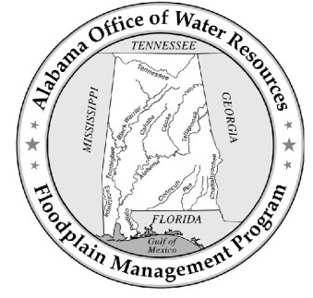
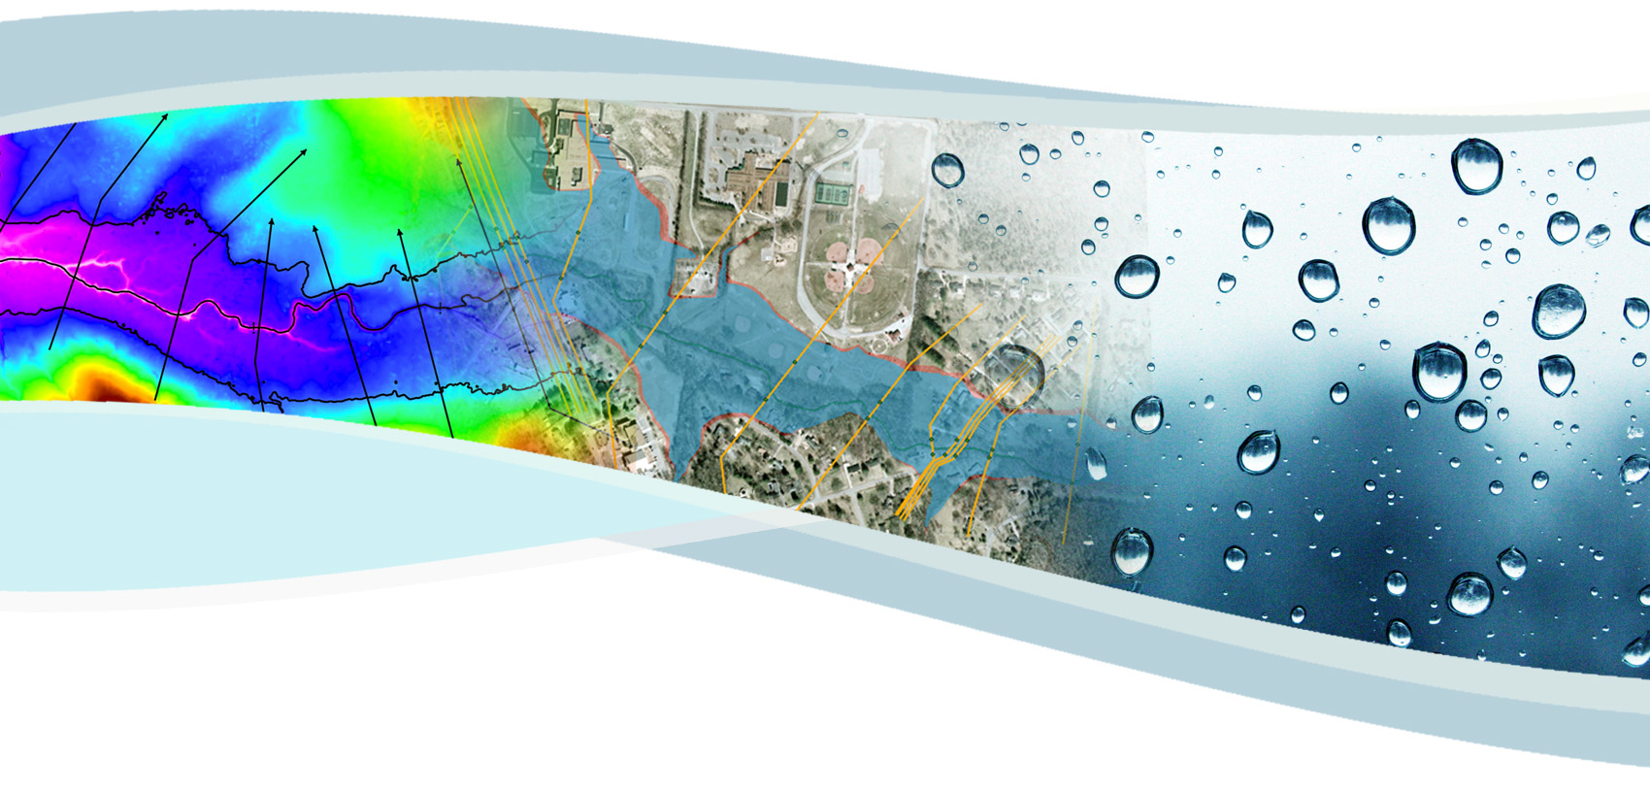

Table of Contents

Page No.
List of Acronyms v
Executive Summary 1
I. Introduction 2
A. Purpose and Need 2
B. Vision, Mission, and Goals 3
1. Vision and Mission Statements 3
2. Program Goals 3
C. Program Organization 4
D. Past Program Accomplishments 4
1. Risk MAP Management Support and Program Management Activities 5
2. Early Demonstration Projects 7
3. Pilot Projects 7
a) Coordinated Needs Management Strategy Pilot Project 7
b) City of Prattville HAZUS Level 2 Analysis 8
c) AL FRIS Pilot Project 8
4. Award of Letter of Map Revision Delegation Authority 9
5. Earned Value Management 9
II. Risk MAP Program Overview 9
A. Program Management 9
1. Community Engagement and Risk Communication 9
a) Targeted Educational Topics and Forums 10
b) Riverine Risk MAP Project Outreach 11
c) Coastal Risk MAP Project Outreach 12
d) Alabama Floodplain Management Program Website 12
e) Mitigation Support 13
2. Technical Trainings 13
a) Advanced LOMR Training 14
b) Risk MAP Tools Training 14
c) Hazard Mitigation Training 14
d) Risk MAP Video Training 14
3. Data Management 15
a) Topography 15
b) Orthophotography 15
c) Parcel Data 16
d) Building Footprints 16
e) First Floor Elevations 16
f) Value of Partner Contributions 16
4. Hazard Mitigation Planning Coordination 17
a) State Coordination 17
b) Local Coordination 18
5. Risk MAP Coordinator Role 18
a) Risk MAP Partnership Building 18
b) Internal and External Coordination for Best Available Data 19
c) Risk Communication Development and Oversight 20
d) Participation in FEMA’s Program Development 20
6. State National Flood Insurance Program 20
7. Letter of Map Revision Delegation 21
a) Connection to the Alabama Department of Economic and Community Affairs 21
b) Connection to the National Flood Insurance Program 22
c) Connection to Local Communities 22
B. Digital Vision 23
C. Project Management 23
D. Program Management Activity Performance vs. Risk MAP Goals 24
III. Five-Year Plan 25
A. Watershed Approach 25
B. Defining Risk in Fiscal Year 2015 and Beyond 27
C. Defining Need in Fiscal Year 2015 and Beyond 29
D. Topographic Data Availability 30
E. Levee Strategies 32
F. Coastal Needs 32
G. Watershed Sequencing FY 2015 through FY 2019 33
H. Funding in Fiscal Year 2015 35
I. Proposed Fiscal Year 2015 Project Deliverables 36
IV. Current Risk MAP Performance Measures 36
A. Deployment 36
B. New, Validated, or Updated Engineering 40
C. Awareness 40
D. Action Measure 41
V. Summary and Program Funding Required 42

List of Tables

Table 1. Types of Local Partner Contributions 17
Table 2. AFPMP Program Management Activities and Specific MAP Goals by Activity 24
Table 3. HUC 8 Watershed Prioritization Based on Risk 29
Table 4. Watershed Sequencing for Fiscal Years 2015 to 2019 33
Table 5. Funding for Fiscal Year 2015 35
Table 6. Proposed Risk MAP Product Development for Fiscal Year 2015 36
Table 7. Criteria for Risk MAP Projects Counting Towards Deployment 37
Table 8. FEMA’s National Targets for Deployment through Fiscal Year 2016 37
Table 9. Alabama Deployment Performance Measure for Fiscal Year 2015 37
Table 10. FEMA’s National Targets for NVUE through Fiscal Year 2016 40
Table 11. FEMA’s National Targets for Action Measures 1 & 2 through Fiscal Year 2015 41
Table 12. Program Funding for Fiscal Year 2015 to Fiscal Year 2019 43

List of Figures

Figure 1. Alabama HUC 8 Watersheds 26
Figure 2. Alabama HUC 8 Watersheds by Risk 28
Figure 3. Current Alabama LiDAR Coverage 31
Figure 4. Alabama HUC 8 Deployed Watersheds 39

Appendices

Appendix A Alabama’s Cooperating Technical Partner Agreement
Appendix B OWR Organizational Chart

List of Acronyms
A
AAFM Alabama Association of Floodplain Managers
AAL Average Annualized Loss
ADCIRC Advanced Circulation Model
ADECA Alabama Department of Economic and Community Affairs
AEMA Alabama Emergency Management Agency
AFPMP Alabama Floodplain Management Program
ALDOT Alabama Department of Transportation
AL FRIS Alabama Flood Risk Information System
AoMI Areas of Mitigation Interest

B
BMP Best Management Practices

C
CAC Community Assistance Contact
CAP Community Assistance Program
CAV Community Assistance Visit
CEO Community Executive Officer
CERC Community Engagement and Risk Communication
CFR Code of Federal Regulations
CLOMR Conditional Letter of Map Revision
CNMS Coordinated Needs Management Strategy
CPI Cost Performance Indicator
CSLF Changes Since Last FIRM
CTP Cooperating Technical Partner

D
DEM Digital Elevation Model
DFIRM Digital Flood Insurance Rate Map

E
EMA Emergency Management Agency
EV Earned Value

F
FBS Floodplain Boundary Standard
FEMA Federal Emergency Management Agency
FIRM Flood Insurance Rate Map
FIS Flood Insurance Study
FLIS FEMA Levee Inventory System
FMMP Flood Map Modernization Program
FRD Flood Risk Database
FRIS Flood Risk Information System
FRM Flood Risk Map
FRR Flood Risk Report
FY Fiscal Year

G
G&S FEMA’s Guidelines and Specifications
GIS Geographic Information System

H
HAZUS Hazards-United States
HUC Hydrologic Unit Code

K
KPI Key Performance Indicator

L
LAMP Levee Analysis and Mapping Procedures
LFD Letter of Final Determination
LiDAR Light Detection and Ranging
LOMC Letter of Map Change
LOMR Letter of Map Revision

M
MAS Mapping Activity Statement
MIP Mapping Information Platform
MMMS Map Modernization Management Support
MNUSS Mapping Needs Update Support System
MOU Memorandum of Understanding

N
NDI National Dam Inventory
NFIP National Flood Insurance Program
NRCS Natural Resources Conservation Service
NVUE New, Validated or Updated Engineering
NWS National Weather Service

O
OWR Alabama Office of Water Resources
P
PAL Provisionally Accredited Levee
PM Program Management
PMR Physical Map Revision

Q
QA/QC Quality Assurance/Quality Control

R
Risk MAP Risk Mapping, Assessment, and Planning
RSC Regional Support Center

S
SFHA Special Flood Hazard Area
SHMO State Hazard Mitigation Officer
SPI Schedule Performance Indicator
SWAN Simulating Waves Nearshore

T
TMAC Technical Mapping Advisory Council
TVA Tennessee Valley Authority

U
UDF User Defined Facility
USACE U.S. Army Corps of Engineers
USDA U.S. Department of Agriculture
USGS U.S. Geological Survey

Executive Summary
The Office of Water Resources (OWR) is responsible for water resources and all aspects of floodplain management, including protection and planning, within the State of Alabama. Through a Cooperating Technical Partner (CTP) agreement with the Federal Emergency Management Agency (FEMA), Alabama has assumed responsibility for the technical accuracy of Flood Insurance Rate Maps (FIRMs) across the State. OWR has worked closely with FEMA for the past 13 years on various aspects of floodplain management, including the Flood Map Modernization Program (FMMP), the Risk Mapping, Assessment, and Planning (Risk MAP) Program, and all activities associated with the National Flood Insurance Program (NFIP). The goal of the FMMP was to replace the State’s paper flood maps with a more accurate, updated digital product to ensure a solid foundation of quality flood hazard data on which to build and enforce local floodplain management programs. OWR embraced this goal and produced quality, digital flood hazard data across the State within the first five years of the FMMP, meeting or exceeding all of FEMA’s performance metrics for the program. Since 2010, OWR has been a key partner in implementing FEMA’s Risk MAP Program throughout the State, which has focused on increasing flood risk awareness and resilience at the local level through effective community engagement and sustainable mitigation actions. OWR is proud of the federal/state partnership that has been developed through the implementation of the FMMP and Risk MAP, and the result is a successful and robust floodplain management program within the State of Alabama.

OWR has taken advantage of its ability to integrate the FMMP and Risk MAP Program with other floodplain management functions to create the comprehensive Alabama Floodplain Management Program (AFPMP). The primary goals of the AFPMP are to reduce the loss of life and property, minimize suffering and disruption caused by disaster, and better prepare for the consequences of flooding and other hazards. Similarly, FEMA’s goals for Risk MAP are to identify and assess flood risk, communicate flood risk, and ultimately mitigate flood risk through measurable community actions. OWR, through the AFPMP, will accomplish these goals through effective leadership, interagency coordination and community involvement, and by providing communities with the tools and resources they need to effectively manage, assess, and plan for development in flood prone areas; to save lives; and to protect property.

In accordance with FEMA guidance, all watersheds within the State have been prioritized for study based on current flooding risk, the need for engineering updates, and the availability of quality topographic data. Alabama estimates that approximately 48% (2,3160 miles) of existing AE (detailed) studies are still in need of updated engineering in order to meet FEMA’s New, Validated or Updated (NVUE) performance measure. In order to meet FEMA’s goal of 80% NVUE by FY 2020, OWR estimates that approximately $3,700,000 will be needed each year over the next five years. If fully funded, the total program funding level required for FY 2015 to FY 2019 is estimated to be approximately $18,300,000.

Introduction

Purpose and Need
Recognizing the connection between reliable flood maps and effective flood damage reduction, the Federal Emergency Management Agency (FEMA) provided funding for the Flood Map Modernization Program (FMMP) starting in Fiscal Year (FY) 2003 and continuing through FY 2008. The FMMP focused on updating existing Special Flood Hazard Areas (SFHAs) and converting paper flood maps to a digital platform. Through the FMMP, FEMA created an opportunity for Cooperating Technical Partners (CTPs) to manage flood map development at the local level, realizing that local involvement leads to increased flood risk awareness and product acceptance. The Alabama Office of Water Resources (OWR) entered into a CTP agreement with FEMA on September 30, 2002, assuming responsibility for the technical accuracy of the Flood Insurance Rate Maps (FIRMs) across the State. A copy of the current CTP agreement between Alabama and FEMA is attached in Appendix A.

In order to effectively and efficiently deliver the FMMP program within the State of Alabama, OWR created the comprehensive Alabama Floodplain Management Program (AFPMP). Since its conception during the implementation of the FMMP, the AFPMP has grown to include a variety of floodplain management activities including flood hazard mapping, community engagement and risk communication, outreach, community trainings, data management, program management, project planning, project management, Letter of Map Revision (LOMR) delegation, and the State of Alabama National Flood Insurance Program (NFIP). In FY 2010, FEMA transitioned beyond the FMMP into the Risk Mapping, Assessment, and Planning (Risk MAP) Program. To allow for the successful implementation of the Risk MAP vision within the State of Alabama, OWR further expanded the AFPMP to include a Risk MAP Coordinator role, the production of flood risk assessment data, hazard mitigation planning coordination activities, and mitigation action tracking at the local level.

This Business Plan describes how the AFPMP will continue to successfully execute the Risk MAP vision and meet FEMA’s program goals within the State of Alabama through FY 2019. Included in this Business Plan is an overview of past program accomplishments, current program organization, the program vision, mission and goals, program metrics, program management activities, project sequencing and prioritization, and a description of the funding needed to properly support the AFPMP.

OWR is excited about the opportunity to continue its partnership with FEMA and is committed to the success of the AFPMP and the Risk MAP Program. This Business Plan clearly outlines the objectives, sequencing, and funding requirements that will continue to make the AFPMP a success. In order to share the goals and vision of the AFPMP with other federal and state agencies, as well as local communities, the Business Plan is available on the AFPMP website. In addition, OWR coordinates distribution of the Business Plan with the Silver Jackets state team.

Vision, Mission, and Goals

Vision and Mission Statements
The vision of the AFPMP is to create a proactive, continuously improving, and evolving process of floodplain management, including floodplain mapping, risk assessment and risk communication through effective leadership, interagency coordination, and community involvement.

The mission of the AFPMP is to make Alabama and its citizens less vulnerable to the impact of flooding through the effective administration of statewide floodplain management and to provide local communities with the tools and resources for managing, assessing, and planning for development in flood prone areas; to save lives; and to protect property.

FEMA’s vision for Risk MAP is that through collaboration with state, local and tribal entities, Risk MAP will deliver quality data that increases public awareness and leads to action that reduces risk to life and property.

Program Goals
The primary goals of the AFPMP are to reduce the loss of life and property, minimize suffering and disruption caused by disaster, and better prepare for the consequences of flooding and other hazards.

To achieve the Risk MAP vision, FEMA has expanded on flood hazard identification and mapping to include a more integrated process involving identifying, assessing, communicating, planning, and mitigating flood risk. FEMA’s goals for Risk MAP are as follows:

- Goal 1: Flood Hazard Data
  - Address gaps in flood hazard data to form a solid foundation for flood risk assessments, floodplain management, and actuarial soundness of the NFIP.

- Goal 2: Public Awareness / Outreach
  - Ensure that a measurable increase of the public’s awareness and understanding of risk management results in a measurable reduction of current and future vulnerability to flooding.

- Goal 3: Hazard Mitigation Planning
  - Lead and support states and local and tribal communities to effectively engage in risk-based mitigation planning resulting in sustainable actions that reduce or eliminate risks to life and property from natural hazards.

- Goal 4: Enhanced Digital Platform
  - Provide an enhanced digital platform that improves management of Risk MAP, stewards information produced by Risk MAP, and improves communication and sharing of risk data and related products to all levels of government and the public.

- Goal 5: Alignment and Synergies
  - Align Risk Analysis programs and develop synergies to enhance decision making capabilities through effective risk communication and management.

Ultimately, through collaboration with FEMA and strong partnerships with state, local, and tribal entities, the AFPMP will reduce losses of life and property throughout the State of Alabama through local, sustainable mitigation actions based on quality flood hazard data, flood risk assessments, and effective hazard mitigation planning coordination.

Program Organization
The Office of Water Resources is a division within the Alabama Department of Economic and Community Affairs (ADECA). OWR administers programs for river basin management, river assessment, water supply assistance, water conservation, water resources development, floodplain management and mapping, and the NFIP. OWR comprises engineers and planners with expertise in hydrology and water resources; the organizational chart located in Appendix B provides an overview of OWR’s staff and function within the floodplain management team. In addition to floodplain management responsibilities, OWR performs several water resources-related tasks and analyses such as surface water modeling, drought planning and management, water use management, and water policy review and implementation. The OWR staff clearly has the technical and program knowledge and capabilities to perform all functions associated with the AFPMP.

The AFPMP, including the State NFIP Coordinator as well as the State hydrologic engineering and map maintenance groups, are housed within one facility and overseen by one director. This advantageous organization of offices gives OWR the ability to coordinate and leverage floodplain management activities with other water resources programs within the State. This organization is a key factor in the successful implementation of Risk MAP as coordination between state agencies is vital to the integration of risk assessments and mitigation planning in Alabama.

Past Program Accomplishments
OWR has established a proactive environment for managing flood related issues within the State by developing strong partnerships with local communities and other state and federal agencies, increasing public awareness and education of flood hazards through various outreach channels, and utilizing modern mapping technologies to increase the reliability and accuracy of flood hazard delineations. OWR has also been instrumental in several pilot and early demonstration projects in partnership with FEMA to help develop new methodologies and guidance for emerging FEMA programs. The following is a summary of notable AFPMP accomplishments to date.

Risk MAP Management Support and Program Management Activities
- Evaluation of the Floodplain Boundary Standard (FBS) for all counties mapped in Alabama during FY 2003 through FY 2008, which included those counties mapped prior to the implementation of the FBS.
- Development of a geodatabase to house a digital base map inventory for the entire state, which contains available base map data including type of data, properties of data, date of creation, owner, and contact information as well as coordination with the U.S. Geological Survey (USGS) to convert digital elevation models (DEMs) from a 30 meter cell size to a 10 meter cell size for every county in the State.
- Outreach to educate state and federal agencies about the benefits of base map data sharing and an evaluation of the short-term and long-term feasibility of utilizing the data for flood hazard mapping for the FMMP, which included establishment of the initial Alabama Flood Roundtable that targeted outreach to State and Federal agencies.
- Development of a quality assurance/quality control (QA/QC) plan and protocol to review contractors’ mapping activities (hydrology and hydraulics) to ensure that they comply with FEMA’s Guidelines and Specifications for Flood Hazard Mapping Partners – Appendix C: Guidance for Riverine Flooding Analysis and Mapping, FEMA Procedural Memorandum 35 and standard engineering practices.
- A community-by-community assessment of specific mapping needs encountered during map production for counties funded in FY 2003 through FY 2007 and the inclusion of those mapping needs in FEMA’s Mapping Needs Update Support System (MNUSS) along with an unmet needs prioritization scheme incorporating factors such as flood zone type, age of study, age of map, new infrastructure, population, availability of topographic data, potential for population growth, known observed flooding issues, and existing risk class determinations. MNUSS and the prioritization scheme were developed prior to the creation and implementation of FEMA’s Coordinated Needs Management Strategy (CNMS).
- Development of a draft strategy for levee certification for the State of Alabama. The strategy includes methods for certifying levees, the status of the FEMA Levee Inventory System (FLIS) as it relates to Alabama, and a collection of all FEMA Guidelines and Specifications and Procedural Memorandums related to levee certification.
- Creation of and continual updates to the AFPMP website, which provides access to the most current flood hazard data and an extensive toolset to users for the management of flood mapping data.
- Development and execution of various trainings for state and local officials, community officials, frequent requestors, and stakeholders such as:
  - Use of the AFPMP website and the various tools and floodplain data available.
  - Comprehensive digital tools trainings such as Risk MAP Tools that focused on use of the digital FIRM (DFIRM) database, new flood risk datasets, and various potential uses of digital data contained within the database. Trainings were developed for the basic user as well as the more advanced user.
  - MT-2 Letter of Map Change (LOMC) trainings in order to provide a working understanding of the LOMR application process as well as multiple LOMR trainings that examined the application process step-by-step in detail.
- Creation of and continual updates to the AFPMP Business Plan to reflect program status, goals, objectives, and performance metrics.
- Management of technical mapping activities through bi-monthly planning meetings to discuss project schedules, project budgets, and resources needed to successfully execute the activities outlined in the Mapping Activity Statements (MAS).
- Outreach activities that enhance the understanding of the flood mapping program and ownership of the mapping process at state and local levels, which included specialized coastal outreach meetings and development of a coastal outreach plan, plus specialized LOMR outreach regarding the delegation of LOMR processing responsibilities to the State.
- Execution of specialized outreach to the Alabama Department of Transportation (ALDOT) in an effort to increase LOMR application submittals and to build partnerships across state agencies.
- Ongoing partnership with the State of North Carolina Floodplain Mapping Program to create the Alabama Flood Risk Information System (AL FRIS) to display statewide flood hazard information, flood risk information, modeling data, and Flood Insurance Study data.
- Ongoing Mitigation Planning and Technical Assistance Training focused on building a community’s capability to plan for and reduce risk.
- Ongoing Global Program Management to ensure the successful execution of Risk MAP projects in the areas of scope, schedule, cost, and quality, as well as the accomplishment of Risk MAP program goals in the areas of integration, risk assessment, and communication.
- Completion of the validation evaluation in CNMS for the remaining miles that have exceeded their study lifespan. Assessment of these expiring miles through engineering and GIS will promote prioritization of streams to be targeted for future studies.
- Completion of dam inventories with all counties in a singular database to ensure it is compatible with current National Inventory of Dams (NID) shapefile formatting. This aids in recommendations for adding to the current NID.
- Development of training videos to promote the use and understanding of Non-Regulatory datasets including Changes Since Last FIRM and Flood Depth & Analysis Grids, as well as updates to the Regulatory Database. By enabling both a visual and verbal component to communicate processes and best practices for using these dataset, communities are able to maximize their understanding of local flood risks.
- Service by an OWR representative on FEMA’s Technical Mapping Advisory Council (TMAC), a federal advisory committee established to review and make recommendations to FEMA on matters related to the national flood mapping program. Only 20 representatives from across the U.S. are selected to participate on TMAC.

Early Demonstration Projects
In FY 2010, OWR was selected by FEMA to participate in two Early Demonstration Projects. The objective of these projects was to demonstrate proof of concepts related to flood risk products and datasets as well as various pathways for community engagement. These projects allowed OWR and FEMA to develop an enriched understanding of the Risk MAP vision and gain experience in the effort and costs associated with delivering the new Risk MAP products and messages. OWR helped FEMA to understand the cost of delivering the products as well as to formulate a process for product development that demonstrated efficiencies and standardized best practices.

OWR completed Early Demonstration Projects in Madison County, Alabama, and in the Upper Alabama Watershed. The Madison County project resulted in the development of a Flood Risk Database, Flood Risk Report, and Flood Risk Map, as well as an analysis of the costs associated with developing and delivering these products. The Upper Alabama Watershed project culminated in the development of a template report to communicate dam failure risk within the watershed that can be used as an appendix to the standard FEMA Flood Risk Report. These projects ultimately aligned with the overall vision of Risk MAP to produce a measurable increase in public understanding and awareness of flood risk and provide clear communication regarding dam failure risks within the watershed.

Pilot Projects

Coordinated Needs Management Strategy Pilot Project
OWR participated in FEMA’s CNMS pilot project in an effort to help develop the methodology for implementing the engineering needs tracking strategy on the national level. OWR collected unmet engineering needs for Baldwin, Madison, Cullman, and Randolph Counties (FY 2008 Maintenance Counties) and populated a draft data structure, which was a spatial representation of the unmet engineering needs within those counties. The engineering needs were then evaluated using the New, Validated, or Updated Engineering (NVUE) checklist. OWR delivered the populated data structure as well as a feedback paper detailing effort, methodology, and suggested improvements to FEMA. In addition to the pilot counties, OWR evaluated existing AE streams using NVUE criteria and populated the CNMS database accordingly for 19 additional counties in Alabama. These counties were evaluated in an effort to create a schedule for future map updates in the State while focusing on areas with the greatest need. The CNMS methodology is now part of the national standard for developing FEMA funding requests.

City of Prattville HAZUS Level 2 Analysis
Using FY 2010 Project Management funds, OWR completed a pilot project within the City of Prattville (Autauga County) that included a Level 2 Hazards-United States (HAZUS) analysis in order to assess flooding risk within the community. In conjunction with the state and local emergency management agencies (EMAs) and the Autauga County Geographic Information System (GIS) Office, OWR established an inventory of building footprints, structure type/value, contents, first floor elevations, criticality, maximum occupancy and loss history. The HAZUS analysis was based on new, updated, or validated flood depth grids for multiple flood frequencies and the local building data that was made available by the community. The analysis also included losses for hurricane winds and earthquake. The HAZUS analysis provided more accurate loss estimates for the City of Prattville that were made available to be incorporated into the local hazard mitigation plan. This pilot project also provided OWR with a better understanding of local data availability, the coordination efforts required for obtaining the local data, and the labor effort associated with running a Level 2 HAZUS analysis using User Defined Facility (UDF) information. Based on the success of this pilot project, all standard Risk MAP projects in Alabama incorporate a Level 2 HAZUS analysis.

AL FRIS Pilot Project
OWR was invited by the State of North Carolina Division of Emergency Management, a fellow CTP, to partner in the development of a digital Flood Risk Information System (FRIS). The main objectives in the development of the FRIS are to: 1) better utilize digital technology to display flood hazard and flood risk data in order to reduce the costs associated with producing paper map products and 2) create a singular digital platform on which all flood hazard data can be displayed, providing the user with the ability to produce ‘on the fly’ Flood Insurance Studies (FIS) and FIRMs, which will simplify access to the data and remove the need for the user to consult multiple FEMA products in order to obtain the same level of information.

While a worthy undertaking, the development of the FRIS is not a simple process. The database schema that supports the FRIS platform differs from the DFIRM database schema required by FEMA’s Guidelines and Specifications (G&S), which is the basis for the creation of all Alabama flood hazard data. In order to understand and define the process steps and the costs associated with converting Alabama’s DFIRM database schema into the FRIS database format, OWR initiated a pilot implementation of this process within the Upper Alabama watershed. The Upper Alabama Watershed was selected as a pilot project due to the recent production of Risk MAP products in compliance with FEMA’s G&S and the mix of rural and urban communities within the watershed that brings different levels of familiarity and GIS capabilities to the user group. Currently, OWR is identifying challenges and lessons learned for developing Risk MAP products that are compatible with both FEMA’s G&S and the FRIS database schema.

Award of Letter of Map Revision Delegation Authority
FEMA clearly recognizes the need for advantageous and effective partnerships in producing accurate mapping products by continuing to offer the opportunity for CTPs to process LOMRs within their jurisdiction. OWR gladly accepted this opportunity and has been responsible for the review and processing of all LOMR requests within the State since July 2010. At present, 113 cases have been approved by FEMA with a final determination issued, and there are 8 cases on schedule for approval. FEMA maintains strict guidelines for the time allowed for the completion of case reviews, and the Alabama program is currently bettering the time allowance by more than a 30% margin.

Earned Value Management
OWR has successfully used the Mapping Information Platform (MIP) to provide monthly updates on the earned value (EV) of mapping projects, which represents performance standards through a cost performance index (CPI) and a schedule performance index (SPI). The CPI and SPI are calculated using the actual cost and schedule of work performed and comparing them to the expected cost and schedule of work performed, or “baseline”. Alabama’s SPI and CPI values currently average 0.91 and 1.00, respectively.

Risk MAP Program Overview

Program Management
The State of Alabama has taken a holistic approach to floodplain management by combining several FEMA and State programs to create a robust floodplain management program. With the transition of the NFIP program from the Alabama Emergency Management Agency (AEMA) to OWR in June 2002, Alabama established a proactive environment for managing flood related issues and concerns through the creation of the AFPMP, which is a multi-faceted and comprehensive plan for program management essential to success execution of the Risk MAP vision in Alabama. The following is a summary of the program management activities that are planned for FY 2015 and beyond.

Community Engagement and Risk Communication
OWR has developed an education and community engagement strategy that aims to build risk awareness and understanding at the local level, increase a community’s ability to communicate risk at the local level, support local efforts to reduce natural hazard risk within a community or watershed, and keep communities and other stakeholders engaged through the Risk MAP process. This Community Engagement and Risk Communication (CERC) strategy will increase community awareness and understanding of flood risk as well as the overall understanding of the NFIP. The education and outreach activities help to create a better understanding of the floodplain mapping process and facilitate early project buy-in at state and local levels, which leads to effective flood risk reduction at the completion of a Risk MAP project. Ultimately, the community engagement activities will increase flood risk awareness that leads to sustainable mitigation actions that reduce flood risk. The program management community engagement activities that are currently planned or underway for the AFPMP are outlined below.

Targeted Educational Topics and Forums
OWR will prepare a series of educational presentations that will cover a range of topics from why proper floodplain management is essential to how Risk MAP datasets can be used for effective floodplain management at the local level. Together, the series of presentations will form a clear picture of the necessity for a strong floodplain management program, the floodplain management and mapping process itself, data requirements, data availability, the organization and value of the AFPMP itself, and the potential for partnerships across local, state, and federal organizations. The goal of the stakeholder engagement effort is to increase the strength and effectiveness of the AFPMP by educating local, state, and federal officials, establish best management practices (BMPs) for daily floodplain management, and develop or strengthen partnerships across agencies and with local communities. The educational outreach topics, targeted stakeholders, and potential forums are as follows:

Target Message: The Importance of Floodplain Management
- Education Topic: Educate state and local stakeholders about the mission and goals of the AFPMP; include local case studies as to why floodplain management is important and how it affects each citizen. The goal is to stress the impacts of proper and improper floodplain management and to motivate stakeholders to be proactive about developing strong floodplain management programs.
- Target Audience: Floodplain administrators, community CEOs, emergency management personnel, and regional planning commissions.
- Potential Forum: Annual AEMA conference and annual Alabama Association of Floodplain Managers (AAFM) conference.

Target Message: Floodplain Management Best Management Practices
- Education Topic: Provide a general overview of federal regulations regarding floodplain management; discuss a model ordinance and floodplain management BMPs; partner with a local community to showcase the practices of effective floodplain administrator.
- Target Audience: Floodplain administrators and community CEOs.
- Potential Forum: Floodplain Management 101 Course administered by AFPMP staff.

Target Message: Effectively Utilizing Risk MAP Tools
- Education Topic: Provide an overview of the new non-regulatory flood risk datasets that are produced as a result of a Risk MAP project; discuss the potential use of each product during daily floodplain management and/or hazard mitigation planning activities; discuss available grant funding; showcase known success stories.
- Target Audience: Floodplain administrators, community CEOs, emergency management personnel, and regional planning commissions.
- Potential Forum: Annual AEMA conference and annual AAFM conference.

Target Message: The Importance of Building Partnerships and Investing in Floodplain Management
- Education Topic: Discuss the importance of building state and local partnerships in order to successfully obtain FEMA funding for a Risk MAP project; identify data requirements and discuss cash match opportunities.
- Target Audience: Revenue commissioners, floodplain administrators, community CEOs, county engineers, emergency management personnel, and regional planning commissions.
- Potential Forum: Annual AEMA conference and annual AAFM conference.

Target Message: Identifying and Implementing Sustainable Mitigation Actions
- Education Topic: Discuss the importance of identifying sustainable mitigation projects within the community in order to reduce risk and prevent loss of life and property in the future; discuss opportunities for grant funding for project implementation; create a working plan for identifying and advancing mitigation actions.
- Target Audience: Floodplain administrators, community CEOs, county engineers, emergency management personnel, and regional planning commissions.
- Potential Forum: Annual AEMA conference, annual AAFM conference, Hazard Mitigation Planning and Technical Assistance trainings.

Riverine Risk MAP Project Outreach
OWR has developed a Risk MAP Project Engagement Strategy Plan (previously Outreach Plan) to be implemented throughout the life of a typical Risk MAP project. The plan aligns with FEMA’s Risk MAP project life cycle and the project milestones for CERC and outreach that are identified in a typical Risk MAP Flood Study MAS. The Risk MAP Project Engagement Strategy Plan incorporates the integration planning, action strategy, community prioritization, Watershed and Community Assessment, Relationship Management and Action Plan, and Communication and Outreach Strategy that are required by FEMA and developed on the watershed level prior to and during the Discovery process. To date, the Risk MAP Project Outreach Plan has been completed within the Upper Alabama watershed and the Houston County project and is in process for the Middle Coosa, Upper Choctawhatchee, Wheeler Lake, Locust Fork and Cahaba watershed projects. The communication, outreach, and engagement plans will continue to be implemented during the beginning stages of future projects at the earliest opportunity for initializing stakeholder engagement and will continue throughout the life of the project.

Coastal Risk MAP Project Outreach
OWR has developed a specialized Coastal Outreach Plan to engage, educate, and inform the coastal communities within Baldwin and Mobile Counties of the benefits of the new coastal flood maps and the potential effects of the on-going coastal mapping update project. The Coastal Outreach Plan identifies target audiences, key messages, milestone dates, and specific outreach materials such as fact sheets, press releases, and information to be displayed on the AFPMP website throughout the life of the mapping project. OWR will also conduct additional community meetings to supplement the typical project outreach performed under the mapping project’s MAS. To date, the coastal outreach plan has been implemented as follows:

- Outreach Flyer #1, Scoping – distributed July 2012
- Introductory meeting with local media – held November 2012
- Outreach Flyer #1 version 2, Scoping – distributed April 2014 with updated project timelines
- Storm surge analysis update meeting – held May 2014
- Outreach Flyer #2, Map Production – distributed August 2014
- Outreach Email, Status Update – distributed January 2015
- Discovery Meeting – held May 2015
- Outreach Email, Status Update – October 2015 (planned)

Alabama Floodplain Management Program Website
OWR has developed a comprehensive floodplain management website to disseminate information to local floodplain managers, CEOs, emergency management personnel, and the general public. The website includes an overview of Risk MAP including new flood risk datasets and products as well as critical fact sheets to promote understanding of the goals of a Risk MAP project. The website also includes a self-guided comprehensive training program on floodplain management that targets OWR employees, other state agency employees, and local officials. The training orients Alabama officials to flooding, the NFIP, and basic skills such as reading a DFIRM and FIS. The website also provides a County Status link under which Preliminary or Effective FIRMs are available for each county along with the FIS Report, Summary of Map Actions, and all community correspondence. Finally, the website provides a forum for posting the AFPMP Business Plan in order to share the goals and vision of the AFPMP with other federal and state agencies as well as the local communities.

OWR has also partnered with the North Carolina Floodplain Mapping Program to create the Alabama Flood Risk Information System (AL FRIS). AL FRIS currently has the capability to display all effective flood hazard mapping data throughout the entire state. AL FRIS hosts the effective engineering models to back the flood hazard mapping data along with critical flood study components such as the Floodway Data Table and Summary of Discharges data. AL FRIS will have a point and click functionality that will allow the user to identify flood risk at any point along a flooding source as well as depth and loss damage calculations on a structure by structure basis. This display of flood risk data will provide local citizens and floodplain administrators with unprecedented access to the most up-to-date flood risk information in their community.

Mitigation Support
OWR plans to leverage Risk MAP data, decision support analyses, and related products and processes to support communities in advancing mitigation actions. Through development of an Action Identification and Advancement Plan, OWR will work closely with the AEMA throughout the lifecycle of a Risk MAP project to collect and quantify actions as part of a project-specific MAS. The following activities are included in this task:

- Actions Identified – Support for communities to identify mitigation opportunities and/or select amongst alternatives by providing data and/or analysis.
- Actions Advanced – Support for communities to advance mitigation opportunities including scoping/design, budgeting, obtaining funding, project planning, technical support for zoning and ordinance development, and outreach strategies for project support.
- Evaluation and Valuation – Support provided to the community to evaluate and demonstrate the value of mitigation investment, including the calculation of economic, environmental, and/or social benefits or the losses avoided from natural hazard events.

Actions will be collected for up to two years after the closeout of a Risk MAP project to provide for the coordinated effort with AEMA for communicating with communities outside of the lifecycle of the Risk MAP project. All watersheds that are within two years beyond project lifecycle fall within the scope of work for FY 2015.

Please refer to Section 2.c below for information related to Hazard Mitigation Technical Training conducted by OWR. OWR will continue to offer targeted trainings for watersheds where Risk MAP projects have been completed.

Technical Trainings
OWR believes in a strong culture of open communication, information sharing, and comprehensive stakeholder trainings. OWR has executed many successful trainings and workshops in the past as previously noted and will continue to do so through current and future program management activities. The program management training activities that are currently planned for the AFPMP are outlined below.

Advanced LOMR Training
OWR continues to conduct an annual advanced LOMR training session that targets frequent requestors and community officials throughout the State in an effort to provide them with a comprehensive understanding of the LOMR application process and best practices. This training examines a typical LOMR application step-by-step in greater detail than the previous LOMR application trainings. The goal of this training is to reduce the time and cost of processing LOMR applications by improving the quality of the initial applications and providing frequent requestors with the latest requirements and lessons learned.

Risk MAP Tools Training
OWR understands that flood risk awareness leads to action that reduces that flood risk, and that those who are more aware of their flood risk are more likely to take sustainable mitigation action. Building on this fundamental principle, OWR will continue to execute project-specific Risk MAP Tools Training workshops throughout the State that will focus on the non-regulatory Flood Risk Database (FRD) and the flood risk datasets contained therein. These workshops educate the everyday user on the attributes contained within each dataset and the various uses of the datasets that can be applied during daily floodplain management and hazard mitigation activities. The goal of this project-specific workshop is to leave local officials empowered, informed, ready to take action, and armed with the tools they need to provide effective outreach to citizens within their own communities. These workshops also help OWR to understand the products and datasets that will allow local officials to communicate most effectively and will help shape project deliverables for future Risk MAP projects.

Hazard Mitigation Training
In collaboration with AEMA, OWR conducted a Hazard Mitigation Technical Training Session for the communities served by the Southeast Alabama Regional Planning and Development Commission to coincide with the Commission’s regional hazard mitigation planning efforts. This training focused on an introduction to Risk MAP and the regulatory and non-regulatory products. The training session stressed the education, use and incorporation of new flood hazard, and available risk information into the mitigation plan risk assessment, as well as updating and refining mitigation strategies based on this new flood hazard and flood risk information.

Risk MAP Video Training
OWR has developed a program to produce a series of short training videos on a variety of Risk MAP topics. These trainings will be posted to the AFPMP website or to YouTube with an AAFMP website link. Video topics include the updated regulatory database; Risk MAP products including Changes Since Last Firm (CSLF), Depth Grids, Flood Risk Analysis, and HAZUS data available. The videos are targeted to local community data users and are generally 10 to 15 minutes in length.

Data Management
OWR continuously collects statewide geospatial information, which contributes to the State’s goal of creating accurate floodplain maps based on the best available data. In the absence of a comprehensive management agency for statewide GIS data, OWR is a resource and a digital warehouse for communities’ information and prevents the duplication and inefficiency that multiple databases present. A strong data management plan is essential to the goal of producing quality flood risk data, which is the basis of quality flood risk assessments and effective flood risk reduction. Below is a summary of the types of data included as well as a plan for data collection, continuous database updates, and the leverage value of the data that is to be considered for future Risk MAP projects.

Topography
OWR recognizes the need for quality elevation data to perform new or updated flood studies. OWR will continue to leverage all local topographic data that meets FEMA’s floodplain mapping standards. Furthermore, OWR has developed partnerships with ALDOT, USGS, the Natural Resource Conservation Service (NRCS), and various cities and counties within the State to cost-share the development of LIDAR data for use in current and future flood studies. OWR will focus the development of these partnerships and the acquisition of new data in watersheds where high risk and high need has been demonstrated and a local contribution has been committed. OWR will gather information regarding best available topographic data through annual Revenue Commission surveys, the Discovery process, and functions of the Risk MAP Coordinator.

In late August 2015, OWR submitted a pre-proposal to the USGS for the 3D Elevation Program (3DEP). Titled the “Alabama LiDAR Acquisition Project,” the pre-proposal identified FY 2016 priorities for ADECA-OWR and United States Department of Agriculture (USDA)-NRCS for LiDAR acquisition for 12 counties in Alabama: Bibb, Perry, Dallas, Chilton, and Coosa for ADECA-OWR and Franklin, Marion, Fayette, Pickens, Greene, Sumter, and Hale. OWR was later invited by the USGS to submit a full proposal for the project. The total proposed project area is approximately 8,844.8 square miles from northwest Alabama to central Alabama.

Orthophotography
Up-to-date orthophotography is necessary to produce quality flood hazard data as well as raster based flood maps. OWR will continue to leverage all local orthophotography for use in engineering analysis and flood map panel production. OWR will gather information regarding the best available orthophotography through annual Revenue Commission surveys, the Discovery process, and functions of the Risk MAP Coordinator.

Parcel Data
Parcel data is required for flood risk assessments that utilize a Level 2 HAZUS analysis based on user defined facility (UDF) points. HAZUS is FEMA’s loss estimate tool for flood damage. Quality flood risk assessments are essential for hazard mitigation planning and effective flood risk reduction. Statewide parcel data is paid for by the Alabama Revenue Commission, but the data must be obtained from the local communities. To this end, OWR has distributed statewide HAZUS data surveys to better understand which communities maintain the necessary data to run a Level 2 HAZUS analysis. The statewide surveys were distributed in July 2011, and the master geodatabase has been updated with the information and data received. OWR will continue to distribute follow-up surveys to ensure the most recent data available is on record.

Building Footprints
Building footprints are also required for flood risk assessments that utilize a Level 2 HAZUS analysis based on UDF points. Building footprints are available for all communities from the local Revenue Commissioner. The previously mentioned statewide data surveys also included questions regarding the availability of building footprints, and the master geodatabase has been updated with the information and data received. OWR will continue to distribute follow-up surveys to ensure the most recent data available is on record.

First Floor Elevations
First floor elevations are also required for use in a Level 2 HAZUS analysis based on UDFs. OWR has developed a tool to establish a first floor elevation based on the parcel data and building footprints received. The tool uses the best available topographic data, the foundation type, and HAZUS standard values for first floor height based on the foundation type. This tool is very effective in assigning an estimated first floor elevation when this building specific attribute is not available from the local communities. The statewide data surveys also requested information regarding first floor elevations, and actual elevation data is used where available.

Value of Partner Contributions
It is essential to quantify the leverage value of the local data obtained as it is OWR’s goal that 25% of the federal funding received for a mapping project is matched by local contributions. OWR uses the data reflected in the master geodatabase to calculate the local contributions available within each watershed. These local contributions are taken into consideration when sequencing watersheds for study and are used to assess the need for partnerships for data development within those watersheds with the greatest risk and need.

FEMA has established leverage values for the various types of data typically utilized in a flood map production project. However, Risk MAP projects require a larger set of data for which FEMA has not yet assigned leverage values. OWR believes that this data should be considered in addition to the traditional mapping data and that FEMA should consider revising the Blue Book to allow for these additional types of leverage data. A list of local data sets typically leveraged by the OWR for use in a Risk MAP Project is outlined in Table 1 below. The OWR will work with state and local revenue commissions to determine a leverage value for these Risk MAP data sets. An actual cost may also be used in place of the assigned unit value when calculating the total partner contribution to a project.

Table 1. Types of Local Partner Contributions
Data Type | Unit | Leverage Value  ($/unit)
Discovery | Community | 4,000
Outreach | Community | 2,500
Topography | Square Mile | 250
Base Map Preparation | Project | 15,000
Orthophotography | Square Mile | 100
Hydrologic Analysis | Linear Mile | 3,000
Hydrologic Analysis Independent QA/QC | Linear Mile | 300
Hydraulic Analysis | Linear Mile | 4,000
Hydraulic Analysis Independent QA/QC | Linear Mile | 650
Preliminary DFIRM Production QA/QC | Panel | 190
Parcel Data | Community | TBD
Building Footprints | Community | TBD
First Floor Elevations | Community | TBD
Source: FEMA, Estimating the Value of Partner Contributions to Flood Mapping Projects, “Blue Book”, Version 3.0, September 2011

Hazard Mitigation Planning Coordination
FEMA’s ultimate goal for Risk MAP is to reduce loss of life and property through effective local mitigation activities based on quality flood hazard data, risk assessment and mitigation planning. Therefore, it is critical that coordination with state and local hazard mitigation planning staff be incorporated into the Risk MAP project life cycle in order to meet this goal. OWR plans to address this critical element by addressing hazard mitigation planning coordination on the state and local levels as outlined below.

State Coordination
OWR developed a workshop for AEMA and OWR staff to discuss each agency’s vision and goals for Risk MAP and the organizational functions that can be modified and coordinated to better meet the goals of each agency. Each agency presented their understanding of Risk MAP and provided a basic explanation of daily operations, community coordination, and federal coordination efforts in order to examine any overlap. This workshop strengthened the existing partnership between the AEMA and OWR and facilitated in the development of a cohesive mission and vision across state agencies. OWR will continue coordination efforts with the AEMA to develop the most effective strategy for hazard mitigation planning coordination. See Section III for additional information regarding OWR’s clear and steady progress towards meeting FEMA’s Risk MAP Program metrics.

Local Coordination
OWR will conduct a series of Hazard Mitigation Planning Technical Assistance Trainings for the local communities within the Middle Coosa, Upper Choctawhatchee, Wheeler Lake, Coastal, Locust Fork, and Cahaba watersheds. These trainings will focus on building the local communities’ capabilities to plan for and reduce risk. The trainings will include the education, use and incorporation of the new flood hazard and risk information available to them; updating and refining mitigation strategies based on the new flood hazard and flood risk information; training mitigation planning teams; and incorporating mitigation into existing community plans, programs, and policies. Ultimately, these trainings will ensure that once the quality flood hazard data and flood risk assessments have been produced, the data will be carried forward and incorporated into hazard mitigation plan updates. This action will complete FEMA’s vision of the Risk MAP life cycle shown below.

Risk MAP Coordinator Role
Starting in FY 2011, FEMA offered the opportunity for CTPs to develop and define a Risk MAP Coordinator Role to facilitate the transition from the FMMP into Risk MAP. OWR accepted this opportunity, and the Chief of the Floodplain Management Branch within OWR serves as the Risk MAP Coordinator for the AFPMP. The State Risk MAP Coordinator serves as the primary liaison between the AFPMP, the State Hazard Mitigation Officer (SHMO) with AEMA, USGS, NRCS, National Weather Service (NWS), ALDOT, local and state GIS and HAZUS staff, mitigation planners (both State and FEMA), and the FEMA Regional Risk MAP Coordinator. Below is a description of the specific Risk MAP Coordinator activities.

Risk MAP Partnership Building
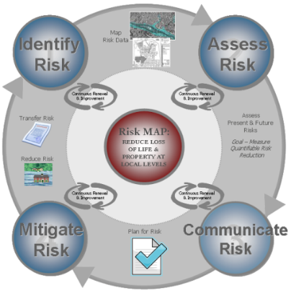
The Risk MAP Coordinator actively works to promote communication and partnerships between OWR staff, SHMO, GIS and HAZUS staff, and mitigation planners at the State level. The Risk MAP Coordinator regularly communicates with the SHMO, the State NFIP Coordinator, and the FEMA Regional Risk MAP Coordinator to foster more open lines of communication across the program areas and to better integrate the two agencies in an effort to execute the Risk MAP vision and meet FEMA’s Risk MAP goals in Alabama. Discussion topics may include but are not limited to the following:

- Coordinate schedules for Hazard Mitigation Plan updates with schedules for flood hazard data updates. Regular updates of flood hazard data should result in regular updates to hazard mitigation plans.
- Ensure that risk assessment results are incorporated into state and local hazard mitigation plans. Ensure that state and local jurisdictions are using the most recent flood mapping data in their mitigation plans.
- Discuss development of an Enhanced State Plan. Evaluate the effectiveness of the State Hazard Mitigation Plan through the tracking of funded mitigation projects, flood losses avoided or damages avoided.
- Develop mitigation planning “best practices” and develop examples of “model” mitigation plans that communities can apply to their own plans.
- Discuss integration of land-use, zoning, and development officials into the development of local hazard mitigation plans. Help integrate the use of hazard mitigation plans into local planning processes, land-use plans, capital improvement, and economic development plans and transportation plans.
- Discuss areas where resources can be leveraged – Work with other state and federal agencies to ensure a cohesive program. Discuss data availability across state agencies.
- Discuss joint education and outreach opportunities to communities. Ensure a consistent and cohesive message is being delivered to communities.

This activity focuses on communication and process development at the program level to form a cohesive vision across state agencies.

Internal and External Coordination for Best Available Data
Alabama does not have a comprehensive management agency for the collection and housing of statewide GIS data. In the absence of a statewide GIS office, the Risk MAP Coordinator will coordinate with other state agencies to determine the following: list of existing data, future mapping needs, mitigation planning needs, response needs, recovery needs, and information gaps. The Risk MAP Coordinator will add the data needs and potential data sources for a watershed to the existing master geodatabase detailed in Section II.A.3 once a project has been sequenced for an upcoming funding year. Once the watershed project is funded, the data will be collected in accordance with OWR data collection protocol:

- Identify data sources and execute data sharing agreements, if needed
- Coordinate with the agency to exchange the data
- Evaluate data accuracy and usability
- Transfer the data to the mapping contractor

Ultimately, the Risk MAP Coordinator will develop and maintain partnerships with other local and state agencies to collect and share data. These partnerships will be extremely beneficial in addressing data gaps and mapping and mitigation needs for future projects. The Risk MAP Coordinator will also work with other agencies to better align data collection activities to reduce duplication of effort.

Risk Communication Development and Oversight
Risk communication is an ongoing task that not only occurs during the production and adoption of new flood maps but at all times. The State Risk MAP Coordinator will work to identify and develop risk communication tools that are most effective for the local communities and will work to implement and outreach those tools. The Risk MAP Tools Training workshop will be a critical stakeholder engagement opportunity to learn which tools the local officials find most and least effective. The Risk MAP Coordinator will also communicate these findings to FEMA in support of development of national communication tools.

Participation in FEMA’s Program Development
The Risk MAP Coordinator will participate in the development, review, and evaluation of new or existing tools and programs as requested by FEMA. These activities include conference calls and meetings and the review of tools, documents, and vision statements. The Risk MAP Coordinator will also participate in the Risk MAP Knowledge Sharing Site (KSS), Levee Analysis and Mapping Procedures (LAMP), and FEMA Headquarters or Regional Pilot Projects as requested.

State National Flood Insurance Program
The State has enhanced its technical capabilities by adding staff members who provide assistance to the State NFIP Coordinator’s office. The FPMP staff consists of engineers, GIS specialists, planning and economic development specialists, and administrative support personnel. OWR, through FEMA’s Community Assistance Program (CAP) funding process, provides technical assistance to communities in order to achieve and maintain compliance and good standing in the NFIP program. The primary objectives of the NFIP are: 1) reducing flood losses in participating communities through adherence to participating communities’ Flood Damage Prevention Ordinance, NFIP regulations, mitigation planning, education, and awareness; 2) working with communities during post disaster operations to provide needed technical assistance to address NFIP issues; and 3) recruiting nonparticipating communities into the NFIP program.

Currently, 427 Alabama communities participate in the NFIP with more than 58,500 flood insurance policies in force. In partnership with FEMA, federal and state funds are used to meet the overall objective of reducing flood hazards in communities participating in the NFIP. Each year, the NFIP staff conducts approximately 18 in-depth Community Assistance Visits (CAV) and 65 Community Assistance Contacts (CAC) through telephone contact or a brief visit. The outreach efforts of this program include technical consultations with public officials, telephone contact providing published material to the public, and presenting seminars and conferences on floodplain management and mitigation. The State NFIP Coordinator also presents the Floodplain Management 101 Course. This course targets floodplain administrators throughout the State to provide them with a working understanding of their position and responsibilities and the tools available to them to perform their duties.

In June 2013, OWR prepared a Strategic Plan for NFIP State Coordination. The purpose of this Strategic Plan was to evaluate the current role of the State NFIP Coordinator within the comprehensive AFPMP and to form recommendations so this role may be improved and/or expanded to ensure coordination efforts of the NFIP are effective and best serve the citizens, property, and resources within the State. The NFIP coordination efforts were reviewed and evaluated per the elements of the Community Assistance Program – State Support Services Element (CAP-SSSE) methodology. Recommendations for enhancing the NFIP coordination efforts within the State were made to expand efforts within each CAP-SSSE element for a more robust, comprehensive program. For each element, needs and opportunities that should encourage growth in NFIP coordination activities are identified. Both long-term and short-term strategies are identified. Long-term strategies define the overall goals of the Alabama program, while short term strategies define specific actions and include an implementation schedule, deliverables, budget, staffing, and support monitoring and evaluating tasks, as necessary.

In January 2015, OWR developed and implemented an automated process for CACs and data collection requirements to streamline the interview process with communities. Additionally, the automated process aims to increase the number of CACs performed each year with communities identified as Tier 2 by FEMA’s CAV Tier 1 Prioritization Tool.

Letter of Map Revision Delegation
As a CTP with FEMA, OWR has assumed responsibility for the technical accuracy of the FIRMs within the State and the associated political implications. Building on this commitment, OWR gladly accepted a LOMR delegation opportunity from FEMA and has been responsible for reviewing and processing all LOMR requests within the State since July 2010. OWR is confident that the LOMR delegation responsibilities will continue to contribute to the success of the AFPMP. The following strategy points outline the program management aspects and operating advantages that have made and will continue to make this effort a success.

Connection to the Alabama Department of Economic and Community Affairs
ADECA is the State agency charged with providing resources to meet critical economic, community development, job growth, community enhancement, and public safety needs to Alabamians in all 67 counties as they work to build better communities and a better life for themselves. This work is accomplished, in part, by administering grants worth hundreds of millions of dollars annually to provide staff, equipment, services, and infrastructure to meet these needs while encouraging the wise use and conservation of the State’s natural resources. With OWR being housed within one of the key departments responsible for new development and improving communities, it is an ideal agency for the processing of LOMRs within the State.
OWR will create Division and Agency partnerships that will allow for outreach in the development community regarding best management practices and regulatory requirements. OWR will continue outreach efforts and the development of partnerships to ensure compliance at the state level by developing a state project tracking program for projects that affect SFHAs. OWR will specifically continue its outreach efforts to ALDOT to ensure that the most accurate flood hazard data is available based on current roadway projects.

Connection to the National Flood Insurance Program
In partnership with FEMA, federal and state funds are used to meet the overall objective of reducing flood hazards in communities participating in the NFIP. OWR, through the State NFIP Coordinator, works to assure that the communities within Alabama maintain the legal ability to enforce the NFIP development requirements, and that the State Model Ordinance is consistent with federal and State Law. Ordinance reviews are routinely a part of the above mentioned CAVs and CACs. Assistance is provided to communities required to adopt and amend ordinances as a result of map revisions. OWR coordinates with the FEMA Regional Office for any instances of non-compliant ordinances.

The State NFIP Coordinator also plays an integral role in the AAFM. The State NFIP Coordinator regularly disseminates information to members of the AAFM regarding the various aspects of floodplain management and ordinance enforcement. This in-house NFIP connection provides OWR with the ability to coordinate floodplain management efforts with the State NFIP Coordinator and provides a channel to provide LOMR outreach efforts to the local communities.

Connection to Local Communities
OWR maintains an open line of communication with all LOMR requesters and numerous community officials. OWR often coordinates with local communities in advance of application submittals to help ensure a quick and smooth LOMR review process. OWR also coordinates with local engineers who request data or have processing or review questions prior to data submittal in order to streamline the review process. Furthermore, requesters frequently hand-deliver data and request in-house meetings with OWR staff to discuss key issues. Recently, OWR has met with local officials from the City of Birmingham to discuss options, including a LOMR or Physical Map Revision (PMR), for incorporating into one of their on-going projects on a stream known for flooding issues. OWR makes every effort to ensure that every case is processed efficiently and well in advance of FEMA’s goal for a 90-day review period. Within the last year, OWR worked with the City of Dothan to reissue two cases that were inadvertently left out of the new community maps. The reissuance of these cases was accomplished in less than 40 days exceeding the review period goal by more than 50 percent. These local case studies provide just a couple of examples of the value and effectiveness of the State LOMR delegation.

Digital Vision
One of FEMA’s Risk MAP goals is to provide an enhanced digital platform that improves management of the Risk MAP Program, stewards the information produced by a Risk MAP project, and improves the communication and sharing of risk data and regulated products with all levels of government and the public. OWR currently maintains the digital Flood Hazard Layer for the State of Alabama on the AL FRIS website. OWR uses this data to provide state and local officials as well as the general public access to flood risk information. Alabama’s Flood Hazard Layer is available to all stakeholders through this geospatial information system. Users can view effective flood hazard data through an address look-up tool or through zoom and pan functions. Furthermore, through the LOMR delegation responsibilities, OWR is able to maintain the most up-to-date flood hazard layer within AL FRIS through the continuous incorporation of effective and mappable LOMRs.

Project Management
OWR has increased the effectiveness of the State to deliver flood mapping products by establishing a strong Program and Project Management structure as well as thorough QA/QC procedures. Through a team approach of NFIP staff and floodplain management staff, OWR remains the main point of contact with all Alabama communities in an effort to streamline requests for data and dissemination of information. Program Components include:

- OWR Program Management: A dedicated Manager at OWR who oversees overall program schedule and OWR project managers.
- OWR Project Management: Each individual mapping project is assigned a dedicated OWR Project Manager that manages project schedules and ensures the Contractor is on schedule and within budget.
- Contractors: OWR has two contractors, Amec Foster Wheeler Environment & Infrastructure, Inc. (Amec Foster Wheeler) and Atkins Global, Inc. (Atkins). Individual task orders are issued for each project. Each Contractor has a Program Manager to oversee multiple projects and project managers.
- Map Production: Contractors are assigned production tasks to produce the mapping product within the schedules outlined in the MAS and MIP. OWR holds each contractor responsible for MAS deliverables and schedules.
- QA/QC: In accordance with the QA/QC plan, independent QA/QC is performed at specified intervals in the schedules with OWR auditing the submittals and reviewing checklists. In general, each contractor reviews the other’s work such that Amec Foster Wheeler will review Atkins’ submittals and vice versa. Each contractor utilizes standard OWR QC checklists. By utilizing contractors for review, OWR Project Managers can concentrate on project schedules, deliverables, specific outreach activities for projects, and special problems. The OWR Project Manager oversees the review process and resolves, with Amec Foster Wheeler and Atkins, any discrepancies or disagreements on mapping products.
Utilizing this team approach, OWR’s flood mapping team has the capability to perform all work associated with the flood mapping program from Discovery through the development of the preliminary maps, plus the post preliminary processing. OWR will be able to ensure consistent, thorough communication between everyone involved in a Risk MAP project such as the contractor, OWR, the communities, the Regional Support Center (RSC) IV, and FEMA Region IV. This management system will result in quality mapping products that are on time and within budget.

OWR will add staff and provide training as needed to assist with project management and provide technical review for the consultants’ work. By utilizing the two main contractors and their sub-contractors, OWR can maximize flood map production capabilities while focusing on meeting FEMA’s Risk MAP Program performance metrics and the overall goals of the AFPMP.

Program Management Activity Performance vs. Risk MAP Goals
The matrix below summarizes the current AFPMP program management activities as detailed herein and the specific Risk MAP goals that are being met and addressed by each activity.

Table 2. AFPMP Program Management Activities and Specific MAP Goals by Activity
Program Management Activity | Data Gaps | Awareness  & Understanding | Mitigation  Planning | Digital Platform | Synergize  Programs
Education and Outreach
Targeted Educational Topics & Forums |  | √ | √ | √ | √
Riverine Risk MAP Project Outreach | √ | √ | √ | √ | √
Coastal Risk MAP Project Outreach | √ | √ | √ | √ | √
AFPMP Website & AL FRIS | √ | √ | √ | √ | √
Mitigation Support |  | √ | √ | √ | √
Technical Trainings
Advanced LOMR Training |  | √ |  | √ | √
Risk MAP Tools Workshop |  | √ | √ | √ | √
Hazard Mitigation Training |  | √ | √ | √ | √
Data Management | √ | √ | √ | √ | √
Hazard Mitigation Planning Coordination
State Coordination | √ | √ | √ | √ | √
Local Coordination/Mitigation Training | √ | √ | √ | √ | √
Risk MAP Coordinator Role
Risk MAP Partnership Building | √ | √ | √ | √ | √
Best Available Data Coordination | √ |  | √ | √ | √
Risk Communication Development | √ | √ | √ | √ | √
Participation in FEMA’s Program Development |  | √ | √ | √ | √
State National Flood Insurance Program | √ | √ | √ | √ | √
Letter of Map Revision Delegation | √ | √ |  | √ | √
Digital Vision | √ | √ | √ | √ | √
Project Management | √ | √ | √ | √ | √

Five-Year Plan
OWR remains committed to providing the citizens of Alabama with the highest quality flood risk data. As with any data set, a strong plan for updates and maintenance is needed to maintain the value of the initial investment and to utilize the best available data. The first goal in Risk MAP is to address gaps in the flood hazard data. OWR will continue to maintain the high quality of the flood hazard data in Alabama to ensure a solid foundation for flood risk assessments. Engineering and mapping products must be developed to effectively interface with risk assessments and mitigation planning. Engineering and mapping will be conducted on a watershed level to align with natural flood risk boundaries and to facilitate the sharing of data. To accomplish this goal, OWR will:

- Initiate Risk MAP projects to address needs in high risk areas;
- Develop flood depth grids for multiple flood frequencies based on updated or validated engineering studies for use in risk assessments and risk communication outreach;
- Evaluate levee status information to ensure accurate risk zone depiction for counties impacted by levees; and
- Update existing approximate studies when new elevation data is obtained. Currently, all updated approximate studies are and will continue to be model based with the ability to produce profiles for multiple frequencies.

Watershed Approach
In accordance with FEMA guidance, Alabama is using a watershed-based approach when planning for future map updates. Hydrologic and hydraulic analyses will be performed at the Hydrologic Unit Code (HUC) 8 (or smaller) level and mapping updates will be physical map revisions rather than countywide revisions, when appropriate. The watersheds selected for map updates will be prioritized based on risk in the watershed, need in the watershed, and the availability of quality topographic data in the watershed. Therefore, this business plan includes proposed map updates for high risk and high need watersheds utilizing grant monies for FY 2015 to FY 2019. Figure 1 on the following page demonstrates the HUC 8 level watersheds within Alabama as well as the current watershed sequencing for the entire State. Please refer to Table 3 in Subsection G below for additional information on watershed sequencing.

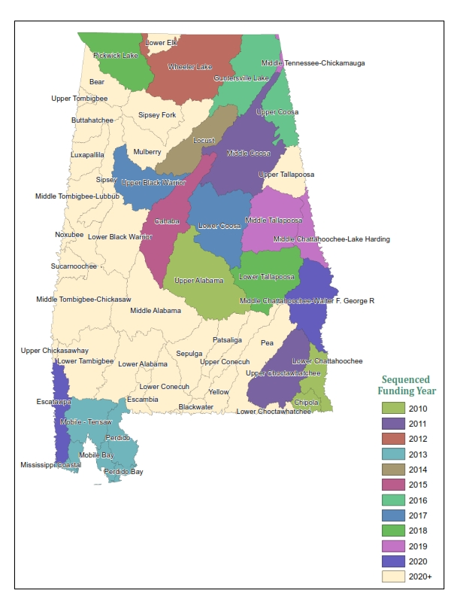
Figure 1. Alabama HUC 8 Watersheds

Defining Risk in Fiscal Year 2015 and Beyond
The second goal in Risk MAP is to ensure that a measurable increase of the public’s awareness and understanding of risk results in a measurable reduction of current and future vulnerability to flooding. Today’s flood maps identify risk for specific areas and properties but do not assess or quantify the risk to people and property. Sound flood hazard data will allow for accurate flood risk assessments that quantify potential physical, social, and economic losses from flood hazards. These flood risk assessments are provided to state and local officials and will ultimately be used to influence economic and planning decisions. The ultimate goal is that an increase in awareness of flood risk will result in decisions and actions that reduce risk to life and property from flooding.

Risk is defined at the watershed level based on HAZUS loss estimate studies – a quantification of risk to people and property. In FY 2010, FEMA conducted a Level 1 HAZUS flood analysis to estimate average annualized losses (AAL) for the entire nation. For current and future Risk MAP projects, OWR will provide flood depth grids for multiple flood frequencies on all new, updated, or validated engineering studies in watersheds scheduled for hydraulic analyses updates. These flood depth grids will be used for a Level 2 HAZUS analyses, and the results will be provided to the State and local authorities responsible for hazard mitigation planning for use in local risk assessments. Local officials and local emergency planners can use this information to develop mitigation strategies and evacuation plans and to increase public awareness. As defined by the Risk MAP Coordinator Role, regular updates of flood hazard data should result in regular updates of a jurisdiction’s hazard mitigation plan. This action will contribute to FEMA’s goal of increased risk awareness and communication.

The results of the Level 2 HAZUS analysis will also be displayed within AL FRIS to allow for ease of access and to ensure a wide dissemination of the flood risk assessment data. AL FRIS will have a point and click functionality that will allow the user to identify flood risk at any point along a flooding source as well as depth and loss damage calculations on a structure by structure basis.

In order to develop a strategic plan for the funding and deployment of Risk MAP projects within the State of Alabama, the HUC 8 level watersheds within the State have been prioritized by risk. In Figure 2, the HUC 8 level watersheds have been identified and organized by the total average annualized dollar loss value within the watershed. This dollar loss value is also based on FEMA’s 2010 Level 1 HAZUS analysis. Table 3 contains the prioritization of the HUC 8 level watersheds based on FEMA’s 2010 Level 1 HAZUS analysis.

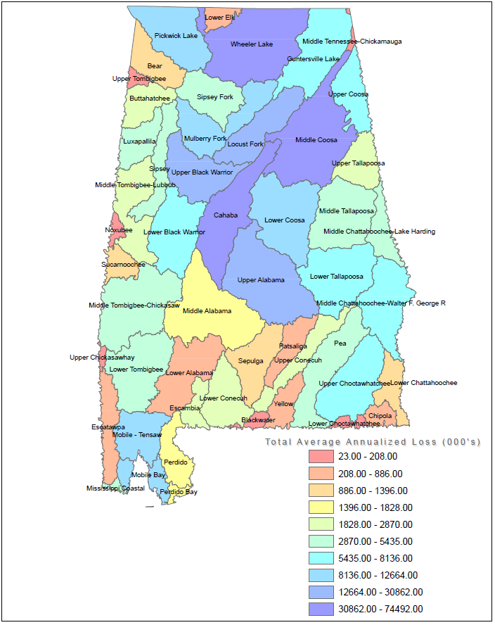
Figure 2. Alabama HUC 8 Watersheds by Risk
Table 3. HUC 8 Watershed Prioritization Based on Risk
Priority Class | Watersheds
1 | Perdido Bay, Mobile Bay, Mississippi Coastal, Perdido, Mobile-Tensaw, Middle Coosa, Wheeler Lake, Cahaba, Locust Fork, Upper Alabama, Upper Black Warrior
2 | Mulberry Fork, Lower Coosa, Pickwick Lake, Middle Chattahoochee-Walter F. George, Lower Black Warrior, Lower Tallapoosa, Guntersville Lake, Upper Coosa, Upper Choctawhatchee, Middle Chattahoochee – Lake Harding
3 | Lower Tombigbee, Pea, Sipsey Fork, Middle Tombigbee – Chickasaw, Middle Tallapoosa, Luxapallila, Sipsey, Escambia, Middle Tombigbee – Lubbub, Upper Tallapoosa
4 | Lower Conecuh, Upper Conecuh, Buttahatchee, Middle Alabama, Bear, Lower Chattahoochee, Sucarnoochee, Sepulga, Lower Elk, Lower Alabama
5 | Yellow, Patsaliga, Escatawpa, Chipola, Noxubee, Lower Choctawhatchee, Blackwater, Upper Tombigbee, Middle Tennessee – Chickamauga, Upper Chickasawhay

In addition to the HAZUS Level 2 flood risk assessments, the Alabama OWR recognizes that dam failure risk awareness and dam failure communication are potential major components of Risk MAP in the future. OWR maintains a dam inventory and is also partnering with the Alabama NRCS to add additional dam information as it becomes available.

Defining Need in Fiscal Year 2015 and Beyond
The ultimate goal in addressing gaps in the flood hazard data is to ensure that 80 percent of Alabama’s flood hazard data are new, validated or updated. Three principle factors drive the need for updated flood hazard analyses:

- Physical changes: Man-made influences that may include new bridges, culverts, and levees in the floodplain as well as development that may influence watershed characteristics as well as natural changes, which may include erosion and wildfires.
- Climate changes: Changing rainfall data, hurricane patterns, and intensities.
- Engineering methodology changes: Improved computer models and better understanding of the physics governing storm surges and major flooding events.

Under Risk MAP there is an emphasis on creating accurate maps using accurate topographic data. FEMA’s NVUE protocols have heightened the focus on ensuring that the quality of mapping products meet floodplain mapping and engineering standards for FY 2006 projects and later. The goal for Risk MAP is to increase NVUE metrics to 80% for effective flood studies. Projects funded prior to FY 2006 did not include these metrics as a requirement. These projects account for over 73% of Alabama’s population and 31% of the stream miles in the State.

There are approximately 36,881 total mapped stream miles within Alabama. Of these mapped stream miles, 15,653 have a current validation status of Valid within the CNMS database. Therefore, Alabama’s current NVUE performance measure is at 42%; however, this 42% performance measurement also includes Zone A stream miles and only 52% of existing Zone AE stream miles are considered Valid by FEMA’s NVUE criteria. Alabama estimates that approximately 48% (2,316 miles) of existing AE studies are still in need of updated engineering in order to meet FEMA’s New, Validated or Updated (NVUE) performance measure.

Topographic Data Availability
The watersheds selected for map updates will be prioritized based on risk in the watershed, need in the watershed, and the availability of quality topographic data in the watershed. OWR has focused on the continual development of LiDAR across the State and has developed partnerships with ALDOT, USACE, USGS, NRCS, and various cities and counties within the State to cost-share the development of county-wide LiDAR data for use in current and future flood studies. OWR will continue to focus the development of these partnerships and the acquisition of new data in watersheds where high risk and high need have been demonstrated. As part of this focus, OWR submitted a pre-proposal to the USGS for the 3D Elevation Program (3DEP). Titled the “Alabama LiDAR Acquisition Project,” the pre-proposal identified FY 2016 priorities for ADECA-OWR and United States Department of Agriculture (USDA)-NRCS for LiDAR acquisition for 12 counties in Alabama: Bibb, Perry, Dallas, Chilton, and Coosa for ADECA-OWR and Franklin, Marion, Fayette, Pickens, Greene, Sumter, and Hale. LiDAR needs in Alabama have been prioritized based on the 3DEP proposal and the proposed project sequencing as discussed above. OWR has proposed to acquire future LiDAR data ahead of the Risk MAP funding for the applicable watershed in order to more efficiently implement the Risk MAP projects. As more LiDAR is collected, additional flood depths beyond the 1-percent and 0.2 percent conditions such as the 10-percent or 2-percent frequencies can be accurately mapped and utilized for flood risk identification and mitigation. Figure 3 below demonstrates the current LiDAR coverage across the State including the date of the topographic data collection.

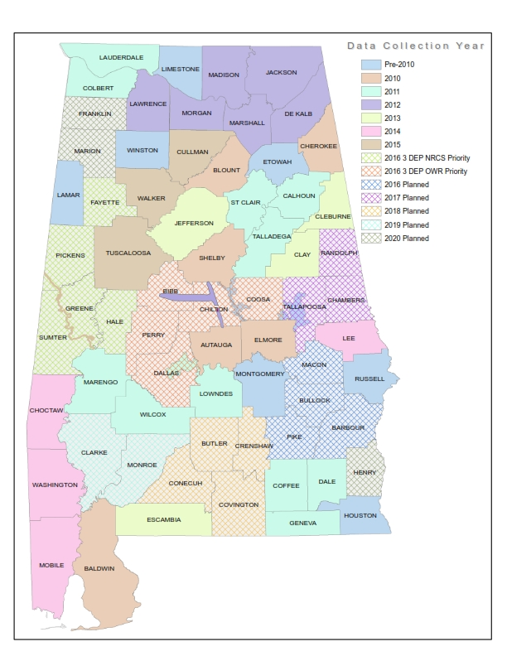
Figure 3. Current Alabama LiDAR Coverage

Levee Strategies
The extent of floodplain mapping that is impacted by levee systems in Alabama is limited. OWR has identified five levees in counties that have been or are sequenced to be updated:

- OWR has worked with TVA and the USACE to determine that three levees have been certified and comply with the requirements of 44 CFR 65.10. This includes the levees located in Geneva, Elba, and along the Black Warrior River in Tuscaloosa.

- One levee is a provisionally-accredited levee (PAL) located in the City of Prattville in Autauga County; however, the PAL expired in 2010. Autauga County falls within the Upper Alabama Watershed, which was funded as a Risk MAP project in FY 2010. OWR anticipates that this levee will not be certified and is currently awaiting new Levee Analysis and Mapping Guidance (LAMP) currently under development by FEMA. The levee panels will not be updated in Autauga County until the LAMP guidance is final and new modeling methodologies are utilized. In conjunction with FEMA Region IV, OWR has developed a strategy to update the panels impacted by the levee to maintain the integrity of the national flood hazard layer. OWR will continue to maintain a detailed list of levees that impact floodplain mapping and develop a strategy as appropriate for each levee to meet the requirements of 44 CFR 65.10.

- The fifth levee is located within the Colbert County near the City of Muscle Shoals. TVA is finalizing the construction plans and is currently working with the City to finalize the operation and maintenance plan prior to certifying the levee and submitting for FEMA review to ensure it complies with the requirements of 44 CFR 65.10.

Coastal Needs
Hurricanes Katrina and Ivan demonstrated the importance of accurate and up-to-date coastal flood hazard maps. FEMA's original coastal studies were done in the early 1980's and included only the hurricane storm surge still water levels. Since then, most maps have been updated to add the additional hazards associated with waves and storm erosion, but the original base still-water levels have never been re-evaluated. Improved computer techniques for storm surge modeling, together with twenty additional years of storm data, now make it possible to improve the accuracy of coastal flood maps.

There are approximately 211 coastal miles that are currently being updated in Alabama; 111 miles in Baldwin County and 100 miles in Mobile County. The coastal remapping study that is currently underway includes storm surge analysis and overland wave height analysis. This study is being performed in conjunction with the Northwest Florida Water Management District (NWFWMD) and covers an eight-county coastal area. In Alabama, this includes Baldwin and Mobile Counties. This study involves new and existing methodologies such as LiDAR-based topography, new digital orthophotos, statistical analyses using appropriate Joint Probability Methods for storm analyses, Simulating Waves Nearshore (SWAN) 2-D wave model, and Advanced Circulation model (ADCIRC) 2-D hydrodynamic modeling. The coastal flood maps for Baldwin County are anticipated to be Preliminary in the summer of 2016; and the maps for Mobile County in late 2016/early 2017.

Watershed Sequencing FY 2015 through FY 2019
In accordance with FEMA guidance, watersheds sequenced for funding in FY 2015 to FY 2019 will be chosen based on risk in the watershed, need in the watershed, and the availability of quality topographic data in the watershed. To this end, OWR has divided the watersheds in Alabama into 5 distinct priority classes as shown previously in Table 3. The priority level for the watersheds may be adjusted based on future risk assessments and CNMS updates. The watersheds sequenced for hydraulic updates starting in FY 2015 through FY 2019 are shown in Table 4 below. OWR developed this list assuming a level of funding available to prepare a Risk MAP study for one Alabama watershed per year. Should additional funds be available, OWR and its contractors have the capability to perform studies on multiple watersheds simultaneously and the sequencing and priority would be adjusted accordingly. Discovery for Upper Black Warrior, and Guntersville Lake was completed in 2011. Therefore these studies can be done efficiently once funds are available.

Table 4. Watershed Sequencing for Fiscal Years 2015 to 2019
Discovery Funding Year | Engineering &  Mapping Funding Year | Watershed | Counties
2011 | 2015 | Locust Fork  (Post-Preliminary Processing Only) | Blount, Etowah, Jefferson, Marshall
2011 | 2015 | Cahaba | Bibb, Chilton, Dallas, Perry, Jefferson, Shelby, St. Clair, Tuscaloosa
2011 | 2016 | Guntersville Lake  (Including Post-Preliminary Processing) | Blount, DeKalb, Etowah, Jackson, Marshall
2016 | 2016 | Upper Coosa | Calhoun, Cherokee,  Cleburne, DeKalb
2011 | 2017 | Upper Black Warrior | Bibb, Fayette, Jefferson, Tuscaloosa, Walker
2016 | 2017 | Lower Coosa | Autauga, Chilton, Clay, Coosa, Elmore, Montgomery, Shelby, Talladega, Tallapoosa
2016 | 2018 | Pickwick Lake | Colbert, Franklin, Lawrence, Lauderdale
2017 | 2018 | Lower Tallapoosa | Bullock, Chambers, Elmore, Lee, Macon, Montgomery, Pike, Russell, Tallapoosa
2018 | 2019 | Middle Chattahoochee – Lake Harding | Chambers, Lee, Randolph, Russell
2018 | 2019 | Middle Tallapoosa | Chambers, Clay, Coosa, Elmore, Lee, Randolph, Tallapoosa
2018 | 2020 | Middle Chattahoochee – Walter F. George | Barbour, Bullock, Henry, Lee, Macon
2019 | - | Pea | Barbour, Coffee, Crenshaw, Dale, Geneva

Funding in Fiscal Year 2015

Table 5 below provides an overall summary of FY 2015 funding provided by FEMA.

Table 5. Funding for Fiscal Year 2015
Project Name | HUC 8 Watershed ID | Type of Project | Total Requested FEMA Funding | Proposed CTP Leverage | Description of Match or Leverage | NVUE  +10% | NVUE  +20% | NVUE  +30% | 1st FY of FEMA Funding | Amount of 1st FY of FEMA Funding | 1st FY of FEMA Funding will complete project through | Proposed  Project Completion  Date | Preliminary Project Justification | Primary Risk to Project | Additional Risks to Project
Locust Fork  (Blount, Etowah, Jefferson,  Marshall, and Walker Counties) | 03160111 | Preliminary Map Products and Post-Preliminary Map Processing | $200,000 | $40,000 | OWR staff time; QA/QC | NA | NA | NA | FY 2011 | $314,855 | Discovery | January 2017 | Develop and support of flood hazard data and activities | Schedule Delays | Cost Overrun
Cahaba  (Bibb, Chilton, Dallas, Jefferson, Perry, Shelby, St. Clair, and Tuscaloosa Counties) | 03150202 | Hydraulics, Mapping, Non-Regulatory , and Preliminary Map Products | $1,490,000 | $676,000 | LiDAR Data,  Orthophotos/ Aerial Photographs | $1,790,000 | $2,090,000 | $2,390,000 | FY 2011 | $30,000 | Discovery | March 2017 | Develop and support of flood hazard data and activities | Schedule Delays | Cost Overrun
Program  Management | NA | Business Plan; Global Program Management; CNMS; QA/QC Plans | $220,000 | $50,000 | Business Plan; Global Program Management; CNMS; QA/QC Plans | NA | NA | NA | FY 2015 | $220,000 | Completion of FY 2015 PM MAS Activities | September 2016 | CTP activities undertaken for managing multiple projects | Schedule Delays | Cost Overrun
Community Engagement  and Risk Communication | NA | Strategic Planning; Mitigation Support; Training; CERC Pilot Projects | $155,000 | $50,000 | Strategic Planning; Mitigation Support; Training; CERC Pilot Projects | NA | NA | NA | FY 2015 | $155,000 | Completion of FY 2015 CERC MAS Activities | September 2016 | CTP support to build risk awareness and engage community stakeholders | Schedule Delays | Cost Overrun
LOMR Delegation | NA | Evaluation of CLOMR and LOMRs | $158,750 | NA | NA | NA | NA | NA | FY 2015 | $158,750 | Completion of FY 2015 Cases Received | September 2016 | Delegation Staffing | Cost Overrun | Technical Errors
Coastal Storm Surge Refinement | NA | Coastal Modeling and Mapping | $200,000 | NA | NA | NA | NA | NA | FY 2012 | 171,310 | Discovery | March 2017 | Coastal Map Updates | Schedule Delays | Technical Errors
Wheeler Lake Additional Funding | 06030002 | Mapping | $50,000 | NA | NA | NA | NA | NA | FY 2012 | 2,175,000 | Discovery and Risk MAP Products | May 2016 | Develop and support of flood hazard data and activities | Schedule Delays | Cost Overrun
Totals |  |  | $2,472,750 | $816,000
NA – not applicable.

Proposed Fiscal Year 2015 Project Deliverables
Table 6 below provides an overview of the Risk MAP products that are proposed for development in FY 2015.

Table 6. Proposed Risk MAP Product Development for Fiscal Year 2015
Watershed(s) and/or Project Areas | Flood Risk Products | Flood Risk Datasets
 |  | CSLF | Depth & Analysis Grids¹ | Flood Risk Assessment² | AOMI | Other
Bibb County, AL |  |  |  | √ | √
Chilton County, AL |  |  |  | √ | √
Dallas County, AL |  |  |  | √ | √
Jefferson County, AL | √ | √ | √ | √ | √
Perry County, AL |  |  |  | √ | √
Shelby County, AL | √ | √ | √ | √ | √
St. Clair County, AL | √ | √ | √ | √ | √
Tuscaloosa County, AL |  |  |  | √ | √
¹New or updated studies only. ²Flood Risk Assessment will consist of a HAZUS Level 2 analysis for new or updated flood studies; the FEMA 2010. AAL Study will be used for non-revised flooding sources.

Current Risk MAP Performance Measures
FEMA’s vision for the Risk MAP Program is to deliver quality data that increases public awareness and leads to action that reduces risk to life and property. FEMA has selected key performance measures or program metrics that can be used to determine whether desired program outcomes are being achieved.

Risk MAP performance measures are aligned across FEMA Headquarters and Regional offices. Risk MAP will focus on the four key performance measures listed below:

- Deployment
- NVUE
- Awareness
- Action

Deployment
Deployment is defined as the percentage of population where Risk MAP has been deployed. The Deployment metric is developed as a ratio between the populations receiving a Risk MAP project (numerator) over the entire national population (denominator). The criteria for a Risk MAP project counting towards Deployment are summarized below. Deployment may be counted for a watershed once Discovery and non-regulatory products have been funded.

Table 7. Criteria for Risk MAP Projects Counting Towards Deployment
Category | Discovery | Conversion Memo | Watershed | Includes Changes Since Last FIRM | Includes Base Products and Other Base Datasets (new engineering) | Population Footprint
Riverine | Yes | Yes | Yes | Yes | Yes | Watershed
Coastal | No | Yes | No | Yes | Yes | Community
Levee | No | Yes | No | Yes | Yes | Project  Footprint
Conversion | No | Yes | No | Yes | No | Project Area

Deployment is measured using the 2010 census population data located within the Risk MAP project footprint. Populations within a given footprint can only be counted once (one single project). FEMA’s national targets for Deployment through FY 2016 are summarized below.

Table 8. FEMA’s National Targets for Deployment through Fiscal Year 2016
FY 2012 | FY 2013 | FY 2014 | FY 2015 | FY 2016
44% | 47% | 50% | 53% | TBD

Table 9 below summarizes the Risk MAP projects and population footprints that are being counted towards Alabama’s current Deployment performance measure for FY 2015. Alabama’s current Deployment performance measure is at 68% while the national target is 53%. Figure 4 below depicts the watersheds and counties for which Discovery and non-regulatory products have been funded and therefore the populations have been counted towards Deployment.

Table 9. Alabama Deployment Performance Measure for Fiscal Year 2015
Project Area | Category | Population Footprint | 2010 Population | % Total Alabama Population | Current Project Phase
Upper Alabama Watershed | Riverine | Watershed | 360,970 | 7.55 | Risk MAP Project Complete
Houston County | Riverine | Project Footprint | 101,547 | 2.10 | Risk MAP Project Complete
Middle Coosa Watershed | Riverine | Watershed | 417,433 | 8.73 | Post-Preliminary Processing
Upper Choctawhatchee | Riverine | Watershed | 182,182 | 3.81 | Post-Preliminary Processing
Wheeler Lake Watershed | Riverine | Watershed | 554,757 | 11.61 | Hydraulics, Mapping, and Non-Regulatory Products
Baldwin County | Coastal | Community | 122,513 | 2.56 | Hydraulics, Mapping, and Non-Regulatory Products
Mobile County | Coastal | Community | 140,839 | 2.95 | Hydraulics, Mapping, and Non-Regulatory Products
Locust Fork Watershed | Riverine | Watershed | 395,529 | 8.28 | Hydraulics, Mapping, and Non-Regulatory Products
Upper Black Warrior | Riverine | Watershed | 336,767 | 7.05 | Discovery
Guntersville Lake | Riverine | Watershed | 176,786 | 3.70 | Discovery
Cahaba Watershed | Riverine | Watershed | 458,800 | 9.60 | Discovery
Totals |  |  | 3,248,123 | 67.96

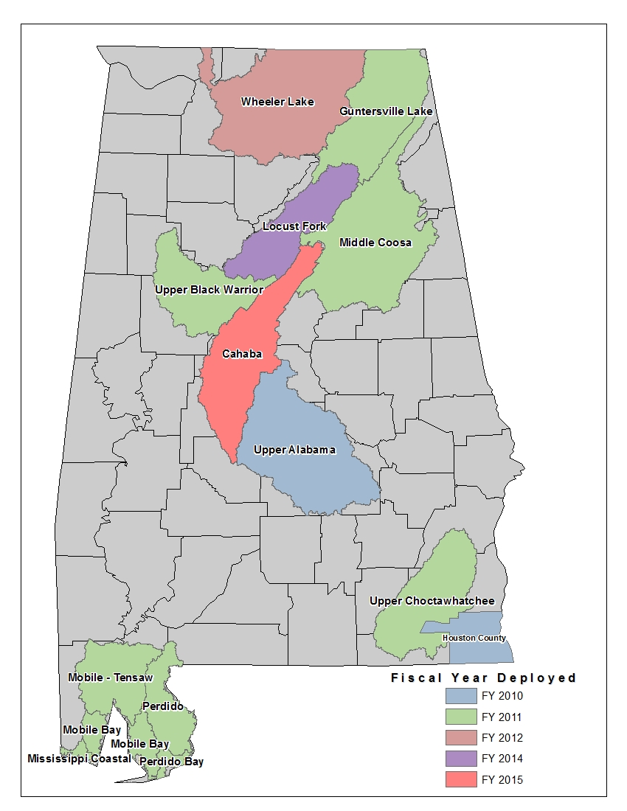
Figure 4. Alabama HUC 8 Deployed Watersheds

New, Validated, or Updated Engineering
NVUE is a methodology used to determine whether a mapped flood study is a valid representation of the hazard based upon Physical, Climatologically, and Engineering factors. FEMA developed the CNMS to systematically evaluate the validity of the current mapped inventory. Each flooding source within the CNMS database is attributed with a current validation status. The CNMS database is updated at the following specific milestones during the Risk MAP project life cycle:

- At Risk MAP project initiation (Discovery) as defined by a geospatial scope of work reflecting the stream segments or coastline representing the extents of the updated engineering analysis.
- At preliminary issuance of the FIRM and FIS report.
- Prior to Issuance of the Letter of Final Determination.

National targets have been established for NVUE attainment based on the current inventory of data. FEMA’s national targets for NVUE through FY 2016 are summarized below.

Table 10. FEMA’s National Targets for NVUE through Fiscal Year 2016
FY 2012 | FY 2013 | FY 2014 | FY 2015 | FY 2016
55% | 58% | 61% | 64% | TBD

Only 52% of Alabama’s existing Zone AE stream miles are considered Valid by FEMA’s NVUE criteria.

Awareness
Risk awareness is measured as the percentage of local officials who are aware of flood risk within their community. FEMA conducts an annual Flood Risk Awareness Survey in order to track progress towards increasing the flood risk awareness of Risk MAP communities. Based on FEMA’s FY 2013 Flood Risk Awareness Survey, 77 percent of community officials surveyed in Risk MAP communities believe their community is at risk of flooding. This represents a slight increase of 68% from the previous three surveys.

This performance measure is measured on the national level, and there are no regional targets. However, OWR is being proactive in reaching this performance measure through its various community engagement efforts. OWR believes that community officials should be the voice for flood risk awareness in their communities. OWR will work to understand which Risk MAP products and datasets will allow community officials to communicate flood risk most effectively within their own communities. Through targeted stakeholder engagement efforts, OWR will leave community officials feeling empowered, informed and ready and able to take action by arming them with the tools they need to communicate flood risk at the local level.

Action Measure
The Action Measure provides a tool to measure actions taken by communities to reduce flood risk directly as a result of a Risk MAP project. Risk MAP has adopted a multi-tier approach to tracking action since community actions may take several years to complete. The Action Measure will track actions as they evolve from an idea during Discovery to an actual completed project during the lifecycle of a Risk MAP project. The Risk MAP Deployment Measure provides the baseline population for the Action Measures.

Action Measure 1 is defined as the percentage of population where Risk MAP helped identify new strategies or improve current planned mitigation actions. Through collaboration between Risk MAP project teams and communities, previously identified actions (from Hazard Mitigation Plans) are improved on or new strategies are developed. Action Measure 2 is defined as the percentage of population that has advanced identified mitigation actions. This includes communities that at a minimum advanced or began implementing identified mitigation actions, either from their Mitigation Plan or from new strategies identified during the Risk MAP project.

Targets for Action Measure 1 and 2 have been set at 50 percent of the deployed to population. Targets for both measures are phased in gradually over the lifecycles of the projects. FEMA’s national targets for Action through FY 2016 are summarized below.

Table 11. FEMA’s National Targets for Action Measures 1 & 2 through Fiscal Year 2015
National Targets for Action Measure 1
Risk MAP Projects | FY12 | FY13 | FY14 | FY15 | FY16
FY09 | 50% | 50%+ | 50%+ | 50%+ | 50%+
FY10 | 40% | 50% | 50%+ | 50%+ | 50%+
FY11 | 20% | 40% | 50% | 50%+ | 50%+
FY12 |  | 20% | 40% | 50% | 50%+
FY13 |  |  | 20% | 40% | 50%
FY14 |  |  |  | 20% | 40%
FY15 |  |  |  |  | 20%
Combined | 37% | 40% | 42% | 43% | 44%

National Targets for Action Measure 2
Risk MAP Projects | FY12 | FY13 | FY14 | FY15 | FY16
FY09 | 40% | 50% | 50%+ | 50%+ | 50%+
FY10 | 25% | 40% | 50% | 50%+ | 50%+
FY11 |  | 25% | 40% | 50% | 50%+
FY12 |  |  | 25% | 40% | 50%
FY13 |  |  |  | 25% | 40%
FY14 |  |  |  |  | 25%
FY15
Combined | 33% | 38% | 41% | 43% | 44%

To support tracking of this action measure, FEMA has developed an Action Measure Tracker Tool. In addition to watershed project entries, OWR entered mitigation actions as identified during the Discovery Process for the Guntersville Lake Watershed and the Coastal Watersheds. Approximately 60 mitigation actions have been identified to date with 204 entries into the Action Mitigation Tool. OWR will continue to coordinate with AEMA to ensure mitigation actions as identified during the mitigation planning process are entered and tracked in the Action Measure Tool for the State of Alabama.

Summary and Program Funding Required
OWR is committed to providing the citizens of Alabama with accurate up-to-date flood maps. OWR will utilize the foundation and partnerships already developed through the FMMP and the very successful development and implementation of the AFPMP to meet and exceed the goals established for Risk MAP in the State of Alabama.

Alabama estimates that approximately 48% (2,316 miles) of existing AE studies are still in need of updated engineering. In order to meet FEMA’s goal of 80% NVUE by FY 2020, OWR estimates that approximately $3,700,000 will be needed each year over the next five years. If fully funded, the total program funding level required for FY 2015 to FY 2019 is estimated to be approximately $18,300,000.

Table 12. Program Funding for Fiscal Year 2015 to Fiscal Year 2019
Fiscal Year | Engineering & Mapping Funding | Non-Regulatory Product Funding | Program Management Funding | CERC Funding | LOMR Delegation Funding | Total FEMA Funding Required
2015 | $2,165,400 | $240,600 | $220,000 | $155,000 | $210,000 | $2,991,000
2016 | $4,775,000 | $477,500 | $150,000 | $175,000 | $210,000 | $5,310,000
2017 | $2,756,250 | $275,625 | $150,000 | $175,000 | $210,000 | $3,291,250
2018 | $2,894,063 | $289,406 | $150,000 | $175,000 | $210,000 | $3,429,063
2019 | $3,000,000 | $300,000 | $150,000 | $175,000 | $210,000 | $3,535,000
Totals | $15,590,713 | $1,583,131 | $820,000 | $855,000 | $1,050,000 | $18,315,713

OWR has developed an approach that will meet all the goals and objectives of the Risk MAP Program. The costs identified in Table 12 demonstrate the dollars needed to accomplish this plan within the established timeline. The AFPMP includes costs associated with technical studies, mapping, outreach, development of non-regulatory products, post preliminary processing, program management, community engagement and risk communication, and LOMR Delegation.

APPENDIX A
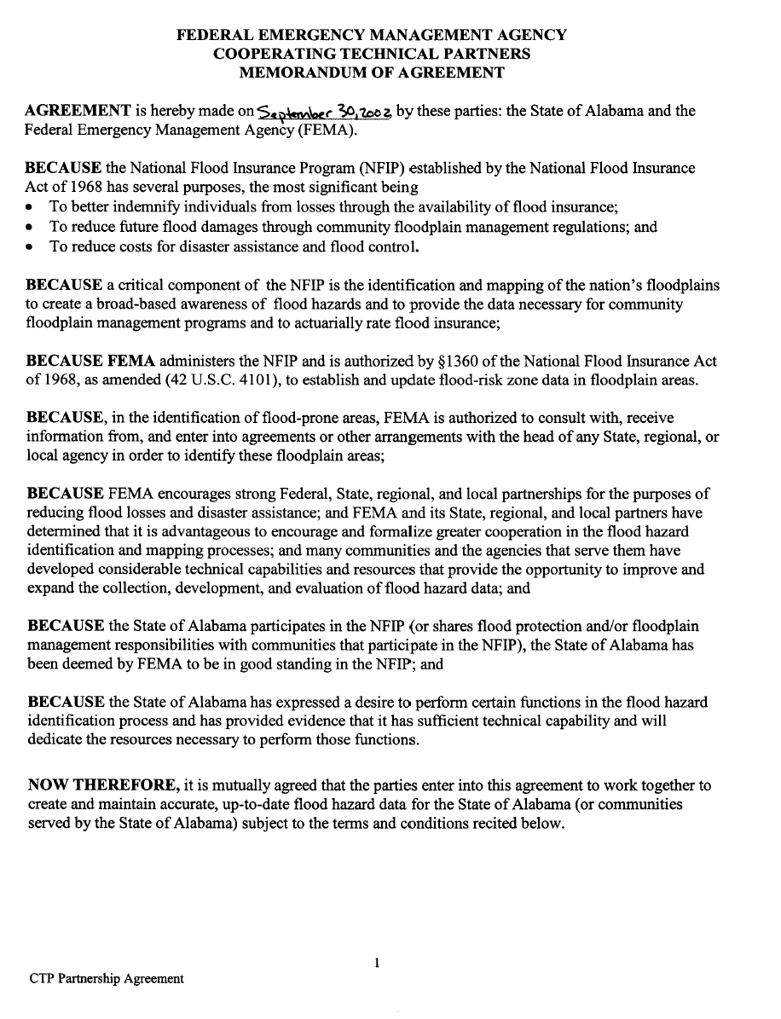

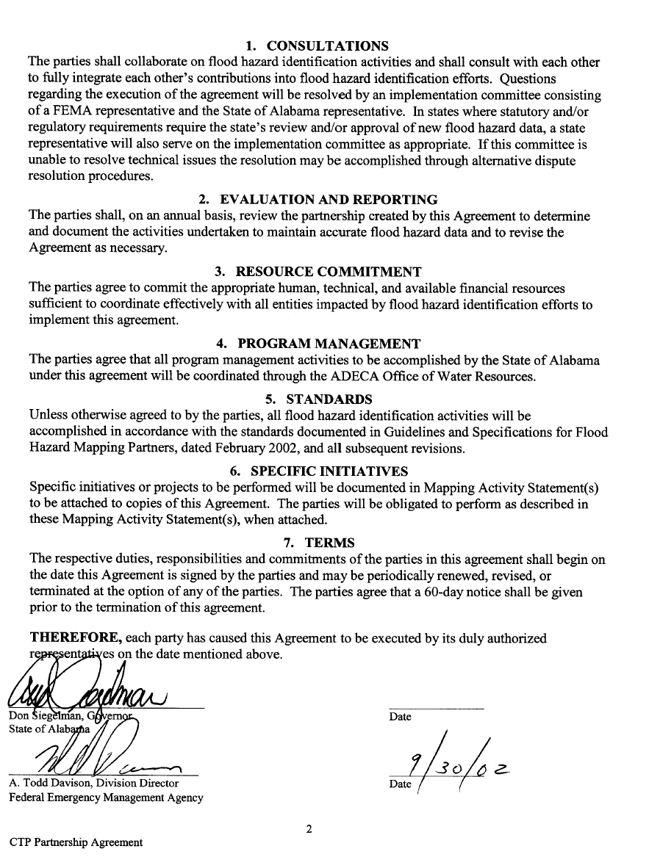

APPENDIX B

ADECA Office of Water Resources
Organizational Chart

