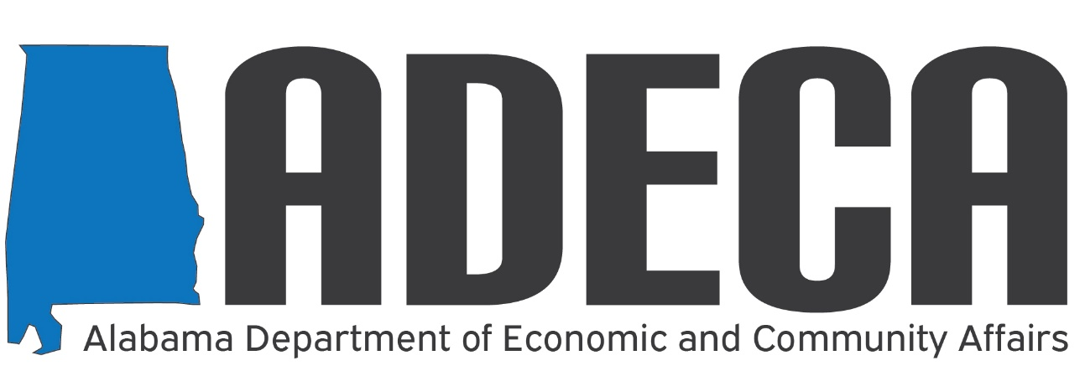

ReConnect Loan and Grant Program Workshop
The Alabama Department of Economic and Community Affairs (ADECA) has partnered with CTC Technology & Energy to provide planning, mapping, and technical assistance services associated with broadband in the state. ADECA and CTC have hosted a series of webinars to address the various information and technical assistance needs of leaders in the state's broadband future.
To continue these efforts, ADECA and CTC are holding an informational workshop about the opportunities associated with the USDA's Broadband ReConnect Program. This program furnishes loans and grants to provide funds for the costs of construction, improvement, or acquisition of facilities and equipment needed to provide broadband service in eligible rural areas. The USDA's new Broadband ReConnect Program rules dramatically expand eligible areas and effectively redefine broadband. Please join us as we review the program's continuing and new rules, provide guidance on how to take advantage of this funding opportunity, and share tips on how to position your application.
The ReConnect Loan and Grant Program Workshop will be held on Monday, November 29 from 12:00 p.m. – 1:00 p.m. CDT. In this workshop, there will be time to provide answers and strategic direction to participants.
You may register in advance for this meeting by visiting:
https://zoom.us/meeting/register/tJIuceygrTorH9KeJkkzKhbTeIm5i4IR7gAK
After registering, you will receive a confirmation e-mail containing information about joining the meeting.
Thank you,
BROADBAND ALABAMA TEAM
Website: http://adeca.alabama.gov/broadband
E-mail: broadband.fund@adeca.alabama.gov
Phone: (334) 242-5290
Address: Post Office Box 5690
Montgomery, Alabama 36103-5690

