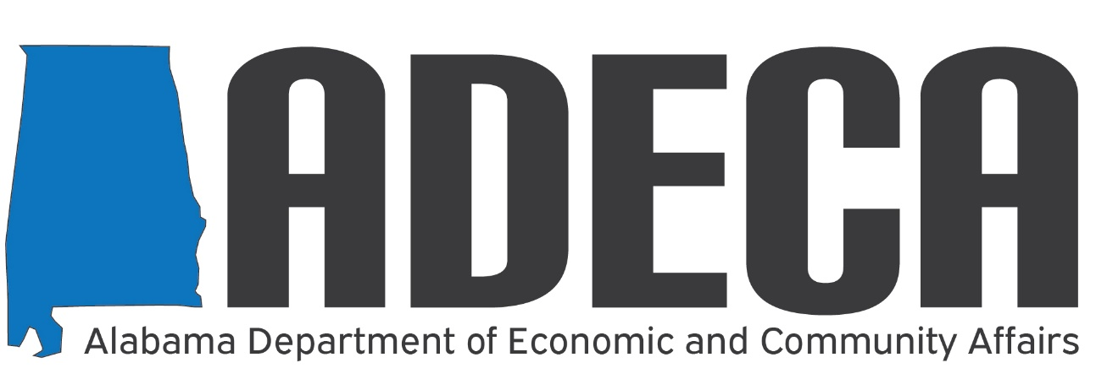

Local Government Broadband Workshop
The Alabama Department of Economic and Community Affairs (ADECA) has partnered with CTC Technology & Energy to provide planning, mapping, and technical assistance services associated with broadband in the state. ADECA and CTC have hosted a series of webinars to address the various information and technical assistance needs of leaders in the state's broadband future.
The next webinar in this series is designed specifically for local government leaders. Please join us as we present information about state and federal funding, public/private partnerships, best practices, and other strategies for bringing broadband to communities in Alabama.
The Local Government Broadband Workshop will be held on Friday, November 19 from 9:30 a.m. – 11:00 a.m. CDT. In this workshop, there will be time to provide answers and strategic direction to any specific municipality or county commission.
You may register in advance for this meeting by visiting:
https://zoom.us/meeting/register/tJ0vdu2gqTMjE9Gbhod5I7CCnEmTQ3DmzSpZ
After registering, you will receive a confirmation e-mail containing information about joining the meeting.
Thank you,
BROADBAND ALABAMA TEAM
Website: http://adeca.alabama.gov/broadband
E-mail: broadband.fund@adeca.alabama.gov
Phone: (334) 242-5290
Address: Post Office Box 5690
Montgomery, Alabama 36103-5690

