HUD Exchange Links
to the
PY2022 HUD Income Limits for CDBG Program
and
Income Eligibility Calculator

CDBG Income Limits - HUD Exchange

CDBG Income Limits
Date Published: June 2022

Description

FY 2022
FY 2022 CDBG Income Limits
Effective June 15, 2022
FY 2022 CDBG-DR 120% Income Limits
Effective June 15, 2022. The 120% income limits are available for limited use, only as allowed by the applicable Federal Register Notice. Please review the Federal Register Notice for direction, to assure a CDBG-DR funded recovery effort maintains compliance.
FY 2022 Puerto Rico Income Limits – CDBG-DR Only
Effective April 18, 2022
FY 2022 U.S. Virgin Islands Income Limits – CDBG-DR Only
Effective April 18, 2022
FY 2022 Uncapped 80% of Median Calculations
FY 2022 Uncapped Income Limits Memo

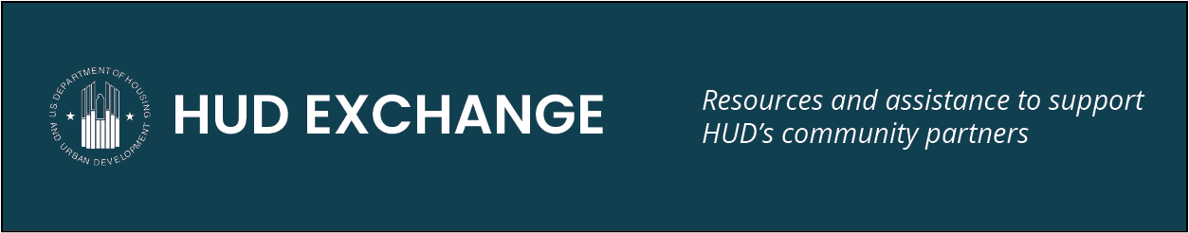

Home | Programs | Resources | Training

FY 2022 Income Limits Published for CDBG, CDBG-DR, NSP, and HOPWA

The FY 2022 Income Limits for the following programs are published and effective June 15, 2022:
- Community Development Block Grant (CDBG)
- CDBG Disaster Recovery (CDBG-DR)
- Neighborhood Stabilization Program (NSP)
- Housing Opportunities for Persons With AIDS (HOPWA)
Please note the CDBG-DR Income Limits for Puerto Rico and the U.S. Virgin Islands are effective April 18, 2022.
Currently all Community Planning and Development (CPD) FY 2022 Income and Rent Limits are published and can be accessed on the HUD Exchange's Income Calculator page under “Related Materials.”

Home | Programs | Resources | Training

CPD Income Eligibility Calculator Updated with FY 2022 Income Limits

The Community Planning and Development (CPD) Income Eligibility Calculator has been updated to incorporate FY 2022 Income Limits for the following programs:
- Brownfield Economic Development Initiative (BEDI)
- Community Development Block Grant Program (CDBG)
- CDBG Disaster Recovery (CDBG-DR)
- HOME Investment Partnerships Program (HOME)
- Housing Opportunities for Persons With AIDS (HOPWA)
- Housing Trust Fund (HTF)
- Neighborhood Stabilization Program (NSP)
- Section 108 Loan Guarantee Program
- Self-Help Homeownership Opportunity (SHOP)
The FY 2022 CDBG-DR Income Limits for Puerto Rico and the U.S. Virgin Islands are effective April 18, 2022. For all other programs, the FY 2022 Income Limits are effective June 15, 2022.
These updated limits can be accessed on the CPD Income Eligibility Calculator page under "Related Materials."

How Does This Affect the Income Calculator?
Income Limit Updates
All calculations that are currently in a user's dashboard in the CPD Income Eligibility Calculator, as well as calculations completed going forward, will use the FY 2022 Income Limits for the purposes of determining eligibility.
Although a user's data and calculations are accessible within the CPD Income Eligibility Calculator for a period of time, this tool is designed to allow users to more easily update a beneficiary’s income in the future; it is not a repository of income calculations completed in the past.
Now that the CPD Income Eligibility Calculator has been updated with FY 2022 Income Limits, calculations based on the FY 2021 Income Limits data are accessible only if downloaded from the calculator and saved to a user’s hard drive (or printed off) prior to today.
Functionality Updates
The income calculator was also updated to include changes for enhanced functionality. Read more about these functionality updates and their impact.
If you have any comments or questions, please contact the HUD Exchange.

Home | Programs | Resources | Training

Update for CPD Income Eligibility Calculator Users

On June 15, the CPD Income Eligibility Calculator will be updated for two reasons: a) for enhanced functionality and b) to include the Fiscal Year (FY) 2022 Income Limits. These changes will affect calculations in your Income Eligibility Calculator (IEC) dashboard, so please take note of the following:
- Please be sure to complete any in-progress calculations and download the summary files of your existing calculations for your records before the IEC is updated on June 15.
- Due to the nature of the functionality updates, data loss may occur for the calculations that are currently in a user's dashboard. Therefore, users should be prepared to review/restart any existing calculations that they want to reuse once the update occurs.
  - HOME Investment Partnerships Program (HOME) and Housing Opportunities for Persons With AIDS (HOPWA) users – note that all existing Adjusted Income and Rental Assistance calculations will be deleted during the update. If necessary, you can create new Adjusted Income and Rental Assistance entries by re-completing the existing Annual Income calculation for the household and then progressing to the additional calculations.
- After the update, the IEC will use the FY 2022 Income Limits for the purposes of determining eligibility.
This update is applicable to all IEC programs:
- Brownfield Economic Development Initiative (BEDI)
- Community Development Block Grant Program (CDBG)
- CDBG Disaster Recovery Assistance (CDBG-DR)
- Emergency Solutions Grants (ESG)
- HOME
- HOPWA
- Housing Trust Fund (HTF)
- Neighborhood Stabilization Program (NSP)
- Section 108 Loan Guarantee Program
- Self-Help Homeownership Opportunity (SHOP)
When using the Income Eligibility Calculator after the update, if you experience any issues, please try clearing the cache on your web browser first to see if that resolves the issue. If that does not work, please submit any comments or questions to the HUD Exchange Contact Us form.

