ADECA CED Division
CDBG-DR Grant Program for Hurricanes Sally and Zeta
Fraud, Waste, and Abuse - Internal Audit Policies and Procedures

Pursuant to the U. S. Department of Housing and Urban Development’s Federal Register Notice of Grant Funds to Address Major Disasters Occurring in 2020 and 2021 (Hurricanes Sally and Zeta in the State of Alabama) published on February 3, 2022 in Volume 87, Number 23 on pages 6364-6392, HUD has several requirements pertaining to guarding against fraud, waste, and abuse for purposes of administering this grant. This information is at the links https://www.govinfo.gov/content/pkg/FR-2022-02-03/pdf/2022-02209.pdf and 2022-02209.pdf (govinfo.gov). These requirements are stated as follows:

Federal Register, February 3, 2022, Volume 87, No. 23
Federal Register, February 3, 2022, Volume 87, No. 23, page 6377:

III. Grant Administration

III.A. Pre-Award Evaluation of Management and Oversight of Funds

III.A.1. Certification of financial controls and procurement processes, and adequate procedures for proper grant management.
* * *
III.A.1.a. Documentation requirements.
* * *
(6) Procedures to detect and prevent fraud, waste, and abuse. A grantee has adequate procedures to detect and prevent fraud, waste, and abuse if it submits procedures that indicate:
(a) How the grantee will verify the accuracy of information provided by applicants;
(b) the criteria to be used to evaluate the capacity of potential subrecipients;
(c) the frequency with which the grantee will monitor other agencies of the grantee that will administer CDBG-DR funds, and how it will monitor subrecipients, contractors, and other program participants, and why monitoring is to be conducted and which items are to be monitored;
(d) it has or will hire an internal auditor that provides both programmatic and financial oversight of grantee activities, and has adopted policies that describes the auditor’s role in detecting fraud, waste, and abuse, which policies must be submitted to HUD;
(e)
(i) for states or grantees subject to the same requirements as states, a written standard of conduct and conflicts of interest policy that complies with the requirements of 24 CFR 570.489(g) and (h) and subparagraph III.A.1.a(2)(a) of the Consolidated Notice, which policy includes the process for promptly identifying and addressing such conflicts;
(ii) for units of general local government or grantees subject to the same requirements as units of general local government, a written standard of conduct and conflicts of interest policy that complies with 24 CFR 570.611 and 2 CFR 200.318, as applicable, which includes the process for promptly identifying and addressing such conflicts;
(iii) for Indian tribes, a written standard of conduct and conflicts of interest policy that complies with 24 CFR 1003.606, as applicable; and
(f) it assists in investigating and taking action when fraud occurs within the grantee’s CDBG-DR activities and/or programs. All grantees receiving CDBG-DR funds for the first time shall attend and require subrecipients to attend fraud related training provided by HUD OIG, when offered, to assist in the proper management of CDBGDR grant funds. Instances of fraud, waste, and abuse should be referred to the HUD OIG Fraud Hotline (phone: 1–800–347–3735 or email: hotline@hudoig.gov).
Following a disaster, property owners and renters are frequently the targets of persons fraudulently posing as government employees, creditors, mortgage servicers, insurance adjusters, and contractors. The grantee’s procedures must address how the grantee will make CDBG-DR beneficiaries aware of the risks of contractor fraud and other potentially fraudulent activity that can occur in communities recovering from a disaster. Grantees must provide CDBG-DR beneficiaries with information that raises awareness of possible fraudulent activity, how the fraud can be avoided, and what local or state agencies to contact to take action and protect the grantee and beneficiary investment. The grantee’s procedures must address the steps it will take to assist a CDBG-DR beneficiary if the beneficiary experiences contractor or other fraud. If the beneficiary is eligible for additional assistance as a result of the fraudulent activity and the creation of remaining unmet need, the procedures must also address what steps the grantee will follow to provide the additional assistance.

ADECA, as the grantee/grant recipient of the CDBG-DR Grant funds for Hurricanes Sally and Zeta, must have adequate policies and procedures to guard against fraud, waste, and abuse for purposes of administering this grant. For purposes of the HUD Secretary’s certification, a grantee has adequate procedures to detect fraud, waste, and abuse of funds if the following statements are true:
1. The grantee has policies and procedures to detect fraud, waste, and abuse. The grantee’s procedures are adequate if the procedures indicate:
  - a. how the grantee will verify the accuracy of information provided by applicants;
  - b. the criteria to be used to evaluate the capacity of potential subrecipients; and
  - c. the frequency with which the grantee will monitor other agencies that will administer CDBG-DR funds, how it will monitor subrecipients, contractors, and other program participants, and why monitoring is to be conducted and which items are to be monitored. [See the February 3, 2022 Federal Register Notice at Section III.A.1.a.(6)(a)-(c).]

2. The grantee has or will hire an internal auditor that provides both programmatic and financial oversight of grantee activities, and has adopted policies that describes the auditor’s role in detecting fraud, waste, and abuse (which must be submitted to HUD). [See the February 3, 2022 Federal Register Notice at Section III.A.1.a.(6)(d).]
3. The grantee has a written standard of conduct and conflicts of interest policy that complies with the requirements of 24 CFR 570.489(g), 24 CFR 570.489(h), and other sections described in the applicable Federal Register notice, which includes the process for promptly identifying and addressing such conflicts. [See the February 3, 2022 Federal Register Notice at Section III.A.1.a.(6)(e)(i).]
4. The grantee assists in investigating and taking action when fraud occurs within the grantee’s CDBG-DR activities and/or programs. All grantees receiving CDBG-DR funds for the first time shall attend and require subrecipients to attend fraud-related training provided by HUD OIG, when offered, to assist in the proper management of CDBG-DR funds. [See the February 3, 2022 Federal Register Notice at Section III.A.1.a.(6)(f).]
5. The grantee indicates that instances of fraud, waste, and abuse will be referred to the HUD OIG Fraud Hotline (phone: 1-800-347-3735 or email: hotline@hudoig.gov). [See the February 3, 2022 Federal Register Notice at Section III.A.1.a.(6)(f).]
6. The grantee has procedures that indicate how the grantee will make CDBG-DR beneficiaries aware of the risks of contractor fraud and other potentially fraudulent activity that can occur in communities recovering from a disaster. Grantees must provide CDBG-DR beneficiaries with information that raises awareness of possible fraudulent activity, how the fraud can be avoided, and what local or state agencies to contact to take action and protect the grantee and beneficiary investment. [See the February 3, 2022 Federal Register Notice at Section III.A.1.a.(6)(f).]
7. The grantee’s procedures address the steps it will take to assist a CDBG-DR beneficiary if the beneficiary experiences contractor or other fraud. If the beneficiary is eligible for additional assistance as a result of the fraudulent activity and the creation of remaining unmet need, the procedures also address what steps the grantee will follow to provide the additional assistance. [See the February 3, 2022 Federal Register Notice at Section III.A.1.a.(6)(f).]

ADECA maintains the ADECA Policies and Procedures Manual, the most recent edition being issued on November 4, 2020, wherein Chapter 9 of this manual, entitled “Grant Administration Overview,” contains Section 9.6 pertaining to “Internal Audit” governing ADECA’s policies and procedures for the Department’s audit functions. These audit policies and procedures will be applicable to the CDBG-DR Hurricanes Sally and Zeta subgrant recipients. This Section 9.6 “Internal Audit” states as follows:

9.6 INTERNAL AUDIT

The Audit Section provides independent, objective assurance and consulting services designed to add value and improve the organization’s operations. ADECA’s Audit Section helps the agency accomplish its objectives by bringing a systematic and disciplined approach to evaluate and improve the effectiveness of risk management, control, and governance processes. The Audit Section complies with the United States Government Accountability Office’s (GAO) Government Auditing Standards and the Institute of Internal Auditors’ (IIA) International Professional Practices Framework. The Internal Audit Charter, approved by the Director sets forth the purpose, authority, and responsibility of the Audit Section.

OVERVIEW

The annual audit plan is a guide that is developed for the utilization of the section’s resources during the fiscal year in order to address the risks of the Department. Audits and other projects selected for review and included in the annual audit plan are those areas that represent risk to the agency based on the agency-wide annual risk assessment. The audit plan is a dynamic document that may change during the fiscal year as circumstances change. Requests from management, changes in audit resources, and changes in the agency’s organization or operations could result in changes to the plan. Any significant changes to the plan would require approval from the Chief Audit Executive and the Director. Project objectives proposed in the plan are in general terms. The specific objective of each audit project is determined by the detailed assessment of relative risks for the project at the time the project is initiated. The audit plan will be developed using current audit resources available in the first quarter of each fiscal year. Additional projects will be submitted to the Director for review and approval as supplemental hours become available.
The Audit Charter requires the agency to conduct a program of internal auditing that includes an annual audit plan prepared using risk assessment techniques and identifies the individual audit projects to be conducted during the year. This plan is developed based on an assessment of risk and potential exposures that may affect the organization. Ultimately, Audit’s objective is to provide management with information to reduce exposure to the negative effects that may be associated with operations intended to achieve management’s objectives. The degree or materiality of exposure can be viewed as risks mitigated by establishing sound internal controls. The planning process is consistent with the agency’s approved Audit Section Charter and the division’s goals. The plan of engagements is based on a documented risk assessment. In addition to the risk assessment, the planning process includes the assessment of available audit resources. Federal program requirements specific to programs administered by ADECA may require additional reviews and audits that will need to be addressed each year during the annual audit planning phase.

TYPES OF REVIEWS

The Audit Section conducts performance audits, non-audit services, investigations, desk reviews, as well as follow-up reviews.
• Performance audits are engagements that provide assurance or conclusions based on an evaluation of sufficient appropriate evidence against stated criteria. These type of audits also include compliance audits. Performance audits provide objective analysis so that management and those charged with governance and oversight can use the information to improve program performance and operations, reduce costs, facilitate decision making by parties with responsibility to oversee or initiate corrective action, and contribute to public accountability. Therefore, the sufficiency and appropriateness of evidence needed and tests of evidence will vary based on the audit objectives and conclusions.
• Non-audit services are advisory service activities which are intended to add value and improve the agency’s governance, risk management, and control processes. Examples include counsel, advice, facilitation, training and other special projects. This type of project can only be conducted if providing the non-audit service does not create impairments to independence, either in fact or appearance, with respect to future audit projects.
• Investigations include following up on tips of suspected irregularities reported through the fraud hotline, program monitors, and others. Irregularities involve such matters as conflicts of interest, falsification of records, misappropriation of assets, and other allegations of waste, fraud and abuse. Appropriate ADECA management and officials will be notified when allegations of irregularities are scrutinized. When necessary, applicable federal program personnel and law enforcement agencies shall also be informed and consulted.
• Follow-up reviews are conducted to determine the adequacy, effectiveness, and timeliness of actions taken by management on reported engagement findings and recommendations. This work determines if management actions have resulted in lowering risks or if management has assumed the risk of not taking corrective action on reported findings. Follow-up projects are conducted on previous Audit Section’s reported findings, as well as other external entities’ reported audit findings. These audits are scheduled within a reasonable time frame to allow management sufficient opportunity to implement corrective actions.
• Desk reviews are performed to ensure that all audit reports submitted by subrecipients of ADECA meet minimum reporting standards established by Generally Accepted Government Auditing Standards (GAGAS) and Generally Accepted Auditing Standards (GAAS). All subrecipients are required to submit annual audit and/or single audit reports if they meet the threshold requirements as established by 2 CFR 200.501 and ADECA in their respective contract and/or grant agreements. All audit reports shall be submitted directly to the Audit Section of ADECA. Additionally, the reports’ financial statements related to ADECA financial assistance shall be reconciled to the accounting records of the Department. Audit reports will be entered into the Audit Section’s system to track the review process. Deficiencies and audit findings related to federal programs funded through ADECA will be reported to Program Management so that follow-up can be included in program monitoring activities. Resolution should take place within six months from the date the audit report was accepted.
The scope of activities performed by the Audit Section may relate to any phase of the Department’s activities including:
• Evaluating and enhancing the Department’s accounting policies and procedures that constitute its internal control structure.
• Assessing compliance with appropriate policies, laws, and regulations – both State and Federal.
• Evaluating the accuracy of reported data utilized by departmental and department management in making operational decisions.
• Appraising the efficiency and effectiveness of the Department’s organizations, programs, functions, and activities.
• Ensuring and evaluating the Department’s procedures for monitoring compliance of subrecipients and contractors.
• Assisting program staff in ensuring necessary corrective actions are taken to resolve monitoring or audit issues related to findings and collection of disallowed costs.
• Reviewing grant applications, contract provisions, and budget revisions prior to submission to the Director for approval.
• Assessing the efficiency of operations and developing recommendations for cost savings.
• Ascertaining that all Department revenue is maximized, safeguarded, and controlled.
• Determining that all operational data is safeguarded and accurately maintained.
• Discovering the extent to which Department assets are accounted for and safe guarded from loss.
• Investigating allegations of fraud, waste, abuse and theft through various sources.

DEVELOPMENT OF THE AUDIT PLAN

The Audit Section allocates its resources in a manner that is consistent with the mission and goals of the Department. To support the Department’s mission, audit coverage is considered across the agency. The audit plan is designed to provide coverage of key business processes, over a reasonable period of time, given the existing staff. The following key factors were considered to assess risk and develop the audit plan:
• Potential for impact on agency-wide policies and procedures
• Changes in systems, processes, policies, or procedures
• Results and time since last audit engagement
• Extent of government regulation
• Information and communication
• Transaction volume
• Staff turnover
In addition to the projects selected based on risk assessment results, audit hours are also dedicated to follow-up reviews, carry-forward projects, and non-audit services. The Audit Section will also conduct certain activities on an annual and/or periodic basis, such as an internal quality control assessment and annual audit report. Those annual/periodic activities are also included in the audit plan. To ensure the auditors maintain a steady workload throughout the year, some audit projects are scheduled to start near the end of one fiscal year and require time in the following year to complete. Specific carry-forward projects will be identified in the Audit Plan Schedule.

AUDIT PROGRAMS

Audit activities will vary as a result of the differences in the nature of operations, organizational structure and management style, and by the competence, employee capabilities, and concepts of operation control. Specific audit programs will be developed from each activity to be audited within each fiscal year. Audit programs will be designed in regards to services, compliance requirements, performance considerations, and specialized skills required for each project. All audit programs, work papers and reports will be conducted in accordance with appropriate professional standards. The Audit Section will also provide any assistance to the Department’s management when they request special assignments/projects. These special assignments will typically be performed in addition to the normally scheduled audit work planned.

Also, in 2012, ADECA adopted a CDBG-DR Internal Audit policy and procedures when the State received disaster assistance grant funds from HUD for tornado recovery efforts in 2011. This policy will be applicable to the CDBG-DR Hurricanes Sally and Zeta subgrant recipients. This policy is contained on the ADECA website www.adeca.alabama.gov at the link https://adeca.alabama.gov/cdbg-disaster-recovery/2011-tornadoes/. This policy is stated as follows:

CDBG DISASTER RECOVERY GRANT PROGRAM (CDBG-DR)
INTERNAL AUDIT POLICY AND PROCEDURES

ADECA’s Audit Section functions as the CDBG-DR Internal Auditor, reporting independently to the Director (see the following ADECA organization chart) any detection of fraud, waste, and abuse. These matters are communicated at the time of occurrence and through an annual report for all P.L. 113-2 grants. ADECA has several internal controls in place to help mitigate fraud, waste, and abuse. Internal controls are part of a continuous process in the management of programs. The Audit Section provides independent, objective assurance and consulting services designed to add value and improve the organization’s operations. ADECA’s Audit section helps the agency accomplish its objectives by bringing a systematic and disciplined approach to evaluate and improve the effectiveness of risk management, control, and governance process.

Desk reviews are performed throughout the year to ensure that all audit reports submitted by subrecipients of ADECA meet minimum reporting standards established by the Generally Accepted Government Auditing Standards (GAGAS) and Generally Accepted Auditing Standards (GAAS). All subrecipients are required to submit annual audit and/or single audit reports if they meet the threshold requirements as established by 2 CFR 200.501 and ADECA in their respective contract and/or grant agreements. Additionally, the reports’ financial statements related to ADECA financial assistance are reconciled to the accounting records of the Department in order to determine completeness. Deficiencies and audit finding related to federal programs funded through ADECA are reviewed and reported to Program Management so that follow-up can be included in program monitoring activities. This action includes any findings related to fraud, waste, and abuse, which is also reported to the Director once discovered.

The Audit Section also has a separate fraud hotline and email address where reports of fraud may be made. This information is found on the CDBG Disaster Recovery website of ADECA under the “How to report fraud within ADECA programs” link. Investigations include following up on tips of suspected irregularities reported through the fraud hotline or email, program monitors and others. Irregularities involve such matters as conflicts of interest, falsification of records, misappropriations of assets and other allegations of fraud, waste and abuse.

In addition, ADECA is reviewed annually by the Department of Examiners and Public Accounts, an independent legislative audit agency for the State of Alabama. The Department has the authority to perform audits of the accounts of all entities receiving or disbursing public funds. As part of the Legislative branch of state government, the Department is independent of the Executive and Judicial branches of state government, as well as all local governments in the State.

(NOTE: This policy was developed as required for P.L. 113-2 grants, per the March 5, 2013 Federal Register Notice at page 14334, paragraph 10.)

Based on the above-stated audit policies, ADECA maintains adequate policies and procedures to guard against fraud, waste, and abuse for purposes of administering this grant. ADECA adheres to the following policies:
1. ADECA, as the grantee, has policies and procedures to detect fraud, waste, and abuse. These procedures are adequate because they indicate:
  - a. How ADECA will verify the accuracy of information provided by applicants;
  - b. The criteria ADECA will use to evaluate the capacity of potential subrecipients; and
  - c. The frequency with which ADECA will monitor other agencies that will administer CDBG-DR funds, how ADECA will monitor subrecipients, contractors, and other program participants, and why monitoring is to be conducted and which items are to be monitored.
2. ADECA, as the grantee, has on staff an internal auditor that provides both programmatic and financial oversight of ADECA's activities, and has adopted policies that describe the ADECA auditor’s role in detecting fraud, waste, and abuse (which must be submitted to HUD).
3. ADECA, as the grantee, has a written standard of conduct and conflicts of interest policy that complies with the requirements of 24 CFR §570.489(g), 24 CFR §570.489(h), and other sections described in the applicable February 3, 2022 Federal Register Notice, which includes the process for promptly identifying and addressing such conflicts.
4. ADECA, as the grantee, assists in investigating and taking action when fraud occurs within ADECA's CDBG-DR activities and/or programs. ADECA, as a grantee receiving CDBG-DR funds for the first time shall attend, and require its subrecipients to attend, fraud-related training provided by HUD OIG, when offered, to assist in the proper management of CDBG-DR funds.
5. ADECA, as the grantee, indicates that instances of fraud, waste, and abuse will be referred to the HUD OIG Fraud Hotline (phone: 1-800-347-3735 or email: hotline@hudoig.gov).
6. ADECA, as the grantee, has procedures that indicate how ADECA will make CDBG-DR beneficiaries aware of the risks of contractor fraud and other potentially fraudulent activity that can occur in communities recovering from a disaster. ADECA, as a grantee, must provide CDBG-DR beneficiaries with information that raises awareness of possible fraudulent activity, how the fraud can be avoided, and what local or state agencies to contact to take action and protect the grantee and beneficiary investment.
7. ADECA's, as the grantee, procedures address the steps it will take to assist a CDBG-DR beneficiary if the beneficiary experiences contractor or other fraud. If the beneficiary is eligible for additional assistance as a result of the fraudulent activity and the creation of remaining unmet need, the procedures also address what steps ADECA, as the grantee, will follow to provide the additional assistance.
ADECA also maintains an online reporting system for concerned/interested parties to report suspected fraud, waste, and abuse directly to ADECA. This system is located on the ADECA website (www.adeca.alabama.gov) at the link https://adeca.alabama.gov/fraud/, and appears as follows:

Report Fraud, Waste, and Abuse
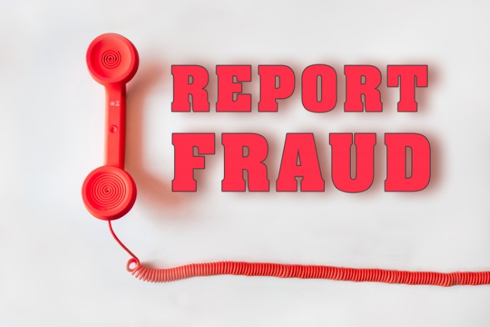
You may report suspected fraud, waste, and abuse by calling (877) 219-9598 or by filling out the form provided below. If we may contact you regarding your reporting, please provide your contact information when calling or completing this form:
Top of Form
Your Name
Your Email
Subject *
Message *
Bottom of Form

Also, ADECA’s CDBG Program grant closeout procedures require that each unit of local government recipient of ADECA’s CDBG Grant Program funds must complete ADECA’s Audit Certification Form and then submit that completed form as part of the local government’s CDBG grant closeout documentation. That form will be applicable to the CDBG-DR Hurricanes Sally and Zeta subgrant recipients. That form is posted on the ADECA website (www.adeca.alabama.gov) at the link https://adeca.alabama.gov/cdbg/closeout/. That form states as follows:

Audit Certification
(Please complete either Block 1 or Block 2 as applicable)

Block 1
As the ___(Select One)___ of the ___(Select One)___ of ____________________________ I do hereby certify, attest, and confirm that the ___(Select One)___ of _________________, as a non-Federal entity and grant recipient of funds awarded from the Alabama Department of Economic and Community Affairs (ADECA), Community and Economic Development Division (CED), has expended $750,000 or more in total (cumulative) Federal Awards during our established Fiscal Year, and, as required, has conducted or procured a single and/or program-specific audit for this Fiscal Year in accordance with the provisions of the Code of Federal Regulations, Title 2: Grants and Agreements, Chapter II, Part 200 Uniform Administrative Requirements, Cost Principles, and Audit Requirements for Federal Awards, Subpart F – Audit Requirements.

This audit has been submitted/reported/procured as required by paragraph §200.507 Program-Specific Audits, paragraph (c)(2) and (c)(3).

_____________________________________ ______________________________
Signature Date

Block 2
As the ___(Select One)___ of the ___(Select One)___ of ____________________________ I do hereby certify, attest, and confirm that the ___(Select One)___ of _________________, as a non-Federal entity and grant recipient of funds awarded from the Alabama Department of Economic and Community Affairs (ADECA), Community and Economic Development Division (CED), did not expend $750,000 or more in total (cumulative) Federal Awards during our established Fiscal Year, and, as such, will not conduct a single and/or program-specific audit for this Fiscal Year per Code of Federal Regulations, Title 2: Grants and Agreements, Chapter II, Part 200 Uniform Administrative Requirements, Cost Principles, and Audit Requirements for Federal Awards, Subpart F – Audit Requirements.

_____________________________________ ______________________________
Signature Date

Also, ADECA maintains an Audit Section within the Department as a separate office that reports directly to the ADECA Director. That Audit Section is reflected on the ADECA Organizational Chart. The ADECA Organizational Chart is maintained by the ADECA Director’s Office and the ADECA Office of Communications and External Affairs. The Organizational Chart can be found on the ADECA website (www.adeca.alabama.gov) at the link https://adeca.alabama.gov/divisions/ and appears as follows:

ADECA Organizational Chart

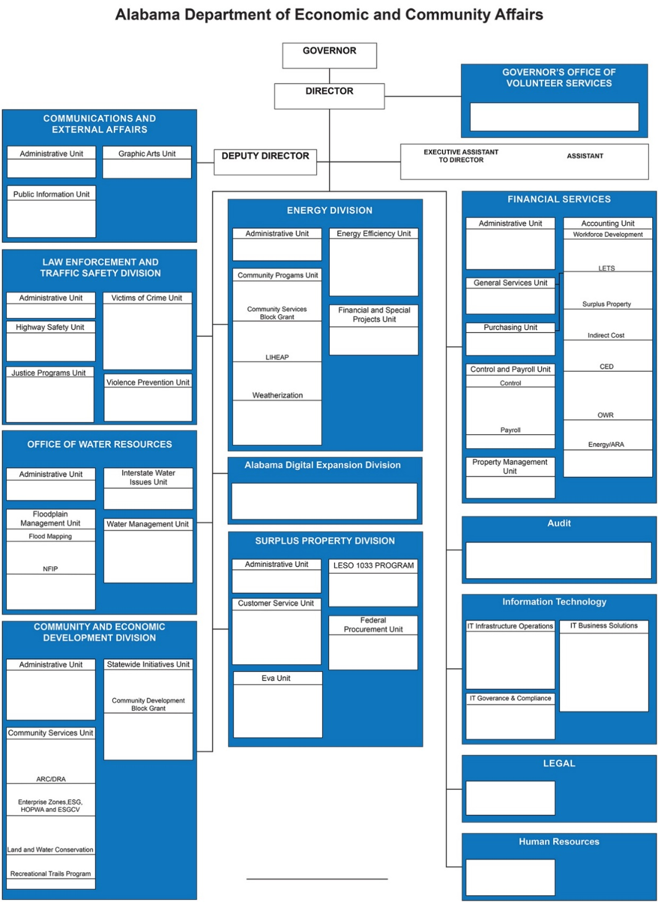

End of Fraud, Waste, and Abuse - Internal Audit Policies and Procedures

