Alabama Inland Port Infrastructure
Program Guide

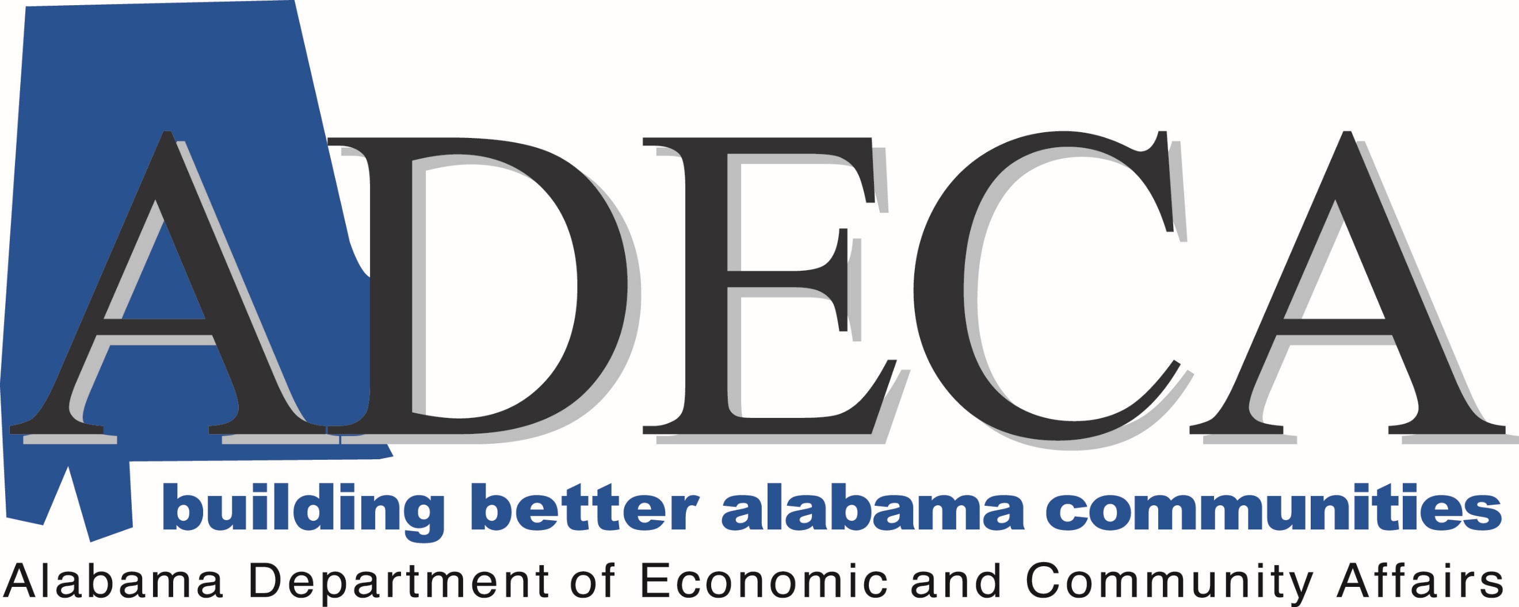

E-mail Address: inland.ports@adeca.alabama.gov

Website: http://adeca.alabama.gov/inlandports

Alabama Inland Port Infrastructure
Program Guide

Purpose

The Alabama Inland Port Infrastructure Program is designed to award infrastructure funds for inland port capital improvement initiatives. For the purposes of this program, an inland port is a port located along one of Alabama’s inland waterways that provides an inter-modal transportation hub.

Program Available

The program has a total amount of $1,762,994.80, which is the maximum award amount. There is no minimum for an award amount.

Match Requirement

Grant funds awarded through this solicitation, require at least a twenty percent (20%) match of the total project amount requested. ADECA will only fund up to eighty percent (80%) of the total project amount requested. However, additional points may be awarded for match amounts that exceed the 20% requirement.

Incurred Cost, Previously Expended, or Encumbered Funds
ADECA will not consider previously incurred costs or previously expended or encumbered funds for reimbursement under the grant or towards the matching requirement for any project.

Eligible Applicants

Eligible applicants for the program are port authorities, commissions, or their subdivisions and agents under existing authority, as well as a political subdivision of a local government, tribal government, a public agency or publicly chartered authority established by the state.

Funding Priorities

Priority for funding shall be given to inland port projects that propose measurable and proven activities that will reduce congestion on public highways, that propose measurable and proven activities that will increase tonnage at port facilities, and/or that will enhance regional competitiveness for port operators and users. Adding employment can be a factor under the program; however, the applicant must provide documentation indicating how many jobs would be created through the proposed project within the application.

All projects will be scored based on established rating criteria. Those eligible projects receiving the highest score will be selected for funding. The number of projects funded will be determined by the funds available and the total amount of requests made. ADECA may request amended projects and/or offer reduced grant participation.

Ineligible Funding

Funding shall not be approved for routine maintenance, administrative and operational expenses, debt service, or for the dredging of waterways within the state that are not in the immediate vicinity of an inland port facility. Additionally, the use of funding to establish or construct new inland ports, or to acquire land shall not be eligible for funding unless a feasibility study and competitive analysis has been performed and submitted for review to ADECA, prior to the application deadline.

Grant Scheduling

Applications will be accepted beginning March 6, 2020, through Monday, April 6, 2020.

Project Timeline and Close-Out

Projects must be completed within two years of the effective date on the grant agreement. The grant will be in the form of a reimbursement of eligible costs up to the award amount in the grant agreement.

Reimbursements will be made within 30 days of project completion and final inspection by ADECA.

Application Guidelines

The Alabama Department of Economic and Community Affairs (ADECA) will begin accepting applications on April 6, 2020. An applicant may not submit more than one application.

Grants will only be awarded for capital improvements at an inland port owned by a public port authority or an inland port authorized, maintained, or operated by a public port authority through any legal arrangement with the state or federal government or instrumentality.

For purposes of the grant program, capital improvements shall include but are not limited to activities to facilitate and coordinate inland port development, improvement, maintenance, onsite storage, moorings, and construction.

Inland Port Grant Evaluation Committee

The Inland Port Grant Evaluation Committee is comprised of five (5) members appointed by and reporting to the ADECA Director. The members include representatives from the Alabama State Port Authority, the Alabama Department of Transportation, the Alabama Department of Conservation and Natural Resources, the Alabama Department of Environmental Management, and an ADECA-Designated Representative.

The committee shall meet at least one time to review applications and recommend funding to the ADECA Director.

Application Review

Applications will be reviewed by ADECA staff for completeness and accuracy. After the review, ADECA staff will prepare summaries of the proposed applications and submit those summaries to the Inland Port Grant Evaluation Committee within ten (10) business days.

Contact Information:

Mailing Address: Physical Address:
Alabama Department of Economic Alabama Department of Economic
and Community Affairs and Community Affairs
Post Office Box 5690 401 Adams Avenue
Montgomery, Alabama 36103-5690 Montgomery, Alabama 36104

Attention: Energy Division Suite 560

Email Address: Website:
inland.ports@adeca.alabama.gov www.adeca.alabama.gov/inlandports

Phone:
334-242-5290

