Alabama Inland Port Infrastructure Program
Grant Application and Guide

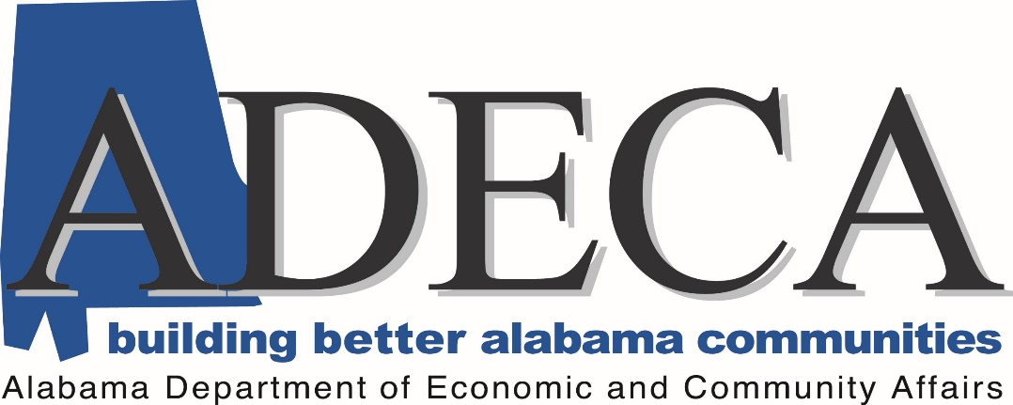

E-mail Address: inland.ports@adeca.alabama.gov

Website: http://adeca.alabama.gov/inlandports

Alabama Inland Port Infrastructure Program
2020 Grant Application and Guide

2020 Grant Application Guidelines

The Alabama Inland Port Infrastructure Program is designed to award infrastructure funds for inland port capital improvement initiatives. This solicitation focuses on capital improvement initiatives that include but are not limited to activities to facilitate and coordinate inland port development, improvement, maintenance, onsite storage, moorings, and construction. For the purposes of this program, an inland port is a port located along one of Alabama’s inland waterways that provides an inter-modal transportation hub.

Applications shall be submitted in PDF format by email to inland.ports@adeca.alabama.gov.
Applications will be accepted starting on March 6, 2020. Completed applications must be submitted by 11:59 PM, CST, on April 6, 2020. Any applications received after the deadline will not be considered. All applications must be complete; however, ADECA reserves the right to contact applicants for additional information and/or clarifications. All applications and supporting materials submitted shall become the property of ADECA and will be posted on ADECA’s website at http://adeca.alabama.gov/inlandports.

Eligibility

Eligible applicants for the program are port authorities, commissions, or their subdivisions and agents under existing authority, as well as a political subdivision of a local government, tribal government, a public agency or publicly chartered authority established by the state.

Grants will only be awarded for capital improvements at an inland port owned by a public port authority or an inland port authorized, maintained, or operated by a public port authority through any legal arrangement with the state or federal government or instrumentality.

Funding shall not be approved for routine maintenance, administrative and operational expenses, debt service, or for the dredging of waterways within the state that are not in the immediate vicinity of an inland port facility. Additionally, the use of funding to establish or construct new inland ports, or to acquire land shall not be eligible for funding unless a feasibility study and competitive analysis has been performed and submitted for review to ADECA, prior to the application deadline.

Funding

The total amount of funds available for this solicitation is $1,762,994.80, which is the maximum award amount. An applicant may not submit more than one application.

Grant funds awarded through this solicitation, require at least a twenty percent (20%) match of the total project amount requested. ADECA will only fund up to eighty percent (80%) of the total project amount requested. However, additional points may be awarded for match amounts that exceed the 20% requirement.

ADECA will not consider previously incurred costs or previously expended or encumbered funds for reimbursement under the grant or towards the matching requirement for any project.

Projects must be completed within two years of the effective date of the grant agreement. The grant will be in the form of a reimbursement of eligible costs up to the award amount in the grant agreement. Reimbursements will be made within 30 days of project completion and final inspection by ADECA.

Priority of funding shall be given to inland ports that have proven performance in reducing congestion on public highways, proven performance in increasing tonnage at port facilities, and/or inland ports that will enhance regional competitiveness for port operators and users. Adding employment can be a factor under the program; however, the applicant must provide documentation indicating how many jobs would be created through the proposed project within the application.

All projects will be scored based on established rating criteria. Those eligible projects receiving the highest score will be selected for funding. The number of projects funded will be determined by the funds available and the total amount of request made. ADECA may request amended projects and/or offer reduced grant participation.

Grant recipients must register in the State of Alabama Accounting and Resource System (STAARS) Vendor Self Service (VSS) portal in order to receive payment. Recipients can elect to be paid via Electronic Funds Transfer (EFT) or paper check when registering.

2019 Grant Application

APPLICANTS MUST USE THE FOLLOWING APPLICATION FORMAT, COMPLETE IT IN ITS ENTIRETY, AND LABEL ATTACHMENTS AS INSTRUCTED. FAILURE TO DO SO, MAY RESULT IN A LOSS OF POINTS.

Applicant Information

Project Name:
Legal Name of Entity:
Mailing Address:
Name and Title of CEO:
Name and Title of Contact:
Phone Number and Email of Contact:

Project Description

This section is worth up to 50 points. Points will be awarded based on verifiable information

Please complete the following section. Any attachments shall be titled Attachment A, Project Description.

- 10 Points - A detailed discussion of the project including specific project activities to be completed, location, and quantifiable benefits to be accomplished.

- 20 Points - A discussion of how the project meets one or more of the program priority areas. This section shall also include a discussion of the review process completed prior to application submission. Preliminary concurrence from applicable authorities and departments is a requirement of the application. All applicants claiming to meet one or more of the program priority areas must provide verifiable documentation of one or more of the following:

  - The applicant proposes measurable and proven activities that will reduce congestion on public highways,
  - The applicant proposes measurable and proven activities that will increase tonnage at port facilities, and/or
  - The applicant proposes to enhance regional competitiveness for port operators and users.

- 10 Points - A discussion of the applicant’s technical and managerial capabilities to complete the project within two years of the effective date of the grant award.

- 10 Points – The applicant shall identify from the list below, how the applicant meets the eligibility requirement. Please include documentation that the applicant is eligible to apply for the funds.

☐ Port authorities
☐ Port commissions
☐ Subdivisions and agents under existing authority
☐ Political subdivision of a local government
☐ Tribal government
☐ Public agency
☐ Publicly chartered authority established by the state.

Project Budget

This section is worth up to 50 points. Points will be awarded based on verifiable information

Please complete the following section. Any attachments shall be titled Attachment B, Project Budget. Please note that a 20% match is required for all projects; however, additional points can be earned throughout this section for all applicants who commit to provide additional matching funds.

- 5 Points - Please complete the table below. The total grant amount cannot exceed the lesser of 80% of total project costs.

- 20 Points - Please provide a detailed project budget narrative to include itemized eligible project expenses. Generally, eligible expenses will be limited to infrastructure funds for inland port capital improvement initiatives that include but are not limited to funds used to facilitate and coordinate inland port development, improvement, maintenance, onsite storage, moorings, and construction.

Funding shall not be approved for routine maintenance, administrative and operational expenses, debt service, or for the dredging of waterways within the state that are not in the immediate vicinity of an inland port facility. Additionally, the use of funding to establish or construct new inland ports, or to acquire land shall not be eligible for funding unless a feasibility study and competitive analysis has been performed and submitted for review to ADECA.

- 10 Points - Please identify the source and amount of matching funds. Appropriate resolutions and/or financial documents should be included. Any additional expenses associated with the project, but not part of the grant budget, should be included.

- 5 Points - A discussion of any other funds associated with the project, but not included in the budget.

- 10 Points - Please complete the following table.

 | Funding Amount and Source
Budget Item | Grant | Match | Total
Engineering/Design | $ - | $ - | $ -
Permits | $ - | $ - | $ -
Construction | $ - | $ - | $ -
Materials | $ - | $ - | $ -
Labor | $ - | $ - | $ -
Other | $ - | $ - | $ -
Materials | $ - | $ - | $ -
Labor | $ - | $ - | $ -
Total | $ - | $ - | $ -

Certifications

- The applicant certifies that it is a (choose all that apply):

☐ Port authority
☐ Port commission
☐ Subdivision and/or agent under existing authority
☐ Political subdivision of a local government
☐ Tribal government
☐ Public agency
☐ Publicly chartered authority established by the state

- The applicant certifies that the funds will not be used for routine maintenance, administrative and operational expenses, debt service, or for the dredging of waterways within the state that are not in the immediate vicinity of an inland port facility.

- The applicant certifies receipt of a preliminary concurrence from the appropriate state agencies such as, Alabama Department of Transportation, Alabama Department of Environmental Management, Alabama Port Authority, or any other applicable authority or department.

Certification
I, the undersigned, am authorized to obligate my entity and enter into agreements for my organization. I understand that the above certifications do not guarantee funding and a grant agreement will be executed prior to project funds being expended. I further understand that if the above statements cannot be verified, no grant funds will be awarded under this program. Finally, to the best of my knowledge the above certifications are true and correct.
Signature of Applicant: | Date:
Title of Applicant:

For more information regarding the Alabama Inland Port Infrastructure Program, please send questions to inland.ports@adeca.alabama.gov, or call (334) 242-5292 between the hours of 8:00 a.m. to 5:00 p.m., Monday through Friday.

State of Alabama – Disclosure Statement

Alabama Act 2001-955 requires the State of Alabama Disclosure Statement (Attachment D) to be completed and filed with all proposals, bids, contracts, and grant proposals to the State of Alabama in excess of $5,000. A fillable PDF is available on our website at http://adeca.alabama.gov/inlandports. Complete all lines as indicated. If an item does not apply, denote ‘N/A’ (not applicable). If you cannot include required information in the space provided, attach additional sheets as necessary. The form must be signed, dated, and notarized.

