Initial Proposal Volume 2

(Requirements 1-2, 4, 8-20) Broadband Equity, Access, and Deployment Program

Alabama Department of Economic and Community Affairs
November 2023

This document is a draft of Volume 2 of the Broadband Equity, Access, and Deployment (BEAD) Program Initial Proposal and is being released for public comment in advance of its submission by the Alabama Digital Expansion Division of the Alabama Department of Economic and Community Affairs (ADECA) to the National Telecommunications and Information Administration (NTIA).
All are welcome to submit comments regarding this draft document. Comments regarding this draft should be submitted via the online form available on ADECA’s website at https://adeca.alabama.gov/alipv1v2 by 11:59 p.m. on December 14, 2023. If you are unable to access the online form, you may contact us by email at broadband.fund@adeca.alabama.gov or call us at (334) 353-0767 for instructions on additional methods of submitting comments. After comments are received and considered, ADECA will submit the final version of Initial Proposal Volume 2 to NTIA for approval.
This project is sponsored by the National Telecommunications and Information Administration, U.S. Department of Commerce, under Assistance Listing 11.035. This document was prepared by the Alabama Department of Economic and Community Affairs using Federal funds under award 01-20-B093 from the National Telecommunications and Information Administration, U.S. Department of Commerce. The statements, findings, conclusions, and recommendations are those of the author(s) and do not necessarily reflect the views of the National Telecommunications and Information Administration or the U.S. Department of Commerce.

Contents
1. Introduction 1
2. Objectives (Requirement 1) 2
3. Local, Tribal, and regional broadband planning processes (Requirement 2) 5
4. Local coordination (Requirement 4) 7
4.1 Full geographic coverage 7
4.2 Meaningful engagement and outreach to diverse groups 11
4.3 Multiple awareness and participation mechanisms 13
4.4 Clear procedures to ensure transparency 14
4.5 Outreach and engagement of unserved, underserved, and underrepresented communities 14
5. Deployment subgrantee selection (Requirement 8) 16
5.1 Deployment subgrantee selection process 16
5.1.1 Principles 16
5.1.2 Technical assistance and administrative support 19
5.1.3 Overview of planned subgrantee selection process 20
5.1.4 Phases 22
5.2 Overall timeline 29
5.3 Scoring methodology 30
5.3.1 Prequalification Phase 30
5.3.2 Scoring Phase 34
5.3.3 Scoring Rubric 39
5.4 Prioritization of unserved BSLs, underserved BSLs, and eligible CAIs 39
5.5 Prioritization of non-deployment projects 40
5.6 Environmental and historic preservation and Build America, Buy America Act compliance 42
5.7 Project area definition 42
5.8 Approach to subsequent funding rounds if no proposals are received 44
5.9 Projects on Tribal lands 44
5.10 Identifying the Extremely High Cost Per Location Threshold (EHCPLT) 45
5.11 Utilizing the EHCPLT 45
5.12 Requiring prospective subgrantees to certify their qualifications 46
5.12.1 Officer certifications 46
5.12.2 Letter of credit/performance bond 47
5.12.3 Financial statements 49
5.12.4 Financial sustainability 50
5.12.5 Managerial capability 51
5.12.6 Technical capabilities 53
5.12.7 Compliance with applicable laws 56
5.12.8 Operational capability 58
5.12.9 Ownership information 59
5.12.10 Information on other public funding 60
6. Non-deployment subgrantee selection (Requirement 9) 62
7. Eligible Entity implementation activities (Requirement 10) 64
8. Labor standards and protection (Requirement 11) 65
8.1 Specific information that prospective subgrantees will be required to provide in their applications and how ADECA will weigh that information in its competitive subgrantee selection processes 65
8.2 Binding legal commitments in subgrants related to labor standards and protections 66
9. Workforce readiness (Requirement 12) 68
9.1 Establishing a baseline for the broadband construction sector in Alabama 68
9.2 Estimating the impact of BEAD on broadband construction jobs 70
9.2.1 Broadband construction spending will require Alabama to grow the broadband construction workforce by over 1,700 jobs 71
9.2.2 Characteristics of key workforce categories 73
9.2.3 Workforce qualification requirements 75
9.2.4 Current unemployment metrics 76
9.2.5 Current training programs at public institutions in Alabama 78
9.3 Continuing to support workforce development in Alabama 82
9.4 Coordination with workforce partners 84
9.5 Ensuring strong labor standards 85
9.6 Ensuring recruitment of qualified, diverse firms 88
9.7 Subgrantee selection process related to workforce considerations 90
9.8 Ensuring long-term economic impact from BEAD deployments 91
9.8.1 Short-term economic impact from initial construction outlay 91
9.8.2 Long-term objectives for enhancing economic growth and job creation 92
10. Minority Business Enterprises (MBEs) / Women’s Business Enterprises (WBEs) / Labor Surplus Area (LSA) firms inclusion (Requirement 13) 94
10.1 Process, strategy, and data tracking methods to ensure that minority businesses, women-owned business enterprises, and labor surplus area firms are recruited, used, and retained when possible 94
10.1.1 Place qualified small and minority businesses and women’s business enterprises on solicitation lists 95
10.1.2 Assure that small and minority businesses and women’s business enterprises are solicited whenever they are potential sources 95
10.1.3 Divide total requirements, when economically feasible, into smaller tasks or quantities to permit maximum participation by small and minority businesses and women’s business enterprises 95
10.1.4 Establish delivery schedules, where the requirements permit, which encourage participation by small and minority businesses and women’s business enterprises 96
10.1.5 Use the services and assistance, as appropriate, of such organizations as the Small Business Administration, the Minority Business Development Agency of the Department of Commerce, and ADECA 96
10.1.6 Require each subgrantee to take these affirmative steps as they relate to its subcontractors 96
10.2 Certification 97
11. Cost and barrier reduction (Requirement 14) 98
11.1 Promote the use of existing infrastructure 98
11.1.1 Streamline access to state conduits, poles, and rights-of-way 98
11.1.2 Encourage local communities to leverage their poles and conduits 99
11.1.3 Allow access to limited access rights-of-way for last-mile broadband providers providing service to unserved locations 100
11.1.4 Facilitate applicant access to mapping data 100
11.2 Promote dig-once policies by providing best practice guide for localities 100
11.3 Streamline permitting processes 101
11.3.1 Optimize local permitting processes 101
11.3.2 Streamline state permitting processes by developing fast-track permit and pre-approved construction methods 101
11.3.3 Shrink federal permitting timelines by partnering with NTIA to discuss a streamlined “shot clock” permit process 102
11.4 Reduce construction costs 102
11.4.1 Encourage specialized equipment sharing 102
11.4.2 Facilitate construction to and within buildings 102
11.5 Reduce drop costs 103
11.6 Reduce labor costs 103
11.6.1 Strike a balance between skilled and certified labor requirements and the cost of labor 103
11.6.2 Increase supply of labor through workforce development initiatives 103
11.7 Reduce overhead costs 104
11.7.1 Adopt reasonable, compliance-focused regulatory and reporting requirements 104
11.7.2 Create fast-track screening for environmental compliance 104
11.7.3 Create an ISP technical assistance team 104
11.8 Reduce materials costs 104
11.8.1 Identify approved vendors compliant with BABA and negotiate discount rates 104
11.8.2 Encourage awardees to form joint purchase coalitions and joint purchase agreements 104
12. Climate assessment (Requirement 15) 105
12.1 Identifying geographic areas subject to an initial hazard screening 105
12.2 Most important weather and climate hazards to account for and respond to in areas susceptible to climate-related risks 108
12.2.1 Dam failures 109
12.2.2 Drought 109
12.2.3 Earthquakes 110
12.2.4 Extreme temperatures 112
12.2.5 Flooding 116
12.2.6 Hail 119
12.2.7 High winds 121
12.2.8 Landslides 127
12.2.9 Lightning 129
12.2.10 Sea level rise and coastal land change 131
12.2.11 Sinkholes and land subsidence 131
12.2.12 Wildfire 132
12.2.13 Winter storms 134
12.3 Projected weather and climate risks to new BEAD-funded broadband infrastructure 138
12.4 Avoidance and mitigation of weather and climate risks 138
12.4.1 Hazard mitigation for anticipated BEAD-funded projects in Alabama 139
12.4.2 Adopted risk mitigation processes 140
12.5 Plan for completing the climate assessment process over the life of the program 140
13. Low-cost broadband service option (Requirement 16) 142
13.1 Low-cost broadband service option that must be offered by Alabama BEAD subgrantees 144
13.2 Incentivizing lower-cost offerings 147
13.3 Certification 147
14. Middle-class affordability plan 148
15. Use of 20 percent of funding (Requirement 17) 152
15.1 Planned use of funds requested 152
15.2 Amount of Initial Proposal Funding Request 153
15.3 Certification 153
16. Eligible Entity regulatory approach (Requirement 18) 154
16.1 Alabama laws imposing requirements on certain public sector providers 156
16.2 Optional attachment 156
17. Certification of compliance with BEAD requirements (Requirement 19) 157
17.1 Certification of compliance 157
17.2 Subgrantee accountability procedures compliance 157
17.2.1 Overview 157
17.2.2 Risk-based monitoring 157
17.2.3 Fraud, waste, and abuse 158
17.2.4 Distribution of funds on a reimbursement basis 158
17.2.5 Clawback provisions 159
17.2.6 Timely reporting requirements 159
17.2.7 Robust subgrantee monitoring 159
17.3 Certification of nondiscrimination and civil rights compliance 160
17.4 Certification of cybersecurity and supply chain risk management compliance 161
Appendix A: Local coordination tracker tool 163
Appendix B: Federally-recognized Tribe correspondence 164
Appendix C: Contributors on workforce considerations 165
Appendix D: Summary of subgrantee selection process 167
Appendix E: Proposed scoring rubric for subgrantee selection process 172

Figures
Figure 1: Alabama broadband technical assistance outreach to counties 8
Figure 2: ADECA resident survey dates by region 10
Figure 3: 30-minute drive time around Alabama institutions training roles relevant to in-the-field broadband construction 81
Figure 4: Composite county hazard risk scores in Alabama 107
Figure 5: Risk of earthquakes in Alabama 111
Figure 6: Risk of heat waves in Alabama 113
Figure 7: Risk of cold waves in Alabama 115
Figure 8: Risk of coastal flooding in Alabama 117
Figure 9: Risk of riverine flooding in Alabama 118
Figure 10: Risk of hail in Alabama 120
Figure 11: Risk of tornados in Alabama 122
Figure 12: Risk of hurricanes in Alabama 124
Figure 13: Risk of strong winds in Alabama 126
Figure 14: Risk of landslides in Alabama 128
Figure 15: Risk of lightning in Alabama 130
Figure 16: Risk of wildfire in Alabama 133
Figure 17: Risk of winter weather in Alabama 135
Figure 18: Risk of ice storms in Alabama 137
Figure 19: Share of low-income households in Alabama willing to pay for internet service at different price points 146
Figure 20: Monthly cost of home internet service by household income 149
Figure 21: Amount willing to pay for high-speed, reliable home internet service by household income 150

Tables
Table 1: State broadband goals and objectives 3
Table 2: Tentative schedule for Prequalification Phase 24
Table 3: Tentative format for county-based applications 25
Table 4: Tentative schedule for Scoring Phase 27
Table 5: Tentative schedule for Negotiation Phase 28
Table 6: Tentative grant process timeline 29
Table 7: Performance of Alabama’s broadband deployment sector (2018 – 2022) 69
Table 8: Anticipated distribution of broadband investment across sectors 71
Table 9: Estimated workforce requirements for broadband deployment occupations 71
Table 10: Occupations needed for broadband deployment 73
Table 11: Characteristics of key occupations impacted by broadband investment 74
Table 12: Work experience of occupations impacted by broadband investment 75
Table 13: Unemployment for occupations impacted by broadband investment 77
Table 14: Occupations impacted by broadband investment, job postings vs. hires (2022) 78
Table 15: Broadband workforce training programs at public higher education institutions 79
Table 16: U.S. labor laws noted in the BEAD NOFO 86
Table 17: Estimated economic effects of investing $1.68 billion in broadband construction 92
Table 18: Estimated economic effects of investing $1.9 billion in broadband construction 92
Table 19: Threats to infrastructure posed by weather risks 138
Table 20: Planned use of funds requested 152
Table 21: Alabama laws imposing requirements on certain public sector providers 156
Table 22: Summary of subgrantee selection process documents and milestones 167

Introduction
ADECA, the Eligible Entity for the State of Alabama, is pleased to present this second volume of the BEAD Initial Proposal, which includes all of the requirements established by NTIA in the BEAD Notice of Funding Opportunity (BEAD NOFO). ADECA reserves the right to update this Initial Proposal Volume 2 in response to comments received or additional guidance from NTIA. In addition, ADECA would like to avail subgrantees of the 2 C.F.R. Part 200 exceptions and adjustments NTIA applies in the BEAD Program. Should any revisions to this Initial Proposal be needed to accomplish this, ADECA would like an opportunity to make those revisions.

Objectives (Requirement 1)
The Alabama Connectivity Plan, issued in December 2021 by the Alabama Digital Expansion Division, a division of ADECA, was designed to align with the opportunities created by the federal Infrastructure Investment and Jobs Act (IIJA) broadband funding programs even before the rules for those programs had been released by NTIA. The Alabama Connectivity Plan states the following goals for achieving broadband connectivity for Alabamians:
- Facilitating the expansion of high-speed broadband
- Considering the need for broadband expansion in rural, underserved, and unserved areas
- Addressing obstacles to broadband adoption
- Developing funding strategies and plans for middle-mile and long-haul fiber, as well as last-mile infrastructure and services
As explained in ADECA’s Five-Year Action Plan for the BEAD Program, the state’s primary objectives for broadband deployment will enhance economic growth and job creation, and they are aligned with the principal focus of the BEAD Program:
- Serving 100 percent of unserved locations (i.e., below 25/3 Mbps) with a minimum of 100/20 Mbps service within five years
- Serving 100 percent of underserved locations (i.e., between 25/3 Mbps and 100/20 Mbps) with a minimum of 100/20 Mbps service within five years (if sufficient funds are available)
- Delivering gigabit connections to community anchor institutions (CAIs) that do not have that level of service within five years (if sufficient funds are available)
Informed by earlier strategic planning and goals, as well as by the comprehensive and ongoing outreach efforts described in the Five-Year Action Plan and this Initial Proposal, the State of Alabama has identified the following goals and key objectives for achieving broadband deployment and digital opportunity:
Table 1: State broadband goals and objectives
Goal | Strategic areas | Key objectives
Facilitate the expansion of high-speed broadband | Broadband availability and access | - Develop plans to provide broadband access to all unserved and underserved Alabama residents regardless of location (if sufficient funds are available).  - Develop grant programs for high-quality, future-proof middle-mile and last-mile fiber deployment in the state with an emphasis on rural and unserved areas.  - Develop, maintain, and expand capacity of a state broadband map that incorporates broadband service data for the public and in support of state grant programs.  - Foster productive working relationships with internet service providers (ISPs) and other partners to support reliable, affordable, and future-proof broadband access via financially sustainable networks.  - Support CAI access to gigabit broadband service.  - Support economic growth through workforce development for broadband deployment.
Consider the need for broadband expansion in rural, underserved, and unserved areas | Broadband availability and adoption | - Conduct technical assistance outreach to partners in each county.  - Provide county broadband and digital opportunity profiles.  - Complete and implement the Alabama Statewide Digital Opportunity Plan to address digital opportunity needs in line with the five pillars of digital opportunity defined in the IIJA.
Address obstacles to broadband adoption | Broadband affordability and adoption, digital opportunity, and digital skills | - Require ISPs that are awarded grant funds to participate in the FCC’s Affordable Connectivity Program (ACP), as applicable.  - Conduct survey outreach to residents to understand broadband and digital opportunity needs.  - Conduct outreach and questionnaires to organizations that serve and represent covered populations and underrepresented communities to assess the needs of these populations.  - Complete and implement the Alabama Statewide Digital Opportunity Plan.
Develop funding strategies and plans for middle-mile and long-haul fiber, as well as last-mile infrastructure and services | Strategic planning | - Strategically leverage federal and state infrastructure funding sources to achieve universal availability of broadband throughout the state.  - Develop grant programs for middle-mile fiber deployment in rural, unserved, and underserved areas in the state.  - Develop grant programs for last-mile fiber deployment emphasizing rural and unserved areas.

Local, Tribal, and regional broadband planning processes (Requirement 2)
As explained in ADECA’s Five-Year Action Plan, ADECA initiated a comprehensive external engagement process to support local, Tribal, and regional broadband planning processes, including identification of key current and potential partners and representative groups. Engagement efforts consisted of in-person meetings held in all 67 counties in the state, additional virtual discussion sessions, multiple online questionnaires capturing knowledge from partner organizations, and a statistically valid phone survey of residents. Following submission of this Initial Proposal, ADECA will continue to engage and collaborate with partners throughout the implementation process.
The state has made significant progress in its external inclusive outreach and engagement efforts that will support both this Initial Proposal and the Alabama Statewide Digital Opportunity Plan:
- Identified key state and local partners that serve covered populations/underrepresented communities and have experience with barriers and opportunities to broadband access and digital opportunity to inform the state’s planning processes; developed a comprehensive outreach list and online data tool for events and educational materials. Additional research and updates to the outreach list is ongoing.
- Developed and implemented a statistically valid, regionally based statewide resident survey on digital access and opportunity issues designed to “oversample” in ways that will identify unique needs of covered populations/underrepresented communities; analyzed survey results.
- Developed and distributed partner questionnaires and related presentation materials to gather data on programmatic assets, workforce, covered population/underrepresented communities barriers and obstacles, affordability programs, and measurable objectives; analysis of the questionnaires is in progress.
- Planned and conducted in-person technical assistance meetings in all 67 Alabama counties with county-level executives and local, regional, and statewide community partners to provide technical assistance, discuss programmatic assets and opportunities, barriers to broadband access, and partner collaboration for planning activities. ADECA initiated this program with a U.S. Department of Commerce Economic Development Administration (EDA) grant, providing services to the applicants to ADECA’s Alabama Community Broadband Technical Assistance Program. It then expanded the program to all 67 counties. Having these meetings in the counties reduced the burden on the governments and community partners.
- Held statewide facilitated discussions virtually and developed specific presentation materials for ISP, local and regional government, and nonprofit community organization partners.
- Developed detailed county-level profiles that provide analysis of digital opportunity and broadband access data, resident survey results, mapping, research, and modeling to support local capacity building and planning for increased digital opportunity; work on these county-level analyses is ongoing and will serve as the foundation for additional outreach and meetings with key county government and local entity partners.
- Attempting to coordinate engagements with the federally-recognized Tribal Nation in Alabama, coordinating engagements with several state-recognized Tribes, historically black colleges and universities (HBCUs), and additional community-based organizations throughout the state.
More information regarding ADECA’s external engagement process can be found in Section 5.1 of the Five-Year Action Plan and Section 4 of this Initial Proposal.

Local coordination (Requirement 4)
This section describes how ADECA has coordinated and will continue to coordinate with all communities within its jurisdiction and relevant partners, including those representing covered populations/underrepresented communities. A Local Coordination Tracker Tool is included as a linked file in Appendix A. It is a draft document and will be updated as necessary to reflect any new data prior to ADECA’s submission of Initial Proposal Volume 2 to NTIA.
ADECA conducted its local coordination efforts for BEAD and the Digital Equity Act in tandem as one cohesive effort to avoid confusion and reduce the burden on local partners. As described below, ADECA’s efforts meet each of the local coordination criteria included in the BEAD NOFO.

Full geographic coverage
ADECA’s outreach included in-person technical assistance meetings in each of the 67 counties in the state, as shown in the map below. ADECA took full advantage of local knowledge while planning for these engagements; local leadership investment in this process was critical to its success. An average of 19 attendees per session and over 568 organizations participated in these in-person sessions over a six-month period.
Figure 1: Alabama broadband technical assistance outreach to counties
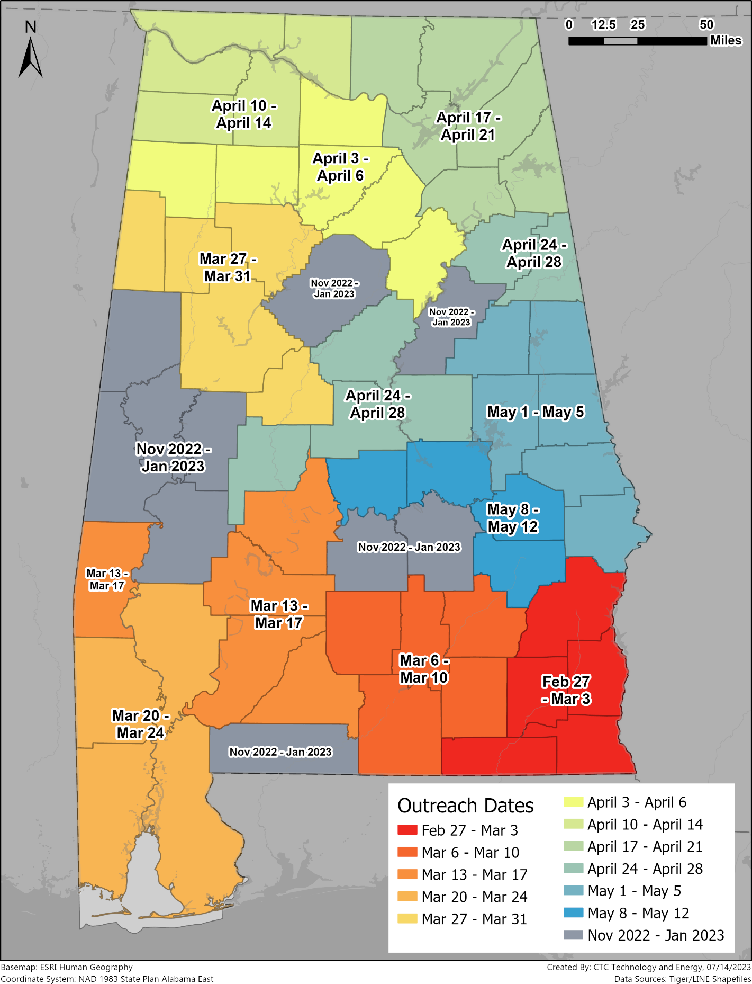
The engagement process began with outreach to county and local leaders to plan the in-person meeting. Planning participants varied by county but often included regional planning commission representatives, county commissioners and administrators, local elected officials, municipal clerks, county-level economic development authority representatives, and other interested organizations. ADECA worked with local planning entities to gather contacts for invitations and finalize on-site logistics.
In addition, ADECA worked with the local entities, as well as statewide member organizations, such as the Association of County Commissions of Alabama and the Alabama League of Municipalities, to help raise awareness among the public and colleagues by sharing the invitation to (and promotional materials about) the meetings as they deemed appropriate. ADECA felt the direct communication from local organizations would increase participation. State and regional partners were also invited to attend the local meetings.
ADECA then held full- and half-day in-person meetings with attendees. As noted, members of the public were invited and encouraged to participate and commonly did. During these meetings, ADECA provided information about the various broadband programs; shared information about broadband service in the county based on the Alabama Broadband Map; and listened to feedback from partners and community members regarding service gaps, programmatic shortcomings, and other unmet needs preventing full use of the internet. ADECA documented discussions during these meetings to capture insights on local infrastructure and programmatic assets, barriers, and obstacles to broadband (both accessibility and digital opportunity), and other needs and gaps.
In parallel to outreach through in-person engagements, ADECA conducted nine regional phone surveys in preparation for the Alabama Statewide Digital Opportunity Plan as well as to inform this Initial Proposal to capture resident input across the state on a region-by-region basis. This approach informs needs and gaps analysis for the state’s broadband and digital opportunity planning efforts with greater specificity than a single statewide survey.
The phone surveys collected data on the perceived reliability of Alabama residents’ home internet, household monthly internet expenses, and perception of their digital skills, among other topics. Because of their larger populations, Jefferson and Montgomery Counties were surveyed independently. Each survey collected a minimum of 400 responses, supporting estimation of true population proportions within ±2.5 percent.
ADECA conducted surveys over the phone to reach those without internet access. Calls were made from morning to evening to capture input from those with various working hours. ADECA provided resident survey analysis results in the Alabama Statewide Digital Opportunity Plan.
Figure 2: ADECA resident survey dates by region
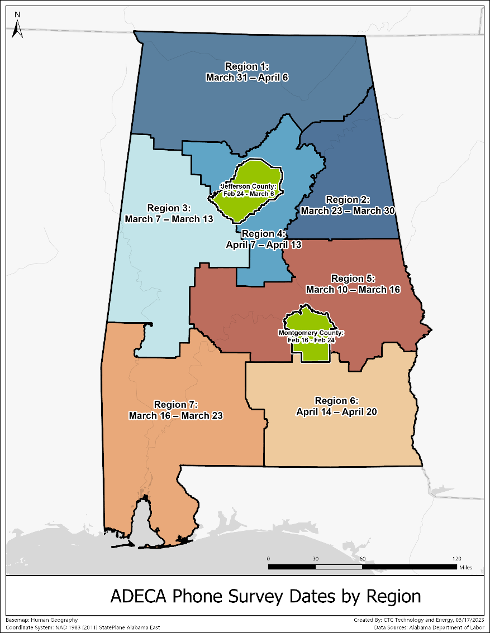

Meaningful engagement and outreach to diverse groups
ADECA worked with county and local leaders to develop invitation lists for in-person sessions that included all entities listed in Section IV.C.1.c.ii of the BEAD NOFO. Potential partners were identified via a combination of desk research, ADECA’s local knowledge, and ADECA’s ongoing outreach to and existing relationships with relevant entities. These entities included:
- Local government elected officials and agencies
- County elected officials and agencies
- Regional planning commissions and councils of government
- State agencies, especially those with local field representatives such as the Alabama Cooperative Extension Service, Alabama Department of Human Resources, and Alabama Department of Veterans Affairs
- Local chambers of commerce and economic development entities
- Local housing authorities and community support organizations and agencies
- Local libraries and schools
- Hospital and health care systems
- Public safety agencies
- Civil rights organizations
- The educational community, including higher education and workforce development entities
- Organizations that serve and represent:
  - Low-income households
  - Individuals with disabilities, including organizations that represent children with disabilities such as the Alabama Institute for Deaf and Blind
  - Individuals who are 60 years of age or older
  - Individuals with language barriers, including English learners and individuals with low levels of literacy
  - People of color
  - LGBTQI+ people
  - Immigrants
  - Veterans
  - Individuals in Alabama who are incarcerated or who were recently incarcerated
- ISPs and other companies, such as equipment providers, that support broadband deployment
- Labor unions
- Federal agencies with an interest in the region, such as the Tennessee Valley Authority
- Consumer advocates
- Faith-based organizations
- Neighborhood and regional associations
- Tribal governments (as a separate communication)
- Other organizations that serve as representatives of underrepresented communities
ADECA has also reached out to the Poarch Band of Creek Indians, Alabama’s only federally-recognized Tribe, to schedule a listening session on Poarch territory. In January 2023, ADECA invited the Tribal Leadership to participate in a county session being held close to Tribal land but did not receive a response. In June 2023, ADECA sent a Dear Tribal Leader letter requesting input and in early September 2023 sent a follow-up letter to Tribal Leadership, but as of submission of this Initial Proposal, has not yet received a response. A copy of both letters is included as linked file in Appendix B. ADECA will continue to reach out to the Poarch Band of Creek Indians to try to schedule a listening session to inform both the BEAD and Digital Equity Act funded programs. In addition, ADECA has conducted virtual meetings with the state-recognized MOWA Band of Choctaw Indians, Southeastern Mvskoke Nation, and Ma-Chis Lower Creek Indian Tribe of Alabama, which provided insight on broadband deployment and digital opportunity barriers for Tribes.
ADECA also held virtual discussion sessions with partners statewide—one for ISPs and two each for government agencies and non-profit community-based organizations. Participants included state and regional potential partners who may not have been able to attend the in-person county meetings. These engagements included breakout sessions for potential partners by area of focus.
ADECA collected input on coverage gaps and digital opportunity needs, digital skills and workforce development programs currently in place, and how such programs could be improved with additional resources. This information was also captured from potential partners through questionnaires for ISPs, government agencies, and community-based organizations, which participants were encouraged to fill out after these meetings. Data collected were specific to the potential partners’ area of focus.

Multiple awareness and participation mechanisms
ADECA raised awareness about their outreach program via word-of-mouth through local leaders stemming from the initial planning call to set up the meeting; print, local media, and social media channels; and state outreach using the ADECA website and push pages to listserv subscribers. The processes described above detail many of these mechanisms. In addition, to support distribution through local channels, ADECA provided meeting notice flyers, invitations, and social media blurbs to local leaders and organization leads (such as the Association of County Commissions of Alabama and the Alabama League of Municipalities, as mentioned above) to distribute via print and digital channels throughout their member organization or community. And during the planning phase for these engagements, ADECA asked if special accommodations were needed for persons with language barriers or disabilities and made appropriate accommodations.
Through its robust outreach efforts within each county throughout the state, regionally, and with statewide organizations, ADECA greatly expanded its list of broadband partner contacts and leveraged the resulting extensive contact list throughout the process. ADECA will continue to leverage this list for ongoing announcements and outreach throughout the state. ADECA also maintains a portal on its website that allows anyone to join its email distribution list.
ADECA posted information about both the public in-person and facilitated virtual sessions leading up to and after these events on its website. This information includes presentation slides, videos and handouts, and other information for and from these sessions. More information about ADECA’s BEAD awareness and participation mechanisms can be found in the Local Coordination Tracker Tool included as a linked file in Appendix A.

Clear procedures to ensure transparency
Through its BEAD Program and digital opportunity outreach efforts to every one of Alabama’s counties, as described above, ADECA conducted public in-person engagements that enabled it to hear from community leaders and members about their needs and experiences regarding access to broadband services and digital opportunity programs.
As is evident in the outreach process described above, ADECA was diligent about ensuring transparency to state and local leaders, community-based organizations, ISPs and other broadband-related companies, and the public. Much of the data collected are included in the Alabama Statewide Digital Opportunity Plan, which was posted for public review and comment.
Additionally, these local engagements informed and contributed to ADECA’s development of county profiles, which specifically document broadband infrastructure and coverage, access and affordability barriers residents face, and digital skills and workforce programs for each county. These profiles assess the county’s broadband and digital opportunity needs and assets, and provide recommendations to local leaders on what actions the county and its communities may take to strengthen partnerships and leverage opportunities to achieve broadband and digital opportunity goals within the county.
During summer 2023, ADECA presented a draft county profile to county leaders in order to elicit local leaders’ feedback before publishing a final version of the county profile. The county profiles are publicly available on ADECA’s newly launched, Be Linked Alabama website at https://broadband.alabama.gov/profiles/.
The county engagement process and broadband profiles are integral to the success of Alabama's broadband goals. ADECA has invested in an approach that informs, listens to, and empowers communities to be active partners in achieving these statewide goals.

Outreach and engagement of unserved, underserved, and underrepresented communities
ADECA reached out to and engaged with unserved, underserved, and underrepresented communities in each county in the state, inviting county and municipal government representatives, local organizations who represent covered and other populations (including those listed in the State Digital Equity Planning Grant NOFO Section I.C.g.), and ISPs to interactive workshops. The Local Coordination Tracker Tool included as a linked file in Appendix A provides an overview of these efforts, including a list of participant organizations, partner engagement tracker, local plans received, and any associated public comment.
ADECA began its all-county on-site program in the Black Belt region of Alabama (Lowndes, Greene, Sumter, Marengo, Pickens, and Hale counties), a rural area with many low-income households without access to high-quality broadband. This enabled ADECA to immediately learn about barriers and obstacles from an area with a high concentration of individuals living in poverty, individuals from racial and ethnic minorities, and the elderly.
ADECA is conducting ongoing meetings with many of the HBCUs and Minority Serving Institutions (MSIs) in the state in conjunction with the Student Freedom Initiative, a national nonprofit that supports African American students. Dr. Cynthia Warrick, president of Stillman College, told ADECA in a meeting at Stillman College, that students avoid the dining hall if the Wi-Fi is down. She added that she hopes to share the benefits of a better broadband network with the community around the school. ADECA has used these meetings to gather additional information about barriers and obstacles in the community, provide additional information to the institution’s community, and to inform the community about the ACP.
ADECA also met with other community-based organizations that support underrepresented communities, such as C.H.O.I.C.E., which provides digital navigators and other digital support services in Uniontown, and AARP, which provides training and other support to the elderly throughout the state.
As noted previously in Section 4.2, ADECA has reached out to the one federally-recognized Tribe in the state and to state-recognized Tribes, and continues to work to schedule listening sessions with the other Tribes.

Deployment subgrantee selection (Requirement 8)
This section of Initial Proposal Volume 2 describes in detail how ADECA proposes to structure, design, and implement its grant program to award BEAD funds to subgrantees to deploy broadband infrastructure in Alabama. This section includes extensive discussion of the structure of the program, the timeline, the scoring, and the steps ADECA will take to try to maximize the reach and impact of the BEAD funds throughout Alabama. Appendix D includes a detailed chart summarizing the subgrantee selection process described in this section, including the documentation, milestones, and phases required in the process.
ADECA developed this subgrantee selection process to meet both NTIA’s requirements and the state’s goals. While every effort has been made to propose scoring criteria and requirements that will enable ADECA to make awards to subgrantees for projects that will maximize the impact of the BEAD funding and other resources the state may commit to the BEAD Program, ADECA also recognizes that this grant program, like any such program, will not have guaranteed outcomes. For example, some areas may not attract any applicants, or may attract only one applicant. Further, the BEAD Program breaks new ground and is experimental in that no entity, state or federal, has ever been required to design a program that would address the needs of 100 percent of eligible locations. ADECA therefore reserves the opportunity to revise this subgrantee selection process and to negotiate with applicants as needed, so long as the state meets the BEAD Program requirements.

Deployment subgrantee selection process
The subgrantee selection process described below is designed to be fair and to avoid arbitrary decisions. It does this through detailed descriptions of selection rules and procedures, discussion of application of fair and consistent rules to all applicants, and to the extent possible, definition of quantitative scoring methods that minimize subjective judgment in grant decisions. The process and rules proposed below include such protections as requirements that selection officers will certify that they do not have conflicts of interest and that they will apply grant rules fairly and without bias.

Principles
ADECA is an experienced grantmaking entity and has administered multiple successful broadband grant programs in recent years that reflect its experience with managing fair, open, and competitive processes to deploy broadband to unserved and underserved households throughout Alabama.
ADECA intends to use the capabilities and structures it has developed for pre-BEAD programs to inform, to the greatest extent possible, the BEAD deployment subgrantee selection process in a way that is fair, open, and competitive. All elements of the BEAD Program have been designed with these goals at the forefront, as well as ADECA’s related BEAD design principles:
- Impact
  - Grant strategy should seek to make limited funds reach as far as possible
  - Fiber-to-the-premises should be prioritized and funded to every possible unserved and underserved location
  - Process and requirements should make prudent use of public funds through rigorous review and qualification of applications
- Simplicity and widespread participation
  - The process should be designed to encourage maximum participation by eligible applicants and opportunity for smaller and local applicants
  - The program, from design to final execution of grant agreements, should limit burdens on applicants and enable efficient applicant participation
  - The program design should also enable efficient grant program administration while accounting for BEAD’s complexity
- Openness, fairness, and competition
  - The process should reflect the key goals of enabling participation through openness, sharing of information, fairness, and commitment to competition
  - All elements of grant strategy, including geographic units for proposals, should be designed to increase the potential for competition among applicants statewide and in specific areas
Openness represents a core value and guiding principle for ADECA as it undertakes both the BEAD Program and other broadband and digital opportunity initiatives. Openness is crucial to ensure the best outcomes for unserved and underserved communities and will involve a range of strategies:
- Open and inclusive eligibility for grant awards, welcoming applications from a wide range of entities
- Community input at all stages of the BEAD process, including through engagement and feedback to the planning process and the plans themselves
- Openness and transparency in the evaluation process, with feedback to unsuccessful applicants to build trust and encourage participation
Fairness for ISP applicants in a competitive grant program for building broadband infrastructure is essential to encourage competition, innovation, and the efficient use of resources while ensuring that unserved and underserved areas receive the connectivity they need. To ensure fairness in its BEAD grant process, ADECA anticipates the following:
- Open and transparent processes, with all grant materials and guidance available to all potential applicants on the same timeline, including publication of the scoring rubric and guidance for how to self-score applications based on the scoring criteria established by ADECA
- Ongoing and frequent communications through public grant workshops, technical assistance meetings, and frequently-updated frequently asked questions (FAQs) to enable maximum information sharing with potential applicants
- Inclusive eligibility criteria that are clear, comprehensive, and not overly restrictive, within the parameters of the BEAD Program, to ensure that entities of all sizes can participate
- Clear scoring criteria
- Competitive process that encourages applicants to submit innovative proposals and cost-effective solutions
- Fair review process that is impartial and free from conflicts of interest, with independent evaluators engaged to assess proposals, consistent with ADECA’s past broadband grant programs. To insure against risks of bias, collusion, conflicts of interest, and self-dealing, ADECA will ensure that all reviewers are financially independent of all applicants. Reviewers will be required to certify in writing that they have no employment, contractor, or other business relationship with any applicant or any affiliate or subsidiary of any applicant.
Competition is at the heart of ADECA’s goals, methodology, and commitments. Creating a competitive environment for the BEAD Program will be ensured through multiple means:
- Broad eligibility and participation of a wide range of entities, including non-traditional broadband providers identified in the BEAD NOFO
- A low-burden grant program designed to make it feasible for all sizes of entities to compete without facing unreasonable costs or level of effort
- Incentives for collaboration by applicants with other providers, local governments, and community organizations
- Incentives for community support for proposed projects

Technical assistance and administrative support
To support openness, fairness, and competition in its BEAD grant efforts, ADECA plans extensive communications, technical assistance, and administrative support for applicants throughout the process. As it has done with its other broadband grant programs, ADECA will leverage its considerable grant funding experience and existing program framework to provide technical assistance resources and administrative support during the subgrantee selection process for its BEAD grant funding program. ADECA will use its existing communications channels to provide all partners in the state with the most accurate and up-to-date information regarding key deadlines and milestones for its BEAD Program. ADECA’s outreach processes and technical assistance materials will provide guidance, templates, and information about each of the subgrantee selection process elements discussed below.
Through its state broadband mapping efforts, community engagement, and outreach listserv, ADECA has an extensive email list of partners, including ISPs, local governments, CAIs, state agencies, and nonprofit organizations. ADECA also has a robust web and social media presence. ADECA will use these tools to alert potential applicants of each milestone during the process outlined below as well as providing information on technical assistance opportunities or updated information about program requirements. ADECA’s partners will also be encouraged to further distribute information about the BEAD Program through their own email lists and website postings. ADECA will also use its website as a repository for potential applicants to access detailed application materials and technical assistance resources, including those issued by NTIA.
ADECA expects to implement the following process for its BEAD grant funded outreach and communications:
- ADECA will announce the dates of its Prequalification Phase in accordance with the timeline described in Section 5.1.4.1. Potential BEAD subgrantees must participate in the Prequalification Phase in order to be eligible to submit a project-specific funding proposal during the Scoring Phase.
- At approximately the same time as this announcement of the Prequalification Phase dates, ADECA will make prequalification materials available on its website using a dedicated webpage
- ADECA will conduct an online application workshop on or around the first day of the Prequalification Phase window. This workshop will provide general instructions, discuss the program’s goals and objectives, map out major program milestones, answer questions, and provide other technical assistance. This workshop will be recorded and available on the ADECA website and the FAQ document will be updated to reflect questions and answers from the workshop.
- During the Prequalification Phase window, ADECA will use its established email communications channel to enable participants to ask questions and request technical assistance. To provide transparency, fairness, and additional technical assistance, ADECA will update its FAQ document on a regular basis with the questions and answers generated by the email inquiries and in-person meetings.
- ADECA will allow for reasonable curing to seek to ensure an optimal participation level of qualified ISPs
ADECA expects to follow the same steps detailed above for its Scoring Phase, including another application workshop. During the Scoring Phase, ADECA will also provide grant application materials and information. These materials will consist of an Application and Guide, Program Guide, and FAQ documents. ADECA will provide an additional resources page on its website to direct potential applicants to third-party resources that may be of use, including those provided by NTIA, NIST, FCC, and others. ADECA will continue to use all available communication channels to update applicants on milestones, deadlines, updated FAQ material, and technical assistance resources as they are made available by ADECA, NTIA, NIST, FCC, or other relevant partners.

Overview of planned subgrantee selection process
The following is ADECA’s planned subgrantee selection process, which is part of ADECA’s larger plan for ensuring broadband availability for all Alabama locations that are currently unserved and underserved, if sufficient funds are available.
ADECA anticipates a multi-step process for selecting subgrantees for its BEAD funds that will (1) begin with prequalification of applicants (referred to as the Prequalification Phase), (2) then proceed to receipt and scoring of grant applications (referred to as the Scoring Phase), and (3) then proceed to negotiations with applicants (referred to as the Negotiation Phase).
ADECA would like to avail subgrantees of the 2 C.F.R. Part 200 exceptions and adjustments NTIA applies in the BEAD Program. Should any revisions to this Initial Proposal be needed to accomplish this, ADECA would like an opportunity to make those revisions.
ADECA anticipates that applicants will be able to apply for both unserved and underserved locations based on application service boundaries that the applicants will determine themselves, subject to the requirements described below. ADECA believes that Alabama’s interests will be best served by enabling the applicants to determine application boundaries rather than ADECA attempting to do this. NTIA rules give states the option of designating application boundaries to which applicants must conform their applications and within which applicants must commit to serving all eligible locations. By enabling applicants to do this design themselves, ADECA anticipates that companies of all sizes will have equal opportunity to apply for the funds—thus ensuring that small ISPs are not disadvantaged by the structure of the grant program. Furthermore, it is ADECA’s experience that applicants are best suited to determine the most economically-viable grouping of unserved and underserved locations into a single geographic unit for application, and ADECA seeks to structure a grant program that makes best use of this expertise.
At the same time, ADECA has chosen county boundaries as a means of creating structure for application service design. Alabama’s 67 counties and the communities within them have been key partners for ADECA over the past year as BEAD planning has been undertaken, and county boundaries are frequently logical boundaries of broadband infrastructure service areas.
ADECA thus plans to establish all 67 counties as application categories and to solicit applications for service to all or some of the eligible locations within the county. Applicants will be able to apply for multiple counties if they choose, but each application will be focused on a single county and all or a portion of the unserved and underserved locations in that county. Applicants will be able to file only a single application per county and will be required to provide all addresses they propose to serve, as well as a single polygon that illustrates their service area commitments and that allows for analysis of overlap and coverage.
Given the statutory requirement to develop a broadband solution for 100 percent of unserved and underserved locations, ADECA will prioritize applications that commit to deploying broadband to all eligible locations, either by individual applicants or by consortia as provided herein.
Through these approaches, ADECA anticipates being able, during the Negotiation Phase following receipt of applications, to undertake negotiations with one or more applicants per county to arrive at an outcome that results in broadband service to all eligible locations.
ADECA recognizes the preference in federal BEAD policy for projects that involve deployment of fiber-to-the-premises, which are considered by NTIA to be “Priority Broadband Projects.” That federal preference is consistent with the ADECA’s own policy to use public funds to build infrastructure capable of 100/100 Mbps speeds wherever possible. Given these two considerations, ADECA plans to prioritize fiber-to-the-premises proposals, consistent with the BEAD NOFO, and to make awards for alternative technologies only if and where the costs of fiber exceed the Extremely High Cost Per Location Threshold.
ADECA’s data suggest that there exists a business case with respect to 100 percent of currently unserved and underserved locations for applicants to request funding for fiber at a level that will be equal to the BEAD funds available. Despite this analysis, given the unpredictability of fiber construction costs during the BEAD timeline and considering the challenges of reaching many extremely remote locations in some parts of Alabama, alternative technologies may still be necessary to address the needs of some unserved and underserved locations. Furthermore, there may not exist in every part of the state an interested potential applicant that provides service over fiber. Given this, and in order to maximize the benefits of competition and increase the range of options available, ADECA intends to accept applications not only for fiber but also for alternative technologies such as fixed wireless that are considered “non-Priority” under the BEAD NOFO, and to make those awards as necessary in the event that locations do not receive viable Priority Broadband applications.
In addition, given the large size of many Alabama counties and the goal of reaching 100 percent of each county, ADECA will accept applications from groups of applicants that choose to apply together, in consortium, to cover specific counties. In a consortium application, one entity should serve as the lead applicant and designated recipient of the award. The consortium must demonstrate in its application how it is organized and how it will meet the requirements of the grant program. Furthermore, all consortium members must provide all relevant information during the Prequalification and Scoring Phases of the grant program. If ADECA makes a provisional award to a consortium and the lead applicant declines to accept the obligations of the award, the entire provisional award may be cancelled and ADECA may seek an alternative solution for that county.

Phases
The BEAD funding effort will be comprised of the following three phases:
- Prequalification Phase, to establish the qualifications of prospective applicants
- Scoring Phase, during which ADECA will receive, review, and score grant applications
- Negotiation Phase, in which ADECA will engage with applicants to reach final project boundaries and costs
In addition, ADECA reserves the opportunity to undertake a second-round grant process to seek alternative applications in the event ADECA determines that it could get a better outcome by receiving new applications based on alternative parameters, such as for unserved locations only, or in the event an area receives no viable applications.
The following subsections detail the phases ADECA anticipates for the BEAD subgrantee selection process, per NTIA’s template for Initial Proposal Volume 2.

Prequalification Phase
During the Prequalification Phase, ADECA will accept prequalification materials from all prospective applicants, enabling applicants to establish their qualifications and ADECA to prequalify them in advance of the Scoring Phase.
The Prequalification Phase is designed to serve several crucial purposes. First, it helps mitigate the challenges of the compressed timeline for BEAD. It will enable ADECA to maximize the limited time available for the Scoring Phase, extending the available time to this earlier phase to allow both prospective applicants and ADECA’s reviewers sufficient time to address qualifications. Given the rigorous and robust documentary requirements for BEAD, a prequalification process will enable applicants to spread their grant application efforts across a lengthier timeline.
Second, the Prequalification Phase will help ADECA manage its own resources more efficiently. By filtering out applicants that do not meet the minimum criteria, a prequalification process can ensure that reviewers can focus their time and attention on evaluating proposals from organizations that meet NTIA’s and ADECA’s requirements and are most likely to achieve the objectives of the BEAD Program.
Third, a Prequalification Phase will enable adequate curing opportunity by providing additional time for follow-up data requests by ADECA, as necessary, and the provision of additional information by applicants. With an earlier process for qualification, this curing need not take place at the same time as curing of proposed project applications, which will be an enormous undertaking in and of itself.
Alabama’s BEAD application materials will specify the information and certifications that are required for prequalification, together with the format and date for submission. The information and certifications will be focused on materials that address financial, managerial, and technical qualifications as well as experience and capacity of applicants.
All entities whose prequalification materials are determined to be sufficient will be qualified by ADECA to proceed to the Scoring Phase of the program and submit proposals.
The Prequalification Phase will launch in early 2024, during the time that NTIA is reviewing the Initial Proposal, thus enabling ADECA and prospective applicants to benefit from the additional time before NTIA formally approves the Initial Proposal and enables the grant process to begin. The Prequalification Phase will begin early and will afford potential applicants considerable time to prepare and submit their prequalification materials.
The following is a tentative schedule for the Prequalification Phase:
Table 2: Tentative schedule for Prequalification Phase
Process element | Tentative date
Prequalification materials released | 15 days in advance of opening of Prequalification Phase window for acceptance of prequalification materials
Prequalification workshop/webinar | On or around release of prequalification materials
Prequalification responses accepted by ADECA | 30 days following opening of window for acceptance of prequalification materials
Review of prequalification materials, including curing as necessary | 45 days following closing of window for acceptance of prequalification materials
Announcement of prequalification determinations | Within 60 days of closing of window for acceptance of prequalification materials

Scoring Phase
Following NTIA approval of ADECA’s challenge process outcome and the subgrantee selection Process described in this Initial Proposal Volume 2, ADECA will accept, review, and score grant applications for specific projects.

Geographic boundaries
ADECA anticipates accepting applications for all unserved and underserved locations, as determined by the outcome of the challenge process, based on geographic parameters that will be selected by the applicants within a county. This reflects ADECA’s experience that applicants are best suited to determine the most economically-viable grouping of unserved and underserved locations into a single geographic unit for application.
ADECA will require that applicants divide their potential applications by county and submit separate applications for each county in which they propose to build new broadband infrastructure. The county has been selected as the framework geographic area because local governments and ADECA have built strong partnerships in recent years, because this allows for established geographic boundaries to enable comparison of applications, and because county boundaries may align with efficient broadband design parameters.
ADECA will encourage submission of applications that address 100 percent of unserved and underserved locations in a county, but understands that, in many counties, two or more applicants may be required to ensure 100 percent coverage. In addition, in every county, there may be individual locations that are so remote and hard to reach—with any terrestrial technology—that including those locations in an application may make the area non-viable for applications at a cost that fits into the finite BEAD budget.
For these reasons, ADECA will allow applications for less than 100 percent of eligible locations in a county but notes that its goal is to ensure service to 100 percent and, for that reason, may fund applications that propose to serve 100 percent or multiple applications that propose to serve portions of a county. Applicants will be advised that they will potentially be competing with applications that present better options for reaching ADECA’s goal of 100 percent coverage.
ADECA has designed this strategy with an eye toward creating as much competitive pressure as possible so that applicants will provide the most competitive and well-priced applications for as much as possible of each county. Applicants that understand that their competitors might be submitting applications based on a larger percentage of locations within a county are likely to expand their proposed service area or propose lower pricing in an effort to be competitive. As a result, this strategy will provide a range of alternative options for how ADECA can use its finite BEAD funds to reach as many unserved and underserved Alabama locations as possible in the most efficient and impactful way.
Below is a tentative format, subject to revision and clarification, in which ADECA will provide the opportunity for applicants to submit applications for each county based on this approach. Applicants will also be required to provide mapping data per ADECA’s specifications so that applications can be scored and compared to each other.
Table 3: Tentative format for county-based applications
County [name]
Percentage of unserved locations within the county applicant proposes to serve
Percentage of underserved locations within the county applicant proposes to serve
Total requested grant funds
Average cost per location applicant proposes to serve

Cost as a factor in scoring
To enable effective scoring of applications, ADECA undertook a modeling process in 2023 to understand technical, financial, and economic parameters of building fiber to all unserved and underserved locations in Alabama. The projections from that process will be utilized to create cost benchmarks that will facilitate ADECA’s scoring of the costs proposed in each grant application. To maximize competition and incentivize the lowest cost proposals possible, the benchmark data will not be released to potential applicants but will serve as a means by which ADECA can evaluate proposed pricing.
The benchmark costs will be derived in part from ADECA's own cost model, which represents a customized engineering and financial modeling tool whose inputs have been developed based on local and regional data regarding capital costs, operating costs, and revenue opportunities in various parts of Alabama. The cost model allows ADECA to develop an area-by-area benchmark by which to evaluate funding proposals and proposed match commitments.
Critically, use of localized benchmarks for scoring cost proposals is a means of ensuring fairness of process across the state and for all ISPs. This is because the cost scoring will be based on the relationship of proposed costs to the local benchmark, which reflects local deployment conditions in which some locations are considerably more expensive to deploy than others. ADECA has concluded that such scoring is more appropriate and fairer than scoring costs based on a fixed formula that does not recognize the considerably higher costs that some locations require.
To effectuate this set of goals, ADECA proposes to award up to 50 points (out of 100 total possible points) for proposed grant costs and proposes to score applications based on the grant amount proposed relative to the benchmarked pricing developed by ADECA for each location. Specific information regarding scoring is included in Section 5.3 below.

Application process
ADECA anticipates launching the BEAD application window as follows:
- ADECA will make BEAD application materials available on its website using a dedicated webpage. These materials will consist of an Application and Guide, Program Guide, and FAQ documents. ADECA will provide an additional resources page on its website to direct potential applicants to third-party resources that may be of use, including those provided by NTIA, NIST, FCC, and others.
- ADECA will conduct an online application workshop on or around the day that the grant application window opens. This workshop will provide general instructions, discuss the program’s goals and objectives, map out major program milestones, answer questions, and provide other technical assistance. This workshop will be recorded and available on the ADECA website and the FAQ document will be updated frequently to reflect questions and answers from the workshop and questions received by email.
- During the time the grant application window is open, ADECA will have a dedicated email address available for participants to use to ask questions and request technical assistance and reasonable curing. To provide transparency, fairness, and additional technical assistance, ADECA will update its FAQ document on a regular basis with the questions and answers generated by the email inquiries and in-person meetings.
The following is a tentative schedule for the Scoring Phase:
Table 4: Tentative schedule for Scoring Phase
Process element | Tentative date
Application materials released | Within 30 days following approval by NTIA of Initial Proposal Volume 2
Application workshop/webinar | On or around the date of release of application materials
Q&A period | 30 days following release of application materials
Applications accepted by ADECA | 45 days following release of application materials
Review of application materials, including curing as necessary | 45 days following closing of application window for receipt of applications

Negotiation Phase
During the Negotiation Phase, ADECA will engage with applicants in negotiations designed to reach final agreement on two topics: project area boundaries and costs.
Once applications are received, ADECA will evaluate the full range of applications that are received and will consider how to follow up in a process that is designed to enable ADECA to reach the best possible comprehensive and statewide outcome through the BEAD grant process. NTIA’s rules for the program explicitly allow for negotiation for a range of purposes, including to expand or reduce geographic boundaries for proposed projects or reduce or change pricing. ADECA intends to use the Negotiation Phase of the program for both purposes: to negotiate geographic boundaries where necessary to ensure like-to-like comparisons of competing proposals, as well as to negotiate pricing with applicants to secure for the consumers of Alabama the best possible deal for the BEAD funds.
Geographic boundaries. In the event that areas exist that do not receive any application at all, ADECA will negotiate with one or more applicants to determine whether and under what circumstances they would be willing to serve those. ADECA may negotiate with one or more entities at a time in order to maximize the compressed timeline and secure the best possible deal for taxpayer funds, enabling the BEAD funds to serve as many unserved and underserved locations as possible. Furthermore, in the event proposed geographic areas overlap with each other, ADECA will negotiate with one or more applicants to secure the required outcome: a single awardee for each unserved and underserved location, with the most cost-effective pricing given the available BEAD funds.
Pricing. ADECA will negotiate pricing with respect to locations for which no applications are received and for which ADECA would like to attract other applicants, as well as with respect to locations that received applications but where it may be possible to secure lower pricing. ADECA reserves flexibility to negotiate with one or more entities regarding potential pricing, seeking to maximize the reach and value of the BEAD funds to bring broadband to unserved and underserved locations throughout Alabama. Among the range of circumstances in which ADECA may wish to negotiate pricing are the following:
- A location does not receive any applications and ADECA negotiates for pricing to serve it
- More than one applicant provides a proposal for a given location and ADECA negotiates with all to secure best and final offers that deliver the best pricing prior to establishing final scoring
In sum, ADECA believes that flexibility to take the necessary steps during the Negotiation Phase is an essential element of securing the best, fairest, and most competitive outcome for the BEAD process, particularly given the need for ADECA’s efforts to develop a broadband solution for 100 percent of unserved and underserved locations in Alabama.
The following is a tentative schedule for the Negotiation Phase:
Table 5: Tentative schedule for Negotiation Phase
Process element | Tentative date
Completion of application review and scoring | 45 days following closing of window for receipt of applications
Negotiations between ADECA and one or more applicants for each county | Within 90 days following closing of window for receipt of applications
Announcement of second round for receipt of applications, if necessary, with distribution of application materials | Within 90 days following closing of window for receipt of applications, as necessary
Review, evaluation, and scoring of second round applications, if necessary | Within 120 days following closing of window for receipt of applications, as necessary
Announcement of provisional awards | Within 150 days following initiation of the Scoring Phase

Provisional awards and Final Proposal
Once ADECA and the applicants have concluded successful negotiations, ADECA will issue provisional awards under the agreed upon terms. These pending awards will be included in ADECA’s Final Proposal that will be submitted to NTIA following a 30-day public comment period, as required by federal rules.
Upon NTIA approval of the Final Proposal, ADECA will finalize and execute subgrant agreements with the successful. As discussed below, ADECA will incorporate NTIA’s recommended Sub-granting Accountability Procedures in its subgrant agreements, which will include: 1) disbursement of funding to subgrantees on a reimbursable basis, to ensure completion of subsidized activities; 2) claw-back provisions to allow for the recoupment of funds in the case of broken commitments; and 3) timely subgrantee reporting mandates and robust monitoring procedures aligned with ADECA’s reporting schedule to NTIA.
If an applicant is provisionally awarded one or more projects and the awarded party fails to execute on all commitments—such as when the party is not willing to accept full responsibility of the entire award—ADECA reserves the right to declare the award in default and solicit alternate proposals from incumbents or proposers of nearby project areas.

Overall timeline
The following is a tentative overall timeline for the full grant process:
Table 6: Tentative grant process timeline
Process element | Tentative date, subject to change
Prequalification materials released | 15 days in advance of opening of Prequalification Phase window for acceptance of prequalification materials
Prequalification workshop/webinar | On or around release of prequalification materials
Prequalification responses accepted by ADECA | 30 days following opening of window for acceptance of prequalification materials
Review of prequalification materials, including curing as necessary | 45 days following closing of window for acceptance of prequalification materials
Announcement of prequalification determinations | Within 60 days of closing of window for acceptance of prequalification materials
BEAD grant application materials, including eligible locations, released | Within 30 days following approval by NTIA of Initial Proposal Volume 2
BEAD grant application workshop/webinar | On or around the date of release of application materials
BEAD grant applications accepted by ADECA | 45 days following release of application materials
Review of BEAD grant application materials, including curing as necessary | 45 days following closing of application window for receipt of applications
Negotiation process and/or second phase grant window | Within 90-120 days following closing of window for receipt of applications
Review of BEAD grant application materials, including curing as necessary | Within 90 days following closing of window for receipt of applications, as necessary
Announcement of provisional BEAD determinations, subject to NTIA approval of the Final Proposal | Within 150 days following initiation of the Scoring Phase
30-day public comment period | Immediately following announcement of provisional BEAD determinations
Submission to NTIA of the Final Proposal | Within 365 days of approval by NTIA of the Initial Proposal Volume 2

Scoring methodology

Prequalification Phase
Alabama’s BEAD application materials will specify the materials and certifications that are required for prequalification, together with the format and date for submission. The materials and certifications will be focused on materials that address financial, managerial, and technical qualifications as well as experience and capacity.
Other than materials regarding Fair Labor Standards, the materials submitted during the Prequalification Phase will not be scored but will rather be evaluated to determine whether or not the submitting entity is qualified to participate in the process. Materials regarding Fair Labor Standards will be evaluated for prequalification purposes and also will be considered during the Scoring Phase if the applicant passes the Prequalification Phase, per the scoring rubric described below.
In the event reviewers find the data submitted to be insufficient or unclear, ADECA may choose to cure submissions by providing applicants with up to 5 business days to clarify or submit additional materials. All requests for clarification or additional submissions will be made in writing and all responses will be required to be in writing, with full documentation.
All entities whose prequalification materials are determined to be sufficient will be qualified by ADECA to proceed to the Scoring Phase of the program and submit proposals.
In the Prequalification Phase, ADECA will require the following materials for purposes of determining whether prospective subgrantees are qualified to receive awards in the event their applications score accordingly:
Financial capability
- Financial statements from the prior fiscal year that are audited by an independent certified public accountant
- If the applicant has not been audited during the ordinary course of business, in lieu of submitting audited financial statements, it must submit unaudited financial statements from the prior fiscal year and certify that it will provide financial statements from the prior fiscal year that are audited by an independent certified public accountant by a deadline specified by ADECA
- A statement signed by an executive with the authority to bind the company that certifies the financial qualifications
Managerial capability
- Resumes of relevant management staff that cumulatively demonstrate a minimum of five years of experience with broadband network design, construction, maintenance, and operations
- An organizational chart and a narrative detailing the applicant’s processes and structure to manage large projects
Technical capability
- If not submitted as part of the managerial capability requirements, applicants must provide the resumes of an employed Chief Technology Officer (or equivalent) and contractor oversight team with the relevant certifications (both management and non-management) for deployment projects as mandated by state and federal law
- Certification that, if the applicant chooses to contract resources, all contracted resources will have the relevant and necessary skills
Operational capability
- Certification that the applicant has provided a voice, broadband, and/or electric transmission or distribution service for at least two consecutive years or that it is a wholly owned subsidiary of such an entity and attest to and specify the number of years the applicant or its parent company has been operating
- If the applicant has provided a voice and/or broadband service, certification that the applicant has timely filed FCC Form 477s and Broadband DATA Act submissions, if applicable, as required during this time period, and otherwise has complied with FCC requirements
- If the applicant has not provided broadband service and has operated only an electric transmission or distribution service, the applicant will be asked to submit qualified operating or financial reports, that it has filed with the relevant financial institution for the relevant time period along with a certification that the submission is a true and accurate copy of the reports that were provided to the relevant financial institution
Legal compliance
- A legal opinion from the applicant’s legal counsel attesting to compliance and detailing any violations or pending court proceedings
- Certification that the applicant will permit workers on BEAD deployment projects to create worker-led health and safety committees that management will meet with upon reasonable request
- Ownership information consistent with the requirements set forth in 47 C.F.R. § 1.2112(a)(1)-(7)
Cybersecurity compliance
- Certification that the applicant has a cybersecurity risk management plan in place that is either: (a) operational, if the applicant is providing service prior to the award of the grant; or (b) ready to be operationalized upon providing service, if the applicant is not yet providing service prior to the grant award
- Certification that the applicant’s cybersecurity plan reflects the latest version of the NIST Framework for Improving Critical Infrastructure Cybersecurity (currently Version 1.1) and the standards and controls set forth in Executive Order 14028 and specifies the security and privacy controls being implemented
- Certification that the applicant’s cybersecurity plan will be reevaluated and updated on a periodic basis and as events warrant and a timeline for how frequently the plan is reevaluated and updated
- Certification that the applicant’s cybersecurity plan will be submitted to ADECA prior to the allocation of funds, and if the applicant makes any substantive changes to the plan, a new version will be submitted to ADECA within 30 days
Supply chain compliance
- Certification that the applicant has a supply chain risk management (SCRM) plan in place that is either: (a) operational, if the applicant is already providing service at the time of the grant; or (b) ready to be operationalized, if the applicant is not yet providing service at the time of grant award
- Certification that the applicant’s SCRM plan is based upon the key practices discussed in the NIST publication NISTIR 8276, Key Practices in Cyber Supply Chain Risk Management: Observations from Industry and related SCRM guidance from NIST, including NIST 800-161, Cybersecurity Supply Chain Risk Management Practices for Systems and Organizations and specifies the SCRM controls being implemented
- Certification that the applicant’s SCRM plan will be reevaluated and updated on a periodic basis and as events warrant and a timeline for how frequently the plan is reevaluated and updated
- Certification that the applicant’s SCRM plan will be submitted to ADECA prior to the allocation of funds, and if the applicant makes any substantive changes to the plan, a new version will be submitted to ADECA within 30 days
Other public funding:
- A list disclosing any application the applicant or its affiliates have submitted or plan to submit, and every broadband deployment project that the applicant or its affiliates are undertaking or have committed to undertake at the time of the application using public funds.
- At a minimum, the applicant must disclose, for each broadband deployment project: (a) the speed and latency of the broadband service to be provided (as measured and/or reported under the applicable rules); (b) the geographic area to be covered; (c) the number of unserved and underserved locations committed to serve (or, if the commitment is to serve a percentage of locations within the specified geographic area, the relevant percentage); (d) the amount of public funding to be used, (e) the cost of service to the consumer; and (f) the matching commitment, if any, provided by the subgrantee or its affiliates.
In addition, consistent with NTIA’s requirements, ADECA will require the following materials regarding Fair Labor Practices, which will be part of both prequalification and later grant application scoring:
- Certification from an Officer/Director-level employee, or an equivalent, of consistent past compliance with federal labor and employment laws on broadband deployment projects in the last three years, including:
  - Certification that the applicant, as well as its contractors and subcontractors, have not been found to have violated laws such as the Occupational Safety and Health Act, the Fair Labor Standards Act, or any other applicable labor and employment laws for the preceding three years, or
  - Disclosure of any findings of such violations
- Certification that the applicant and its proposed contractors and subcontractors have existing labor and employment practices in place and that the applicant will recertify this annually for the duration of the BEAD implementation period, including:
  - Applicable wage scales and wage and overtime payment practices for each class of employees expected to be involved directly in the physical construction of the network
  - Certification that the applicant will ensure the implementation of workplace safety committees that are authorized to raise health and safety concerns in connection with the delivery of deployment projects and that the applicant will recertify this annually for the duration of the BEAD implementation period

Scoring Phase
ADECA’s scoring rubric is consistent with NTIA’s rules, which specify three primary criteria that together must account for 75 percent of scoring, as well as secondary criteria that are based on Alabama’s own public policy priorities.
ADECA will begin its evaluation of proposals by ensuring that the applicants have provided all required materials. Incomplete applications will not be considered.
Following a determination of completeness, ADECA will review and evaluate the proposals based on the criteria discussed below, which can add up to a total score of 100.
Consistent with NTIA requirements, some scoring criteria are different for “Priority Broadband Projects” (i.e., fiber-to-the-premises) when compared to “Other Last-Mile Broadband Deployment Projects” (i.e., other technologies). The discussion below notes the differing criteria or factors where relevant; where clear differentiation is not discussed, that scoring criterion will be identical for both Priority Broadband Projects and Other Last-Mile Broadband Deployment Projects.

Primary criteria
Minimal BEAD Program outlay: up to 40 points
ADECA will score applications based on the grant amount proposed relative to ADECA’s benchmark pricing analysis for the service area proposed by the applicant. The benchmark pricing analysis is based on ADECA’s own cost model. Points will be awarded based on the following formula:
- Proposals that are equal to the benchmark will receive 20 out of a possible 40 points
- Proposals that are less than or equal to 20 percent of the benchmark (80 percent or more below the benchmark) will receive the full 40 points.
- Proposals that are less than 100 percent but more than 20 percent of the benchmark will receive 20 points plus the total of 20 multiplied by the fraction of the benchmark proposed for grant funding
- Illustration: proposals for 50 percent below the benchmark will receive 30 points: 20 plus 10 (50 percent of 20)
- Illustration: proposals for 10 percent below the benchmark will receive 22 points: 20 plus 2 (10 percent of 20)
- Proposals that are more than the benchmark will receive 20 points minus the total of 20 times the fraction of the benchmark proposed for grant funding
- Illustration: proposals for 50 percent more than the benchmark will receive 10 points: 20 minus 10 (50 percent of 20)
- Illustration: proposals for 10 percent more than the benchmark will receive 18 points: 20 minus 2 (10 percent of 20)
- Proposals that exceed the benchmark by 100 percent or more will receive zero points
Affordability: up to 20 points
For Priority Broadband Projects: Applications will be scored based on applicants’ commitments to offer a symmetrical 1 Gbps service to BEAD-funded locations that will not exceed the cost of the same service in any other location in Alabama or surrounding states in which the applicant offers service. Full points will be awarded to applicants that make this commitment in clear and unambiguous terms, without caveats that compromise the commitment. This criteria will work in conjunction with the lower-cost residential service scoring criteria below to encourage applications to propose affordable service offerings.
For Other Last-Mile Broadband Deployment Projects: Applications will be scored based on applicants’ commitments to offer 100/20 Mbps to BEAD-funded locations that will not exceed the cost of the same service in any other location in Alabama or surrounding states in which the applicant offers service. Full points will be awarded to applicants that make this commitment in clear and unambiguous terms, without caveats that compromise the commitment. This criteria will work in conjunction with the lower-cost residential service scoring criteria below to encourage applications to propose affordable service offerings.
Fair labor practices: up to 15 points
Up to 15 points will be awarded based on (1) a demonstrated history of compliance with federal labor laws; (2) demonstrated commitments to future compliance with federal labor laws; (3) the quality and contents of labor practice-related items submitted during the Prequalification Phase; (4) demonstrated commitment to use of local hire provisions; and (5) demonstrated commitment to use an appropriately credentialed workforce.
New entrants without a lengthy record of labor and employment law compliance will receive points in this category based on specific, concrete commitments to strong labor and employment standards and protections going forward.
Up to 5 points will be deducted if the applicant has received any final finding of violation of any Federal labor or employment laws in the three years preceding the date of application.

Secondary criteria
Speed to deployment: up to 1 point
Based on the BEAD rules, all funded projects must be complete within four years following execution of grant awards. Applicants will be awarded an extra point if they can demonstrate that they will complete deployment in three years or less.
Community/Local government/Tribal government support: up to 10 points
ADECA will award up to 10 points to applicants for demonstrations of support from local governments, Tribal governments, and other community institutions and partners. Points will be awarded based on the clarity and extent of support demonstrated in the documentation. Documents can include such items as minutes from community meetings, board or council resolutions, commitments of funding, commitments to purchase services if the project is funded, plans for additional community adoption partnerships. Communities, local governments, and Tribal governments may support more than one application in their area if they choose.
Speed of Network and Other Technical Capabilities: up to 10 points (for Other Last-Mile Broadband Deployment Projects only)
Pursuant to NTIA rules, applications will be scored based on applicants’ demonstration of the speeds, latency, and other technical capabilities of the technologies proposed for projects that are not Priority Broadband Projects (i.e., that use technologies other than fiber-to-the-premises).
NTIA requires assigning greater weight to those applications that propose to use technologies that exhibit greater ease of scalability with lower future investment and whose capital assets have longer useable lives over those proposing technologies with higher costs to upgrade and shorter capital asset cycles.
Accordingly, ADECA will award up to 10 points to Other Last-Mile Broadband Deployment Projects that can demonstrate the following:
- Speed of Network and Sufficient Capacity: 4 points will be awarded to applicants that demonstrate that the proposed project can reliably deliver 100/20 Mbps broadband services to at least 80 percent of unserved and underserved locations in the proposed service area. Applications must detail the selection of technology and particular hardware configurations in both backbone and last-mile segments, including any assumptions and/or calculations around capacity oversubscription, limitations imposed by terrain, and geographic constraints, to definitively demonstrate the connection speed and network capacity requirements can be met. Applicants that do not make this demonstration will be awarded zero points for Speed of Network and Sufficient Capacity.
- Scalability: 3 points will be awarded to applicants that demonstrate that the proposed infrastructure will be capable of delivering higher speeds in the future, including that the infrastructure will be scalable with respect to capacity to support higher speeds to 80 percent of currently unserved and underserved locations in the proposed service area. Applications must detail the specific approach to scalability both in backbone and last-mile segments of the network, such as increased wireless base station sectorization, hardware upgrades, addition of towers, etc., to include projected capital costs per location associated with upgrades necessary to deliver increased service level thresholds of the applicant's choosing (i.e., 100/100 Mbps, 500/100 Mbps, 1000/1000 Mbps). Applications that do not make this demonstration will be awarded zero points for Scalability.
- Cost-effective future upgrade and capital investment path: Up to 3 points will be awarded to applications that demonstrate a cost-effective projected technical upgrade path, including a capital investment timeline and costs for equipment refresh and replacement cycles.
Percentage of unserved locations: up to 10 points (for Priority Broadband Projects only)
As discussed extensively in this Initial Proposal, unserved locations represent the priority for BEAD funding, followed by underserved locations. ADECA seeks to address the needs of both through the BEAD Program and seeks also to ensure that inclusion of underserved areas does not accrue to the disadvantage of unserved areas through the process of enabling applicants to define their own service areas. ADECA also recognizes that it is challenging and costly to reach many unserved locations with fiber-to-the premises.
To incentivize the inclusion of unserved locations in fiber-to-the-premises applications in addition to underserved locations, ADECA proposes to award up to 10 points to applications that demonstrate that the proposed project will include high percentages of unserved locations. For purposes of determining the points awarded under this scoring category, ADECA will consider the relative proportion of unserved to underserved locations in the proposed project area, as follows:
- Proposed projects that include at least 50 percent of unserved locations relative to all unserved and underserved locations will receive the full 10 points in this scoring category.
- Proposed projects that include at least 40 percent of unserved locations relative to all unserved and underserved locations will receive 5 points in this scoring category.
- Proposed projects that include at least 30 percent of unserved locations relative to all unserved and underserved locations will receive 2 points in this scoring category.
- Proposed projects that include less than 30 percent of unserved locations relative to all unserved and underserved locations will receive zero points in this scoring category.
Lower-cost $30 per month residential service: up to 4 points
ADECA seeks to incentivize service providers to deliver $30 per month service to households with income equal to or below 200 percent of the federal poverty line, but recognizes that it will not be possible to deliver such service in all locations and for all business models. ADECA will award up to 4 points to service providers committing to offering this service for five years, inclusive of all government taxes and fees, with application of an annual inflation factor based on the Alabama Producer Price Index for the State of Alabama. As noted in the Alabama Statewide Digital Opportunity Plan, the most-cited reason for not subscribing to internet service in Alabama is price. The availability of $30 per month service, where economically feasible, will help address the gap between the level of internet adoption in Alabama and in the nation as a whole.

Scoring Rubric
A summary of ADECA’s proposed scoring rubric is provided below, first for Priority Broadband Projects and then for Other Last-Mile Broadband Deployment Projects. When this Initial Proposal is submitted to NTIA, it will include the scoring rubric as Appendix E, modeled after NTIA’s template.
Scoring Criteria for Priority Broadband Projects
Primary scoring criterion (all are mandatory under NTIA rules) | Points available
Minimum BEAD Program outlay | 40
Affordability | 20
Fair labor practices | 15
Primary Criteria subtotal | 75
Secondary Criteria
Speed to deployment (mandatory under NTIA rules) | 1
Community/Local government/Tribal government support | 10
Percentage of unserved locations | 10
Lower-cost residential service | 4
Secondary Criteria subtotal | 25
Total | 100

Scoring Criteria for Other Last-Mile Broadband Deployment Projects
Primary scoring criterion (all are mandatory under NTIA rules) | Points available
Minimum BEAD Program outlay | 40
Affordability | 20
Fair labor practices | 15
Primary Criteria subtotal | 75
Secondary Criteria
Speed to deployment (mandatory under NTIA rules) | 1
Speed of network and other technical capabilities (mandatory under NTIA rules) | 10
Community/Local government/Tribal government support | 10
Lower-cost residential service | 4
Secondary Criteria subtotal | 25
Total | 100

Prioritization of unserved BSLs, underserved BSLs, and eligible CAIs
ADECA recognizes the service prioritization structure under BEAD, with unserved locations as first priority, underserved locations as second priority, CAIs as third priority, and affordable housing and other priorities following the first three. This prioritization is mandated by federal law and aligns with ADECA’s plans for how to utilize the BEAD funds.
ADECA's internal modeling suggests that the funds available may provide for fiber-to-the-premises to all currently unserved and underserved locations in Alabama (this modeling is based on an optimized deployment scenario but does not confirm that there will be a willing bidder for all locations). However, ADECA believes it is unlikely, given current inflationary pressures and projected demand for broadband construction labor and materials during the BEAD deployment process, that Alabama will have sufficient BEAD funds for eligible CAIs or the other efforts established by federal law as lower priorities than getting broadband infrastructure to unserved and underserved locations.
Furthermore, ADECA will provide extensive funding to serve CAIs through its Alabama Anchor Institution/Middle-Mile (AIMM) Program. That grant effort is underway as of the date of this Initial Proposal and will potentially award over $232 million in grants to connect CAIs that require a symmetrical gigabit connection.
Given this analysis and the data that ADECA has reviewed, ADECA proposes to focus the BEAD funding on unserved and underserved locations. In the event that all unserved and underserved locations can be served with fiber-to-the-premises based on the results of the BEAD application process described above, ADECA reserves the opportunity to undertake an additional application round with remaining BEAD funds for service to eligible CAIs.
Furthermore, ADECA plans that, if the funds are insufficient to deliver fiber to all unserved and underserved locations, applications to serve high-poverty areas will be prioritized through the additional points available in scoring for applications that propose to serve such areas.

Prioritization of non-deployment projects
At this time, ADECA does not anticipate having non-deployment subgrantees based on its internal modeling. If, however, ADECA has additional BEAD funds available after provisionally awarding grants for broadband deployment to all unserved/underserved locations and eligible CAIs, it will plan to fund non-deployment activities consistent with the BEAD NOFO. Specifically, ADECA would consider non-deployment projects as outlined in the Five-Year Action Plan to support workforce development efforts and provide opportunities for Alabamians to achieve digital skills, improve secure online privacy and cybersecurity, gain access to affordable consumer devices and technical support for those devices, and develop and strengthen partnerships with and between entities that support digital opportunity. However, consistent with the BEAD NOFO, ADECA also will consider supporting additional nondeployment activities related to the following:
- User training with respect to cybersecurity, privacy, and other digital safety matters
- Remote learning or telehealth services/facilities.
- Digital skills (from beginner level to advanced).
- Computer science, coding, and cybersecurity education programs.
- Implementation of Alabama Statewide Digital Opportunity Plan activities (to supplement, but not to duplicate or supplant, planning grant funds received by ADECA in connection with the Digital Equity Act of 2021).
- Broadband sign-up assistance and programs that provide technology support.
- Multi-lingual outreach to support adoption and digital skills.
- Prisoner education to promote pre-release digital skills, job skills, online job acquisition skills, etc.
- Digital navigators.
- Direct subsidies for use toward broadband subscription, where ADECA shows the subsidies will improve affordability for the end user population (and to supplement, but not to duplicate or supplant, the subsidies provided by the ACP).
- Costs associated with outreach and engagement, including travel, capacity-building, or contract support.
- Targeted projects to support broadband access for rural businesses in such categories as agriculture and forestry. This use of funds aligns with the goals of the Innovation and Small Business Act, which is Play 3 of The Game Plan legislation signed into law by Alabama Governor Kay Ivey in April of 2023.
- Other allowable costs necessary to carrying out programmatic activities of an award, not to include ineligible costs described in Section V.H.2 of the BEAD NOFO.
In accordance with the BEAD NOFO, such projects would supplement—and not duplicate or supplant—ADECA efforts proposed in the Alabama Statewide Digital Opportunity Plan and funded by the Digital Equity Act.

Environmental and historic preservation and Build America, Buy America Act compliance
ADECA recognizes the importance of compliance with all applicable environmental and historic preservation requirements as well as the obligations imposed under the Build America, Buy America Act (BABA). ADECA plans to highlight these compliance requirements for potential applicants during the application workshops and in the various application materials, including but not limited to the program application/guide and FAQs. In accordance with NTIA guidance, ADECA will refer to the Environmental and Historical Preservation and Climate Resiliency Preparation Checklist for additional information when engaging prospective subgrantees on these issues. In addition, ADECA would like to avail subgrantees of the draft limited general applicability nonavailability waiver of certain BABA requirements for the BEAD Program, if adopted by the U.S. Department of Commerce.
ADECA will require applicants to certify that they have no history of failure to comply with applicable environmental, historic preservation, or BABA requirements as part of the application process. Any applicant that cannot certify a track record of full compliance will be required to provide a detailed narrative and documentation regarding its compliance history. Successful applicants will be required to certify their continuing compliance with applicable environmental, historic preservation, or BABA requirements as part of the subgrant agreement process. In addition, ADECA will verify subgrantee compliance with these requirements as part of its post-award subgrantee monitoring program.

Project area definition
As described above in Section 5.1.4.2.1, ADECA plans that BEAD applicants will define proposed project areas within each of Alabama’s 67 counties, with ADECA prioritizing projects proposing to serve all unserved/underserved locations in a county.
ADECA believes that Alabama’s interests will be best served by enabling the applicants to determine application boundaries rather than ADECA attempting to do this. NTIA rules give states the option of designating application boundaries to which applicants must conform their applications and within which applicants must commit to serving all eligible locations. By enabling applicants to do this design themselves, ADECA anticipates that companies of all sizes will have equal opportunity to apply for the funds—thus ensuring that small ISPs are not disadvantaged by the structure of the grant program. Furthermore, it is ADECA’s experience that applicants are best suited to determine the most economically-viable grouping of unserved and underserved locations into a single geographic unit for application, and ADECA seeks to structure a grant program that makes best use of this expertise.
At the same time, ADECA has chosen county boundaries as a means of creating structure for application service design. Alabama’s 67 counties and the communities within them have been key partners for ADECA over the past year as BEAD planning has been undertaken, and county boundaries are frequently logical boundaries of broadband infrastructure service areas. Furthermore, given the statutory requirement to develop a broadband solution for 100 percent of unserved and underserved locations, ADECA will also prioritize applications that commit to deploying broadband to all eligible locations, either by individual applicants or by consortia as provided herein.
ADECA thus plans to establish all 67 counties as application categories and to solicit applications for service to all or some of the eligible locations within the county. Applicants will be able to apply for multiple counties if they choose, but each application will be focused on a single county and all or a portion of the unserved and underserved locations in that county. Applicants will be able to file only a single application per county, and will be required to provide all addresses they propose to serve, as well as a single polygon that illustrates their service area commitments and that allows for analysis of overlap and coverage. In this way, ADECA anticipates being able, during the Negotiation Phase following receipt of applications, to undertake negotiations with one or more applicants per county to arrive at an outcome that results in broadband service to all eligible locations.
In addition, given the large size of many Alabama counties and the goal of reaching 100 percent of each county, ADECA will accept applications from groups of applicants that choose to apply together, in consortium, to cover specific counties. In a consortium application, one entity should serve as the lead applicant and designated recipient of the award. The consortium must demonstrate in its application how it is organized and how it will meet the requirements of the grant program. Furthermore, all consortium members must provide all relevant information during the Prequalification and Scoring Phases of the grant program. If ADECA makes a provisional award to a consortium and the lead applicant declines to accept the obligations of the award, the entire provisional award may be cancelled and ADECA may seek an alternative solution for that county.
Allowing applicants to design grant areas will likely result in receipt of applications with overlapping geographic commitments. ADECA will, for those counties for which no 100 percent solution is possible, review all applications and undertake a deconfliction effort to determine how overlapping proposals should be fit together; ADECA will also use the Negotiation Phase to work with applicants to revise their commitments so to fund as many eligible locations as possible within the BEAD budget. ADECA has extensive experience with similar deconfliction efforts from its administration of the Alabama Broadband Accessibility Fund Program over the past few years.

Approach to subsequent funding rounds if no proposals are received
As described above, in the event no proposal (or no viable proposal) is received for eligible locations, ADECA plans to undertake one or both of the following processes, depending on the circumstances.
- First, ADECA anticipates undertaking negotiations with one or more applicants that have applied for adjacent areas to determine whether other applicants would be willing to take on commitments to fund those locations, based on costs that will be negotiated between the applicant and ADECA. ADECA may choose to negotiate with one or more applicants to maximize the chances of determining a solution for those locations.
- Second, ADECA anticipates that, depending on circumstances, it may choose to undertake a second (and possibly third) competitive process to formally attract applications for those locations.
ADECA reserves for itself the flexibility to undertake one or both of these processes following receipt and review of the applications. ADECA believes that the flexibility to undertake these processes based on specific circumstances will increase the competitive pressure on applicants and for that reason declines to limit its options in this regard.

Projects on Tribal lands
Pursuant to NTIA requirements, ADECA will not award any funds for a proposed project on Tribal lands without a Resolution of Consent from the relevant Tribal government, from the Tribal Council or other governing body, upon whose Tribal Lands the infrastructure will be deployed. This will apply to the Poarch Band of Creek Indians, as the only federally recognized Tribe in Alabama.
As explained above, ADECA invited the Tribal Leadership for the Poarch Band of Creek Indians to participate in a county session being held close to Tribal land in January 2023, but did not receive a response. In June 2023, ADECA sent a Dear Tribal Leader letter requesting input and in early September 2023 sent a follow-up letter to Tribal Leadership, but as of submission of this Initial Proposal, has not yet received a response. A copy of both letters is included as a linked file in Appendix B. ADECA will continue to reach out to the Poarch Band of Creek Indians regarding BEAD-related engagement.
To the extent ADECA receives an application to deploy broadband on the Tribal Lands of the Poarch Band of Creek Indians, it intends to award points in scoring to indications of support from Tribal Leadership. This scoring criterion is intended to incentivize potential applicants to engage with, collaborate with, and understand the needs of the Poarch Band of Creek Indians on whose land they propose to deploy broadband.
Under NTIA rules, Tribal approval is a required element for any award. Furthermore, while lack of pre-application Tribal consent will not be a disqualifying factor, ADECA anticipates that, during the Negotiation Phase of the grant program, it will request that applicants provide the required consent and written support from Tribal authorities if such documents have not already been provided. In the event that a presumptive awardee cannot provide the required documentation, ADECA will use the Negotiation Phase to engage with other applicants and/or to meet with Tribal authorities as needed.

Identifying the Extremely High Cost Per Location Threshold (EHCPLT)
ADECA will determine the Extremely High Cost Per Location Threshold (EHCPLT) once it has received all grant applications and will use it to efficiently allocate its BEAD funding based on the applications received. In accordance with NTIA guidance and ADECA’s goal of funding fiber-to-the-premises wherever possible, ADECA will set the EHCPLT as high as possible to ensure that end-to-end fiber projects are deployed wherever feasible.
The EHCPLT will be set primarily based on the pricing and associated data provided by applicants through the application process, including feedback and outcomes from the Negotiation Phase of the process, as well as additional data such as that developed by ADECA in the course of previous grant program and in market research efforts.
Based on all these inputs, ADECA will develop the EHCPLT in order to determine at what cost per location (if any), fiber-to-the-premises is too costly to reach the critical BEAD goal of achieving 100 percent broadband coverage with the funds provided in the BEAD allocation.

Utilizing the EHCPLT
Given ADECA’s goals of achieving 100 percent broadband availability statewide, while maximizing fiber-to-the-premises, ADECA proposes the following approach to determining whether to fund fiber applications that exceed the EHCPLT where a lower cost non-Priority Broadband Project has been proposed and meets the minimum standards:
For counties that receive proposals to serve 100 percent of eligible locations with fiber, ADECA will provisionally award the highest-scoring applicant, so long as the proposed pricing is below the EHCPLT. If the proposed pricing is above the EHCPLT, the highest-scoring applicant may be given opportunity to reduce its proposal, or ADECA may provisionally award the second highest-scoring applicant.
If the applicant(s) for 100 percent of locations with fiber cannot reduce costs below the EHCPLT, ADECA will then review the applications for less than 100 percent of the county with fiber and undertake a deconfliction and negotiation process with the applicant(s) for less than 100 percent to determine how to develop a solution for all eligible locations. ADECA may also consider whether other applicants that have provided fiber proposals for nearby areas could potentially serve the applicable area. If such potential exists, ADECA will negotiate with one or more of those applicants to determine if they will amend their application to include the subject areas at a cost that is below the EHCPLT.
If the fiber applicants are unable to offer a cost per location that is below the EHCPLT, ADECA will then undertake the same process with applicants that propose an alternative, non-fiber technology that meets the BEAD Program’s requirements for Reliable Broadband Service.
If this process does not result in a satisfactory outcome, ADECA will then undertake the same process with applicants for non-fiber technologies that do not meet the BEAD Program requirements for Reliable Broadband Service (while otherwise satisfying the BEAD Program technical requirements).

Requiring prospective subgrantees to certify their qualifications
ADECA will require potential subgrantees to demonstrate financial capability through a series of application questions and document requests. Applicant responses and documentation will be collected through an online portal and analyzed to support an informed assessment of the potential subgrantee’s financial capability to meet the obligations of the project, maintain available funds to support the project, and demonstrate financial viability of the project.
ADECA’s Prequalification Phase and its Scoring Phase application process will require potential subgrantees to provide narrative responses, certifications, and documentation to demonstrate financial capability and available resources to meet program requirements and successfully complete a funded project.

Officer certifications
As part of the Prequalification Phase, ADECA will require a certification from an officer or director of a prospective subgrantee with the authority to bind the company that the organization has the necessary financial qualifications, capabilities, and resources to comply with all program requirements and successfully participate in the program.
Only prequalified applicants will be allowed to submit applications for project funding during the Scoring Phase. During the Scoring Phase, applicants will be required to submit project-specific certifications by an officer or director of the company. The organization will certify that it will have sufficient financial resources to successfully complete its proposed project and will further certify that it understands the program will use a reimbursement model, requiring subgrantees to commit resources to construct the network and begin service prior to receiving grant award funding as reimbursement for eligible expenses.
Additionally, during the Scoring Phase, ADECA will require certifications from the applicant that it will have sufficient financial resources to provide the pledged matching funding as required by the BEAD Program rules. In particular, ADECA will require applicants to demonstrate in their budgets and pro forma statements that they will comply with the match requirements set forth in the BEAD NOFO (i.e., minimum 25 percent match for non-high cost locations). Applicants will also be required to certify that they will have the financial resources to support all project costs necessary to complete the project, even if those costs exceed the amount of the grant award and pledged matching funds.
These certifications, along with the financial documentation discussed below, will provide ADECA with necessary assurances of the applicant’s financial qualifications and capabilities. To the extent these certifications and other terms may need to be revised due to potential Special Award Conditions, ADECA will ensure that such revisions: (a) are specific and clearly defined; (b) are measurable in whether or not they are achieved; (c) have a specific timeframe; and (d) note the reviewing party and associated responsibilities.

Letter of credit/performance bond
The BEAD NOFO established letter of credit (LOC) obligations for prospective subgrantees. Such obligations required prospective subgrantees to submit a letter during the application process from a bank meeting eligibility requirements consistent with those set forth in 47 C.F.R. § 54.804(c)(2) committing to issue an irrevocable standby LOC, in the required form, to the prospective subgrantee. Such obligations further required prospective subgrantees to provide an irrevocable standby LOC, in the required form, in a value of no less than 25 percent of the subaward amount. In addition, the obligations required prospective subgrantees to provide an opinion letter from legal counsel stating that, in a proceeding under the Bankruptcy Code, the bankruptcy court would not treat the LOC as property of the winning subgrantee’s bankruptcy estate.
On November 1, 2023, NTIA issued a conditional programmatic waiver that modifies the LOC requirements for prospective subgrantees (NTIA LOC Waiver). Specifically, the NTIA LOC Waiver:
- Allows a prospective subgrantee to meet the LOC requirements by using any United States credit union that is insured by the National Credit Union Administration and has a credit union safety rating issued by Weiss of B– or better
- Allows a prospective subgrantee to use a performance bond in lieu of a LOC if: (a) during the application process, the prospective subgrantee submits a letter from a company holding a certificate of authority as an acceptable surety on federal bonds as identified in the Department of Treasury Circular 570 committing to issue a performance bond to the prospective subgrantee; (b) the letter provides the dollar amount of the performance bond; and (c) prior to entering into any subgrant agreement, the prospective subgrantee obtains a performance bond in a value of no less than 100 percent of the subaward amount
- Allows ADECA to reduce LOC/performance bond obligations upon subgrantee completion of milestones that are publicly specified by ADECA and applicable to all subgrantees subject to the LOC requirements; with the completion of each milestone, the subgrantee may obtain a new LOC or reduce the amount of the performance bond, subject to limitations established in the NTIA LOC Waiver
- Allows a prospective subgrantee to obtain a LOC for less than 25 percent of the subaward amount or a performance bond for less than 100 percent of the subaward amount if: (a) ADECA issues funding on a reimbursable basis; (b) reimbursement is for no more than six months; and (c) the subgrantee commits to maintain a LOC or performance bond in the amount of 10 percent of the subaward amount until it has demonstrated to ADECA that it has completed the buildout of 100 percent of locations to be served by the project or until the period of performance of the subaward has ended, whichever occurs first
ADECA is reviewing the NTIA LOC Waiver and seeks comment regarding its application to the qualifications for prospective subgrantees under the BEAD Program. ADECA will have a model LOC posted on its website as part of the BEAD application materials and applicants may meet their LOC requirements in accordance with the process established in the BEAD NOFO. However, ADECA currently anticipates implementing the NTIA LOC Waiver to provide additional flexibility for prospective subgrantees.
ADECA’s LOC/performance bond process will require program participants to satisfy the following requirements:
- As part of the Prequalification Phase, ADECA will require participants to certify that they are aware of and understand the updated LOC and performance bond obligations based on the NTIA LOC Waiver. Participants will further certify that they have the qualifications and resources to obtain the required letter of commitment, LOC, or performance bond.
- Second, as part of the application phase, applicants choosing to obtain a LOC will be required to present a letter of commitment from a qualified financial institution. ADECA will define a “qualified financial institution” as one that meets the program rules for the FCC’s RDOF program (47 C.F.R. § 54.804(c)(2)) as well as any United States credit union that is insured by the National Credit Union Administration and has a credit union safety rating issued by Weiss of B– or better. Applicants choosing to obtain a performance bond will be required to submit a letter from a company holding a certificate of authority as an acceptable surety on federal bonds as identified in the Department of Treasury Circular 570 which contains the dollar amount of the performance bond.
- For applicants choosing to obtain a LOC, the letter of commitment must describe the type of financial institution that is making the commitment using the categories in 47 C.F.R. § 54.804(c)(2). The letter of commitment must also state that the financial institution stands ready to issue an irrevocable standby LOC for the proposed project in the required amount and must specify the expected amount. The financial institution must also state that it has reviewed the model LOC and is prepared to comply with all terms and conditions for the LOC under this program.
- Upon completion of the Scoring Phase, successful subgrantees with awarded projects will be required to obtain an irrevocable standby LOC or performance bond from the previously identified institution. Submission of this LOC or performance bond will be a condition of the final subaward agreement. A copy of the LOC or performance bond for each funded project must be submitted directly from the issuing financial institution or surety company within 60 days of the notification of the award and prior to the finalization of the subaward agreement. Failure to submit the LOC or performance bond directly from the issuing financial institution or surety company within 60 days of the notification of the award may result in award revocation. ADECA will ensure that funding will only be committed or distributed upon submission of a proper LOC or performance bond.
As an additional condition of the final subaward agreement, subgrantees that obtain a LOC will be required to submit a bankruptcy opinion letter from legal counsel that states the LOC is drafted in such a way that, under a Title 11 bankruptcy proceeding, the bankruptcy court will not treat the LOC or proceeds from the LOC as “property” of the subgrantee’s bankruptcy estate under Section 541 of the United States Bankruptcy Code. This requirement does not apply if a subgrantee chooses to obtain a performance bond in accordance with the NTIA LOC Waiver.

Financial statements
In addition to the certifications discussed above, ADECA will require potential subgrantees to submit documentation of their financial capabilities. During the Prequalification Phase, each applicant will be required to submit to ADECA financial statements from the prior fiscal year that are audited by an independent certified public accountant. If the applicant has not been audited during the ordinary course of business, in lieu of submitting audited financial statements, it must submit unaudited financial statements from the prior fiscal year and certify that it will provide financial statements from the prior fiscal year that are audited by an independent certified public accountant by a deadline specified by ADECA. ADECA will not approve any grant for the deployment or upgrading of network facilities unless it determines that the documents submitted to it demonstrate the applicant’s financial capability with respect to the proposed project.
Other entities that may have alternative financial reporting requirements, such as public entities and electric cooperatives, will be allowed to submit relevant and applicable financial documentation, in accordance with the BEAD NOFO, that provides substantially similar information and that will allow ADECA to substantiate the potential applicant’s financial qualifications and capabilities to participate in the program. A certification by an officer of the entity and a narrative explanation by the entity must accompany the submitted financial documentation.
During the Scoring Phase, ADECA will review these financial statements together with the applicant’s submission of project-specific financial documentation discussed below, such as budgets, capital expenditures, and pro forma business case analyses as part of the applicant’s overall showing of financial qualifications and capability.

Financial sustainability
During the Scoring Phase, ADECA will request specific and detailed documentation and narrative descriptions of the applicant’s business plans, budgets, and timelines for the proposed project.
To assess the financial sustainability of a proposed project, ADECA will require applicants to complete and submit a budget narrative, proposed budget, and pro forma business case analysis. Applicants will be required to use provided templates for these submissions.
Applicants will be allowed to upload additional documentation that they believe will complement the template information and will present a fuller picture of the applicant’s financial capabilities and the proposed project’s financial sustainability.
The budget narrative template requires applicants to provide a detailed breakdown of the expected budget for 11 standardized categories. Additionally, the narrative will require a description of each charge, the entity or team responsible for that budget expense (if applicable and if known), and how each category expenditure relates to the project objectives. If the applicant will be providing a cash or in-kind match in this cost category, this must be noted and explained in the justification to include a break-down of the grant and match share of each proposed cost.
ADECA will require applicants to demonstrate that costs proposed for this grant program will be reasonable, allowable, allocable, and necessary to the supported activity. ADECA’s BEAD Application and Guide, as well as its Program Guide, will reference 2 C.F.R. Part 200 for applicable administrative requirements and cost principles. These program materials will also discuss program objectives and describe the specific allowable and unallowable costs and activities. ADECA will provide additional technical assistance and FAQs to support this element of an applicant’s showing.
Applicants will also submit templates to present a pro forma business case analysis to demonstrate their financial projections to ensure sustainability. These templates ask for assumptions regarding take rates, churn, revenue-per-user, operating expenses, cash flow, and capital expenditures over the course of the construction and start-up operations for a 10-year period. The template also requests a proposed project budget with standard categories that correspond with the cost categories in the template budget narrative.
By standardizing application requirements through the use of templates, ADECA can review the financial sustainability of each project in a more consistent, fair, and transparent manner.
ADECA will further review these materials, in combination with the audited financial statements submitted during the applicant’s Prequalification Phase, to validate the showing of financial sustainability. ADECA will additionally consider the expected growth of the project and ongoing benefits to the community beyond completion of the build and disbursement of grant funding.
However, recognizing that applicants may have different internal recordkeeping and business planning processes, in addition to the required template information, ADECA will also accept supplemental documentation that gives applicants the opportunity to present further information regarding financial sustainability tailored to the proposed project.
ADECA will ensure that requests for the pro forma and business plan information in this section of the Scoring Phase application will be complementary to, not duplicative of, documentation provided by the applicant in response to other sections of the application or the applicant’s Prequalification Phase submissions. To avoid inefficient and duplicative submissions, applicants will be allowed to reference submissions from other parts of its application to satisfy these requirements.

Managerial capability
ADECA will require potential subgrantees to demonstrate managerial capability to successfully complete and support a BEAD-funded broadband network. ADECA will request documentation during both the Prequalification Phase and the Scoring Phase application. The potential subgrantee’s showing of its managerial capability is expected to be comprehensive and robust and demonstrate a commitment to long-term success of the project well beyond the period of construction. ADECA expects to put a detailed reporting framework in place that will require successful subgrantees to demonstrate ongoing commitment of resources, stable leadership, and continued improvement of processes and services to the funded area.

Key management personnel resumes
During the Prequalification Phase, participants will be required to provide current resumes of all key management personnel, as well as a narrative discussion of each individual’s expected role in a BEAD-funded project. Each of the identified individuals shall be an employee of the organization, have at least five years of experience in the same or similar role within the communications industry, and have the demonstrated experience, skills, and authority to successfully fulfill the obligations of the role.
ADECA will expect participants to identify personnel in current roles, such as officers and directors of the organization, executive level management, financial planning and strategy, technical design, risk management, human resources, equipment procurement, operations, and planning.

Organizational charts
In addition to resumes for key individuals within the organization, applicants will be required to submit detailed organizational charts of the organization’s structure, key management personnel, and relevant operational teams. These charts will also provide information regarding the organization’s parent company and affiliates, if any. The organizational chart is expected to correspond to the other elements of the entity’s showing of managerial capability, including mapping back to each identified key management personnel and functional teams. The Prequalification Phase participant should describe any recent or expected changes to the organization’s structure, processes, and planning that may impact its BEAD project efforts.

Organizational experience and qualifications
As an additional part of the Prequalification Phase, applicants will be required to provide a narrative description of the organization’s background and experience managing broadband infrastructure projects of similar size and scope and under similar circumstances, such as the timeframes, reimbursement models, and geographic characteristics.
The applicant’s narrative will also be required to describe the organization’s experience, resources, and readiness to provide the required service offerings, level of service, and maintenance over the completed network. The organization will be required to describe plans to maintain a sufficient level of management resources through training, retention, and recruitment activities to support its service delivery efforts throughout the federal interest period.
The entity will be expected to also describe and provide documentation regarding any independent contractors, consultants, and subcontractors that it plans to retain to supplement its managerial capabilities. This description should include the scope of the third-party contractor’s role and the expected term of the engagement.
A Prequalification Phase participant that is a new entrant will be required to demonstrate how it will develop its organization’s managerial expertise and resources through the recruitment of directly employed key management personnel with the requisite leadership experience of at least five years in prior roles and positions in the communications industry.
All applicants must certify that there is no collusion, bias, or conflict of interest and provide all required ownership and partnership disclosures as outlined in 47 C.F.R. § 1.2105(a). All applicants must likewise disclose foreign interest, if pertinent.
All applicants must certify that they will not engage in prohibited communications as defined in 47 C.F.R. § 1.2105 starting from the date of submission of preregistration application until final award.

Project-specific managerial requirements
While applicants will be expected to make their managerial capability showing during the Prequalification Phase, applicants will also be required to provide additional data and descriptions of management capabilities to specifically address any unique needs of the proposed project that is the subject of the Scoring Phase application. This project-specific management showing should reflect and correspond to other elements of the Scoring Phase application, including financial capability, network design, budgeting, and planning.
For example, if a proposed project will primarily serve a rural area, applicants should include specific references to key management personnel, organizational teams, and the entity’s general experience with projects in rural areas. Similarly, if an applicant proposes a project that will serve significant numbers of multi-unit buildings or utilize a unique construction technique, applicants should highlight the experience of the entity or its management personnel in those areas. ADECA will require information that demonstrates that the applicant has sufficient managerial capabilities to support a successful BEAD-funded project, with specific reference to the uniqueness of the project.

Technical capabilities
During the Prequalification Phase, participants will be expected to demonstrate their technical capability to participate in the program and successfully complete a funded project. This showing will complement the applicant’s management capabilities and will provide ADECA with additional detail to substantiate overall technical expertise, knowledge, and capabilities as well as information about the applicant’s federal and state technical certifications, licenses, and standards.

Officer and director certifications
Prequalification Phase participants will be required to provide certifications from an officer or director of the company that they are fully and properly licensed in Alabama to conduct funded activities and comply with all post-award obligations.
Also, as part of the Prequalification Phase, and if not submitted as part of the managerial capability requirements, applicants must provide the resumes of an employed Chief Technology Officer (or equivalent) and contractor oversight team with the relevant certifications (both management and non-management) for deployment projects as mandated by state and federal law.
Participants will further certify that they have the processes and resources in place to employ an appropriately skilled and credentialed workforce and that key technical personnel and technical team members are current on all required training, licensing, and license renewals.
ADECA will provide a list of required licenses and certifications as part of its BEAD Program Guide posted on its website and discussed during the Prequalification Phase workshop.

Certifications and licenses
In addition to the certifications from an officer or director, Prequalification Phase participants will be required to provide a list of the business and technical certifications and licenses that will be relevant to their participation in the BEAD Program that they hold nationally and in Alabama. This list will include certifications and licenses held by key technical personnel as well as those held by the organization. The list will be required to include unique identifiers and license numbers to allow ADECA to validate the reported data.
Prequalification Phase participants will also submit descriptions of workforce training and certification programs that they rely on, or expect to rely on, to support a continued commitment to a highly skilled and trained workforce. These programs could include certified apprenticeship programs, community college curricula, and for-profit certification programs, programs offered by trade and labor unions, as well as industry-sponsored programs. Alabama provided a list of these programs available to workers in the state as part of its Five-Year Action Plan and further discusses these programs in Section 9.
Information regarding certifications, training, and licensing of key technical personnel submitted as part of this element of the Prequalification Phase will be considered complementary to and not duplicative of the information and data submitted in other elements of the application. Applicants will be encouraged to cross-reference materials to avoid duplicative submissions.

Narrative description
Prequalification Phase participants will also be expected to provide a narrative description of the entity’s experience designing and constructing broadband infrastructure projects of similar size and scope and its experience with operating networks to offer last-mile services. This description should reference the key management personnel referenced in the prior application section as well as the experience and expertise of the technical teams the organizations will use to design, construct, and operate the proposed project.

Scoring Phase – project-specific certifications
As part of the Scoring Phase application process, ADECA will require applicants to list the employment categories, job titles, and job descriptions that will be necessary to successfully complete the proposed project. Applicants will also be required to provide any additional certifications, licenses, or other qualifications that are unique and specific to the proposed project, which will supplement the information provided as part of the Prequalification Phase.
Applicants must provide supporting documentation to demonstrate that they have completed, or are in the process of completing, these additional requirements to become fully and properly qualified to successfully complete the proposed project. Each applicant will also be required to describe the processes it will have in place to track and maintain required certifications, licenses, and training programs for construction and post-construction activities to ensure that the organization will maintain a highly skilled workforce throughout the federal interest period of the project.

Scoring Phase – description of the proposed project
As part of the Scoring Phase process, applicants will be required to provide a detailed description of the proposed project. Applicants will be encouraged to review the Prioritization and Scoring Phase section of the application (discussed in Section 5.3 of this Initial Proposal Volume 2) to ensure that the project description submitted in this section of the application will satisfy program requirements and related scoring rubric elements.
This submission will consist of the following required elements:
- Network design and diagrams using shapefiles that display fiber routes, interconnect points, and required right-of-way usage
- Narrative descriptions of the geographic location, characteristics of the local community, anticipated labor requirements, and other related information that will provide ADECA with a complete picture of the community to be served
- Descriptions of the proposed project’s technical specifications and design, including project elements such as the proposed miles of fiber, number of interconnection points, technology types to be deployed, number of passings, and anticipated speeds and latency of the services to be offered over the completed network. A template for this requirement, hereinafter referred to as the Technical Specifications Template, will be provided by ADECA in the application materials.
- Deployment timelines and milestones that reflect a construction and installation process of no longer than four years, including planning, design, procurement, construction, installation, network turn-up and testing, and service initiation. A template for this requirement, hereinafter referred to as the Project Timeline Template, will be provided by ADECA in the application materials.
- In addition to the budget narrative and pro forma analysis provided as part of the showing of financial sustainability (including anticipated take rates over time, average revenue per user, churn, and other related elements), this section of the application will require applicants to provide documentation of project costs, operational costs, and budgets and to connect these showings to other sections of the application to create a comprehensive description of the proposed project and showing of technical and financial feasibility.
ADECA will review the timelines and milestones for the proposed project to ensure that they correspond and map directly with the capital expenditures and schedules provided as part of the applicant’s showing of financial sustainability for the project.
ADECA will also review the description of the proposed project’s technical specifications, network design, and diagrams to ensure that the related project budgets, financial analysis, and business case pro forma analysis support the applicant’s project-specific financial sustainability showing.
As each of these application elements must correspond and connect with each other to present a comprehensive picture of the proposed project, ADECA intends these showings to be complementary and not duplicative. Applicants can reference attachments and information provided in other parts of the application.

Certification of a Professional Engineer
To support ADECA’s own analysis of an applicant’s technical capabilities, as well as the reasonableness and benefits of a proposed project, the applicant will be required to produce a certification by a Professional Engineer during the Scoring Phase. ADECA will require that the certifying engineer hold all required professional licenses, but the engineer does not have to be licensed in Alabama to provide the Professional Engineer certification.
ADECA will provide a sample certification as part of the application materials. The Professional Engineer certification will cover the proposed network design, diagram, project costs, build-out timeline and milestones for project implementation, and the capital investment schedule evidencing complete build-out and initiation of service within four years of the date on which the entity receives the subgrant. The certification will further state that the proposed network can deliver broadband service that meets the requisite performance requirements to all locations served by the proposed project.
The applicant will be required to upload documentation of the Professional Engineer’s licenses as well as any written reports, letters, or analysis provided by the engineer regarding the proposed project as part of the certification.

Compliance with applicable laws
ADECA’s Prequalification Phase will require participants to provide a legal opinion by an attorney licensed in Alabama that the organization is aware of the federal, state, and local laws applicable to BEAD-funded broadband deployment projects, including those related to procurement, and that the organization possesses the qualifications and resources to perform BEAD-related commitments in compliance with all applicable federal, state, and local laws.
The legal opinion will further attest to the organization’s current compliance with all relevant federal, state, and local laws and describe any violations of applicable laws and regulations, current or pending investigations, and current or pending legal actions.
The legal opinion must be accompanied by a description of the expertise and qualifications of the attorney and demonstration of the attorney’s familiarity with relevant areas of the law, including preemption and issues of jurisdiction. The attorney must also describe their familiarity with the operations of the organization and the documents, policies, and procedures that they reviewed to render the opinion.
In the BEAD application materials, ADECA will reference the types of laws that Prequalification Phase participants must consider, including federal procurement laws such as applicable BABA requirements, state-specific procurement regulations, federal Uniform Guidance regulations, Department of Commerce Standard Terms and Conditions for grant funding, federal and state environmental and historic preservation requirements, and any specific award conditions that ADECA or NTIA may develop. ADECA will also consult with other state and federal agencies to incorporate additional laws and regulations applicable to BEAD Program projects. In the event of a conflict between federal, state, or local regulations, ADECA will require compliance with the most stringent obligations and requirements to the extent those obligations are not preempted by applicable federal law.
ADECA will also require Prequalification Phase participants to provide a narrative description of the processes they have in place to conduct funding activities in compliance with federal and state laws, including descriptions and documentation of procurement practices. Additionally, participants shall be required to provide an explanation of any special circumstances or considerations that may prevent compliance with specific applicable laws. The narrative must address specific requirements and discuss the participant’s plans to mitigate the impact of any noncompliance on its participation in the program.
ADECA will further require participants in the Prequalification Phase to certify that they have, or will have, processes in place to monitor and support compliance with specific state and federal safety regulations applicable to work on BEAD Program projects, including federal Occupational Safety and Health Act and related state and federal regulations.
As part of this showing, ADECA will require participants to provide documentation of the organization’s policies and practices regarding compliance with health and safety laws and regulations. Participants will also be required to provide documentation of communications with workers and worker representative organizations regarding the applicable labor laws and fair labor standards, as well as the formation of worker-led health and safety committees that management will meet with upon reasonable request. Documentation of a participant’s outreach to workers on these topics may include sample emails, copies of posters, worker surveys, worker meetings, phone call and social media scripts, as well as organizing activities by worker-led organizations.
As an important safeguard, ADECA will include strong subgrantee qualification and compliance provisions in its BEAD subgrant agreements that are: (a) are specific and clearly defined; (b) are measurable in whether or not they are achieved; (c) have a specific timeframe; and (d) note the reviewing party and associated responsibilities.

Operational capability

Experience offering services
During the Prequalification Phase, ADECA will require participants to provide a certification by an officer or director of the organization that it possesses the operational expertise, capabilities, and resources to successfully complete and operate a BEAD-funded project, including the cybersecurity and supply chain certifications described in Section 5.3.1. Subject to exceptions discussed below, the certification must specify that the organization has provided a voice, broadband, and/or electric transmission or distribution service for at least the two consecutive years prior to the date of its application submission, or that it is a wholly owned subsidiary of such an entity, and specify the number of years the prospective subgrantee or its parent company has been operating. If Prequalification Phase participants referenced operations in other states as part of its demonstration of operational capability, the organization will be required to provide a list or chart describing operations providing voice, broadband, and/or electric transmission in other states. The list must include licensing and certification identifiers, years of operating experience, and descriptions of the services provided in each state either by the organization directly or by its affiliates and parent organization.

Compliance with FCC regulations
Prequalification Phase participants will also be required to provide a separate certification that they are in compliance with any applicable federal laws and regulations implemented by the FCC, including timely submission of required reporting under the FCC’s Form 477 regulations for reporting deployment and subscription data. This certification should also include compliance with the Broadband DATA Act (Pub. L. No. 116-130) and implementing regulations including the FCC’s Broadband Data Collection process.
If the participant cannot provide the required certification regarding FCC regulations, it will be required to provide a narrative explanation of any pending or completed enforcement action, litigation, or other action regarding violations or noncompliance with applicable FCC regulations, and a description of any efforts by the organization to cure the noncompliance or violations of the applicable regulations.

Electric service providers and new entrants
If the Prequalification Phase participant is an operator of an electric transmission or distribution service without two consecutive years of experience offering communications services or is a new entrant to the communications market, the participant will be required to provide additional documentation of its operational capabilities to successfully complete and operate a BEAD-funded project.
Such documentation will be considered if it can substantiate the expertise and resources of the organization to deploy and operate a broadband network in compliance with BEAD Program requirements. Such documentation could include additional operational or financial reports that the electric transmission or distribution service provider or new entrant may have originally submitted to a financial institution or applicable regulatory agency. These additional reports must be accompanied by a certification from an officer or director of the organization that they are true and correct copies of the reports originally provided to the financial institution or regulatory agency.
Electric transmission or distribution service providers and new entrants will also be required to provide evidence of plans to acquire additional resources to increase the organizations’ organizational capabilities, including third-party contractors and partners with relevant operational expertise, to the extent that they cannot demonstrate that they have already acquired those capabilities.

Ownership information
During the Prequalification Phase, ADECA will require participants to document their ownership structure and shareholder interests pursuant to federal regulations developed for specific funding and auction programs implemented by the FCC that can be found at 47 C.F.R. § 1.2112(a)(1)-(7). ADECA will specifically request applicants to provide a narrative description of their ownership structure and entity type (e.g., publicly held corporation, limited partnership, limited liability company, general partnership, cooperative, public entity). The showing should reference and correspond to the organizational charts, identification of executive leadership, and financial statements provided in other elements of the Prequalification Phase.
Participants will be required to submit a list of the required ownership information specific to the type of corporate entity, including the name, address, citizenship, and proportion of ownership interest of those owning and controlling the organization, including partners and shareholders with more than a 10 percent ownership interest.
For participants that report ownership information to the FCC, ADECA will review the Prequalification Phase submissions to determine whether they match the information submitted by organizations to the FCC in compliance with 47 C.F.R. § 1.2112 and other FCC reporting requirements, including reporting for Eligible Telecommunications Carriers, licensure, and other purposes. Applicants will be expected to identify and explain any discrepancies or inconsistencies in the reported ownership and corporate structure information provided to the FCC and provided as part of the Prequalification Phase.
ADECA will also check the submitted information against relevant business licensing requirements for the State of Alabama and will require applicants to explain any discrepancies or inconsistencies between the two sets of reported data.
This requirement is critical for ADECA, and NTIA, to uphold their commitments to fairness and transparency under the BEAD Program. Ownership information for each prospective subgrantee will allow ADECA to have a full and complete picture of the participants in the program and who is being entrusted with BEAD funding to ensure an efficient and effective use of funds that benefits the largest number of end users.

Information on other public funding
As part of ADECA’s efforts to substantiate an applicant’s overall expertise and competence to successfully complete a BEAD-funded project and ensure the efficient use of public funds, ADECA will require participants in the Prequalification Phase to submit information about their participation in other publicly-funded broadband programs. ADECA will assess this information to better understand the participant’s experience and knowledge regarding publicly-funded broadband programs, the technical capabilities demonstrated by the sophistication of each project, and the resources that the participant has committed over the terms of these projects.
Participants will be required to submit information about their participation and commitments for publicly-funded broadband programs, including but not limited to the Families First Coronavirus Response Act (Pub. L. No. 116-127), the CARES Act (Pub. L. No. 116-136), the Consolidated Appropriations Act, 2021 (Pub. L. No. 116-260), the American Rescue Plan Act of 2021 (Pub. L. No. 117-2), any federal Universal Service Fund high-cost program (e.g., RDOF, CAF), and ADECA’s own broadband grant programs as well as any local universal service or broadband deployment funding program.
As part of the Prequalification Phase, ADECA will provide a template, hereinafter referred to as the Other Public Funding Template, that participants must complete. Participants will be required to use the Other Public Funding Template to provide the requested information for each publicly-funded broadband deployment project where the participant is planning to submit an application for funding, has an application pending, has been awarded public funding, or has committed to completing a project. Participants will also be required to include information about any publicly-funded broadband projects for their affiliates and parent company.
For each publicly-funded broadband project, ADECA will require Prequalification Phase participants to provide:
- The speed and latency of the broadband service to be provided (as measured and/or reported under the applicable rules)
- The geographic area to be covered
- The number of unserved and underserved locations that the subgrantee committed to serve (or, if the commitment is to serve a percentage of locations within the specified geographic area, the relevant percentage)
- The amount of public funding to be used
- The cost of service to the consumer
- The matching commitment, if any, provided by the subgrantee or its affiliates

Non-deployment subgrantee selection (Requirement 9)
This section outlines non-deployment eligible activities ADECA may support using BEAD Program funds.
At this time, ADECA does not anticipate having non-deployment subgrantees based on its internal modeling. If, however, ADECA has additional BEAD funds available after provisionally awarding grants for broadband deployment to all unserved/underserved locations and eligible CAIs, it will plan to fund non-deployment activities consistent with the BEAD NOFO. Specifically, ADECA would consider non-deployment projects as outlined in the Five-Year Action Plan to support workforce development efforts and provide opportunities for Alabamians to achieve digital skills, improve secure online privacy and cybersecurity, gain access to affordable consumer devices and technical support for those devices, and develop and strengthen partnerships with and between entities that support digital opportunity. However, consistent with the BEAD NOFO, ADECA also will consider supporting additional nondeployment activities related to the following:
- User training with respect to cybersecurity, privacy, and other digital safety matters
- Remote learning or telehealth services/facilities
- Digital skills (from beginner level to advanced)
- Computer science, coding, and cybersecurity education programs
- Implementation of Alabama Statewide Digital Opportunity Plan activities (to supplement, but not to duplicate or supplant, planning grant funds received by ADECA in connection with the Digital Equity Act of 2021)
- Broadband sign-up assistance and programs that provide technology support
- Multi-lingual outreach to support adoption and digital skills
- Prisoner education, for example to promote pre-release digital skills, job skills, and online job acquisition skills
- Digital navigators
- Direct subsidies for use toward broadband subscription, where ADECA shows the subsidies will improve affordability for the end user population (and to supplement, but not to duplicate or supplant, the subsidies provided by the ACP)
- Costs associated with outreach and engagement, including travel, capacity-building, or contract support
- Targeted projects to support broadband access for rural businesses in such categories as agriculture and forestry. This use of funds aligns with the goals of the Innovation and Small Business Act, which is Play 3 of The Game Plan legislation signed into law by Alabama Governor Kay Ivey in April of 2023.
- Other allowable costs necessary to carrying out programmatic activities of an award, not to include ineligible costs described in Section V.H.2 of the BEAD NOFO
ADECA has a limited window to run the state challenge process and select deployment grants in order to prepare its Final Proposal for public comment and review before submitting it to NTIA. NTIA has provided 365 days to complete this work. Given these time constraints, ADECA anticipates that it may need to use a faster process to support any workforce or digital opportunity-related non-deployment activities any remaining funds. This means that ADECA may need to engage in any non-deployment activities directly through ADECA, its contractors. or other state offices.
As ADECA runs its broadband deployment subgrantee selection process, it will monitor the remaining funds closely. If ADECA determines that it may have funds remaining, it will begin planning and preparing a fulsome non-deployment activity plan to submit as part of its Final Proposal.

Eligible Entity implementation activities (Requirement 10)
This section describes initiatives that ADECA, as the Eligible Entity, proposes to implement as the recipient without making a subgrant. As explained above in Section 6, ADECA does not anticipate having non-deployment subgrantees based on its internal modeling at this time. Instead, ADECA anticipates that its BEAD funding allocation will be used for grants for broadband deployment to unserved, underserved, and eligible CAI locations. ADECA will not pursue broadband deployment projects without conducting a competitive subgrant selection process as proposed in Section 5.
However, if ADECA has funds remaining after awarding grants to serve all unserved, underserved, and eligible CAI locations, it may consider implementing non-deployment priorities itself or through existing state programs. ADECA may work with other agencies to support programs that include workforce development related to broadband deployment, digital opportunity, or broadband adoption activities. ADECA also may use remaining funds to support its ongoing mapping or data collection activities. Given the limited time to administer the state’s challenge process and manage the subgrantee selection process to maximize BEAD funding to unserved/underserved locations and eligible CAIs, ADECA is not likely to know if there are remaining funds until late in the Final Proposal process.
As explained above, ADECA has significant experience with grant management and oversight. Consequently, ADECA plans to implement key program administrative and implementation activities without issuing a subgrant. These activities include:
  - General administration and management of the BEAD award
  - Implementation of the state’s challenge process
  - Implementation of the state’s subgrantee selection process
  - Obtaining software to manage the state’s challenge process and subgrantee selection process
  - Overseeing subgrantee compliance

Labor standards and protection (Requirement 11)
This section explains how ADECA will account for and oversee subgrantee adherence to federal labor and employment laws that mandate minimum safety, wage, anti-discrimination, and other workplace standards for all businesses in the United States.

Specific information that prospective subgrantees will be required to provide in their applications and how ADECA will weigh that information in its competitive subgrantee selection processes
As part of the Prequalification Phase and Scoring Phase application process, ADECA will require the following from all applicants:
- Certification from an officer or director-level employee, or an equivalent, of consistent past compliance with federal labor and employment laws on broadband deployment projects in the last three years, including:
  - Certification that the prospective subgrantee, as well as its contractors and subcontractors, have not been found to have violated laws such as the Occupational Safety and Health Act, the Fair Labor Standards Act, or any other applicable labor and employment laws for the preceding three years, or
  - Disclosure of any findings of such violations
- Certification that the potential subgrantee, and its proposed contractors and subcontractors, have existing labor and employment practices in place and that the subgrantee will recertify this annually for the duration of the BEAD implementation period, including:
  - Applicable wage scales and wage and overtime payment practices for each class of employees expected to be involved directly in the physical construction of the network
  - Certification that the potential subgrantee will ensure the implementation of workplace safety committees that are authorized to raise health and safety concerns in connection with the delivery of deployment projects
- Discussion of the potential subgrantee’s workforce plan, including information on training and safety, job quality, local hire and targeted hire preferences, accountability and subcontracting practices, and ongoing operational workforce capacity
- Discussion of current and planned future practices regarding using a directly-employed workforce, robust in-house training, wages and benefits, and a locally based workforce
- Current and planned future practices regarding public disclosure of workforce plans and labor commitments on a website or online portal
- Discussion of job quality considerations as part of the applicant’s workforce development strategies
- Discussion of track record and commitment to maintaining high standards of workplace safety practices, training certification or licensure for all relevant workers, and compliance with state and federal workplace protections
- Certification of compliance with relevant workplace protections, including the Occupational Safety and Health Act, the Fair Labor Standards Act, Title VII of the Civil Rights Act of 1964, and Alabama state labor and employment laws
- Discussion of the anticipated size of the workforce required to carry out the proposed work, a description of plans to maximize use of local or regional workforce, and a description of the expected workplace safety standards and training to ensure the project is completed at a high standard
With respect to all materials and information provided, ADECA will review and evaluate the applicant based on the following:
- Completeness: Are the materials complete and fully responsive to the request?
- Sufficiency: Do the materials demonstrate the appropriate level of compliance and adherence to the standards and statutes?
- Concerns: Are there any omissions or other indications that raise concerns about the potential subgrantee’s, or its contractors’ and subcontractors’, track record and commitments to the standards or statutes?
Based on ADECA’s evaluation of these considerations, the applications will be placed into two categories: (1) for those applications that are deemed complete and sufficient and do not raise any concerns, points will be awarded pursuant to the scoring rubric; (2) for those applications that raise concerns based on omissions or other indications, ADECA will provide clarifying questions to the applicant in writing while affording seven calendar days for the applicant to respond and, upon receipt of the responses, award points pursuant to the scoring rubric.

Binding legal commitments in subgrants related to labor standards and protections
Following an award, successful applicants will be required to submit ongoing workforce reports which shall be incorporated as material conditions of their subgrant agreements with ADECA. The applicants’ representations in the workforce plan section of their application will become binding commitments upon award of a subgrant, and the subgrantees will be subject to regular reviews to ensure compliance as part of ADECA’s post-award monitoring process.
In the event that successful applicants fail to meet program requirements or workforce plan data requirements, or otherwise falsify information regarding such requirements, ADECA shall investigate the failure and issue an appropriate action in accordance with applicable law.
To encourage public confidence in the program, applicants’ disclosures responding to the workforce criteria will be publicly available on ADECA’s website.
Subgrantees shall be required to provide, in regular reports, the information below. This information may be anonymized and aggregated to protect individual privacy:
- Whether the workforce will be directly employed by the subgrantee or whether work will be performed by a subcontracted workforce
- Whether the workforce will receive prevailing wages and benefits, including whether the subgrantee intends to comply with applicable Davis-Bacon and Service Contract Act requirements
- Whether the subgrantee intends to use project labor agreements, local hire preferences, union neutrality commitments, or labor peace agreements
- The entities that the subgrantee plans to subcontract with in carrying out the proposed work, if any
- The job titles and size of the workforce (FTE positions) required to carry out the proposed work over the course of the project
- For each job title required to carry out the proposed work, a description of wages, benefits, applicable wage scales (including overtime rates) and a description of how wages are calculated
- Any in-house training program, including whether the training program is tied to titles, uniform wage scales, and skill codes recognized in the industry; and safety training, certification, and/or licensure requirements, including whether employees are required to have completed OSHA safety training or any training required by law
- Whether the subgrantee has processes and procedures in place to prevent the misclassification of workers

Workforce readiness (Requirement 12)
Alabama’s success in executing broadband deployments under the BEAD Program will require unprecedented collaboration across the public, private, and nonprofit sectors, especially when it comes to fostering a well-trained workforce. This section explains how ADECA will ensure an available, diverse, and highly-skilled workforce for projects funded under the BEAD Program. In particular, this section outlines the workforce needs that will be created by the spending on broadband construction under the BEAD Program, outlines the state’s approach to helping foster a robust and diverse workforce, documents how ADECA intends to meet the labor and workforce requirements in the BEAD NOFO, and describes how BEAD deployments will benefit and work in concert with the state’s long-term economic development goals.

Establishing a baseline for the broadband construction sector in Alabama
According to a 2021 Brookings Institution report, the workforce clusters involved in broadband deployment are represented by the following North American Industry Classification System (NAICS) categories:
- Power and Communication Line and Related Structures Construction
- Fiber Optic Cable Manufacturing
- All Other Electrical Equipment and Component Manufacturing
- Cable and Other Subscription Programming
- Wired Telecommunications Carriers
- Wireless Telecommunications Carriers
The following table, generated using data from the economic and labor market modeling tool Lightcast, outlines the performance of these subsectors that are directly employed in telecommunications in Alabama from 2018 to 2022. (Note: the data nomenclature used by the NAICS changed between the publication of the 2021 Brookings Institution report and now; the category formerly called Cable and Other Subscription Programming is now called Media Streaming Distribution Services, Social Networks, and Other Media Networks and Content Providers.)
Table 7: Performance of Alabama’s broadband deployment sector (2018 – 2022)
NAICS | Industry | 2018 jobs | 2022 jobs | 2018 - 2022 change | 2018 - 2022 % change | Avg. earnings per job - Alabama | Avg. earnings per job - national
237130 | Power and Communication Line and Related Structures Construction | 5,075 | 5,650 | 575 | 11% | $101,984 | $108,440
335921 | Fiber Optic Cable Manufacturing | 188 | 56 | -132 | -70% | $117,338 | $109,335
335999 | All Other Electrical Equipment and Component Manufacturing | 115 | 67 | -48 | -42% | $119,263 | $122,081
516210 | Media Streaming Distribution Services, Social Networks, and Other Media Networks and Content Providers | 424 | 331 | -93 | -22% | $85,543 | $239,987
517111 | Wired Telecommunications Carriers | 6,528 | 5,331 | -1,197 | -18% | $103,738 | $126,979
517112 | Wireless Telecommunications Carriers (except Satellite) | 1,093 | 1,432 | 339 | 31% | $93,413 | $126,584
 | Total | 13,424 | 12,868 | -556 | -4% | $101,490 | $147,794
Source: Lightcast Datarun 2023.3
There has been significant dynamism within Alabama’s broadband deployment sector in the past five years, and the data suggest a few notable trends:
- The growth in Power and Communication Line and Related Structures Construction roles suggests ongoing active construction or utility repair in the state, and functioning mechanisms for training and hiring new workers in the field.
- The decline in Wired Telecommunications Carriers is in alignment with a general contraction in the industry over the past few years. Contributing factors include an increased use of technology in ISP operations, resulting in less reliance on people, and an increase in retirements in the industry.
- The increase in Wireless Telecommunications Carriers may indicate increased deployment of mobile broadband infrastructure (e.g., 5G) and a push by certain carriers like T-Mobile to deploy and market fixed wireless access technology for home internet service.
- The decline in manufacturing roles for Fiber Optic Cable and Electrical Equipment suggests that manufacturing facilities may have recently contracted or invested in automation.
Overall, the state saw a reduction of over 500 jobs in industries related to broadband deployment during this timeframe, which was aligned with national trends; Alabama saw a 4 percent reduction in the broadband deployment workforce and the same sector shrank by 4 percent nationally over the same timeframe.
The state lags behind the nation regarding earnings in a few important categories, suggesting that in some roles, there is a risk that some workers may be enticed out of state. However, salaries for important growth categories—such as construction—are only slightly behind national averages, suggesting that employers should be able to stay competitive without significant impediments to their business models moving forward.

Estimating the impact of BEAD on broadband construction jobs
This analysis estimates that the construction spending due to the BEAD Program will be approximately $1.68 billion, reflective of the entire BEAD allocation for Alabama plus 20 percent. Because the BEAD construction will happen with significant overlap with construction supported by the Capital Projects Fund (CPF), this analysis also adds in anticipated spending in the state from CPF dollars directed to broadband—projected to be about $228 million including match. Taken together, the BEAD and CPF investment is expected to be approximately $1.9 billion.
The ultimate amount spent on construction may be higher or lower depending on how much match can be catalyzed for each deployment, with some projects including 25 percent match or more, and some high-cost areas potentially necessitating much lower match. In addition, factors such as the extent to which inflation in the industry continues to occur, and whether BEAD grants are ultimately taxed as income, will also impact the amount spent. Given all of these unknowns, $1.9 billion in construction spending is proportionally accurate for the analysis at this time.
Based on the 2021 Brookings Institution Report research cited above, broadband construction activities are expected to be allocated in the following proportions across the following relevant industry sectors.
Table 8: Anticipated distribution of broadband investment across sectors
NAICS | Industry | Weight
237130 | Power and Communication Line and Related Structures Construction | 25%
335921 | Fiber Optic Cable Manufacturing | 10%
335999 | All Other Electrical Equipment and Component Manufacturing | 15%
516210 | Media Streaming Distribution Services, Social Networks, and Other Media Networks and Content Providers | 10%
517111 | Wired Telecommunications Carriers | 20%
517112 | Wireless Telecommunications Carriers (Except Satellite) | 20%
Using the anticipated impact across sectors, an input-output methodology with the modeling tool Lightcast was used to understand and analyze the workforce needs based on anticipated broadband spending.

Broadband construction spending will require Alabama to grow the broadband construction workforce by over 1,700 jobs
Though many occupation categories may be involved in broadband deployment in some form or another, this analysis focuses on 12 occupational categories required to deploy broadband, identified by the 2021 Brookings Institution Report cited above. The following table estimates the numbers of workers needed in those categories to execute on a $1.68 billion and a $1.9 billion investment in broadband construction, and the proportional increase in workforce needed for each occupation.
Table 9: Estimated workforce requirements for broadband deployment occupations
Occupation | Currently employed in Alabama | $1.68 billion investment |  | $1.9 billion investment
 |  | New workers needed | % increase | New workers needed | % increase
Project Management Specialists | 3,260 | 52 | 1.60% | 60 | 1.84%
Business Operations Specialists, All Other | 7,019 | 34 | 0.48% | 38 | 0.54%
Software Developers | 15,863 | 81 | 0.51% | 90 | 0.57%
Software Quality Assurance Analysts and Testers | 1,544 | 8 | 0.52% | 9 | 0.58%
Electronics Engineers, Except Computer | 1,901 | 27 | 1.42% | 32 | 1.68%
Sales Representatives of Services, Except Advertising, Insurance, Financial Services, and Travel | 10,467 | 142 | 1.36% | 160 | 1.53%
Customer Service Representatives | 34,310 | 177 | 0.52% | 201 | 0.59%
Construction Laborers | 16,057 | 454 | 2.83% | 516 | 3.21%
First-Line Supervisors of Mechanics, Installers, and Repairers | 11,510 | 158 | 1.37% | 178 | 1.55%
Telecommunications Equipment Installers and Repairers, Except Line Installers | 3,030 | 221 | 7.29% | 253 | 8.35%
Electrical Power-Line Installers and Repairers | 3,190 | 174 | 5.45% | 197 | 6.18%
Telecommunications Line Installers and Repairers | 1,802 | 238 | 13.21% | 271 | 15.04%
Source: Lightcast Datarun 2023.3
Because this chart is based on job classifications regardless of industry (i.e., inclusive of more industries than just those in the broadband deployment sector), there are significantly more employees noted for each job category than in the previous chart, which only included workers employed at broadband deployment-related businesses. For example, a significant number of lineworkers may be working for electric utilities rather than telecommunications companies. However, this chart gives perspective as to the pool of people who could be drawn upon to work—and which categories may be hardest to supply as a percentage of the existing workforce. For example, though Customer Service Representatives and Electrical Power-Line Installers and Repairers will need approximately the same amount of new people (201 and 197, respectively), as a percentage, Electrical Power-Line Installers and Repairers will need to grow by much more, suggesting that it may be significantly harder to fill those roles.
Another factor that impacts how difficult it will be to grow the net workforce in a particular category is how concentrated that workforce is relative to a national baseline in a particular area. When there are notable existing higher-density clusters, not only is filling roles easier with the existing workforce, but there is also more possibility for specialization, mentorship, and even recruitment due to an increased visibility in the community. To demonstrate this, a Location Quotient (LQ) analysis is used to show the relative concentration of an occupation compared to national averages, and as such, which roles may be especially hard to fill. An LQ of 1.00 means an occupation is exactly as concentrated in a region as it is in the whole country. An LQ higher than 1.00 means there is a higher concentration of that occupation in the region (and thus more opportunity for specialization, and more resilience when an influx of these occupations is needed, and more of an existing network in the community), while an LQ less than 1.00 represents a lower concentration (and therefore could be considered a greater scarcity issue in times of occupational need).
Table 10: Occupations needed for broadband deployment
Occupation | % occupational increase required | Location quotient
Telecommunications Line Installers and Repairers | 15.04% | 1.23
Telecommunications Equipment Installers and Repairers, Except Line Installers | 8.35% | 1.33
Electrical Power-Line Installers and Repairers | 6.18% | 1.93
Construction Laborers | 3.21% | 1.18
Project Management Specialists | 1.84% | 0.28
Electronics Engineers, Except Computer | 1.68% | 1.28
First-Line Supervisors of Mechanics, Installers, and Repairers | 1.55% | 1.53
Sales Representatives of Services, Except Advertising, Insurance, Financial Services, and Travel | 1.53% | 0.71
Customer Service Representatives | 0.59% | 0.88
Software Quality Assurance Analysts and Testers | 0.58% | 0.57
Software Developers | 0.57% | 0.75
Business Operations Specialists, All Other | 0.54% | 0.47
Source: Lightcast Datarun 2023.3
Many of these impacted occupations—especially the occupations required to work in the field during construction projects—are at or above national levels of concentration, which is a positive sign for the state’s ability to continue to grow the sector. However, there are several roles, including management specialists and customer service jobs, that are well below national levels of concentration, indicating those roles may be especially hard to fill as more broadband deployment demand is generated across the country. Of particular concern are Project Management Specialists (LQ of 0.28) and Sales Representatives of Services (LQ of 0.71), signaling a need for increased workforce development for those roles.

Characteristics of key workforce categories
Understanding how to create a robust workforce across key categories requires understanding important characteristics of those job categories, such as the average earnings, change in number of employees over the past few years, and importantly, the turnover rate. High turnover rates, which could be represented by people switching jobs or retirements—both of which are trends in parts of the broadband deployment sector—impact the efficiency of organizations by requiring more frequent hiring and training, and losing employees with context and experience. The table below outlines important characteristics of the occupations identified as in need of critical workforce attention.
Table 11: Characteristics of key occupations impacted by broadband investment
Occupation | Currently employed in Alabama | 2018 - 2022 % change | Median annual earnings | Annual turnover rate
Project Management Specialists | 3,260 | 58% | $98,821 | 55%
Business Operations Specialists, All Other | 7,019 | 19% | $89,939 | 51%
Software Developers | 15,863 | 56% | $103,522 | 36%
Software Quality Assurance Analysts and Testers | 1,544 | 23% | $83,158 | 48%
Electronics Engineers, Except Computer | 1,901 | 1% | $104,291 | 32%
Sales Representatives of Services, Except Advertising, Insurance, Financial Services, and Travel | 10,467 | 24% | $55,557 | 79%
Customer Service Representatives | 34,310 | 0% | $34,674 | 110%
Construction Laborers | 16,057 | 35% | $31,637 | 92%
First-Line Supervisors of Mechanics, Installers, and Repairers | 11,510 | 30% | $66,123 | 52%
Telecommunications Equipment Installers and Repairers, Except Line Installers | 3,030 | -12% | $58,594 | 61%
Electrical Power-Line Installers and Repairers | 3,190 | -3% | $82,659 | 43%
Telecommunications Line Installers and Repairers | 1,802 | 23% | $47,778 | 63%
Source: Lightcast Datarun 2023.3
While most of these occupations have seen growth from 2018 to 2022, several occupations have contracted in numbers, such as Telecommunications Equipment Installers and Repairers. This could be due to retirements, technology changes rendering some jobs obsolete, reclassification of occupations, contractions in the industry, or wages that are lower than national averages, causing outward migration. While some workers may be enticed back out of retirement or brought back into the industry despite a previous contraction, a large number are likely out of the sector for good.
Turnover rates also give context for how often employees in each occupation are moving to different employers. High rates of turnover in certain categories should not be a cause for alarm, but instead generally indicate occupations where contract work is most common, such as seasonal work in construction and other occupations related to broadband deployment. To some extent, turnover also illustrates there are opportunities for employment elsewhere with a similar skillset and is a sign of a strong job market. However, the intensity and physical demands of broadband construction jobs are unavoidable, and so higher turnover rates are to some extent inevitable.

Workforce qualification requirements
The following chart outlines qualification requirements for the 12 key broadband deployment occupations, along with typical education and work experience requirements, and typical amount of on-the-job training required to be proficient.
Table 12: Work experience of occupations impacted by broadband investment
Occupation | Typical entry-level education | Work experience required | On-the-job training required
Project Management Specialists | Bachelor's degree | None | None
Business Operations Specialists, All Other | Bachelor's degree | None | None
Software Developers | Bachelor's degree | None | None
Software Quality Assurance Analysts and Testers | Bachelor's degree | None | None
Electronics Engineers, Except Computer | Bachelor's degree | None | None
Sales Representatives of Services, Except Advertising, Insurance, Financial Services, and Travel | High school diploma or equivalent | None | Moderate-term
Customer Service Representatives | High school diploma or equivalent | None | Short-term
Construction Laborers | No formal educational credential | None | Short-term
First-Line Supervisors of Mechanics, Installers, and Repairers | High school diploma or equivalent | Less than 5 years | None
Telecommunications Equipment Installers and Repairers, Except Line Installers | Postsecondary nondegree award | None | Moderate-term
Electrical Power-Line Installers and Repairers | High school diploma or equivalent | None | Long-term
Telecommunications Line Installers and Repairers | High school diploma or equivalent | None | Long-term
Source: Lightcast Datarun 2023.3
A key workforce strategy for filling new roles, retaining existing employees, marketing career opportunities to new recruits, and leveraging on-the-job training opportunities is to define career pathways. Occupations that require more experience and qualifications can sometimes be filled by promotions, thereby transferring the process of bringing new people into the industry to roles that require less previous experience or fewer qualifications.
For example, a customer service representative will naturally learn the essential terminology, basic structure of an ISP and broadband network, and customer-facing soft skills through working in a customer service environment and responding to customer calls. With the right lexicon and customer-facing skills honed virtually, the training required to then start doing in-home installations becomes less onerous than training someone with no experience in ISP customer service. From there, that worker may wish to seek more training and transition again to various forms of higher-paid outside plant (OSP) work—such as fiber splicing—and after a few years, may become a supervisor of an OSP team. These growth paths are not right for everyone and may not be possible in every ISP environment; however, when they are possible, it is beneficial to employers and employees to promote occupational advancement within a company.

Current unemployment metrics
Though unemployment numbers are only aggregated at more general occupation classification levels, some inferences can be made as to how current unemployment numbers may impact the ability to fill open positions in broadband construction.
The chart below outlines the total number of unemployed workers in Alabama by major occupation category, the share of all unemployed people in Alabama represented by that category, and the comparable percentage of all unemployed people in that category for the nation. In other words, while 5 percent of unemployed people in Alabama are from the Construction and Extraction occupations, 13 percent of people nationally who are unemployed are from that category, showing a proportionally smaller availability of those workers in Alabama compared to the nation.
Table 13: Unemployment for occupations impacted by broadband investment
Occupation | Unemployed in Alabama (April 2023) | % of state unemployment | % of national unemployment
Business and Financial Operations Occupations  Project Management Specialists  Business Operations Specialists, All Other | 1,738 | 4% | 6%
Computer and Mathematical Occupations  Software Developers  Software Quality Assurance Analysts and Testers | 610 | 2% | 3%
Architecture and Engineering Occupations  Electronics Engineers, Except Computer | 585 | 1% | 1%
Sales and Related Occupations  Sales Representatives of Services | 3,175 | 8% | 8%
Office and Administrative Support Occupations  Customer Service Representatives | 7,849 | 20% | 13%
Construction and Extraction Occupations  Construction Laborers | 2,159 | 5% | 13%
Installation, Maintenance, and Repair Occupations  First-Line Supervisors of Mechanics, Installers, and Repairers  Telecommunications Equipment Installers and Repairers  Electrical Power-Line Installers and Repairers  Telecommunications Line Installers and Repairers | 1,442 | 4% | 4%
Source: Lightcast Datarun 2023.3
This analysis suggests that, in Alabama, some roles such as Office and Administrative Support Occupations have higher proportional unemployment, and therefore open roles in that category may be easier to fill. Conversely, occupations in Architecture and Engineering Occupations and Installation, Maintenance, and Repair, which include much of the telecommunications and construction roles that will be needed for BEAD deployments, comprise a low proportion of the unemployed workforce in the nation, and an equally low percent of the unemployed workforce in Alabama, further indicating that these roles will be harder to fill.
Staffing shortages can also be examined via job postings. The chart below outlines average monthly postings versus average monthly hires. Hiring data are calculated using a combination of Lightcast jobs data, information on separation rates from the Bureau of Labor Statistics (BLS), and industry-based hiring data from the Census Bureau.
Table 14: Occupations impacted by broadband investment, job postings vs. hires (2022)
Occupation | Avg monthly postings  (Jan - Dec 2022) | Avg monthly hires  (Jan - Dec 2022)
Project Management Specialists | 215 | 276
Business Operations Specialists, All Other | 66 | 422
Software Developers | 928 | 665
Software Quality Assurance Analysts and Testers | 121 | 80
Electronics Engineers, Except Computer | 33 | 57
Sales Representatives of Services, Except Advertising, Insurance, Financial Services, and Travel | 99 | 789
Customer Service Representatives | 939 | 3,202
Construction Laborers | 202 | 1,347
First-Line Supervisors of Mechanics, Installers, and Repairers | 233 | 542
Telecommunications Equipment Installers and Repairers, Except Line Installers | 100 | 166
Electrical Power-Line Installers and Repairers | 33 | 119
Telecommunications Line Installers and Repairers | 60 | 107
Source: Lightcast Datarun 2023.3
One challenge of using job postings alone to quantify the hiring gaps is that hiring does not happen on a 1:1 ratio with postings. Within many occupations, more hiring is happening than job postings are listed, suggesting that hiring occurs via direct recruitment, re-hires, contractors, unions, career fairs, or directly from training or educational programs. In addition, it is common for large firms to use one posting to hire multiple roles at the same position and at the same time. That said, postings and hiring are a useful way to understand almost in real time what specific roles are the most sought after and needed across the state.

Current training programs at public institutions in Alabama
Developing a diverse and highly skilled workforce to meet the needs above requires a coordinated effort across the public and private sectors. There are numerous examples of technical colleges that have created and grown programs to meet the needs of the construction workforce and robust training programs at public institutions are already present in Alabama.
The following is a list of institutions and relevant graduates generated by accessing the Integrated Postsecondary Education Data System (IPEDS).
Table 15: Broadband workforce training programs at public higher education institutions
Institution | Degrees | Associated occupations | County | Number of degrees  granted in 2022
Alabama A & M University | Electrical and Electronics Engineering | Electronics Engineers, Except Computer | Madison | 18
Auburn University | Electrical and Electronics Engineering | Electronics Engineers, Except Computer | Lee | 111
Herzing University-Birmingham | Customer Service Support/Call Center/Teleservice Operation | Customer Service Representatives | Jefferson | 4
Herzing University-Birmingham | Operations Management and Supervision | First-Line Supervisors of Mechanics, Installers, and Repairers | Jefferson | 1
The University of Alabama | Electrical and Electronics Engineering | Electronics Engineers, Except Computer | Tuscaloosa | 97
The University of Alabama | Electrical, Electronics, and Communications Engineering, Other | Electronics Engineers, Except Computer | Tuscaloosa | 1
Tuskegee University | Electrical and Electronics Engineering | Electronics Engineers, Except Computer | Macon | 11
Tuskegee University | Electrical, Electronics, and Communications Engineering, Other | Electronics Engineers, Except Computer | Macon | 1
University of Alabama at Birmingham | Electrical and Electronics Engineering | Electronics Engineers, Except Computer | Jefferson | 15
University of Alabama at Birmingham | Selling Skills and Sales Operations | Sales Representatives of Services, Except Advertising, Insurance, Financial Services, and Travel | Jefferson | 24
University of Alabama in Huntsville | Electrical and Electronics Engineering | Electronics Engineers, Except Computer | Madison | 65
University of North Alabama | Selling Skills and Sales Operations | Sales Representatives of Services, Except Advertising, Insurance, Financial Services, and Travel | Lauderdale | 2
University of South Alabama | Electrical and Electronics Engineering | Electronics Engineers, Except Computer | Mobile | 31
Though these data do not capture graduates from private training programs, technical high schools, or public post-secondary programs that are currently being planned or have been implemented since the last year of available data, they do give an indication of the long-standing programs in the state that are producing trainees able to fit into certain roles.
One new training program is the fiber optic training offered through the Alabama Community College System’s Skills for Success program, which combines virtual and in-person learning. Trainees learn industry standards and best practices via online modules and then complete two days of in-person instruction at one of the state’s community and technical colleges. These programs are available to Alabama high school students and other adults at no charge to the student.
Another important aspect to consider with training programs is their geographic distribution around the state. While some professions related to broadband construction, like Fiber Network Engineers (which are produced under the Electrical and Electronics Engineering category), can effectively operate remotely, others, like lineworkers and installers, are most valuable if they are available across the state to reduce travel and better achieve local hiring goals. To illustrate potential geographic gaps in training, the following map shows a 30-minute drive-time around public institutions that are producing trainees that may be needed for broadband fieldwork. In Alabama’s case, IPEDS data suggest the only long-standing program training people for broadband fieldwork is located at Herzing University-Birmingham.
Figure 3: 30-minute drive time around Alabama institutions training roles relevant to in-the-field broadband construction
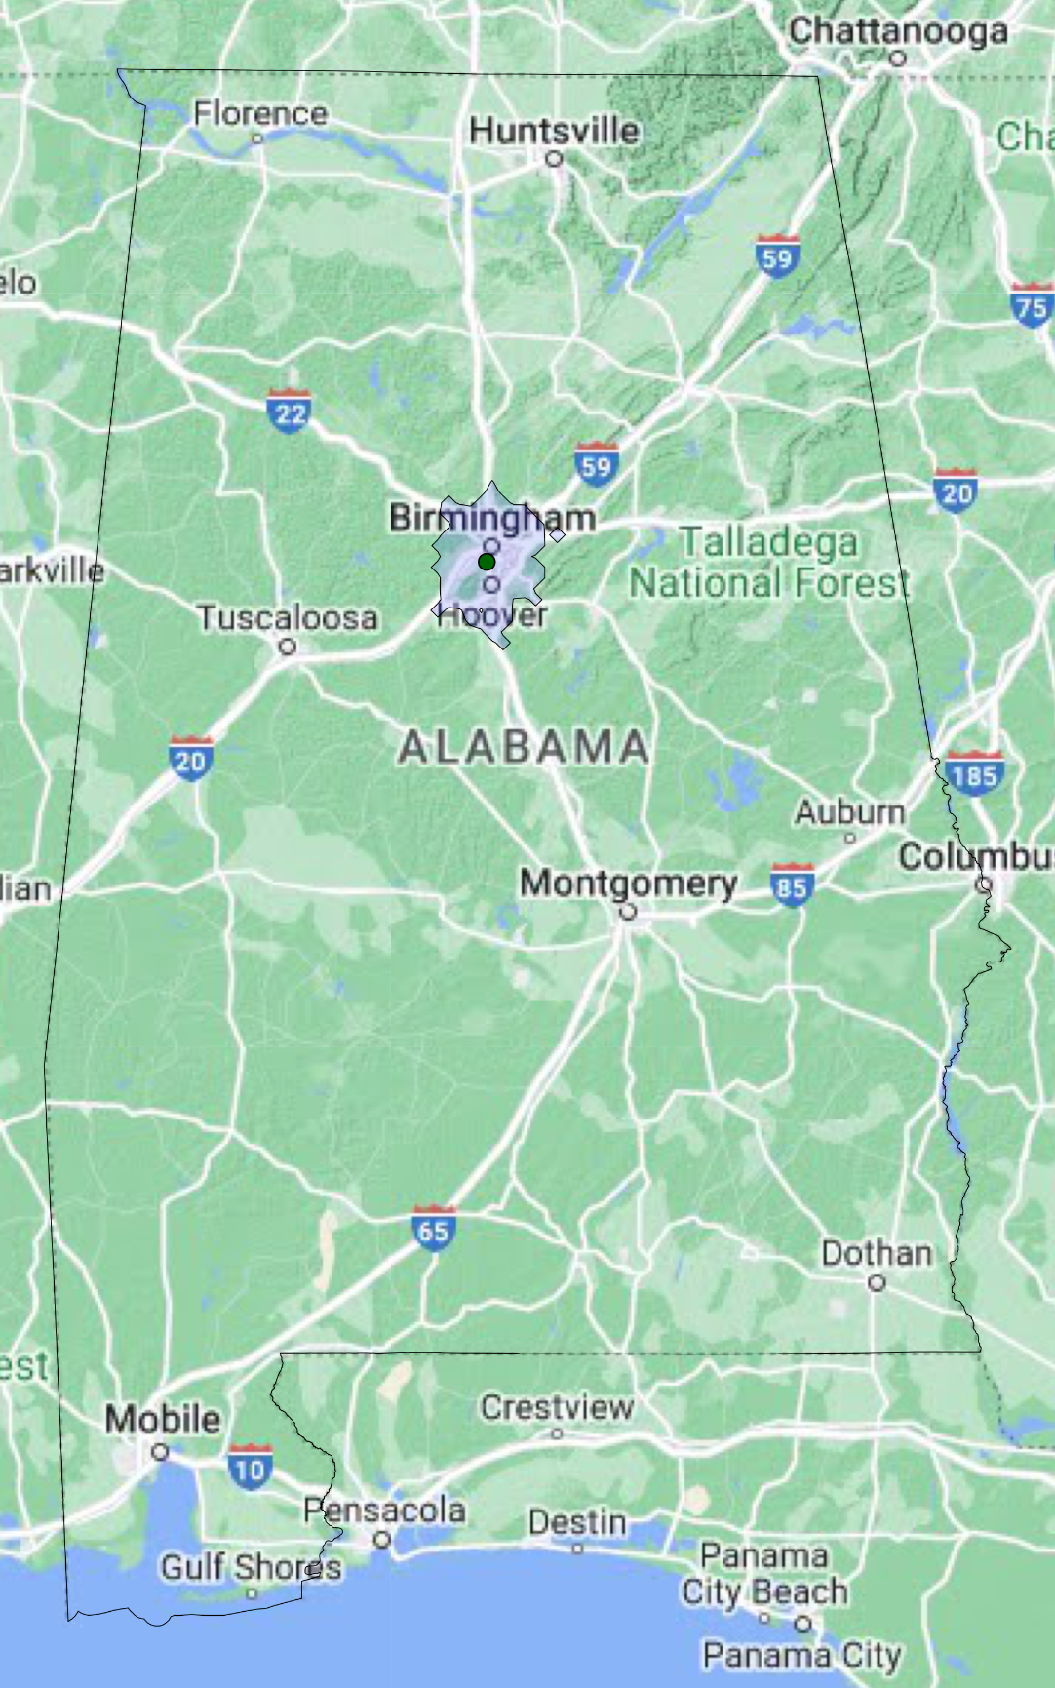
Because the workforce distribution in Alabama will naturally center around cities and locations with broadband construction-related training programs, building networks in the rural parts of the state may require importing construction labor, which will increase the cost of construction due to the expense of transportation and lodging. Training skilled workers across the entire state will therefore be an important strategy to mitigate this problem.

Continuing to support workforce development in Alabama
In the Alabama Statewide Digital Opportunity Plan, ADECA described the economic and workforce deployment goals, plans, and outcomes related to broadband. As part of that work, an obstacle frequently highlighted by partners was the ability to attract and retain a skilled, qualified workforce. Indeed, Alabama’s large BEAD allocation (the seventh highest of any state in the country) means that the amount the workforce needs to grow is substantial. To that end, ADECA endeavors to play an active role in ensuring that the state’s workforce is ready to meet the needs of the BEAD deployment by working to increase the scale of the qualified workforce in the state.
First, ADECA affirms a few strategies employed in the industry and best practices demonstrated by the training providers noted above. These best practices are critical to combating worker shortages, retention challenges, and increasing retirement due to an aging workforce, all of which are present in much of the broadband construction sector.
- Apprenticeships and on-the-job training programs: Apprenticeship models for industries where apprenticeships exist, as well as on-the-job training programs for all industries, provide benefits to both employees and employers. Employers can train people in their systems correctly from the beginning of their career and evaluate employees during introductory periods for the qualities that will set them up for long-term success. Furthermore, employees do not have to pay for separate training before getting a paycheck and can experience the rigors and learning curve of the work in a measured way as they come up to speed in the sector.
- Marketing to all types of prospective workers: The ability to build great networks will be improved with the inclusion of people from all parts of society, including those without significant past representation in the telecom sector. Considering the scale of upcoming deployment work through the BEAD Program, as well as the workforce concerns raised by consulted partners, outreach to all prospective workers is necessary to ensure projects can be completed in a timely and efficient manner. Trade schools, technical colleges, and community colleges have significant experience with outreach to nontraditional students, women, and minorities—and everyone’s participation in growing a qualified telecom sector workforce will be essential to the success of network deployment plans.
- Local hiring: Hiring local workers benefits telecom construction in several ways: It saves money by reducing the travel time and travel expenses (e.g., accommodations) required of laborers; it allows for better recruitment as employees often prefer to stay near their homes; and it ensures the benefits of hiring in labor surplus areas stay in that community. ADECA will encourage local hiring to be prioritized.
- Explicit pathways to advancement: Once a new hire takes the first step into a telecommunications career, their ability to stick with that career and grow in the sector requires well-established pathways to advancement. Establishing great growth pathways can both incentivize people to start in the sector, and ensure they stay to build on their skills and knowledge.
- Coordination between training providers and employers: Ongoing close coordination between training providers and employers is essential to ensure that training providers understand what credentials are meaningful, adapt programs to stay current with the sector’s needs, and collectively evaluate programs’ success and iterate as needed.
- Recruitment strategies tailored to the realities and challenges of the industry: Enticing people into a new sector and new career—especially one as unique as being a telecommunication worker—is difficult, especially when unemployment rates are low. Successful recruitment strategies involve screening for aptitude and ability to learn, marketing opportunities based on the tangible and intangible benefits of the career, and making sure various demographics are represented in marketing materials. However, due to the challenges of the job that can only be understood fully by experience, there will always be significant numbers of people who quit within a few months of employment as a lineworker or installer. Because of this, it is recommended that programs and employers set recruitment targets at double or even triple the number of people needed.
Additionally, given the interest in being more involved in the broadband workforce expressed by partners such as Lit Communities and others, the state will continue to work with and encourage public institutions to develop programs to train the broadband workforce. At the same time, the state encourages the successful training and recruitment programs—such as the fiber optic training programs offered through the Alabama Community College System’s Skills for Success program—to be expanded and continued.
Given the significant gaps in certain critical in-the-field occupations such as electric and telecommunications lineworkers and fiber optic technicians, and the challenges of getting trained workers to the most rural areas of the state where substantial construction will be happening, ADECA encourages training providers to continue to develop explicit pathways for people in the rural parts of the state to take advantage of training programs. Strategies may include increasing marketing and outreach to rural areas, offering more hybrid or fully virtual learning opportunities, or even offering pop-up or temporary training events in rural communities.
Lastly, perhaps the most important workforce role for Alabama is its commitment to ongoing and close coordination with employers and training programs in the broadband sector. Ultimately, the state’s workforce initiatives will be most successful if they are responsive to industry needs. A description of how Alabama intends to stay in close coordination with broadband construction partners is in the next section.

Coordination with workforce partners
Without a robust and highly trained workforce, broadband deployment in Alabama will not happen on time, at cost, or to the high standards that will set the state up for success for decades to come. Employers and worker associations are critical partners both in the deployment of broadband and in the extensive preparation happening across the state to ensure the deployment goes according to plan.
As part of its outreach efforts discussed above in Section 4, ADECA requested input from ISPs, employers, worker groups, educational providers, nonprofits, faith groups, and many representatives of local and state and government regarding workforce issues. A list of the contributors on workforce considerations is included as Appendix C of this Initial Proposal Volume 2.
The feedback of these entities has been instrumental in shaping state plans and understanding the workforce landscape. While many ISPs identified workforce as an “obstacle” in feedback sessions, ADECA also benefited from understanding the many descriptions from employers about the training programs they currently offer, such as Charter’s three-month paid training program, AT&T’s apprenticeship program, and the recruitment efforts of smaller providers in local markets. ADECA appreciated feedback and details about employer plans to retain workers after BEAD deployment for continued expansion, maintenance, repairs, installations, and even wireless deployments in some cases. In addition, important feedback was provided about the need to maintain safety standards through a hiring and deployment process that will require bringing many newer workers into the industry.
ADECA also recognizes the feedback and advocacy provided by the Communications Workers of America (CWA), who noted that “high road” labor standards and practices can ensure safer construction practices and more effective deployment results. In addition, CWA stated that greater use of subcontracted labor may increase the risk of subpar work, as subcontractors often have more of an incentive to rush and are less accountable than the lead contractor. Lastly, CWA articulated that local hiring for broadband construction—and keeping those workers on to do installations and maintenance—is a practice that incentivizes ownership and accountability, and provides long-term benefits to local economies.
ADECA welcomes and plans on participating in ongoing close coordination with worker groups, which is essential for the state to create programs to strengthen the workforce and ensure subgrantee awards can be built and executed according to plan. As such, ADECA will work with previously-identified partners and other parties interested in workforce issues to meet regularly and establish open channels of communication.
Specifically, ADECA seeks ongoing updates from training providers, worker organizations, and firms with workforce needs regarding:
- Recruitment strategies and their effectiveness, including but not limited to the relative efficacy of online postings, job fairs, paid partnerships, and outreach to community and technical colleges
- Progress in training and employing new workers, including training program entrance rates, training program graduation rates, job placement rates, and retention rates after three and six months of employment, or similar data illustrating retention
- Industry trends that may impact training and recruiting needs, including changes in staffing models, technology, certifications, or skillsets required of workers to be effective throughout deployment
- Feedback on state programs, as well as additional ideas the state may consider to improve workforce readiness and reach non-traditional populations

Ensuring strong labor standards
Ensuring strong labor standards throughout the entire BEAD deployment process is important not only for the wellbeing of the vast workforce that will be participating in the process, but it is also important for the long-term integrity of the network. Treating employees well, which includes providing adequate training, ensuring fair compensation and sufficient breaks, and following robust safety protocols, will have numerous benefits to the BEAD effort.
- Worker safety: Worker safety is a primary concern for any construction happening in the state. Many protocols and practices essential to ensuring strong labor standards are paramount to increasing worker safety, such as providing regular and sufficient work breaks, proper training and oversight to new workers, and reasonable working hours and expectations.
- Worker satisfaction and retention: Construction trades are physically difficult and, when a job also requires working at dangerous heights, it is understandable that a portion of workers leave shortly after trying the work. Part of reducing turnover, however, involves implementing sufficient training, safety, pay, and break standards so that the physical challenges are minimized, and new workers become accustomed to the work within a supportive environment.
- Quality, resilient networks: Inordinately rushing construction, or building networks without appropriate oversight or training, will jeopardize the long-term integrity of the networks being built. Strong labor standards will ensure networks are built to the quality and standards expected of this critical infrastructure.
The first step to strong labor standards is recognizing and highlighting the regulations and laws by which subgrantees are bound. Alabama is very familiar with the nature of the following laws and the work needed to ensure compliance:
Table 16: U.S. labor laws noted in the BEAD NOFO
Labor law | Summary
Fair Labor Standards Act | Establishment of minimum wage, overtime pay, recordkeeping, and child labor standards affecting full-time and part-time workers across private and public sectors
Occupational Safety and Health Act | Establishment of safe and healthy workplace standards
Service Contract Act | Establishment of standards for contractors and subcontractors performing services on prime contracts in excess of $2,500
Title VI of the Civil Rights Act of 1964 (see also 15 C.F.R. Part 8) | Prohibition on discrimination on the basis of race, color, or national origin under programs or activities receiving federal financial assistance, including from the Department of Commerce
Title IX of the Education Amendments of 1972 | Prohibition of discrimination on the basis of sex under federally assisted education programs or activities
The Americans with Disabilities Act of 1990 | Prohibition of discrimination on the basis of disability under programs, activities, and services provided or made available by Eligible Entities and local governments or instrumentalities or agencies thereto, as well as public or private entities that provide transportation
Section 504 of the Rehabilitation Act of 1973 | Prohibition of discrimination on the basis of handicap under any program or activity receiving or benefiting from federal assistance
The Age Discrimination Act of 1975 | Prohibition of discrimination on the basis of age in programs or activities receiving federal financial assistance
Parts II and III of Executive Order 11246, Equal Employment Opportunity | Requires that federally assisted construction contracts incorporate and fulfill the nondiscrimination provisions of §§ 202 and 203 of E.O. 11246 and Department of Labor regulations implementing E.O. 11246 (41 C.F.R. § 60-1.4(b))
Executive Order 13166, Improving Access to Services for Persons with Limited English Proficiency | Requires federal agencies to examine the services that they provide, identify any need for services to those with limited English proficiency (LEP), and develop and implement a system to provide those services so LEP persons can have meaningful access to them
Executive Order 13798, Promoting Free Speech and Religious Liberty (see also OMB M-20-09 Guidance Regarding Federal Grants and Executive Order 13798) | States or other public grantees may not condition subawards of federal grant money in a manner that would disadvantage grant applicants based on their religious character

As part of the information that prospective subgrantees will be required to provide in their applications in accordance with Section 8.1 above, ADECA will require applicants to self-certify compliance with the laws and regulations listed in the BEAD NOFO, as well as all applicable state and federal labor laws. In alignment with the BEAD NOFO, ADECA will require:
- Certification from an officer/director-level employee (or equivalent) on past compliance with federal labor and employment laws
- Disclosure of any violations of labor and employment laws in the last three years, or written confirmation of no such violations
- Written description of steps taken to mitigate any violations that occurred in the past three years
- Applicable wage scales and wages and overtime payment practices for each class of employee that will be directly involved in the physical construction of the broadband network
- Plans for the implementation of workforce safety committees that will be authorized to raise any health and safety concerns in connection with the delivery of deployment projects
Self-certification is a common practice that firms are accustomed to complying with and will take place during the subgrantee application process. ADECA will require subgrantee applicants to certify compliance with state workforce and labor laws as well, should state regulations exceed or expand on guidance in the BEAD NOFO.
As with potential labor law infractions in other industries, ADECA makes it known that potential infractions may be reported to the Alabama Department of Labor. Reported infractions will be investigated under the existing protocols established by the state, and the individuals or entities filing reports will be covered under state whistleblower policies, as applicable to the situation and law.
To further ensure self-certification results in appropriate adherence to labor laws, ADECA will follow best practices for evaluation upon indications of noncompliance. Specifically, auditors or compliance workers employed by the state may request and scrutinize business records of subgrantee firms and impose fines should noncompliance be discovered.
Lastly, in alignment with the BEAD NOFO, ADECA encourages workers to create worker-led health and safety committees who can then meet with employer management upon request to raise concerns about labor laws and ensure compliance with occupational safety and health requirements.

Ensuring recruitment of qualified, diverse firms
Not only does the recruitment of qualified, diverse firms as part of the BEAD deployment demonstrate a fair and unbiased process, the scale of the work that needs to be done is so profound that excluding any qualified firms could jeopardize the efficient completion of the work that needs to be done.
ADECA encourages businesses owned by women, ethnic minorities, and veterans to prepare to engage in the BEAD process. This includes firms that directly engage in telecommunications activities, such as telecom construction contractors, lineworkers and installers, and ISPs; however, the deployment process will also require significant participation from firms and businesses not traditionally associated with telecommunications. For example, the deployment process also requires construction of all types, electricians, road flagging crews, tree-trimmers, accountants, and more. ADECA expects firms that supply these services will frequently be brought on as subcontractors or partners to BEAD applicants, and ensuring recruitment of qualified, diverse firms is essential for these types of businesses as well.
To further encourage diverse participation in the BEAD-related workforce, the state will take the following additional actions:
- Collaborate with the Alabama Minority Business Development Agency Business Center, Alabama Minority Business Enterprise Center, Alabama Office of Minority Affairs, Alabama Small Business Development Center, Alabama State Black Chamber of Commerce Network, Alabama VetStart, Office of Minority Business Enterprise, REACH Women’s Business Center (serving Central Alabama), Veterans Business Outreach Center at Mississippi State University (serving Louisiana, Mississippi, and Alabama), Women’s Business Center of North Alabama, Women’s Business Center of Southern Alabama, and other partners to ensure that minority, veteran, and/or women business enterprises are on all relevant solicitation lists.
- Assemble, maintain, and share a list of veteran, minority, and/or women business enterprises that have expressed interest in participation in BEAD deployments and promote the list to help make connections to the broader telecommunications business community.
- Ensure recruitment efforts by training providers and help employers target diverse communities by being a conduit between those entities and groups whose goals include encouraging diverse workforce participation, such as job and career centers in communities with higher populations of people of color, HBCUs, nonprofit and faith groups, and others who have a focus on economic empowerment and promoting inclusive economies.
To affirm its commitment to diverse firms and job availability to diverse worker pools, ADECA intends to allow applicants to voluntarily disclose in their application if they or any of their partners or subcontractors qualify as a veteran-owned, women-owned, or minority-owned businesses.
Lastly, state and local economies and tax bases benefit the most when firms from Labor Surplus Areas are engaged, particularly when they fill staff openings locally. In Alabama, those areas are designated by the U.S. Department of Labor as:
- Dallas County
- Lowndes County
- Perry County
- Prichard, Mobile County
- Selma, Dallas County
- Wilcox County
More information regarding ADECA’s proposed approach for inclusion of minority business enterprises, women’s business enterprises, and labor surplus area firms in BEAD projects can be found below in Section 10.

Subgrantee selection process related to workforce considerations
Section 8.2 above discusses in detail the binding legal commitments ADECA will require BEAD subgrantees to make related to labor standards and protections, which include commitments related to workforce readiness. ADECA will take the following approach to the subgrantee selection process to ensure an appropriately skilled and credentialed workforce:
- Require disclosure of any workforce violations within the past three years. If violations exist, require documentation of how the applicant has updated their policies and practices to ensure compliance moving forward.
- Require documentation of whether subgrantees, their partners, and contractors qualify as a minority-owned enterprises, women-owned enterprises, or labor surplus area firms. ADECA may use answers to these questions as a tiebreaker in the event that multiple equally-qualified and equally-scoring applications for the same area are received.
- Require a written description or affirmation of subgrantee policies or practices for any of the following items:
  - Using a directly-employed workforce, as opposed to a subcontracted workforce
  - Use of local hire provisions
  - Steps taken to prevent the misclassification of workers
- Require applicants to describe their usage of on-the-job training, internship, or apprenticeship programs, as well as credentials they confer upon program completion. This can not only lead to better retention of staff but allows pathways for workers with a wide range of educational backgrounds to participate.
- Require applicants to describe the actions they take specific to recruiting a diverse workforce and/or future plans to do more outreach to diverse groups. This answer may include a description of specific outreach or materials intended to be welcoming to women, people of color, or other groups not typically represented in most telecommunications construction workforces.
- Require that subgrantees state whether they offer Davis-Bacon prevailing wages.
Please see Section 5 above for a full description of the proposed broadband deployment subgrantee selection process.

Ensuring long-term economic impact from BEAD deployments
Alabama’s economy is undoubtedly going to benefit from the broadband expansion that will occur over the next few years. Some benefits will happen ambiently simply due to increased spending in the economy during construction, or the increase in home values that occur with the presence of fiber infrastructure. However, the major long-term impacts to the economy will occur if more broadband adoption happens because of these deployments and if broadband users across the state use their connectivity to access efficient services, move businesses online, leverage new technologies, access remote learning and working opportunities, use telehealth when appropriate, and more.
As noted in the Five-Year Action Plan, Alabama has previously estimated significant impact to jobs and household earnings with the deployment of high-speed internet and increased adoption across the state. This section elaborates on that work to describe how BEAD deployments will help Alabama’s economy in the short- and long-term.

Short-term economic impact from initial construction outlay
Input-output models are industry-standard tools that use advanced data modeling to estimate how money and workforce flow through the economy and between industries; in this case, the model shows how the sector contributes significant direct, indirect, and induced benefits to the state’s economy. The initial broadband construction spending leads to a direct effect that results from the increased demand for goods and services in the broadband construction supply chain (for example, the increased demand for conduit, fiber, and network electronics). The indirect effect results from the increased demand for goods and services that the broadband supply chain uses (for example, the increased demand for the materials and equipment that contribute to the manufacture of conduit and fiber, or the transportation needed to deliver said goods). As the initial, direct, and indirect effects increase earnings for workers, these workers spend their earnings on various goods and services (for example, at grocery stores, restaurants, and clothing stores), which is represented by the induced effect.
The tables below outline the total estimated benefits from a $1.68 billion investment and a $1.9 billion investment in broadband in Alabama. Sales are the industry’s total annual gross receipts for products and services. A job is any position in which a worker provides labor in exchange for monetary compensation. Earnings include wages, salaries, supplements (additional employee benefits), and proprietor income.
Table 17: Estimated economic effects of investing $1.68 billion in broadband construction
Effect | Sales | Jobs | Earnings
Initial | $1,681,466,281 | 4,135 | $391,768,731
Direct | $327,581,294 | 2,076 | $118,511,335
Indirect | $95,924,167 | 705 | $36,145,148
Induced | $549,590,505 | 4,232 | $215,757,666
Total | $2,654,562,246 | 11,148 | $762,182,881
Table 18: Estimated economic effects of investing $1.9 billion in broadband construction
Effect | Sales | Jobs | Earnings
Initial | $1,911,746,281 | 4,702 | $445,422,203
Direct | $372,444,174 | 2,360 | $134,741,688
Indirect | $109,061,163 | 801 | $41,095,295
Induced | $624,857,968 | 4,812 | $245,306,088
Total | $3,018,109,586 | 12,675 | $866,565,274

Long-term objectives for enhancing economic growth and job creation
While the economic benefits from construction spending are considerable, and some economic benefits (like an increase in home values) can be expected just from the presence of fiber on a street, the long-term benefits to Alabama’s economy will be fully realized as a result of increased utilization of the internet. In other words, building better networks is good, but encouraging as much adoption as possible is necessary to maximize the long-term economic benefits.
Importantly, increased high-speed broadband usage and adoption will greatly benefit the state’s existing economic development priorities and plans. Specifically, the BEAD Program will allow the state to:
- Empower workforce advancement and economic growth in unserved and underserved communities and population groups through broadband expansion projects
- Reduce obstacles to digital connectivity and foster an environment conducive to economic growth, academic achievement, and improved healthcare outcomes
- Support programs that alleviate barriers to digital connectivity, enabling economic empowerment, promoting academic success, and enhancing community health
Additionally, Alabama’s significant existing economic output and emphasis on industrial and manufacturing recruitment will receive a further boost with ubiquitous high-speed broadband. Not only is high-speed broadband necessary for the significant technology, robotics, software, and AI that is essential for industrial manufacturing—one of the major benefits of broadband when it comes to large employers is the quality of life that it brings to employees. Especially when it comes to recruiting technologists, knowledge workers, specialists, and skilled occupations, being able to tout widespread availability of high-speed broadband to the home is a major selling point. Excellent broadband at home also allows for greater hybrid work configurations and access to virtual training opportunities, which is beneficial to employers and employees alike.
In summary, as Alabama deploys broadband across the state under the Internet for All mandate, truly maximizing the economic impact of that broadband will require two primary strategies. First, it requires working hard to increase broadband adoption, both in areas of new builds as well as areas of existing broadband, so that as many people as possible can take advantage of the opportunities that great broadband affords. Second, it requires the state continuing down the path of pursuing economic development strategies that leverage the unique ability for high-speed broadband to provide Alabama businesses better access to talent and technology, and allow Alabama’s existing and prospective employers to recruit, train, and retain workers.

Minority Business Enterprises (MBEs) / Women’s Business Enterprises (WBEs) / Labor Surplus Area (LSA) firms inclusion (Requirement 13)
This section documents the process, strategy, and data tracking methods that ADECA will implement to ensure that MBEs, WBEs, and LSA firms are recruited, used, and retained when possible for BEAD-related activities, consistent with applicable federal/state law, 2 C.F.R. Part 200, and the BEAD NOFO.
The State of Alabama, through ADECA’s Office of Minority Business Enterprise (OMBE) and the Alabama Department of Transportation (ALDOT), offers certification processes for MBEs and WBEs, thus facilitating real-time business opportunities. ADECA facilitates the certification and connection of MBEs and WBEs with opportunities through various programs. MBE certification by ADECA signifies that a business is at least 51 percent owned and operated by one or more minorities and, similarly, WBE certification by ADECA requires a woman or women to have majority ownership and control of the business entity. The Alabama Office of Minority Affairs (AOMA) also plays a pivotal role in ensuring that minority and women business owners have direct communication lines for assistance in doing business within the state.

Process, strategy, and data tracking methods to ensure that minority businesses, women-owned business enterprises, and labor surplus area firms are recruited, used, and retained when possible

ADECA is committed to promoting diversity and inclusion by encouraging the recruitment, utilization, and retention of MBEs, WBEs, and LSA firms when possible. The Alabama Department of Finance’s Purchasing Division maintains a portal where MBEs/WBEs can register to receive bid solicitations. Registered businesses are then tracked by OMBE, where a comprehensive database of MBEs/WBEs and LSA firms is maintained.
The U.S. Secretary of Labor is required to annually designate LSAs and disseminate this information for the use of all federal agencies in directing procurement activities and in locating new plants or facilities. States may direct federal funding to designated LSAs where there is high unemployment. Employers located in those areas can be given preference in bidding on federal procurement contracts. An area must have an unemployment rate at least 20 percent above the national rate (including Puerto Rico) during the previous two calendar years to qualify as an LSA. The U.S. Department of Labor identifies six cities and counties in Alabama as LSAs in its 2024 update. The LSAs include the following, with the associated number of businesses, according to U.S. Census Bureau data: Dallas County (675 businesses), Lowndes County (112 businesses), Perry County (106 businesses), Wilcox County (180 businesses), the City of Prichard (224 businesses as of 2017) in Mobile County, and the City of Selma (452 businesses as of 2017) in Dallas County. The total number of LSA firms is approximately 1,297 (assuming that all City of Selma businesses are included in the total for Dallas County).

Place qualified small and minority businesses and women’s business enterprises on solicitation lists
ADECA’s efforts will encompass placing qualified small, minority, and women’s business enterprises on solicitation lists for ADECA-funded solicitations, ensuring they are solicited whenever they are potential sources. Additionally, ADECA will work in conjunction with the U.S. Department of Commerce, AOMA, and ALDOT to deliver regional MBE/WBE business development events and outreach, including training sessions, webinars, mentorship opportunities, and programs aimed at connecting MBEs/WBEs with Alabama state agencies, authorities, and local contracting opportunities.

Assure that small and minority businesses and women’s business enterprises are solicited whenever they are potential sources
ADECA, with the support of AOMA, will work closely with subgrantees to maximize the utilization of qualified MBEs, WBEs, and LSA firms by providing training and opportunities to connect with these certified enterprises. Presently, AOMA coordinates with other state agencies to ensure support is provided for MBEs/WBEs. AOMA is dedicated to raising the voices of these communities, aiding and connecting MBEs/WBEs with opportunities provided by the state.

Divide total requirements, when economically feasible, into smaller tasks or quantities to permit maximum participation by small and minority businesses and women’s business enterprises
By dividing total requirements into smaller tasks or quantities and establishing delivery schedules conducive to participation by small and minority businesses and women’s business enterprises, ADECA aims to promote a more inclusive economic environment in Alabama. Through these efforts, ADECA will maximize participation by small and state-certified minority-owned as well as women’s business enterprises.

Establish delivery schedules, where the requirements permit, which encourage participation by small and minority businesses and women’s business enterprises
Where requirements permit, ADECA will establish delivery schedules to encourage participation by small and minority businesses and women’s business enterprises. ADECA will also seek to be flexible with its requirements to enable greater MBE/WBE engagement.

Use the services and assistance, as appropriate, of such organizations as the Small Business Administration, the Minority Business Development Agency of the Department of Commerce, and ADECA
Through partnerships with organizations such as the Small Business Administration (SBA) and the Minority Business Development Agency (MBDA), ADECA will facilitate the provision of necessary resources and support to these enterprises, thus fostering a thriving and diverse business community in Alabama. The State of Alabama, in close cooperation with the MBDA, operates an MBDA Business Center in Birmingham. Additionally, Alabama provides entrepreneurial programs and business coaching to MBE organizations through The Dannon Project, a recognized MBDA program. ADECA’s OMBE works closely with the Office of Small Business Advocacy of Alabama, part of the Alabama Department of Commerce. ADECA also will work with the Alabama district of the SBA, which offers small business loans and provides online links to relevant resources.

Require each subgrantee to take these affirmative steps as they relate to its subcontractors
As part of the BEAD subgrant agreement, ADECA will require subgrantees to comply with all applicable laws related to contracting with small businesses, MBEs, WBEs, and LSA firms, including but not limited to the requirements set forth in 2 C.F.R. § 200.321. ADECA will work with subgrantees to ensure that they take the necessary affirmative steps to use qualified MBEs, WBEs, and LSA firms whenever possible. This concerted effort will not only contribute to the economic growth of Alabama but also build a more equitable and inclusive business landscape in the state. ADECA may take steps that include, but are not limited to:
- Providing subgrantees with training and opportunities to connect with qualified MBEs, WBEs, and LSA firms
- Demonstrating diversity in suppliers and equitable procurement practices
- Requesting formal assurance from subgrantee confirming organizational commitment to supplier diversity, equity, and inclusion
- Reporting requirements regarding supplier diversity

Certification
ADECA certifies that it will take all necessary affirmative steps to ensure MBEs, WBEs, and LSA firms are used when possible, including the following actions outlined in the BEAD NOFO:
R Placing qualified small and minority businesses and women’s business enterprises on solicitation lists
R Assuring that small and minority businesses and women’s business enterprises are solicited whenever they are potential sources
R Dividing total requirements, when economically feasible, into smaller tasks or quantities to permit maximum participation by small and minority businesses and women’s business enterprises
R Establishing delivery schedules, where the requirement permits, which encourage participation by small and minority businesses and women’s business enterprises
R Using the services and assistance, as appropriate, of such organizations as the Small Business Administration and the Minority Business Development Agency of the Department of Commerce
R Requiring subgrantees to take the affirmative steps listed above as they relate to subcontractors

Cost and barrier reduction (Requirement 14)
This section documents the steps ADECA proposes to take to reduce costs and barriers to deployment through promoting the use of existing infrastructure, dig-once policies, streamlined permitting processes, and cost-effective access to poles, conduits, easements, and rights-of-way, including reasonable access requirements. This section also includes proposed steps to reduce costs associated with construction, labor, overhead, and materials, which ADECA identified as additional barriers to broadband deployment.
ADECA recognizes the importance of efforts to streamline access to assets for placement of equipment, including state and local permitting and pole attachment rates, in such a way as to protect the state’s interests while also ensuring effective and efficient broadband construction permitting. Feedback from outreach and engagement sessions noted that more work needs to be done to support broader access to poles, rights-of-way, and other assets to support new infrastructure builds. However, Alabama has created a structure and environment to support infrastructure access to these critical elements.
Through an extensive review of sources of increased deployment costs and barriers for deployment, ADECA has identified the following proposed strategies for mitigating cost and barrier risks.

Promote the use of existing infrastructure

Streamline access to state conduits, poles, and rights-of-way
ADECA is in discussions with ALDOT to further streamline access to conduits, poles, and rights-of-way on state roads. According to a 2023 study of state departments of transportation compensation structures for accommodating utility and communication installations in public rights-of-way conducted by the National Cooperative Highway Research Program, ALDOT takes a non-revenue generating approach to right-of-way utility accommodations and does not receive compensation (i.e., through charging a one-time permit fee or annual fee, resource sharing, etc.)
ALDOT maintains a list of regional road projects and ADECA may consider those that are suitable for fiber construction throughout the BEAD deployment process. Currently, ADECA requires applicants to consider ALDOT projects when developing broadband expansion projects using funds administered by ADECA.
To support reasonable pole attachment rates for electric utility and incumbent telephone company poles, Alabama has remained under the FCC’s pole attachment rate caps and framework. Additionally, while the Alabama Legislature has given certain electric utilities the authority to offer broadband services, it has also adopted regulations for access to poles owned by these entities that support competitive access by other broadband providers. Other electric providers, as members of the Tennessee Valley Authority (TVA), also have regulations that support competitive pole access.
In addition, the Alabama Legislature passed legislation in 2021 that established procedures to authorize wireless providers to collocate, mount, or install small wireless facilities on existing poles or install new poles on the right-of-way of the state or any state agency, county, or municipality. The legislation also exempted small wireless facilities from certain zoning review and approval procedures and established rates and fees for all permits for small wireless facilities.
ADECA will continue to promote streamlined access to state conduits, poles, and rights-of-way as it implements the BEAD Program.

Encourage local communities to leverage their poles and conduits
Some cities in Alabama have adopted ordinances or other laws to facilitate the deployment of broadband infrastructure in their jurisdictions. ADECA will encourage municipalities that own poles or conduits to make them available and will provide examples of local ordinances or policies as models. These localities can indicate availability of such streamlined access and ADECA will publish this information for eligible areas so grant participants can take it into consideration for their cost proposals. ADECA anticipates providing technical assistance to help local communities navigate issues related to right-of-way and pole access for broadband deployment and can potentially convene partners to resolve questions, if needed.

Allow access to limited access rights-of-way for last-mile broadband providers providing service to unserved locations
ADECA will explore ways it can facilitate subgrantees gaining access to limited-access rights-of-way through streamlined public interest and resource-sharing arrangements. There may be opportunities for ALDOT to allow fiber installations in limited-access state and interstate highways. If delivering broadband to unserved locations is defined as public interest construction, it could potentially facilitate resource-sharing arrangements that could be standardized to reduce permit timelines and costs.

Facilitate applicant access to mapping data
ADECA will facilitate prospective BEAD applicant access to mapping data, including but not limited to the data provided on the Alabama Broadband Map, as well as other information resources to help identify known public and private broadband assets. Such information will be made available to all prospective BEAD applicants, allowing for early planning and budgeting before applications are filed. Access to such information will allow applicants to submit more cost effective, accurate, and informed project applications.
Additional information regarding broadband deployment assets in Alabama can be found in Section 3.3.1 of the Five-Year Action Plan.

Promote dig-once policies by providing best practice guide for localities
ADECA will encourage sharing of open trenches and available conduit via the promotion of dig-once policies, which ensure proper notification has been made before rights-of-way are open with the goal of facilitating collaborative (and concurrent) construction timelines between entities hoping to dig in the same rights-of-way. ADECA plans to publish best practices and guides for localities to consider implementing policies and model local codes that will minimize the number of times rights-of-way will be dug into, allowing even the smallest funded projects to leverage economies of scale to reduce costs.
This approach is in alignment with guidance from the U.S. Department of Transportation’s Federal Highway Administration (FHWA) Office of Transportation Policy Studies, which notes in a policy brief that “the largest cost element for deploying broadband is burying fiber optic cables and conduit underground,” citing the FCC. In the brief, FHWA emphasizes the importance of implementing dig-once policies at the local level, as permits to install or work on existing facilities are often requested from cities and counties.

Streamline permitting processes

Optimize local permitting processes

Establish best practices for county and local permitting
ADECA will publish best practices in broadband permitting policies for counties and localities to consider. These best practices will make recommendations on how localities can best optimize their permitting for broadband deployment, develop and share relevant information regarding their permitting policies, create conditions that make private investment more attractive, develop strategies to increase staffing and administrative support, and publish information on known assets of interest.

Facilitate collaboration with key Department of Transportation and environmental and historic preservation agencies
ADECA will also incorporate best practices for consultation with transportation, environmental, and historic preservation agencies into its educational outreach to counties and localities. These agencies will receive permit requests and materials within a condensed period of time. ADECA can discuss creating standardized templates to simplify the materials required for environmental assessments and other agency reviews, and allowing the same materials to be provided to different agencies where feasible. While ADECA will include federal agencies in its discussions, it highly encourages NTIA as the primary federal agency in charge of BEAD funds to enter into programmatic agreements with such agencies.

Streamline state permitting processes by developing fast-track permit and pre-approved construction methods
In order to increase the feasibility of awarded projects that intend to cross state-protected lands, ADECA will discuss streamlining permitting processes with relevant land-controlling state agencies. These efforts may include developing fast-track permitting policies for construction methods that are known to have low impacts on the surrounding rights-of-way. Additionally, ADECA plans to identify and publish easement corridors and construction methods likely to receive rapid reviews for applicable protected lands, so that potential projects that need to cross land without available roads or rights-of-way may plan their construction to be minimally invasive and maximally cost effective.

Shrink federal permitting timelines by partnering with NTIA to discuss a streamlined “shot clock” permit process
To benefit potential awardees that intend to cross federal lands in Alabama, ADECA will attempt to shrink permitting timelines for access to federal lands by partnering with NTIA to discuss process reforms that might be implemented with key federal land-controlling agencies and exceptions that might be granted to BEAD Program awardees. As the lead federal agency, NTIA can also develop programmatic agreements with agencies to facilitate such permitting. One approach could include a “shot clock” permitting process on certain federal land use permits that would incentivize federal agencies to process BEAD permitting applications within a predetermined, finite, and reasonable amount of time.

Reduce construction costs

Encourage specialized equipment sharing
Installing underground fiber often involves the use of specialized equipment and associated costs. Smaller ISPs in particular may struggle with the high cost and access to specialized equipment needed to drill into hard rock when installing underground fiber. ADECA will encourage providers to enter into resource-sharing agreements as a way to reduce costs and risks.

Facilitate construction to and within buildings
To help reduce costs for providers to serve multiple dwelling units (MDUs) and multi-tenant commercial buildings, ADECA will promote as a best practice that localities encourage developers to create a cable pathway to their building and install standards-compliant in-building cabling or cable pathways.
While the cost for a provider to install conduit from the public right-of-way to a building can be high, a developer may add conduit for fiber optic cable in the same trench when they install conduit for other utilities during construction or renovation at a much lower incremental cost. This pathway typically runs from the facility’s utility room to the property line. If an ISP can use existing conduit, they may also avoid delays associated with constructing a new route, including permitting, engineering, and coordination with the building owner.
Providers can also incur high costs installing the cabling within an apartment or office building to serve individual customers. Municipalities can help mitigate this expense by encouraging developers to install standardized cabling or cable pathways during new construction or renovations.

Reduce drop costs
Drop costs, especially in rural areas where houses are often set back far from the public road, can be very high. Since applicants are required to absorb such costs to connect subscribers under the BEAD Program, they will factor these costs into cost proposals. Prospects for lowering such costs could lead to lower BEAD outlay requests and therefore more unserved and underserved locations that can be connected with Priority Broadband Projects. ADECA will consult with pole owners to determine if they are amenable to making pole locations publicly available for design and cost estimation purposes. If pole owners agree in certain areas, ADECA will offer to disseminate this information to participants in the Prequalification Phase. ADECA will also convene with incumbent local exchange carriers (ILECs) and competitive local exchange carriers (CLECs) to assess the feasibility of using existing copper telephone wires on utility poles to overlash drop fiber cables. ADECA will also convene with electric utilities to assess the feasibility of using existing messenger wires that support low-voltage power to lash drop fiber cables.

Reduce labor costs

Strike a balance between skilled and certified labor requirements and the cost of labor
Extending Priority Broadband Projects to the maximum number of unserved and underserved locations requires lowering barriers to entry and the cost of construction, which includes labor costs. At the same time, ADECA is committed to fair labor standards and wages that reflect the skills and certifications of workers.
Accordingly, ADECA will require certifications appropriate to specific risks and roles, rather than overly broad professional requirements that would require specialized labor for low-skill tasks. ADECA will apply standards consistent with previous broadband initiatives and best practices provided by industry organizations. In addition, when engineering documentation requiring a Professional Engineer certification is a condition of grant participation, ADECA will accept Professional Engineer certifications from other states beside Alabama.

Increase supply of labor through workforce development initiatives
ADECA’s workforce development plan is outlined above in Section 9.

Reduce overhead costs

Adopt reasonable, compliance-focused regulatory and reporting requirements
ADECA will attempt to reduce the overhead costs of construction and network operation by striking an appropriate balance in its regulatory and reporting policies. ADECA will keep the interval of required reporting reasonable, subject to the requirements of the BEAD NOFO, and publish clear and concise reporting workflows so awardees can focus resources and efforts on construction, and leverage existing reporting templates for state grants, RDOF, or ReConnect where appropriate.

Create fast-track screening for environmental compliance
ADECA will consider adopting a fast-track screening for environmental safety evaluations in accordance with NTIA guidance to simplify and help awardees navigate the environmental and historic preservation review process.

Create an ISP technical assistance team
ADECA will create an ISP technical assistance team for the BEAD Program comprised of its subject matter experts and consultants to share guidance and information regarding compliance reporting with awardees.

Reduce materials costs

Identify approved vendors compliant with BABA and negotiate discount rates
ADECA will encourage collaboration among BEAD awardees to identify and share information about vendors that are compliant with BABA requirements and, where applicable, negotiating discounted rates for BEAD awardees.

Encourage awardees to form joint purchase coalitions and joint purchase agreements
ADECA will encourage the creation of joint purchasing coalitions and joint purchasing agreements among BEAD awardees to provide them with additional leverage through which they may negotiate lower materials costs.

Climate assessment (Requirement 15)
This section accounts for and provides an assessment of current and future weather and climate-related risks to new broadband infrastructure in Alabama. These risks include, but are not limited to, wildfires, extreme heat, inland and coastal flooding, and the extreme winds produced by thunderstorms, tornadoes, and hurricanes. ADECA recognizes the importance of building climate-resilient broadband infrastructure.
Relatively mild winters, hot summers, and year-round precipitation characterize Alabama’s agriculture-friendly climate, according to the 2022 State Climate Summary for Alabama published by the National Oceanographic and Atmospheric Administration (NOAA) and the Cooperative Institute for Satellite Earth System Studies (CISESS). Tornadoes and hurricanes are two of the major weather hazards in Alabama. Between 1895 and 2019, an estimated 43 tornadoes, typically occurring in the spring and fall, touched down in Alabama each year.
The future-proof broadband networks made possible by the BEAD Program will deliver more resilient networks. As a functional matter, fiber networks will also enable faster disaster recovery, improving the safety of Alabama residents. During the outreach efforts conducted for the BEAD and Digital Equity Act programs, Alabama residents told ADECA they believe that an important benefit of superior broadband networks would be better disaster recovery.
In Alabama, the Alabama Emergency Management Agency (EMA) takes the lead in disaster mitigation. In accordance with the Disaster Mitigation Act of 2000, the State of Alabama has routinely published a State Hazard Mitigation Plan (SHMP), most recently in 2018. EMA also publishes an Emergency Operations Plan (EOP), last updated in 2023. ADECA reviewed both the SHMP and EOP in the development of its climate assessment.

Identifying geographic areas subject to an initial hazard screening
The SHMP will be the main source of information for evaluating and locating high risk areas. This analysis will also use the work conducted by FEMA’s National Risk Index (NRI) team to identify the hazards likely to impact residents of Alabama. It will employ the FEMA classification scheme, assessing each county’s risks relative to other counties around the nation, and ranking each county’s risks as Very Low (0-20th percentile), Relatively Low (20th-40th percentile), Relatively Moderate (40th-60th percentile), Relatively High (60th-80th percentile), or Very High (80th-100th percentile).
In addition to statewide planning, many permitting requirements and construction standards will govern the construction of BEAD-funded networks. These requirements will be subject to local ordinances. The state has taken steps to ensure local policymakers are taking the latest climate projection data into account as they set their standards and requirements. To this end, the state has prepared numerous resources to support local policymakers to help increase the resilience and adaptability of their jurisdictions, including publishing helpful documents and resources for localities to prepare their own community sustainability plans and climate vulnerability assessment and action plans.
As shown in the map below, FEMA ranks three Alabama counties as being at Relatively High risk overall for natural hazards: Baldwin, Jefferson, and Mobile.
Figure 4: Composite county hazard risk scores in Alabama
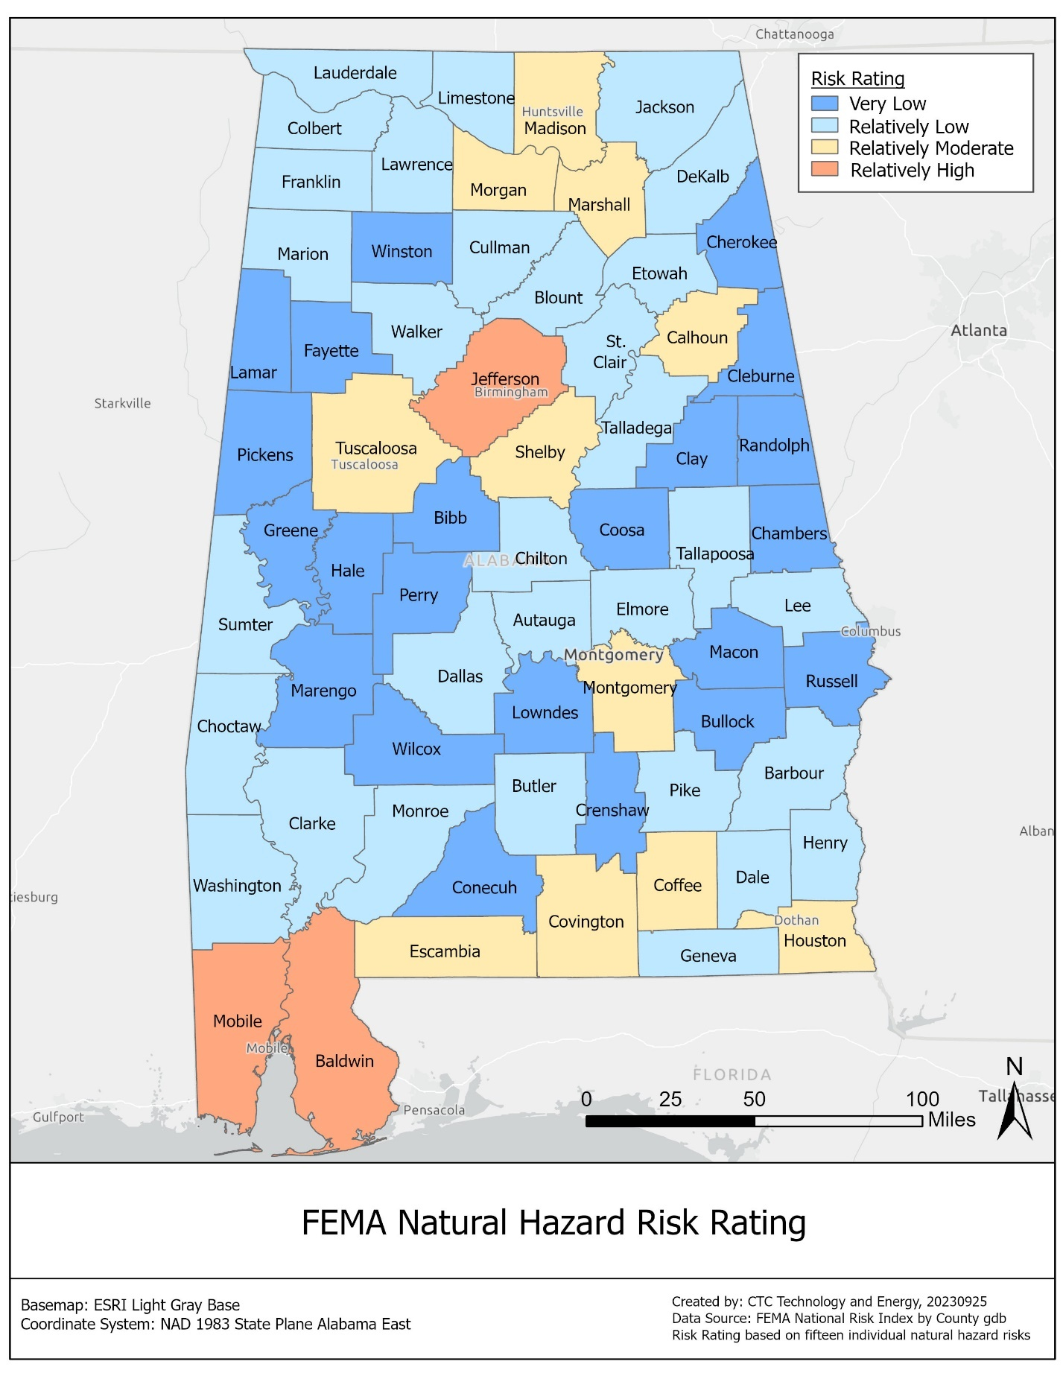

Most important weather and climate hazards to account for and respond to in areas susceptible to climate-related risks
The SHMP identified the following risks as relevant to Alabama:
- Dam failures
- Drought
- Earthquakes
- Extreme temperatures
- Flooding
- Hail
- High winds
- Landslides
- Lightning
- Sea level rise and coastal land change
- Sinkholes and land subsidence
- Wildfires
- Winter storms
In order to prioritize these risks, the SHMP evaluated each risk according to the following five criteria: probability, impact, spatial extent, warning time, and duration. The result was a composite risk factor by which hazards were deemed high risk, medium risk, or low risk.
The SHMP categorized the following hazards as high risk, in descending order of risk:
- Flooding
- High winds
- Sea level rise
The SHMP categorized the following hazards as medium risk, in descending order of risk:
- Winter storms
- Wildfires
- Extreme temperatures
- Drought
- Landslides
- Sinkholes and subsidence
- Lightning
- Earthquakes
The SHMP categorized the following as low risk, in descending order of risk:
- Hail
- Dam failures
As shown below, even low-risk hazards can pose a danger to human life and infrastructure. The text below is adapted from the SHMP. Where FEMA nomenclature differs, FEMA definitions are cited in the relevant section.

Dam failures
The SHMP categorizes dam failures as low-risk but notes that, when they happen, there is rarely any advance warning. The State of Alabama has more than 132,000 miles of river and stream channels and more than 4,800 large dams (defined as dams with a capacity greater than 50 acre-feet or a height greater than 25 feet) that support irrigation, electrical generation, flood control, navigation, and/or recreation.
The most common cause of dam failure is flooding due to heavy rains. As the frequency of heavy rains increases, the incidence of dam failure in Alabama may increase, but the hazard is not readily predictable.

Drought
The SHMP categorizes drought as a medium-priority hazard that tends to cover a large geographic area and can have a long duration.
Drought, which is a normal part of nearly all climates, is a water shortage originating from a deficiency in expected precipitation caused by unusual weather patterns. If these weather patterns persist for several months to several years, the drought is considered to be long-term; a short-term drought may last several weeks to a few months.
The U.S. Drought Monitor, a partnership between the National Drought Mitigation Center at the University of Nebraska-Lincoln, the United States Department of Agriculture, and NOAA, regularly updates drought maps of the United States. The Alabama map shows that counties in the southwestern area of the state are experiencing the most severe drought conditions.
When a drought does occur in Alabama, the social, economic, and environmental impacts have the potential to be severe and widespread. Damage to infrastructure includes increased energy prices due to the loss of hydropower.
In recognition of the potential widespread impacts of drought and to ensure consistent communication of drought conditions and impacts, ADECA’s Office of Water Resources (OWR) regularly updates the Alabama Drought Management Plan (DMP), most recently in 2018. OWR also assists local entities in preparing local drought management plans.

Earthquakes
The SHMP categorizes earthquakes as a medium-priority risk because of their low likelihood of occurrence balanced by their large impact and minimal, if any, advance warning time. It is important to emphasize that earthquakes are low-probability, high-consequence events.
Earthquakes are the sudden, rapid shaking of the earth, caused by the breaking and shifting of underground rock. Earthquakes felt in Alabama are associated with four seismic zones: the Southern Appalachian Seismic Zone, the Bahamas Fracture Seismic Zone, the South Carolina Seismic Zone, and the New Madrid Seismic Zone. Earthquakes centered in Alabama are not the only earthquakes with the potential to impact the state. Intraplate earthquakes associated with the New Madrid Seismic Zone to the northwest and the South Carolina Seismic Zone to the east are often felt in Alabama and have the potential to cause considerable damage.
Secondary seismic hazards can significantly increase the impact of an earthquake. One secondary hazard of particular concern in Alabama is ground failure through landslides, sinkholes, or liquefaction.
Given the high impact but low probability of earthquakes, ADECA will review subgrantees’ business continuity and network recovery procedures rather than specific earthquake-related measures.
As shown in the map below, FEMA ranks most counties in Alabama as at Very High or Relatively High risk of earthquakes, with most risks concentrated in urban and mountainous areas.
Figure 5: Risk of earthquakes in Alabama
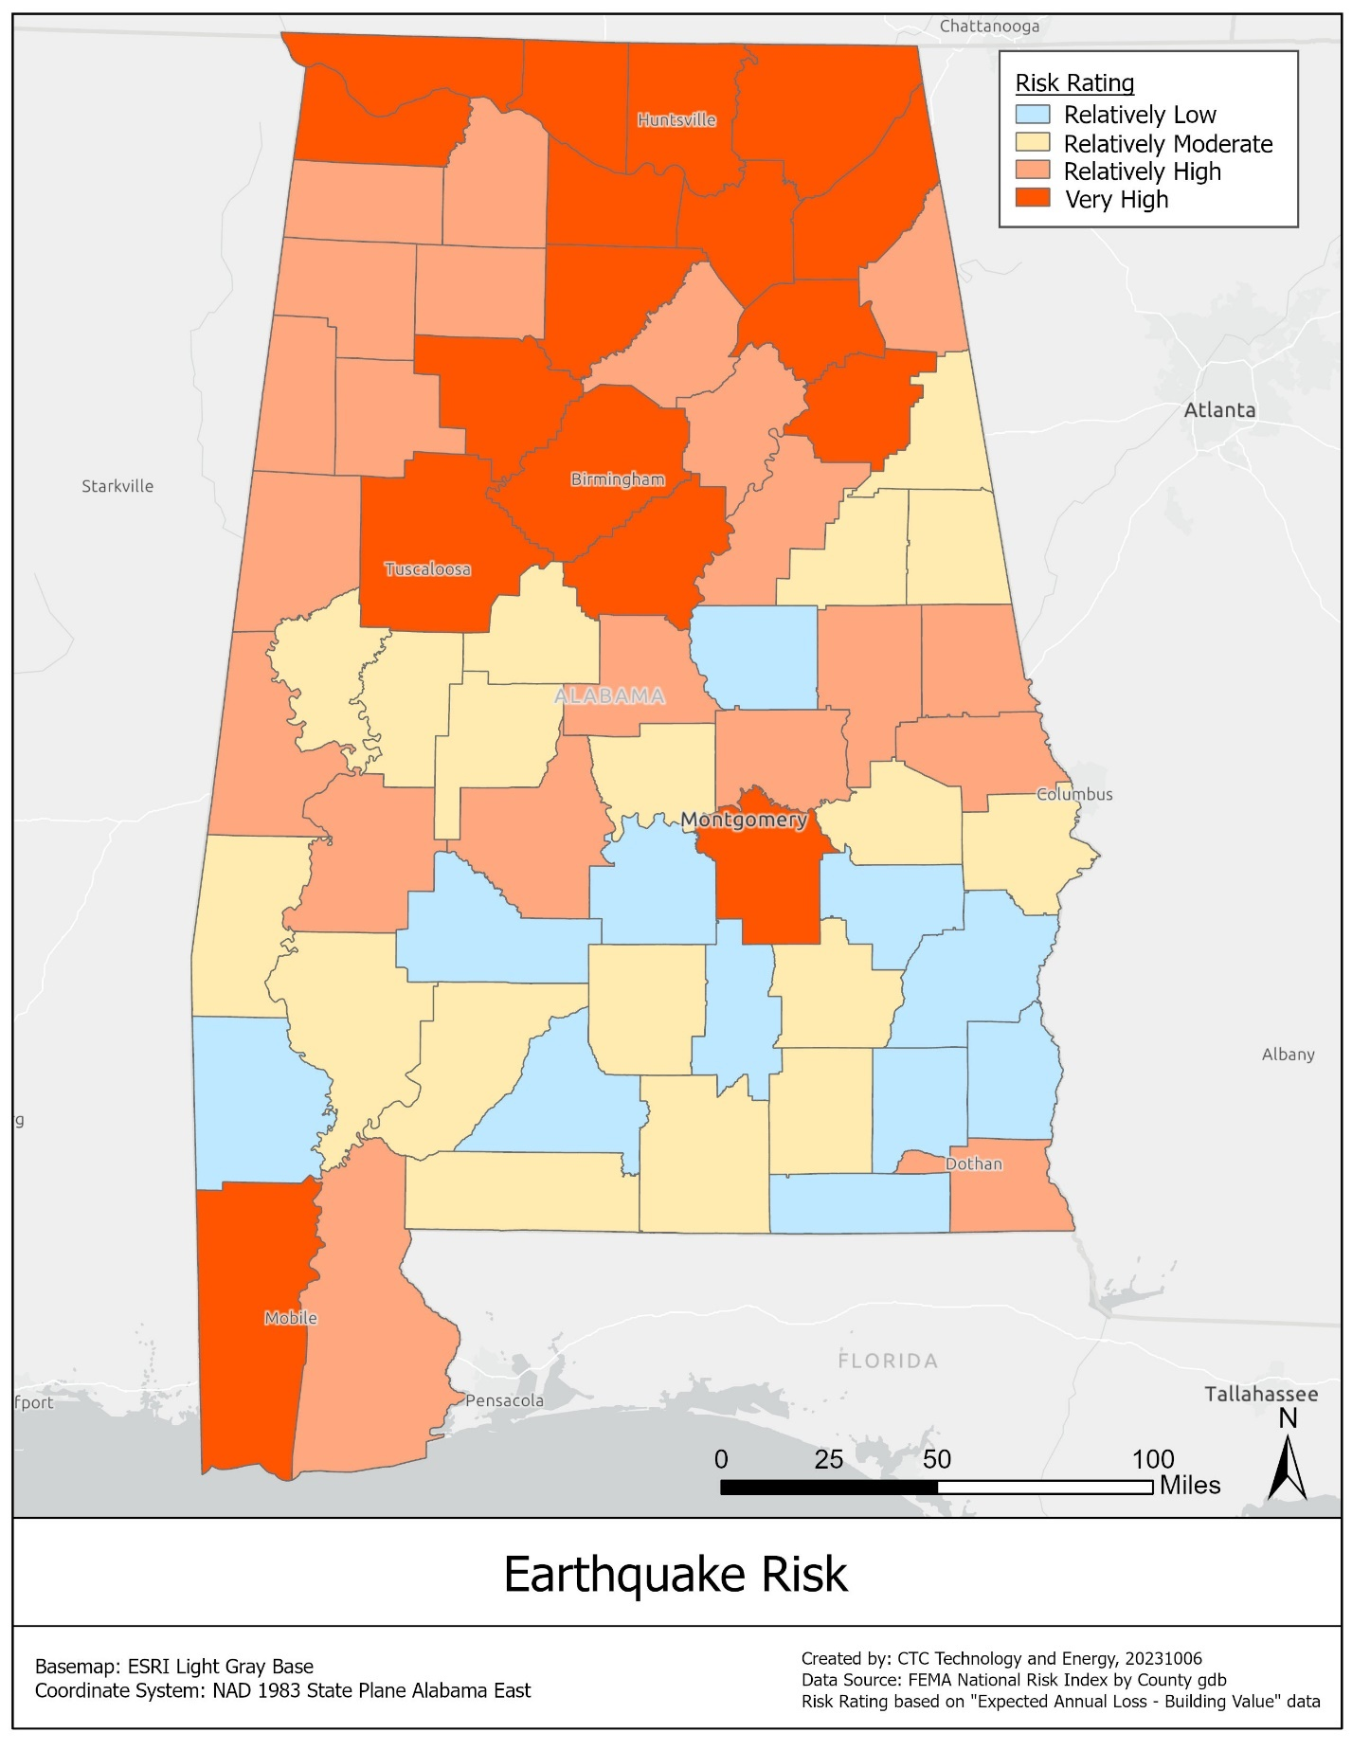

Extreme temperatures
The hazard of extreme temperatures encompasses instances of both extreme heat and extreme cold. The SHMP ranks this hazard as medium-risk, with a high probability and long duration balanced by good warning time and relatively low impact (due to preparedness and mitigation measures).

Extreme heat
Extreme heat is a period of excessively hot weather with higher-than-average temperatures, combined with high humidity. Extreme heat often occurs in the summer months but can vary regionally. In most of the United States, according to FEMA, extreme heat is a period of at least two to three days of high humidity with temperatures over 90 degrees.
Summers in Alabama are among the hottest in the United States, with high temperatures averaging over 90 degrees throughout the state. Because extreme heat is prevalent across Alabama, residents are accustomed to these conditions; however, extreme heat can have a significant impact on utility power services, including those that provide broadband services.
As shown in the map below, FEMA ranks most counties in Alabama as at Very High or Moderately High risk of heat waves.
Figure 6: Risk of heat waves in Alabama
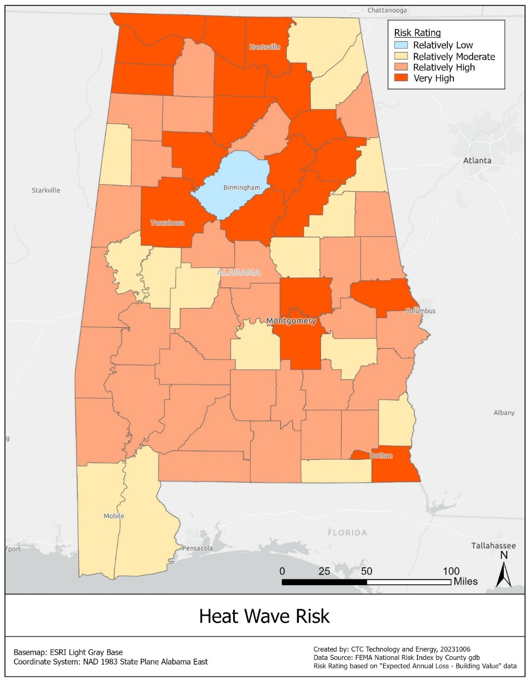

Extreme cold
Although less likely than extreme heat, extreme cold temperatures can also impact Alabama. Alabama residents are less accustomed to and less prepared for extreme cold, and therefore more vulnerable to these events.
As global temperatures rise, the number of extreme cold days in Alabama is expected to decrease. In the northern tier of the state, the length of the freeze-free season may increase by as much as 30 days by the middle of the 21st century.
FEMA defines a cold wave as “a rapid fall in temperature within 24 hours and extreme low temperatures for an extended period.” As shown in the map below, counties in northern Alabama are at Relatively High or Very High risk of cold waves, while the risk in the rest of the state is Very Low, according to FEMA.
Figure 7: Risk of cold waves in Alabama
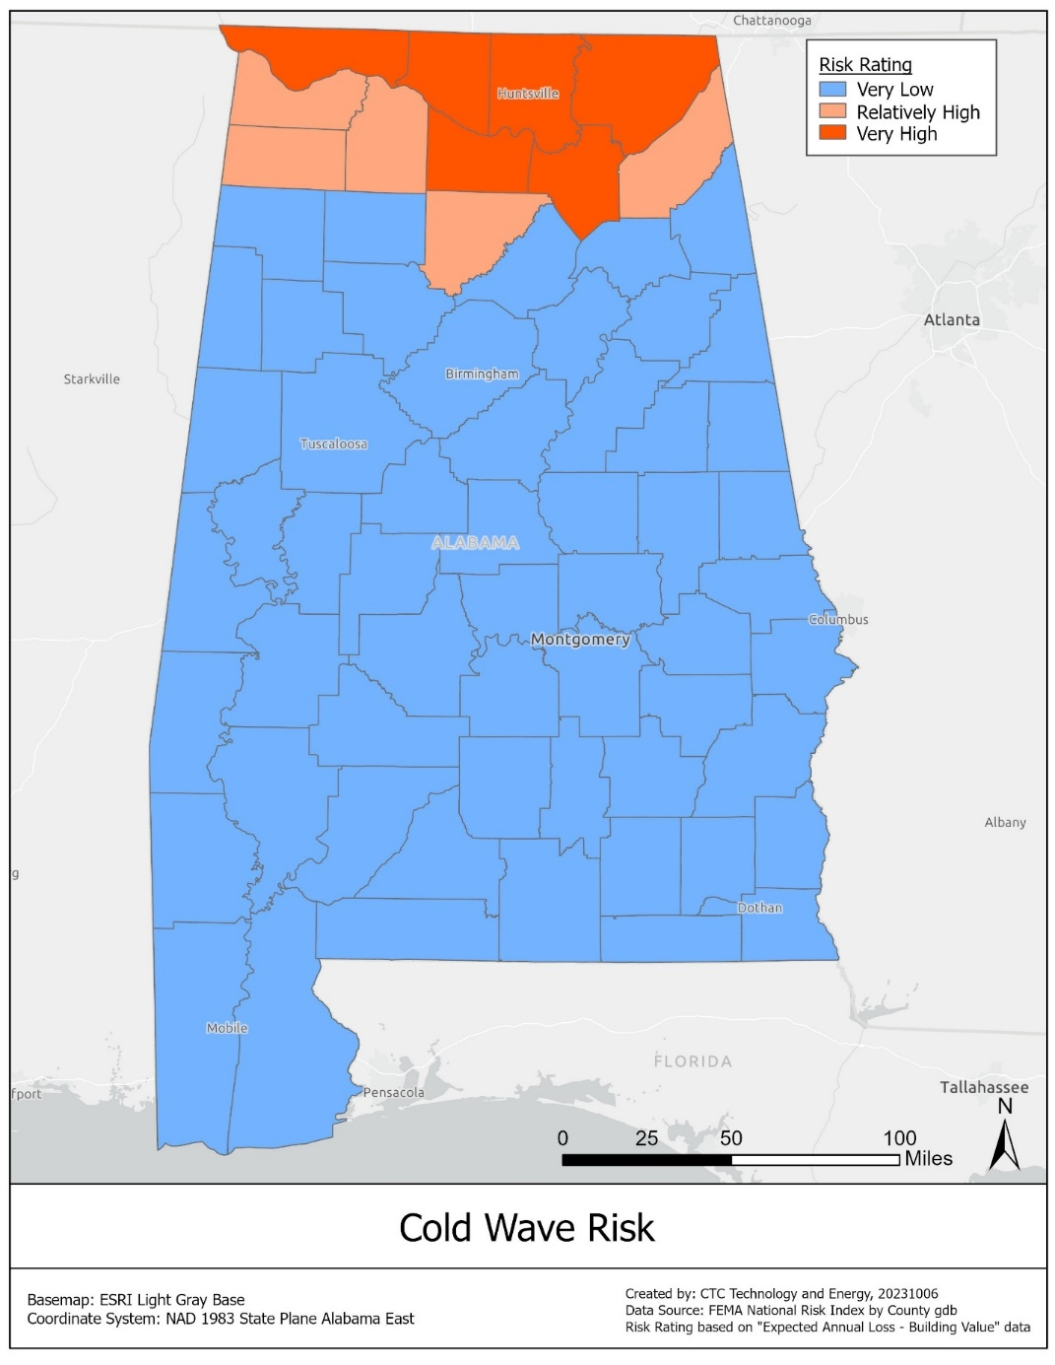

Flooding
The SHMP ranks flooding as Alabama’s highest risk, scoring high on all hazard metrics: probability, impact, spatial extent, warning time, and duration. Alabama experiences flooding and flood impacts almost every year. BEAD deployments in Alabama will have to take this hazard into account.
Flooding is the inundation of normally dry land and is the leading cause of natural disaster losses in the United States. Flooding can be caused by many different types of weather systems, including slow-moving frontal systems, inland-moving tropical cyclones, and intense summertime thunderstorms. In coastal areas, flooding can also be caused or intensified by high tides. When local weather stations issue flood warnings or report flood damage, they often classify flood events into categories based on the extent and velocity of rising waters.
Flood categories include flash floods, floods, coastal floods, nuisance flooding (such as high tides), and, in coastal regions, storm surge. FEMA defines riverine flooding as “when streams and rivers exceed the capacity of their natural or constructed channels to accommodate water flow and water overflows the banks, spilling out into adjacent low-lying, dry land.”
Flooding can cause extensive damage to infrastructure. Moving water creates hydrodynamic forces that can damage the walls of buildings, scour around their foundations, and damage roads and bridges. The magnitude of these forces is related to both the velocity and depth of flooding.
The debris carried by moving water can also cause damage, acting like battering rams against the walls of buildings. Standing water also exerts force on buildings through the weight of the water. Three feet of standing water can exert enough lateral force to collapse the walls of a typical frame house, and basement walls and floors are particularly susceptible to damage. The impact of floods is highly dependent on the amount, type, and design of development in the floodplain.
Alabama has a warm and humid climate characterized by often turbulent weather patterns and year-round precipitation. These features of the state’s climate, together with its location on the Gulf of Mexico, result in frequent riverine and coastal flooding events. Coastal storm surge flood events depend on the size, strength, intensity, and speed of the storm that is driving storm surge and wave action.
As shown in the map below, five southwestern Alabama counties are at Very High risk of coastal flooding, while Alabama’s other counties are at Very Low risk, according to FEMA.
Figure 8: Risk of coastal flooding in Alabama
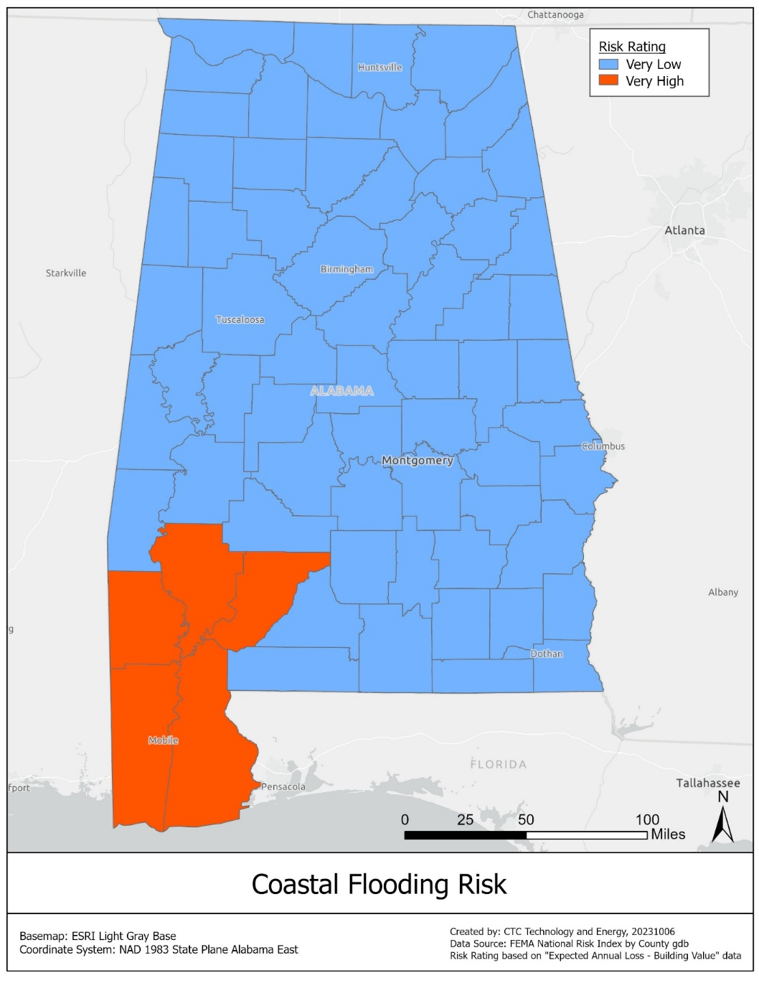
As shown in the map below, counties scattered across Alabama are at Very High risk or Relatively High risk of riverine flooding, according to FEMA.
Figure 9: Risk of riverine flooding in Alabama
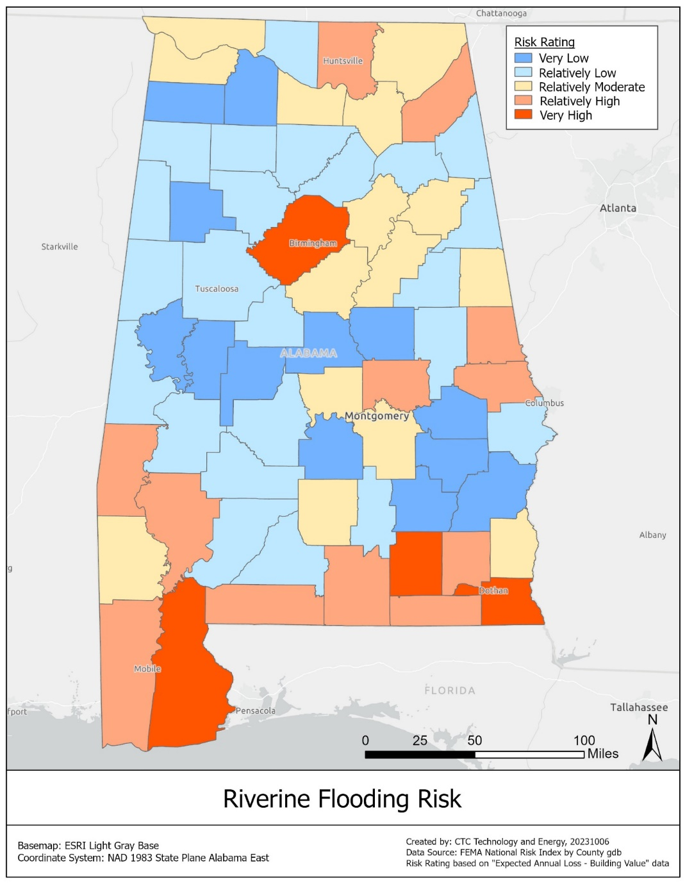
The future probability of riverine flooding in Alabama is likely to change as the frequency of heavy rains increases. The future probability of coastal flooding in Alabama will reflect the risk of tropical cyclones and hurricanes, as well as changes in sea level.

Hail
The SHMP ranks hail as a low priority because, although likely to occur, there is likely to be warning and because hail does not have a long duration. FEMA defines hail as “a form of precipitation that occurs during thunderstorms when raindrops, in extremely cold areas of the atmosphere, freeze into balls of ice before falling towards the earth's surface.”
Hailstorms occur most frequently in the late spring and early summer when the jet stream moves northward across the Great Plains. This creates steep temperature gradients from the surface to upper air masses, producing the strong updrafts required for hail formation. In the U.S., hailstorms cause about $1 billion in economic loss each year. Much of this loss is related to crop damage.
Hailstorms in Alabama are not as common as hailstorms in other parts of the United States, but severe hailstorms are reported every year. More hailstorms are reported in the northern part of the state, where severe thunderstorms are more common. The frequency of hailstorms in Alabama is greatest in the spring, with the most episodes of severe hail generally reported in April. Alabama has historically experienced about 60 hail episodes each year.
As shown in the map below, most counties in Alabama are at Relatively Moderate risk of hail, according to FEMA. Walker and Choctaw counties are at Very High risk, and several counties are at Relatively High risk.
Figure 10: Risk of hail in Alabama
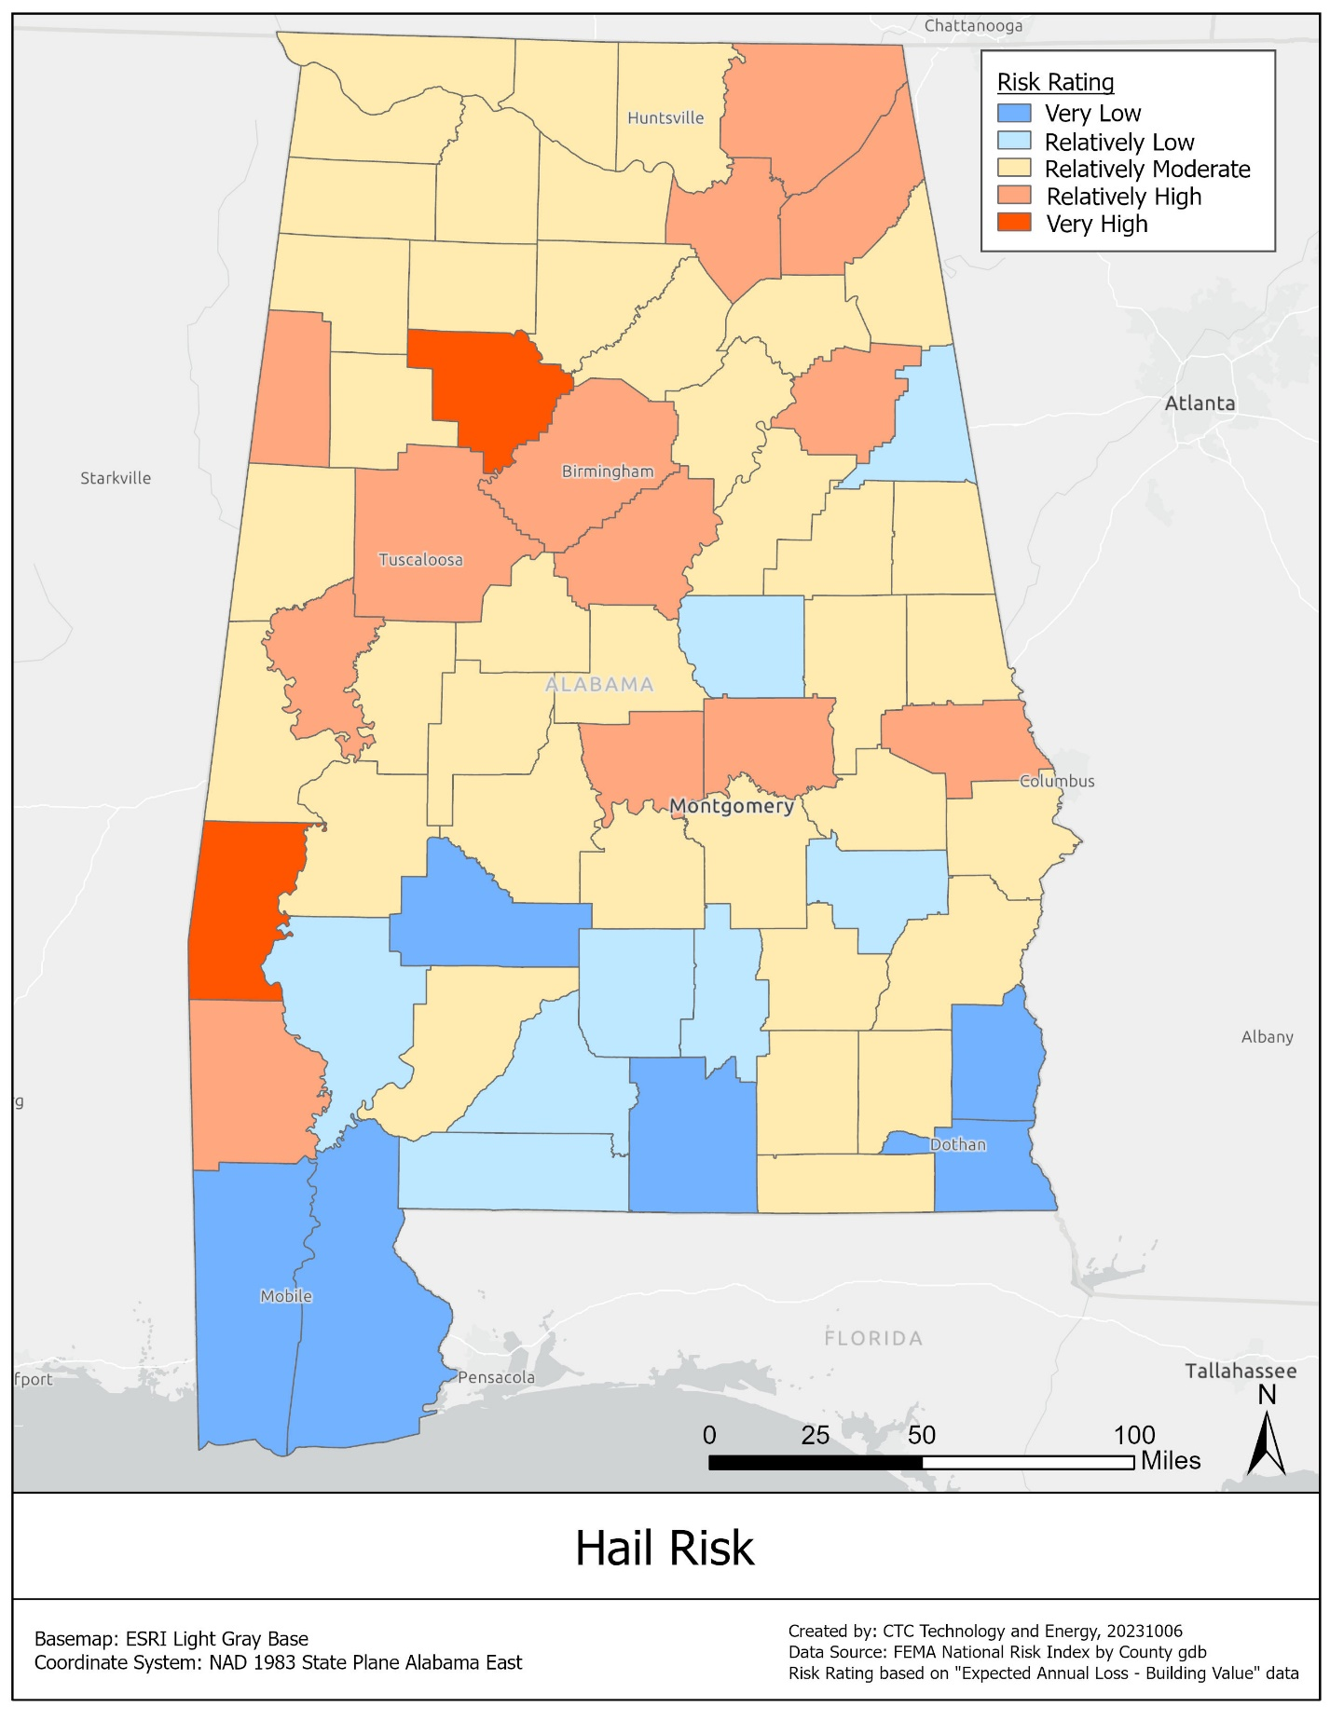
The probability of future hail events is directly tied to the probability of severe thunderstorms. One of the building blocks for severe thunderstorms is the atmospheric instability that results when warm, moist air near the Earth’s surface rises and interacts with cooler and drier air higher in the atmosphere. While the frequency of unstable conditions is expected to increase throughout the twenty-first century, global models predict significant variability from one year to the next.

High winds
The SHMP ranks high winds as high-risk events, with a high probability and little warning time. High winds are generally associated with three weather phenomena: tornadoes, thunderstorms, and tropical cyclones. Because these three phenomena often overlap (hurricanes, for example, can spawn tornadoes and generate severe thunderstorms), this section addresses the high winds associated with all these phenomena. Flooding and storm surge hazards related to hurricanes and severe storms are discussed in Section 12.2.5, above. High winds from thunderstorms, tornadoes, and hurricanes are the largest loss-producing natural hazard in Alabama. Most BEAD deployments in Alabama will need to reference best practices regarding high winds.
Hurricane hazards are generally expected to increase through the twenty-first century, while data regarding tornadoes and thunderstorms is inconclusive.

Tornadoes
Tornadoes are nature’s most violent storms and can strike with little or no warning. These storms can produce internal winds exceeding 300 mph and can lift and move very large objects (including entire buildings). Tornadoes are localized events, with path widths of less than 0.6 miles and lengths ranging from less than a mile to tens of miles.
Tornado frequency and intensity vary across Alabama but are generally associated with the frequency and intensity of thunderstorms. Many regions of Alabama have a disproportionately high frequency of intense thunderstorms, and thus a disproportionately high frequency of strong tornadoes. Although tornadoes are most common between March and August, they can occur at any time.
As shown in the map below, most Alabama counties are at Very High risk or Relatively High risk from tornadoes, according to FEMA.
Figure 11: Risk of tornados in Alabama
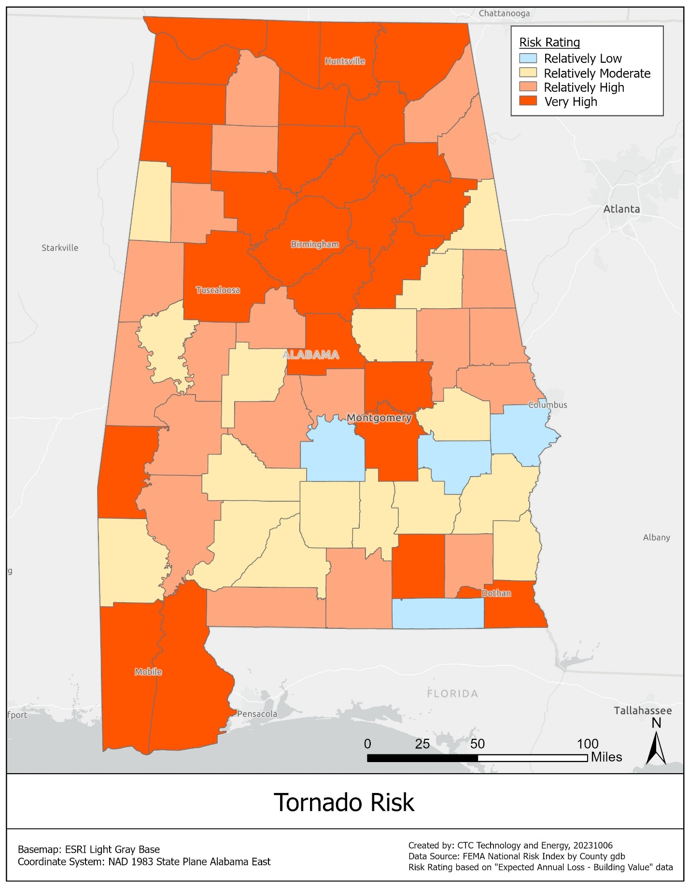

Hurricanes
Hurricanes are intense tropical cyclones with maximum sustained winds over water of 74 mph or higher. These storms are much larger than thunderstorms or tornadoes. The eye of a hurricane typically ranges from 10 to 30 nautical miles in diameter, and the surrounding storm may be 100 to 500 nautical miles in diameter. Although this section only addresses the wind hazard from hurricanes, related hazards include storm surge, coastal erosion, and lightning.
The hurricanes that strike the Gulf Coast region originate as tropical storms in the warm waters of the Gulf of Mexico, Caribbean Sea, or tropical Atlantic, then gain in intensity as they traverse the ocean. Alabama’s coastal region is subject to the highest risk from hurricane winds. Wind speeds tend to decrease significantly within 12 hours of landfall, as drier and cooler air begins to power the eyewall. Depending on a hurricane’s strength and forward motion, however, hurricane force winds (winds greater than or equal to 74 mph) can extend well inland.
As shown in the map below, most of the counties that are at Very High or Relatively High risk of hurricanes in Alabama are those closest to the coast.
Figure 12: Risk of hurricanes in Alabama
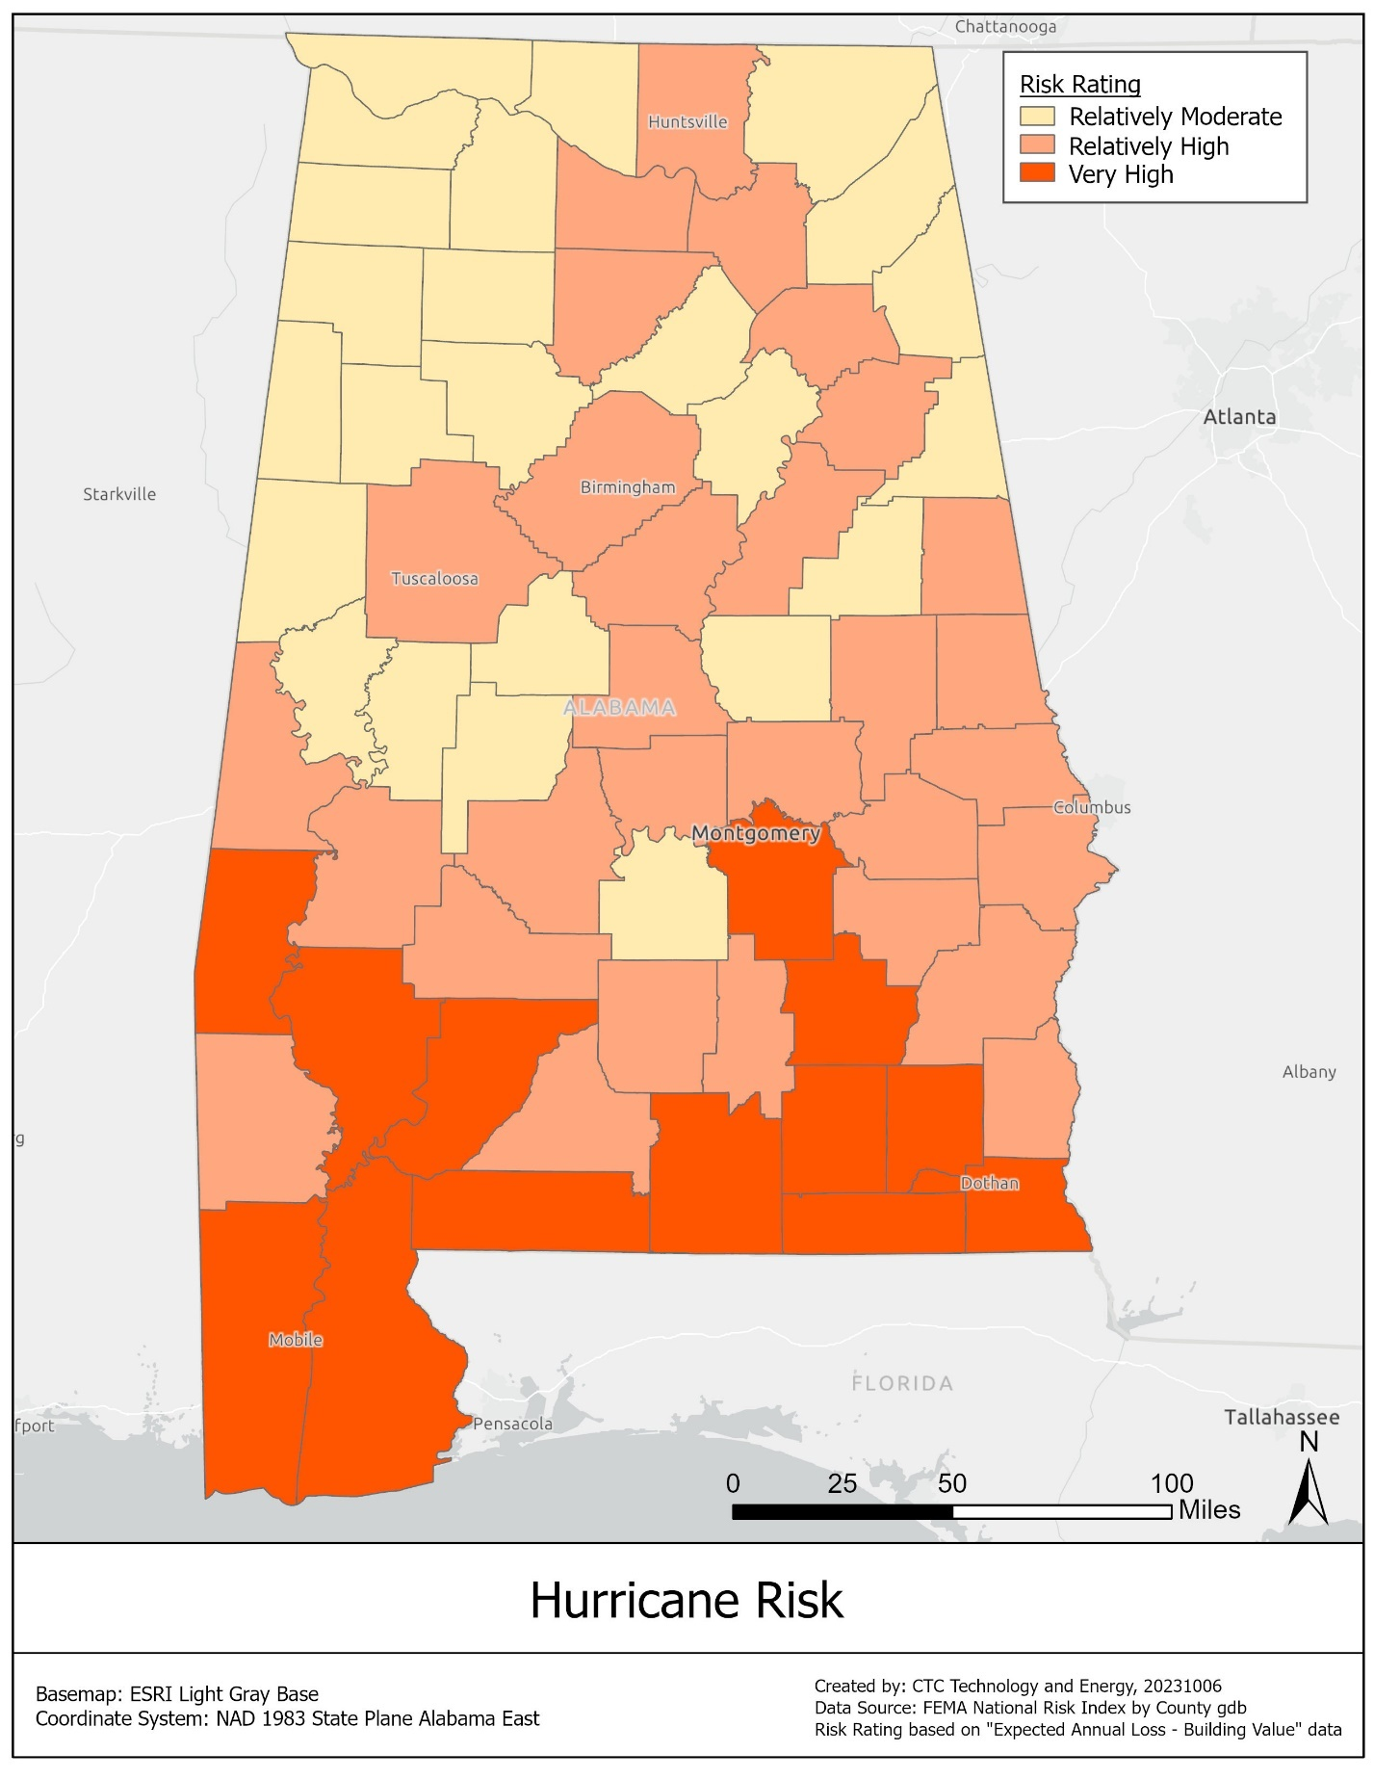

Strong winds
FEMA defines the strong wind hazard as “damaging winds, often originating from thunderstorms, that are classified as exceeding 58 mph.”
Thunderstorms are local storms, usually of short duration, that are accompanied by lightning and thunder. The average thunderstorm in the United States is about 15 miles in diameter and lasts less than 30 minutes in any one location.
As shown in the map below, counties across Alabama are at Very High risk or Relatively High risk from FEMA-defined strong winds.
Figure 13: Risk of strong winds in Alabama
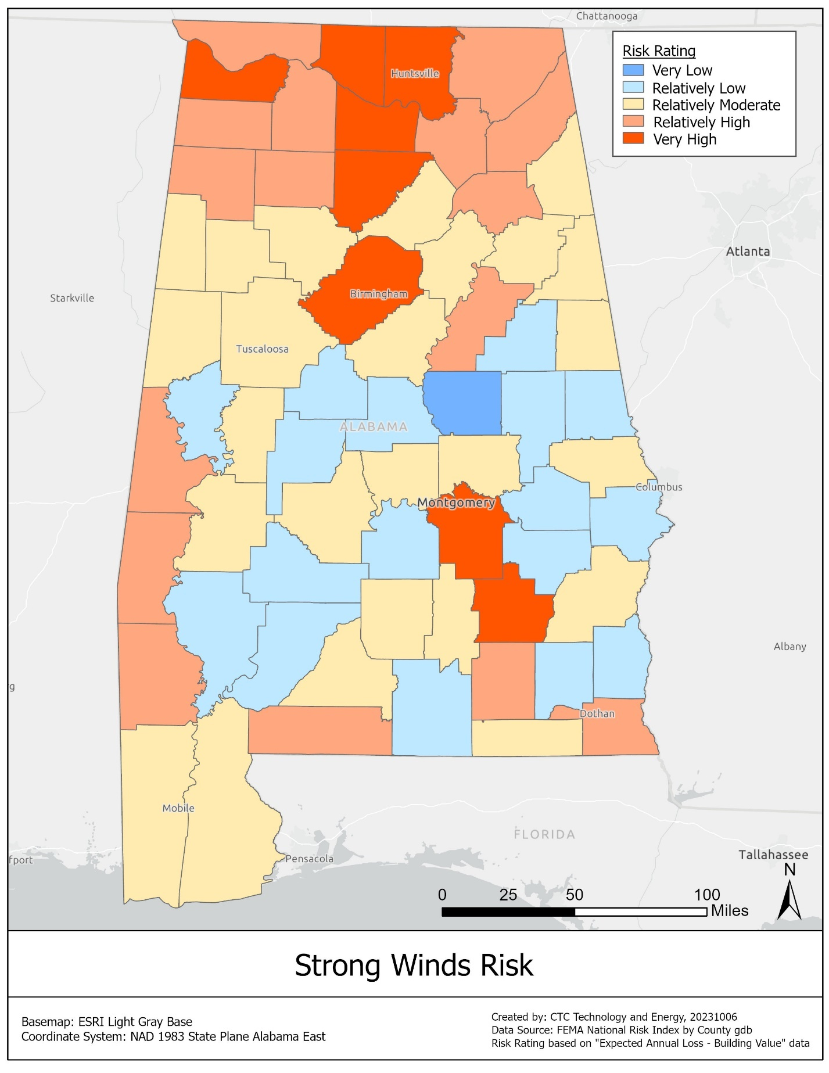

Landslides
The SHMP ranks landslides as medium risk in Alabama, balancing a lack of warning with their brief duration and local spatial extent.
A landslide is the movement of a mass of rock, debris, or earth down a slope. There are many types of landslides, but some of the most common are rock falls, debris flows, mud flows, slides, and creep. Debris flows are considered one of the most dangerous forms of landslides. This type of landslide usually starts on steep slopes during heavy rainfall, and often follows roadway drainage networks and streams. Because debris flows move rapidly and with great force, they can destroy almost everything in their path. Debris flows and mud flows differ only in the materials that flow downslope.
Landslides happen when areas that are landslide-prone are subject to natural and/or human-induced changes in the environment. Landslide-prone areas can be identified based on rock strength, slope, land cover, and known historical landslides. In general, landslides are more likely in areas with steeper slopes, weaker rocks, and sparser vegetation.
The geologic units that are most prone to landslides are those characterized by strongly cemented rocks and very steep slopes (more than thirty degrees); weakly cemented rocks and moderately steep slopes (more than fifteen degrees); and shales, clayey soils, or poorly compacted fills and slightly steep slopes (more than ten degrees). Notable geologic units in Alabama with a documented history of landslides include (but are not limited to): the Tuscaloosa Group, Pottsville Formation, Parkwood Formation, Pennington Formation, Bangor Limestone, and Pride Mountain Formation. Landslides become more likely during heavy rainfall.
BEAD deployments in most areas will need to incorporate best practices regarding landslide mitigation, including connectivity path redundancy.
As shown in the map below, the areas of Alabama at Very High risk of landslides correspond to the urban areas of Birmingham, Huntsville, and Tuscaloosa, plus Lee County.
Figure 14: Risk of landslides in Alabama
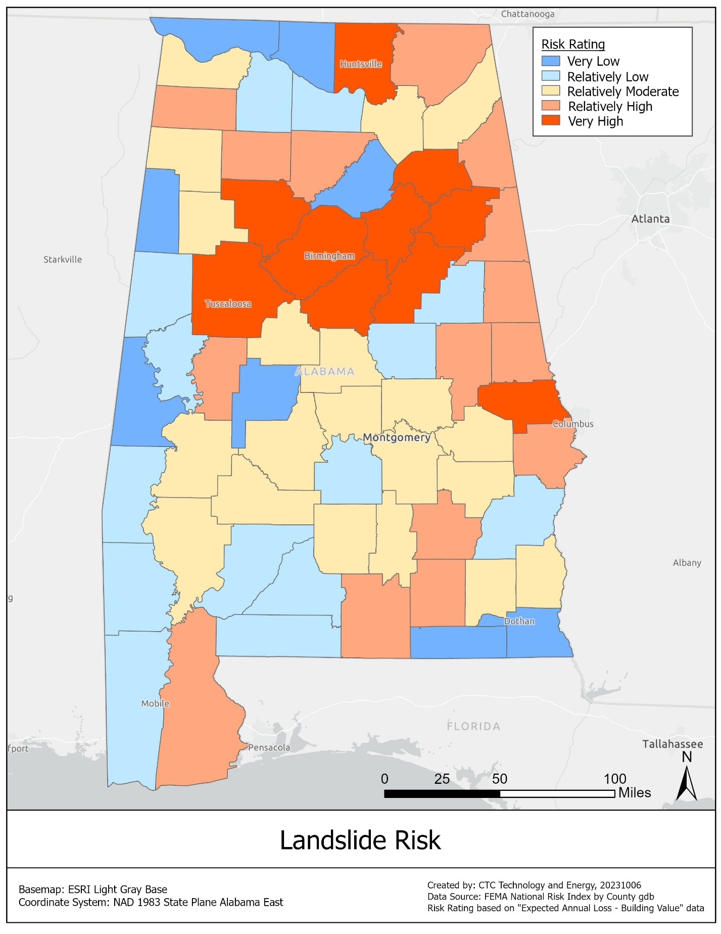
Some processes, such as high precipitation and changes in groundwater levels, may increase the likelihood of landslides. If rainfall events become more intense in the future, the incidence of landslides in Alabama may increase. At the same time, more prolonged and intense drought events could lead to more groundwater withdrawals and the lowering of some water tables. In some instances, this effect could reduce the likelihood of landslides.

Lightning
The SHMP ranks lightning as a medium risk in Alabama, balancing a lack of warning and high probability against their relatively low impact as well as their brief duration and narrow spatial extent. Lightning is a discharge of electricity in the atmosphere that occurs between clouds, the air, or the ground. While lightning can occur during such events as volcanic eruptions, intense forest fires, and large hurricanes, lightning most typically occurs during a thunderstorm.
Lightning can be especially damaging to the equipment associated with broadband infrastructure, but it is a hazard that the industry has experience with and best practices are well defined among ISPs and equipment manufacturers.
Although lightning can occur anywhere throughout the United States, lightning is more likely to occur in areas with conditions conducive to thunderstorm cloud formation. This happens when a large amount of moisture is present low within the atmosphere, surface temperatures are higher, and there is sufficient upward air movement. These conditions are often met along the Gulf of Mexico, which has high frequencies of cloud-to-ground lightning flashes. Alabama, in close proximity to the Gulf of Mexico, ranks seventh out of the 48 continental states in annual average cloud-to-ground flashes per square mile (14 flashes per square mile).
As shown in the map below, a majority of counties in Alabama are at Very High risk or Relatively High risk from lightning.
Figure 15: Risk of lightning in Alabama
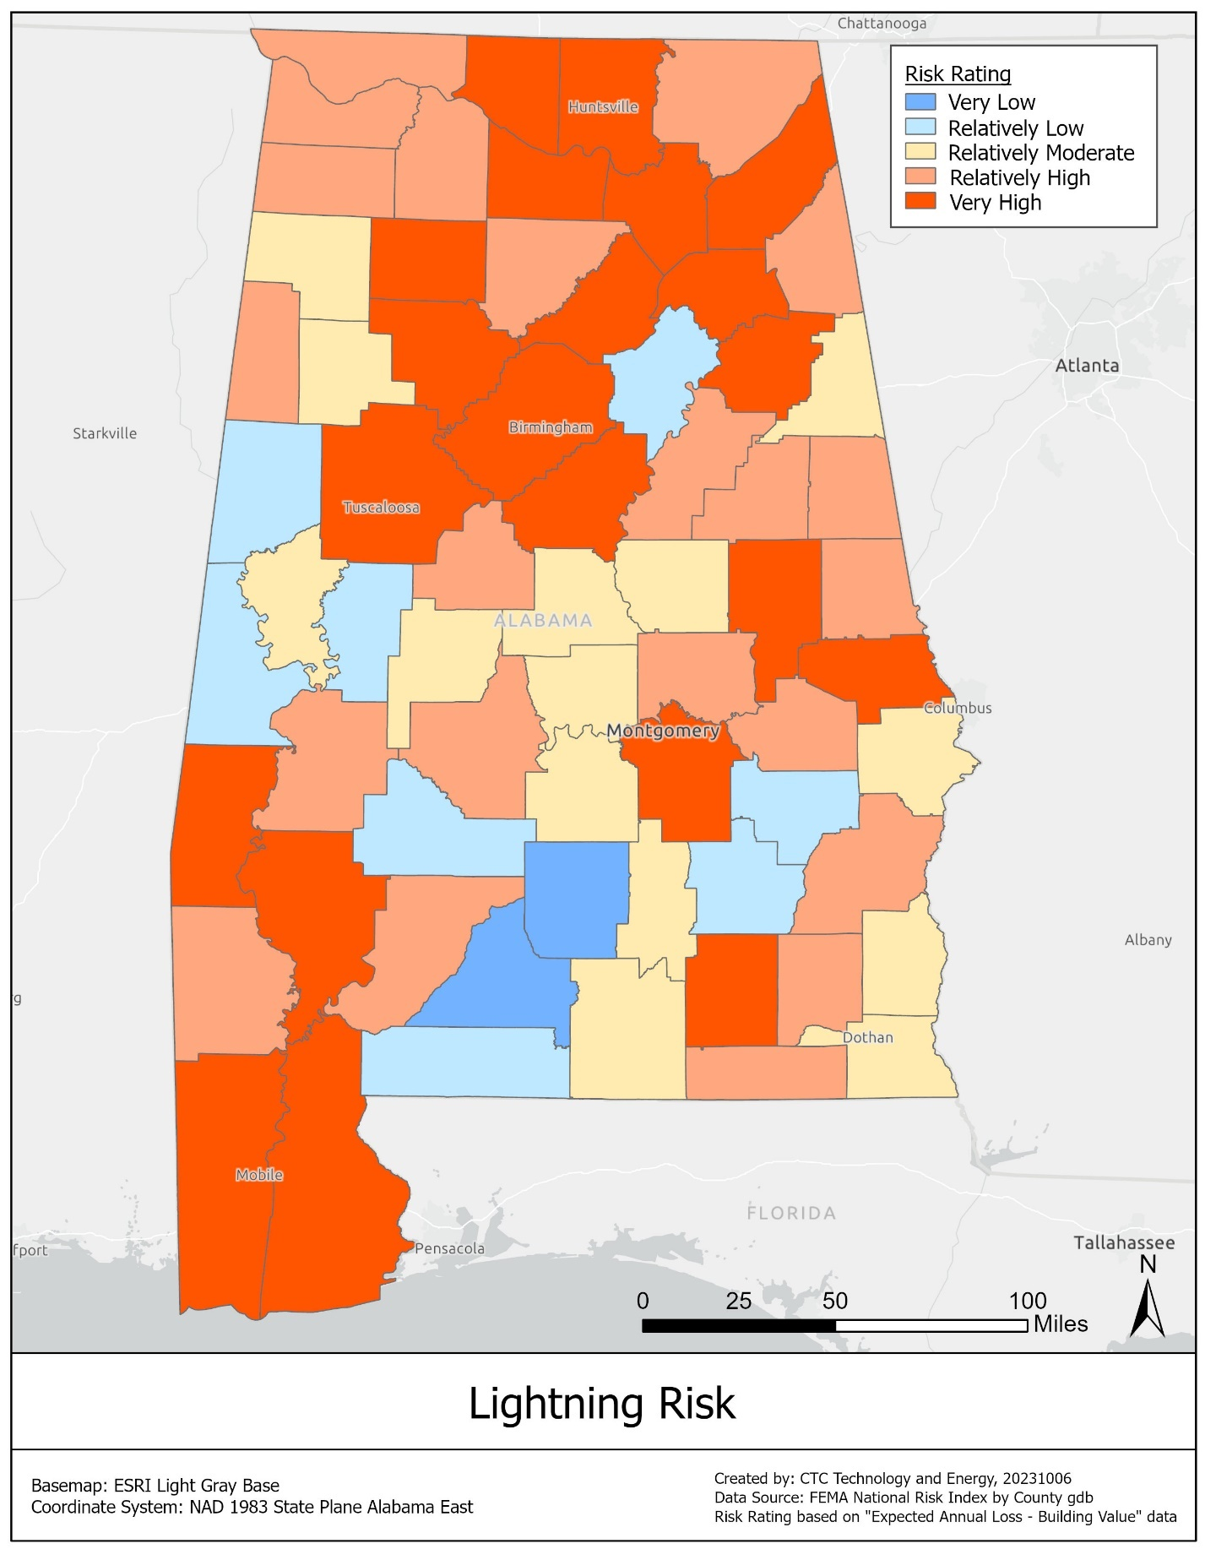
Since the probability of a lightning event is influenced by the probability of a severe thunderstorm occurrence, potential future changes in weather conditions may impact the future probability of cloud-to-ground lightning strikes. However, future projections in the severity and frequency of thunderstorms are uncertain in the Southeast United States.

Sea level rise and coastal land change
The SHMP ranks sea level rise as high risk in Alabama, with a high probability, high impact, and long duration. Sea level rise is a global phenomenon with varying local impacts. The highest rates of sea level rise in the United States are seen along southern coastlines.
Risks in Alabama include coastal land loss and nuisance flooding, where regular or extraordinary high tides cause flooding. Alabama has approximately 607 miles of Gulf Coast shoreline, including the state’s offshore islands and the tidal shorelines of Mobile and Baldwin counties. The future rate of local sea level rise along a particular coast will depend on the future rate of global sea level rise, as well as the future rate of local land subsidence. Each of these rates could follow a range of trajectories. BEAD deployments in areas subject to sea level rise and coastal land change will need to incorporate best practices regarding mitigation.

Sinkholes and land subsidence
The SHMP ranks sinkholes and land subsidence as a medium risk in Alabama, balancing their high probability and lack of warning against their brief duration and local spatial extent. Land subsidence is the loss of surface elevation due to the removal of subsurface support. This geologic hazard can be caused by many different natural processes and human activities, and ranges from slow, regional lowering of the land surface to sudden, localized collapse. Subsidence poses a risk to infrastructure.
Alabama, in particular the north and northeastern part of the state, is part of the well-known Tennessee-Alabama-Georgia area of caves and sinkholes (TAG area). The TAG area is one of the densest karst areas of the United States. The karst areas in Alabama most prone to sinkhole formation are concentrated in four physiographic sections: the Highland Rim, with the greatest sinkhole density in a West-to-East band associated with the geologic unit Tuscumbia Limestone; the Cumberland Plateau, with the greatest density in the northern plateau and Northeast to Southwest trending units of the Bangor Limestone and Knox Group; parts of the Alabama Valley and Ridge, with greatest density in the Knox Group, Chepultepec Dolomite, and Copper Ridge Dolomite; and the southern part of the Coastal Plain, including residuum of the Eocene-Oligocene units, Miocene Series, and parts of the Citronelle Formation.
Localized subsidence is also common in those areas of the state underlain by abandoned coal and iron mines. Pillars left for roof support in the mines generally deteriorate over time and eventually collapse, removing support. This is particularly a problem where mines underlie more recently-developed residential areas and roads. Abandoned coal mines in Alabama are concentrated in the northeast and central parts of the state, especially in areas underlain by the Pottsville Formation geologic unit. Groundwater withdrawal is an important driver of sinkhole development in Alabama.
The probability of sinkholes and land subsidence cannot be expressed in terms of specific frequencies or return periods. These events are the culmination of multiple naturally-occurring and human-induced geological processes that play out over a range of timescales and can be highly localized. Some of the processes that tend to accelerate sinkhole development may be impacted by drought conditions and groundwater withdrawals, both of which can remove the support provided by water pressure and lead to the collapse of underground voids. If drought periods become more intense and prolonged in the future, the incidence of sinkholes in Alabama may increase, particularly in the state’s northern counties.

Wildfire
The SHMP ranks wildfire as medium risk, with a high probability and long duration. A wildfire can be defined as any non-structural fire that occurs in the wild. Wildfires are uncontrolled blazes fueled by weather, wind, and dry underbrush that have the ability to burn a significant amount of land in a very short period of time. Three conditions need to be present for a wildfire to burn: fuel, oxygen, and a heat source.
Approximately 71 percent of Alabama’s land area is forestland and 85 percent of this forestland is owned by nonindustrial, private landowners. Therefore, the vast majority of wildfires in Alabama occur on privately-owned lands. Additionally, the majority of wildfires in Alabama occur in areas where residential properties or other structures are endangered. Areas where homes are built near or among lands prone to wildfires are known as the wildland-urban interface. As more people move into natural areas for their privacy, beauty, recreational opportunities, and affordable real estate, the wildland-urban interface in Alabama is growing and now faces the risk of major losses from wildfires.
Wildfires damage infrastructure and will need to be taken into account in deploying BEAD infrastructure, particularly in wildland-urban interface areas. As shown in the map below, the wildfire risk in Alabama is higher in the southwestern area of the state but is present near most urban areas.
Figure 16: Risk of wildfire in Alabama
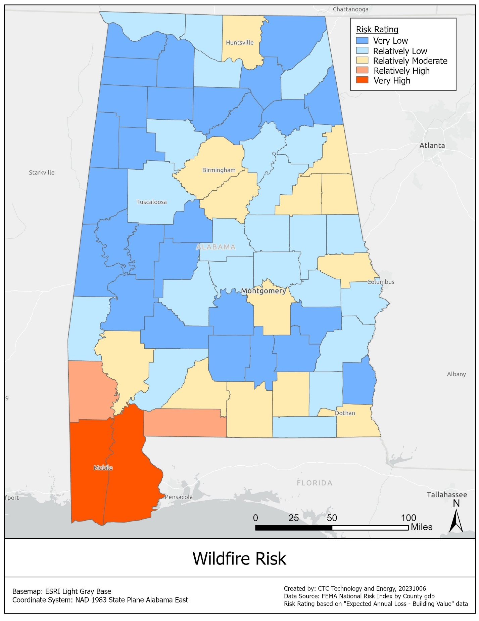
As with most natural hazards, wildfires are strongly influenced by weather phenomena. Alabama is projected to become more prone to wildfire occurrences. Alabama is at risk of facing considerable increasing threat levels from wildfire between now and 2050.

Winter storms
Although the SHMP ranks winter storms as medium risk, they are the highest-ranked medium risk and fourth overall in Alabama. Winter storms are storm events characterized by extreme cold and precipitation in the form of snow, ice, and/or sleet. Winter storms can also spawn other natural hazards, such as coastal flooding and erosion, severe thunderstorms and tornados, and extreme winds. These storm events can have significant impacts in terms of human life, economic loss, and disruption of transportation and commerce. Accumulations of snow and ice can severely impact power and telecommunications infrastructure, and BEAD deployments will need to take mitigation measures and review best practices.
The disruption caused by a winter storm depends on the amount of precipitation, the affected population, and the regional climatology. Areas where winter storms are rare, such as the southeastern United States, tend to be less prepared for these events and therefore tend to experience greater disruption.
Winter storms in Alabama are not as severe or common as winter storms in the northern states. Typically, a winter storm in Alabama consists of freezing rain or a few inches of snow that may or may not be accompanied by frozen roadways. Because Alabama is not accustomed to these events, however, winter storms tend to be very disruptive to transportation and commerce. The local warning criteria established by the Mobile, AL and New York, NY Weather Forecast Offices illustrate how the amount of snow or ice that poses a risk to life and property varies from state to state. While expected snow accumulation of 2 inches in 24 hours is enough to trigger a warning in Mobile, snow accumulation of 6 inches in 12 hours is required to trigger a warning in New York.
FEMA defines winter weather as “winter storm events in which the main types of precipitation are snow, sleet, or freezing rain.” As shown in the map below, Coffee and Houston counties are at Relatively High risk of winter weather, according to FEMA.
Figure 17: Risk of winter weather in Alabama
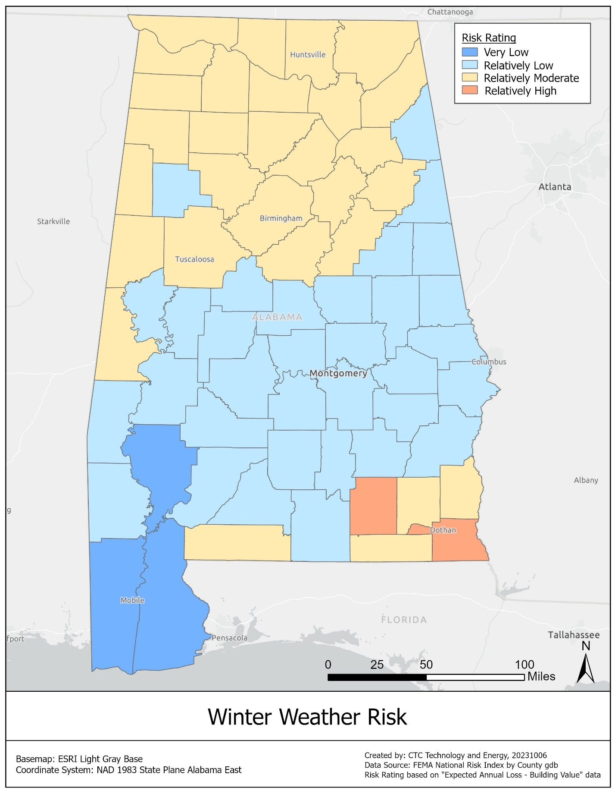
FEMA separately defines an ice storm as, “a freezing rain situation (rain that freezes on surface contact) with significant ice accumulations of 0.25 inches or greater.” Ice storms can cause significant damage to power and telecommunications infrastructure.
As shown in the map below, Choctaw and Chilton counties, and several counties in Alabama’s northern areas, are at Relatively High risk of ice storms.
If historical trends continue, Alabama can expect the probability of hazardous ice storms to remain relatively constant, and the probability of hazardous snowstorms to fall.

Figure 18: Risk of ice storms in Alabama
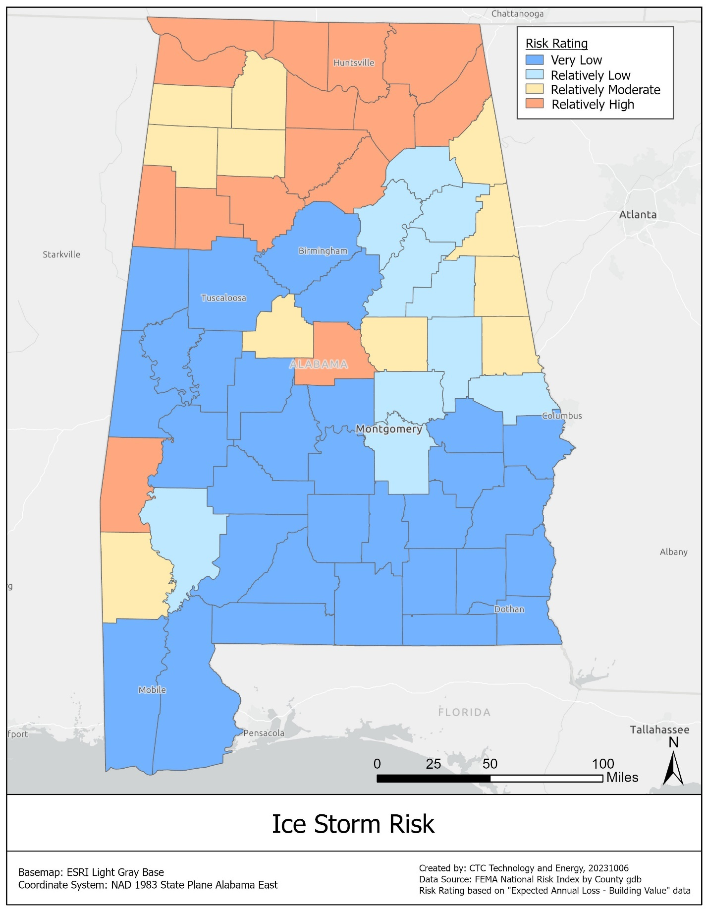

Projected weather and climate risks to new BEAD-funded broadband infrastructure
The top natural hazard risks impact broadband infrastructure in the following ways: through power outages, through equipment damage, and through signal degradation.
Table 19: Threats to infrastructure posed by weather risks
Risks | Potential causes
Power outages | Strong winds, hurricanes, ice storms, flooding
Equipment damage | Lightning, tornadoes, ice storms, flooding, hail, wildfires, landslides, sinkholes
Signal degradation | Flooding, hail
Strong winds, hurricanes, ice storms, and other hazards can cause power lines to go down or power to be turned off for safety, resulting in a break in internet accessibility. Heat and wildfires also impact the power infrastructure. Additionally, aerial fiber (and coaxial cable) is frequently overlashed on power lines that run along poles. When tree branches or ice cause power lines to break, the applied force may also damage the overlashed asset. This risk is raised when a technician untrained in internet infrastructure or fiber attempts to fix downed power lines by cutting through otherwise intact fiber.
Risks such as lightning, tornadoes, flooding, and wildfires can threaten aerial assets of all kinds. Intense winds and debris can damage fiber and even knock down utility poles. Lightning can strike antenna and satellite equipment that is necessary for fixed wireless communications. In either case, the result is severed connectivity.
In addition, risks such as floods and hail can cause the signal between fixed wireless transmitters and receivers to be absorbed or scattered, weakening their performance.
As discussed above, the highest-risk hazards in Alabama include flooding, high winds, and sea level rise, followed by moderate-risk hazards that include winter storms, wildfires, extreme temperatures, drought, landslides, sinkholes and subsidence, lightning, and earthquakes.

Avoidance and mitigation of weather and climate risks
Network infrastructure deployment—especially wireline—generally builds in principles of resilient and reliable networks, which mitigate risks against natural hazards. Since BEAD awardees will be familiar with these practices and incentivized by their profit motive to deploy resilient network technology, ADECA will focus on providing guidance in areas where additional risk mitigation techniques should be considered. The following subsections discuss both hazard mitigation best practices that the anticipated BEAD funded projects in Alabama are likely to include, and how ADECA will adopt processes to ensure climate resiliency.

Hazard mitigation for anticipated BEAD-funded projects in Alabama
In accordance with the BEAD NOFO project prioritization process, ADECA anticipates that the majority of BEAD funding will be awarded to projects proposing fiber optic deployments. However, depending on the outcomes of the subgrantee selection process and available funding, alternative technologies such as fixed wireless may play a role in BEAD deployments in Alabama.
Fiber optic cable is preferred as a matter of national policy because it is future-proof. It is also one of the most resilient media for broadband: it is well encased and protected and does not require power except for a limited amount of network equipment huts and locations with active electronics.
Mitigation of current climate events is typically incorporated into the practices of any ISP which has a vested interest in ensuring business continuity to manage customer satisfaction and operational costs. Burying fiber is the best mitigation to natural hazards but should be supplemented with standard best practices for optimizing network resilience, such as equipment and path diversity.
For current and planned aerial fiber, wireline broadband providers generally depend on utility pole owner actions. Fiber optic cables do not need power and continue to provide signal transport even when the cable is down. Pole technology is evolving, as is the understanding of wind hazards. Poles that are older and/or experience previous strains are weakened and more likely to fail in future events. Mitigation of such risks involves estimating pole risks based on watershed proximity, previous events, and existing drainage. Mitigation strategies include adding drainage and replacing old and weak poles.
For aerial fiber, long-term risk mitigation is similar to mitigation strategies for power lines. In general, changes in the severity and frequency of natural hazards have a longer time horizon and allow for the gradual implementation of hardening efforts. When risks and outages become too frequent, power utilities will convert aerial to buried in vulnerable segments and wireline broadband providers can simply follow their lead and cadence. For communications providers, risk mitigation can therefore include any of the following on a gradual implementation basis:
  - Aligning with power utilities burying aerial power lines
  - Adding more redundant network paths
  - Increasing backup power capabilities at ISP network equipment sites and at customer locations
Tower technology is also evolving. For fixed wireless deployment, tower owners typically make sure the tower is resilient against natural hazards and load studies are conducted frequently on such vertical assets. Owners of such vertical assets therefore typically make reinforcements as needed against different types of hazards.

Adopted risk mitigation processes
ADECA will require all subgrantee applicants to have a business continuity plan, which includes their natural hazard risk mitigation strategy. In addition, ADECA will require applicants whose project area includes identified high-risk areas (in accordance with the data provided above in Section 12.2) to provide specific responses to how they will incorporate mitigation measures into their deployment planning. ADECA will require applicants to describe how they considered the following strategies to address natural hazard risks in their project design:
- Buried fiber compared to aerial in order to mitigate the risks described in this section.
- Retrofitting and hardening existing network assets that are deemed critical to BEAD expansion projects.
- Redundancy in network designs to reduce single points of failure.
- Considering average down time and emergency response time in applicant selection.
- The use of backup generator power systems, where applicable.

Plan for completing the climate assessment process over the life of the program
ADECA plans to update the BEAD climate assessment in conjunction with the EMA’s upcoming update to the State Hazard Mitigation Plan (SHMP). Organizations involved in updating the plan include:
- The Governor of Alabama or her designee, who shall serve as Chair;
- The Commissioner of the Alabama Department of Agriculture and Industries (AGI);
- The Attorney General;
- The Commissioner of the Alabama Department of Conservation and Natural Resources (DCNR);
- The Director of ADECA;
- The Director of the EMA;
- The Director of the Alabama Department of Environmental Management (ADEM);
- The State Forester of the Alabama Forestry Commission (AFC);
- The Office of the State Geologist;
- The State Historic Preservation Officer;
- The Commissioner of the Insurance Department;
- The Director of the Governor’s Legal Counsel Office;
- The Director of the Alabama Department of Public Health (ADPH);
- The Director of the Governor’s Public Information Office;
- The Director of the Alabama Department of Public Safety;
- The Commissioner of the Alabama Public Service Commission (PSC);
- The Secretary of State;
- The Director of ALDOT;
- The Director of the Alabama Association of Regional Councils;
- The Director of the Alabama League of Municipalities;
- The Director of the Association of County Commissioners;
- The Director of the Indian Affairs Commission;
- The Chief of the U.S. Army Corps of Engineers; and
- The Director of the Choctawhatchee, Pea, and Yellow Rivers Watershed Management Authority (CPYRWMA).
The update process will be conducted following SHMP updates. ADECA will conduct a re-examination of the original climate assessment and provide updates to the recommendations and analysis, as necessary.

Low-cost broadband service option (Requirement 16)
Among the numerous barriers to internet adoption, affordability of service is a particularly relevant consideration in the State of Alabama. The American Community Survey reports that 89.9 percent of Alabama residents have a home internet subscription of any kind, which is similar to the national rate of 90.3 percent. However, while the national rate helps to contextualize the state’s position relative to the country, the national rate does not represent the ceiling for achievement and, among Alabama residents that do not have internet at home, 42.6 percent report that a primary reason they do not pay for an internet service at home is an inability to afford service. Additionally, low-income individuals are 15.7 percentage points less likely than higher-income individuals to have a home internet subscription and they are 21.6 percentage points less likely to have a wireline internet subscription—further highlighting the connection between affordability and internet adoption.
Perhaps the most widely recognized intervention to lower the cost of internet service is the FCC’s ACP. The ACP subsidizes up to $30 per month (or $75 per month for applicants residing on Tribal lands) for broadband for qualifying households and may include a one-time $100 subsidy toward buying a laptop or tablet. However, despite the benefit of the subsidy, the ACP is known to be greatly underutilized nationwide. In Alabama, an estimated 40 percent of eligible households have enrolled in the ACP, a rate higher than the estimated national level of 35 percent. Nevertheless, there is still opportunity for expansion of the program in the state.
Beyond providing relevant information for residents about the ACP on its website, Alabama has been a trailblazer in its support of the ACP and other programs that lower the cost of internet for residents. Notably, with the Alabama Broadband Connectivity (ABC) for Students program, the state sought to ensure that students could continue their education via the internet during the 2020-2021 school year despite the COVID-19 pandemic. This $50 million statewide initiative connected over 200,000 Alabama students in 107,000 households—with 76,000 households receiving vouchers from ADECA directly and 31,000 households receiving hotspots distributed by school districts. After ABC for Students funding ended in June 2021, the call center for the program continued to aid Alabama households through August of that year, assisting households in transitioning from the program to other federal broadband subsidies.
Alabama has also made promoting service affordability and outreach for the ACP and similar subsidy programs a goal of the broadband deployment grant programs it administers. The Alabama Broadband Accessibility Fund, which supports last-mile and related middle-mile deployment, awards points to providers in the rating of their applications for making a commitment to improving the adoption rate of broadband services by offering low-cost service programs to qualifying households; participating in the ACP or other federal broadband subsidy programs; or providing devices or digital skills training. ADECA has also incorporated scoring criteria and requirements around affordability into the Alabama Capital Projects Fund Program, which provides grants for providers to deploy last-mile service in rural, unserved areas. Subrecipients are required to participate in the ACP and applicants are scored based on their plans to offer services that are affordable to customers in the proposed service area—potentially including offerings with discounts in addition to the ACP to deliver service at no cost to eligible subscribers—and their plans to promote these offerings. AIMM Program subrecipients that provide service to households using AIMM-supported broadband infrastructure must, for as long as the AIMM-supported broadband infrastructure is in use, either participate in the ACP through the lifetime of the ACP or otherwise provide access to a broad-based affordability program to low-income consumers in the proposed service area of the broadband infrastructure that provides benefits to households commensurate with those provided under the ACP through the lifetime of the ACP. AIMM Program subrecipients that enter into an agreement with a last-mile provider to serve households using AIMM-supported infrastructure must hold the last-mile provider to the same requirement.
As such, when ADECA engaged in outreach with every county in the state, many entities, such as public libraries and ISPs, offered to support Alabama’s ACP outreach efforts at all levels. There are many ISPs operating in Alabama that offer plans at low to nearly no cost for eligible subscribers who enroll in the ACP. There are also several municipal governments, community organizations, and CAIs in Alabama that have engaged in outreach efforts (often using grant funding) to spread awareness about the ACP, encourage ACP participation among eligible households, and assist in the ACP enrollment process. Examples include the City of Montgomery, which received funding in 2023 through the National Competitive Outreach Program, and the Community Action Association of Alabama (CAA), a statewide association of member community action agencies that serve low-income individuals and families, which also received funding from the National Competitive Outreach Program. Alabama residents can also apply for Lifeline—a federal program which subsidizes up to $9.25 of eligible consumers’ monthly phone or internet service bills.
For a more detailed breakdown of the manner in which ADECA and other entities in the state have supported and continue to support the ACP and other subsidy programs, please see ADECA’s Digital Opportunity Report, published in September 2023.

Low-cost broadband service option that must be offered by Alabama BEAD subgrantees
ADECA’s intention is to aid as many Alabama residents as possible while ensuring that the scale of the low-cost broadband service option—and its resulting impact on the business case for ISPs to build to unserved and underserved Alabama locations—is not too burdensome for grant applicants. The income eligibility requirement for the ACP is set at or below 200 percent of the federal poverty line, and NTIA requires that eligibility for the low-cost service option be set at that level. That benchmark also offers the potential to utilize the ACP National Verifier as a useful, low-cost means of verifying eligibility that does not impose additional burden on either the consumer or the ISP. As a result and consistent with NTIA guidance, ADECA intends to set the eligibility threshold for its proposed low-cost broadband service option at incomes at or below 200 percent of the federal poverty line.
As the 200 percent income threshold for the BEAD low-cost broadband service option might, in theory, impose an additional burden upon participating ISPs should the ACP subsidy remain at $30 per month, a proposed $70 monthly service offering aligns with many current ISP low-cost offerings (in the State of Alabama and nationwide) and represents a sensible benchmark for a low-cost broadband service option to be offered by BEAD subgrantees.
This cost is based on the following data analysis:
According to the FCC, the current unweighted median price of 100/10 Mbps broadband service in Alabama is $70 per month, with an overall statewide pricing range of $61 to $110 per month. Furthermore, $65 is the average service fee commitment in grant applications received in the recent CPF Program. Given these data, ADECA concludes that a price point of $70 per month is not likely to adversely impact ISP interest.
With the ACP subsidy applied to the proposed $70 per month service offering, the effective pricing for eligible low-income households purchasing services over BEAD-funded infrastructure would be $40 per month.
This effective cost is considered reasonable in light of the generally accepted economic metric that broadband costs should not exceed two percent of household income.
The average household income of households of four at or below 200 percent the federal poverty level in Alabama is roughly $35,000, yielding a $58 per month reasonable internet cost at two percent of household income ($88 before a $30 per month ACP subsidy). Therefore, a maximum price of $70 per month should allow a large proportion of low-income households to reasonably afford reliable broadband service.
This number is supported by the data from ADECA’s 2023 scientific phone survey, in which, as shown in the chart below, 75 percent of respondents at 150 percent of federal poverty level signaled willingness to purchase internet service priced at less than $40—i.e., $70 before a $30 per month ACP subsidy—suggesting that the number willing to purchase internet at $70 per month would be even higher for households at 200 percent of federal poverty.
Figure 19: Share of low-income households in Alabama willing to pay for internet service at different price points
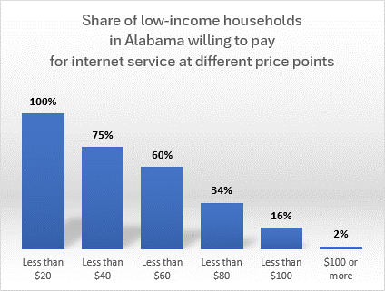
ADECA thus proposes to require all BEAD subgrantees to offer a broadband service option that meets, at a minimum, the following criteria:
- Available to all households that meet the eligibility requirements of the ACP (e.g., available to households with an income equal to or below 200 percent of the federal poverty line)
- Cost of $70 per month or less, inclusive of all taxes and fees, with no additional non-recurring costs or fees (with application of an annual inflation factor based on the Producer Price Index for the State of Alabama)
- Allows an eligible subscriber to apply the ACP subsidy toward the low-cost broadband service option’s price and encourages ISPs to ensure that eligible subscribers are aware of their participation in the ACP
- Meets performance requirements as established by the BEAD Program, with download speeds of at least 100 Mbps and upload speeds of at least 20 Mbps
- Delivers typical latency of no more than 100 milliseconds
- Is not subject to data caps, surcharges, or usage-based throttling, and is subject only to the same acceptable use policies to which subscribers to all other broadband internet access service plans offered to home subscribers by the participating subgrantee must adhere
- Allows eligible subscribers to upgrade at no cost in the event the ISP later offers a low-cost plan with higher speeds (downstream and/or upstream)
The requirement to offer the low-cost broadband service option will be included as a condition of the BEAD subgrant agreement that ADECA executes with successful applicants.

Incentivizing lower-cost offerings
While not requiring such service offerings as part of the low-cost broadband service option, ADECA intends to incentivize ISPs to offer a lower-cost, $30 per month offering, where economically feasible, to households with an income equal to or below 200 percent of the federal poverty line, as described above in the scoring methodology proposed in Section 5.3. Specifically, ADECA will award 4 points to applicants committing to offer this service for 5 years, inclusive of all taxes and fees, with application of an annual inflation factor based on the Producer Price Index for the State of Alabama.

Certification
ADECA hereby certifies that:
R All subgrantees will be required to participate in the ACP or any successor program

Middle-class affordability plan
This section describes ADECA’s middle-class affordability plan, which is designed to ensure that high-quality broadband services will be made available to all middle-class families in the BEAD-funded network’s service area at reasonable prices.
ADECA will continue to review the affordability of available service options within the state and encourage providers to offer a range of options that support broadband adoption. As part of that process, ADECA anticipates establishing a process of periodic monitoring and public reporting to ensure that high-speed internet connections are affordable for middle-class households in Alabama.
This definition has precedent in established thresholds for the affordability of other essential utilities, which have traditionally been set as a percentage of household income based on measures of housing affordability by the U.S. Department of Housing and Urban Development (HUD). HUD includes essential utilities (defined as electricity, gas, heating fuel, water, and sewerage services) within its definition of housing cost. Since 1981, public policy has conventionally set the threshold for an affordable housing cost at 30 percent of a household’s income; the affordability of individual utility bills is then understood as a subset of that cost.
As noted by the National Academy of Public Administration (NAPA), the United States Conference of Mayors, and the American Water Works Association, however, considering affordability as a simple percentage of income can disregard differential burdens placed on certain households. In measuring affordability, ADECA will work to monitor the impact of broadband costs on communities at the highest risk of disconnection, especially given that covered populations in the state are 10.1 percentage points less likely than non-covered populations to subscribe to internet service (of any kind).
Addressing middle-class affordability also requires a definition of middle-class. Multiple frameworks exist within established research to accommodate the complexity of the concept, which contains the overlap of factors including income, education, occupation, and geographic location. Alabama does not have an official definition of middle-class. Median household income can serve as a useful benchmark for the state when it comes to determining middle-class affordability: according to data from the U.S. Census Bureau, the median household income in Alabama was $54,943 in 2021.
A statistically valid survey of residents conducted for the Alabama Statewide Digital Opportunity Plan shows the range of prices subscribers in Alabama at various income levels currently pay for their internet plan (Figure 19) and the amount they are willing to pay for high-speed, reliable service (Figure 20).
Figure 20: Monthly cost of home internet service by household income

Figure 21: Amount willing to pay for high-speed, reliable home internet service by household income

ADECA will encourage providers to offer price points that accommodate subscribers’ ability and desire to pay for reliable, high-speed service through a range of solutions. For example, as discussed above, ADECA plans to award significant points in the BEAD application process to applicants that propose affordable service options, with additional weight given to applicants proposing to offer lower-cost residential service plans. ADECA also will consider other solutions, including but not limited to establishing, making publicly available to consumers, and monitoring benchmarks for affordability.
To support increased adoption of broadband, the state must ensure residents have access to reliable service. To that end, ADECA seeks to effectively address affordability for middle-class subscribers without restricting providers’ participation in BEAD—which could lead to higher-cost awards and fewer residents that are served Priority Broadband Projects (i.e., fiber).
Accordingly, ADECA plans to support middle-class affordability within the context of the BEAD Program by addressing the following areas of risk:
- Small, local providers propose low requested BEAD support, but set high subscription costs: ADECA will encourage ISPs participating in the BEAD grant program to offer areas they serve with grant funding their best price for analogous products they offer in other areas, in alignment with the gigabit best-offered pricing requirement in the BEAD Program rules. (ISPs will disclose current pricing during the Prequalification Phase and a rigorous financial proficiency test will be built into the letter of credit/performance bond and other elements of the application process.)
- Providers shift drop and installation costs to the consumer to recover capital costs: Grant participation rules will make clear that drops and network equipment are eligible BEAD costs and should be built into grant proposals to avoid inflated subscriber prices. ADECA expects this risk to be somewhat mitigated by expanding competition in rural areas from 5G home internet and low earth orbit satellite options.
- Providers refuse to provide service to expensive locations: ADECA will monitor and ensure that awardees make good on their BEAD service commitments, including not assessing additional fees beyond standard installation fees. In addition, ADECA will incorporate monitoring and public reporting requirements regarding affordability into its BEAD subgrant agreements with awardees.
- Differential pricing between urban and new project areas: The gigabit best pricing policy mandated in the BEAD Program sets requirements around geographic non-discrimination.
ADECA is committed to establishing policies that would ultimately lead to more widespread affordability among middle-class households. This holistic commitment to expanding the adoption of broadband throughout Alabama necessitates the accommodation and partnership of subgrantees. In doing so, the state increases the likelihood of ISP participation and, in effect, will provide middle-class Alabama households a genuine opportunity to be fully engaged in the digital world.

Use of 20 percent of funding (Requirement 17)

Planned use of funds requested
Consistent with NTIA guidance, ADECA requests that NTIA obligate 100 percent of the remaining funds of its BEAD allocation, making 2 percent of those funds available immediately for programmatic expenses and an additional 2 percent of those funds available immediately for administrative expenses.
Full obligation of Alabama’s BEAD allocation will achieve the BEAD statutory objective of serving all unserved and underserved locations, while providing potential applicants, local governments, community organizations, and other partners with the assurances they need to invest appropriate time and resources to participate fully in the state’s grant processes. These assurances will allow ADECA and its partners to move to broadband deployment more efficiently by facilitating the timely launch of the state’s challenge and subgrantee selection processes. In addition, full obligation of Alabama’s BEAD allocation would avoid potential legal risks under state law associated with conditionally awarding BEAD grants before NTIA provides final approval of underlying funding. Under Alabama law, ADECA generally is prohibited from “creating or incurring” any debts against the state through payment commitments or other obligations. Consequently, full obligation of Alabama’s BEAD allocation will help ensure that ADECA does not create or incur any prohibited indebtedness or other deficiency under state law.
NTIA provides that the state may budget its BEAD allocation in four expense categories: Deployment, Non-Deployment, Administrative, and Programmatic. Accordingly, ADECA requests 100 percent of its remaining BEAD allocation as follows:
Table 20: Planned use of funds requested
Category | Details | Budget percent | Amount
Deployment Costs | Subgrantee deployment costs (e.g., purchase of inventory including electronics and customer premises equipment, construction) and planning (e.g., environmental permitting, rights-of-way analysis, network design) | 96% | $1,345,173,025.71
Programmatic Expenses | BEAD planning, challenge process, IT systems to run challenge and grant applications, subgrantee selection process development and management | 2% | $28,024,438.03
Administrative Expenses | Staffing, travel, day-to-day monitoring and oversight of subgrantees, training staff, subgrantees, and public, ongoing partner communications | 2% | $28,024,438.03
Non-Deployment Expenses | Workforce program, digital opportunity program supplementation, training, and capacity building | 0% | $0.00

As explained above in Sections 5.5 and 6, ADECA does not anticipate having non-deployment expenses based on its internal modeling and therefore will not initially request funds for non-deployment activities. If, however, ADECA has additional BEAD funds available after provisionally awarding grants for broadband deployment to all unserved/underserved locations and eligible CAIs, it will amend its budget as part of its Final Proposal.

Amount of Initial Proposal Funding Request
ADECA requests $1,401,221,901.77, representing 100 percent of the remaining funds of its BEAD allocation.

Certification
ADECA hereby certifies that:
R ADECA will adhere to BEAD Program requirements regarding Initial Proposal funds usage

Eligible Entity regulatory approach (Requirement 18)
Alabama law supports public sector provider participation in the BEAD Program. In accordance with the BEAD NOFO, ADECA will allow public sector providers such as cooperatives, nonprofit organizations, public-private partnerships, public utilities, public utility districts, local governments, and other non-traditional broadband providers to apply for the BEAD Program in addition to privately-owned ISPs. As explained below, Alabama laws do not preclude public sector providers from participation in the BEAD subgrant competition. To the extent Alabama laws impose specific requirements on certain public sector providers, such laws predate the enactment of the IIJA and will not prevent such providers from competing for BEAD grants.
ADECA does not have the authority to waive state statutes. Instead, state statutes may be amended or rescinded by the Alabama Legislature. The Alabama Legislature currently is not in session. The Alabama Legislature is expected to reconvene on February 6, 2024. With some limited exceptions, the length of the legislative session is limited to 30 meeting days within a period of 105 calendar days.
Alabama laws do not preclude public sector providers from participation in the BEAD subgrant competition.
Under the Alabama Broadband Accessibility Act, ADECA may award broadband grants to “entities that are cooperatives, corporations, limited liability companies, partnerships, other private business entities, or units of government, which provide broadband services.” While the Alabama Broadband Accessibility Act applies to the state-supported Alabama Broadband Accessibility Fund, ADECA also allows public sector providers to apply for federal-supported broadband grant programs. In particular, ADECA allows public sector providers to apply for broadband grants through the Alabama Capital Projects Fund as well as the AIMM Program, both of which are supported by federal American Rescue Plan Act funds. In addition, Alabama counties and municipalities can award broadband grants to public or private entities for the purpose of providing or expanding broadband infrastructure using federal award funds or any other source of funding designated for broadband infrastructure. In order to ensure community input on such projects, these grants must be approved at a public meeting held by the county/municipality.
Alabama laws that impose specific requirements on certain public sector providers predate the enactment of the IIJA.
Municipal providers: Under Ala. Act No. 2000-614, municipalities can “acquire, establish, purchase, construct, maintain, enlarge, extend, lease, improve, and operate” broadband networks and provide broadband services, subject to certain requirements. Such requirements include: (a) prohibiting municipal providers from delivering services to customers outside their jurisdictions; (b) imposing certain nondiscriminatory access/unbundling requirements on municipal broadband services; (c) mandating equal application of certain broadband service rules, cost allocations, and other obligations to municipal and private providers; (d) barring municipal providers from using state/local taxes or appropriations to cover the capital costs/operating expenses of their broadband services; (e) imposing certain public hearing, petition, and local election requirements on municipal providers before broadband services can be offered; and (f) placing limits on municipal provider indebtedness/funding instruments and eminent domain powers to support broadband services.
Electric cooperatives: Under Ala. Act No. 2019-326, electric cooperatives and other electric providers can “own, operate, maintain, construct, install, and replace” broadband networks and provide broadband services over their electric easements and allow other entities to own and operate broadband networks and provide broadband services over electric easements. Such broadband services are subject to certain requirements, including obligations to ensure nondiscriminatory rates, terms, and conditions (including rules regarding pole access) as well as to avoid prohibited cross-subsidies from electric service revenues.

Alabama laws imposing requirements on certain public sector providers
Table 21: Alabama laws imposing requirements on certain public sector providers
Law title | Publicly accessible link | Description | Date enacted | How will the law be applied in connection to competition for the subgrants?
Alabama Act No. 2000-614 (Ala. Code §§ 11-50b-1, et seq.) | Alabama Act No. 2000-614 (https://arc-sos.state.al.us/ucp/B01151AA.AST.pdf)  Ala. Code §§ 11-50b-1, et seq. (https://alison.legislature.state.al.us/code-of-alabama) | Specific requirements on municipal broadband providers, as described above. | 2000 | Municipalities can “acquire, establish, purchase, construct, maintain, enlarge, extend, lease, improve, and operate” broadband networks and provide broadband services, subject to certain requirements.  Municipal broadband providers will be able to compete for BEAD subgrants.
Alabama Act No. 2019-326 (Ala. Code §§ 37-16-1, et seq.) | Alabama Act No. 2019-326 (https://arc-sos.state.al.us/ucp/B19151AA.ABJ.pdf)  Ala. Code §§ 37-16-1, et seq. (https://alison.legislature.state.al.us/code-of-alabama) | Specific requirements on electric cooperative broadband providers, as described above. | 2019 | Electric cooperatives and other electric providers can “own, operate, maintain, construct, install, and replace” broadband networks and provide broadband services over their electric easements and allow other entities to own and operate broadband networks and provide broadband services over electric easements, subject to certain requirements.  Electric cooperative broadband providers will be able to compete for BEAD subgrants.

Optional attachment
The optional attachment is provided as a separate file. Its contents appear in Section 16.1, above.

Certification of compliance with BEAD requirements (Requirement 19)

Certification of compliance
ADECA hereby certifies that it will:
R Comply with all applicable requirements of the BEAD Program, including the reporting requirements
ADECA would like to avail subgrantees of the 2 C.F.R. Part 200 exceptions and adjustments NTIA applies in the BEAD Program. Should any revisions to this Initial Proposal be needed to accomplish this, ADECA would like an opportunity to make those revisions.

Subgrantee accountability procedures compliance

Overview
In creating the BEAD Program through the IIJA, Congress made a once-in-a-lifetime investment in broadband connectivity and digital opportunity. ADECA is committed to ensuring that everyone has access to broadband and the ability to use it meaningfully. ADECA, in executing the BEAD Program, will work diligently to ensure the success of all its recipients’ projects. In achieving that goal, ADECA also takes its role as a steward of federal funding seriously. With its oversight of multiple federal grant programs, including those supporting broadband deployment under the American Rescue Plan Act, ADECA is creating and implementing robust programmatic monitoring, including effective risk-based assessments and active interventions to make sure its subgrantees meet both BEAD and the state goals. ADECA will actively protect this investment through multiple accountability procedures, including but not limited to: risk-based oversight and engagement, distribution of funding on a reimbursement basis, appropriate provisions to clawback funds from subgrantees if needed, timely reporting requirements, and robust subgrantee monitoring, consistent with requirements set forth in the IIJA, 2 C.F.R. Part 200, BEAD NOFO, and the U.S. Department of Commerce Grants and Cooperative Agreements Manual.

Risk-based monitoring
ADECA has developed subrecipient risk assessment policies and procedures for its broadband deployment programs consistent with federal law and includes a risk assessment questionnaire in its broadband program applications. ADECA will establish a manageable approach to its BEAD risk-based management that is pragmatic, yet effective. It is in the best interest of the state for subgrantees to successfully complete their projects and offer broadband service to those who need it most. To that end, ADECA will review the organizational, financial, and technical strengths of each subgrantee and the risk of noncompliance with federal/state statutes, regulations, and the terms and conditions of the subaward agreement. Then, it will assign a risk category and appropriate monitoring and technical assistance resources. ADECA will proactively monitor individual subgrantees throughout the duration of their projects, but it will also monitor the BEAD portfolio using program-wide data to ensure early intervention when it finds cross-cutting issues.

Fraud, waste, and abuse
The state will utilize ADECA’s fraud, waste, and abuse reporting mechanism, which has online and toll-free hotline reporting methods. The state will also utilize federal reporting mechanisms, such as the U.S. Department of Commerce’s Inspector General hotline.

Distribution of funds on a reimbursement basis
ADECA has significant experience with distribution of grant funding to broadband providers on a reimbursable basis, including under its longstanding state-supported Alabama Broadband Accessibly Fund program. Although most federal grants allow grantees and subgrantees to obtain an advanced payment to cover grant-related expenses, ADECA will indicate clearly in its guidance and through its award documentation that its BEAD subgrants will be issued on a reimbursement-only basis. ADECA will require the following from subgrantees before disbursing BEAD funds:
  - Reaching grant milestones
- ADECA will require the timely reporting of the completion of grant milestones, according to the plan outlined in Section 5 (Requirement 8).
- ADECA will ensure that such reporting complies with the requirements set forth in BEAD NOFO Section VII.E and any other performance reporting requirements that NTIA may develop.
    - Providing compliant documentation
  - ADECA will require subgrantees to support a request for reimbursement through a certification and a submittal of as-builts and GIS location data, which will be verified according to procedures outlined in the subaward documents. In administering BEAD funding, ADECA benefits from its experience verifying that networks have been built according to grant proposals and deliver the promised performance.

Clawback provisions
ADECA has developed clawback provisions for its broadband grant programs, including those supported by federal funds. In its subgrant agreements with ISPs, ADECA reserves the right to terminate and/or recoup funding in response to a subgrantee’s failure to meet project milestones, submit required reporting on time, comply with applicable laws/program rules, and other violations. ADECA will work with its legal advisors to ensure that its BEAD subgrant agreements contain similar clawback and other enforcement provisions. In other words, if the BEAD subgrantee fails to meet its obligations under the subaward agreement, ADECA can deny a reimbursement request and/or require partial or full forfeiture of BEAD funds. In extreme cases, ADECA may also refer the subgrantee for suspension/debarment and civil/criminal remedies. For its purposes, ADECA considers non-performance to include failures to meet broadband deployment and performance commitments, offer low-cost service options in accordance with program rules, submit required reporting by applicable deadlines, provide accurate deployment data, and fulfil all additional BEAD requirements.

Timely reporting requirements
Building on its existing broadband funding and grantmaking experience, ADECA will require subgrantees to report on their awards on a timely basis to identify and mitigate risks to ensure both the state’s and subgrantees’ compliance with requirements established by the IIJA, 2 C.F.R. Part 200, and BEAD NOFO. In addition to the subgrantee reporting requirements set forth in BEAD NOFO Section VII.E and any other reporting requirements that NTIA may develop, ADECA’s reporting requirements will include:
    - Regular check-ins with ADECA to discuss the project progress
    - Periodic reporting on project progress and fiscal performance
    - Responses to intermittent requests from ADECA about the project
    - On-site inspections

Robust subgrantee monitoring
ADECA will use various monitoring activities that produce data about subgrantee performance and progress to assess individual and portfolio risks and inform decisions about targeting technical assistance, corrective action, or enforcement actions as needed in accordance with federal subrecipient monitoring and management obligations. Such activities will include:
    - Desk reviews – periodic reviews of subgrantees’ progress and financial reports designed to ensure that ADECA’s own reports to NTIA contain timely and accurate information.
    - Field engineering reviews or audits – engineering teams evaluate constructed segments and full projects against as-built reporting and application requirements.
    - Site visits – periodic visits using a standardized agenda to capture first-hand observations of subrecipient performance along various dimensions, including subgrantee capacity, performance validation, safety practices, and employment practices.
In reviewing its BEAD portfolio, ADECA will establish and update monitoring levels for its projects based on factors including performance reporting, desk reviews, and ADECA interactions.

Certification of nondiscrimination and civil rights compliance
ADECA hereby certifies that it will, in its selection of subgrantees, account for and satisfy each of the following authorities:
R Parts II and III of Executive Order 11246, Equal Employment Opportunity
R Executive Order 13166, Improving Access to Services for Persons with Limited English Proficiency
R Executive Order 13798, Promoting Free Speech and Religious Liberty
Additionally, prior to distributing any BEAD funding to a subgrantee, ADECA will require the subgrantee to agree, by contract or other binding commitment (i.e., subaward agreement), to abide by the non-discrimination requirements set forth in the following legal authorities, to the extent applicable, and to acknowledge that failure to do so may result in cancellation of any award and/or recoupment of funds already disbursed:
R Title VI of the Civil Rights Act
R Title IX of the Education Amendments of 1972
R The Americans with Disabilities Act of 1990
R Section 504 of the Rehabilitation Act of 1973
R The Age Discrimination Act of 1975
R Any other applicable non-discrimination law(s)

Certification of cybersecurity and supply chain risk management compliance
ADECA certifies that it will ensure subgrantee compliance with the cybersecurity requirements of the BEAD NOFO to require prospective subgrantees to attest that:
R The prospective subgrantee has a cybersecurity risk management plan (“the plan”) in place that is either: (a) operational, if the prospective subgrantee is providing service prior to the award of the grant; or (b) ready to be operationalized upon providing service, if the prospective subgrantee is not yet providing service prior to the grant award.
R The plan reflects the latest version of the National Institute of Standards and Technology (NIST) Framework for Improving Critical Infrastructure Cybersecurity (currently Version 1.1) and the standards and controls set forth in Executive Order 14028 and specifies the security and privacy controls being implemented.
R The plan will be reevaluated and updated on a periodic basis and as events warrant.
R The plan will be submitted to ADECA prior to the allocation of funds. If the subgrantee makes any substantive changes to the plan, a new version will be submitted to ADECA within 30 days.
ADECA further certifies that it will ensure subgrantee compliance with the supply chain risk management (SCRM) requirements of the BEAD NOFO to require prospective subgrantees to attest that:
R The prospective subgrantee has a SCRM plan in place that is either: (a) operational, if the prospective subgrantee is already providing service at the time of the grant; or (b) ready to be operationalized, if the prospective subgrantee is not yet providing service at the time of grant award.
R The plan is based upon the key practices discussed in the NIST publication NISTIR 8276, Key Practices in Cyber Supply Chain Risk Management: Observations from Industry and related SCRM guidance from NIST, including NIST 800-161, Cybersecurity Supply Chain Risk Management Practices for Systems and Organizations and specifies the supply chain risk management controls being implemented.
R The plan will be reevaluated and updated on a periodic basis and as events warrant.
R The plan will be submitted to ADECA prior to the allocation of funds. If the subgrantee makes any substantive changes to the plan, a new version will be submitted to ADECA within 30 days. ADECA will provide a subgrantee’s plan to NTIA upon NTIA’s request.
ADECA will ensure that, to the extent a BEAD subgrantee relies in whole or in part on network facilities owned or operated by a third party, it will obtain the above attestations from its network provider with respect to cybersecurity practices and supply chain risk management practices.
Alabama is a center of cybersecurity research and expertise. The state’s Chief Information Security Officer is responsible for establishing and leading the strategic direction of security and privacy for the State of Alabama and can support the state’s efforts to ensure subgrantee compliance with these requirements by setting out a framework and best practices.

Appendix A: Local coordination tracker tool
Appendix A

Appendix B: Federally-recognized Tribe correspondence
Appendix B

Appendix C: Contributors on workforce considerations
Organizations from which input on workforce considerations was sought for this Initial Proposal include, but are not limited to, the following:
- Alabama A&M University
- Alabama County Commission Association
- Alabama Department of Human Resources
- Alabama Department of Rehabilitation Services
- Alabama Department of Veterans Affairs
- Alabama Lightwave
- Alabama Power Company
- Alabama Public Service Commission
- Alabama State Department of Education
- AT&T
- Atmore Economic Development
- AUBix, LLC
- Bevill State Community College
- Bibb County Trade School
- Black Belt Community Foundation
- Brent Utilities
- Brightspeed
- Buzz Broadband
- Calix
- Camellia Communications
- Central Alabama Community College
- Charter Communications
- Clarke-Washington Electric Membership Corporation
- Coastal Alabama Community College
- Collins Communications
- Comcast
- Communications Workers of America
- Conexus Communications
- Coosa Valley Electric Cooperative
- Covington Electric Cooperative
- Eagle Internet Services
- EF Broadband
- Eufaula Career Center
- GetWiredAlabama
- Hayneville Telephone Co.
- Hispanic Federation
- Hispanic Interest Coalition of Alabama
- International Brotherhood of Electric Workers
- Jobs Corps
- Lawson State Community College
- Lit Communities
- Millry Telephone Company
- Montgomery Job Corps Center
- Moundville Telephone
- Pea River Electric Cooperative
- Pickens County College and Career Center
- Pine Belt Communications
- Point Broadband
- PowerSouth
- Rapid Wireless
- Reid State Technical College
- Riviera Utilities
- South East Wireless
- Southeast Alabama Works! (Region 6)
- Southern Company
- Sumter County Opportunities, Inc.
- The Elmore Bolling Initiative
- Tuscaloosa Area Black Chamber of Commerce
- Uniti Fiber
- University of Alabama - Alabama Small Business Development
- Wallace Community College
- West Escambia Utilities
- WOW!

Appendix D: Summary of subgrantee selection process
The following table organizes the documents required from ADECA and from the subgrantee at different points in the subgrantee selection process (see Deployment subgrantee selection (Requirement 8) above). The table is a visualization of the process, not a full accounting of the details of each required document.
Table 22: Summary of subgrantee selection process documents and milestones
Phase | ADECA provides | Subgrantee provides
 |  | Brief description | Section of this Initial Proposal
Preparatory | Prequalification materials (Application, Program Guide, FAQ documents, model LOC, list of required licenses and certifications)
 | Template for detailing other public funding
 | Website information (also directing to third-party resources)
 | Online application workshop and workshop materials
 | Continual updates to FAQ document as questions are received and answered
Prequalification Phase submission window opens
Prequalification | Dedicated email address for questions and technical assistance | Required financial statements and other evidence of financial capability | 5.3.1  5.12.3
 | Continual updates to FAQ document as questions are received and answered | Statement signed by executive of company certifying financial qualifications | 5.3.1  5.12.1
 | Updates and reminders on milestones, deadlines, or technical resources as they come up | Resumes of management staff, CTO, contractor oversight team, and other key personnel; and descriptions of their expected roles in a BEAD-funded project | 5.3.1  5.12.5.1
 |  | Certifications and licenses of the organization, the officer or director, management staff, contractor oversight team, and key technical personnel; and certification of processes and resources to employ continued skilled, credentialed workforce | 5.3.1  5.12.6.1  5.12.6.2
 |  | Description of planned contractors and consultants, and certification that any future contracted resources will have the relevant and necessary skills | 5.3.1  5.12.5.3
 |  | Organizational chart and narrative description of applicants’ processes and structure | 5.3.1  5.12.5.2
 |  | Narrative description of the entity’s experience, resources, and readiness in managing and carrying out the broadband project, referencing key personnel | 5.12.5.3  5.12.6.3
 |  | Certification of history of providing telecommunications or electric service | 5.3.1  5.12.8.1
 |  | Certification of FCC Form 477s and Broadband DATA Act submissions OR Qualified operating or financial reports and certification that submission is accurate | 5.3.1  5.12.8.2  5.12.8.3
 |  | Legal opinion from legal counsel attesting to preparation for compliance with all applicable laws for BEAD-funded projects | 5.3.1  5.12.7
 |  | Narrative description of processes in place to conduct funding activities in compliance with federal and state law, including procurement practices | 5.12.7
 |  | Ownership information, including ownership structure, corporate entity type, and other information, referencing and corresponding to other information provided | 5.3.1  5.12.9
 |  | Certification of history of compliance and of intention to comply with environmental and historic preservation requirements and BABA | 5.6
 |  | Certifications: of cybersecurity risk management plan; that the plan reflects NIST framework and E.O. 14028; and that the plan will be updated periodically; and that the plan will be submitted to ADECA | 5.3.1
 |  | Certifications: of supply chain risk management plan; that supply chain plan reflects NISTIR 8276 and other guidance including NIST 800-161 and specifying the controls being implemented; and that the plan will be updated periodically; and that the plan will be submitted to ADECA | 5.3.1
 |  | List of present or planned applications to federal or state broadband funding, and of every broadband deployment project the applicant is undertaking or will undertake, with details on each project, using ADECA template | 5.3.1  5.12.10
 |  | Materials on fair labor practices and compliance (including certification of compliance with labor and employment laws; yearly recertification of labor and employment practices; discussions of workforce plans, commitments, and development; compliance with workplace safety and processes to monitor and support future compliance) | 5.3.1  5.12.7  8.1
 |  | Documentation of communications with and outreach to workers and worker representative labor organizations | 5.12.7
 |  | Certification of worker-led health and safety committees | 5.3.1  5.12.7
 |  | Certifications: of awareness of LOC/performance bond obligations; of qualifications and resources to obtain letter of commitment and LOC/performance bond | 5.12.2
Prequalification Phase submission window closes
 | Reasonable curing
 | Announcement of prequalification determinations
NTIA approval of Initial Proposal Volume 2
Completion of Challenge Process
NTIA Challenge Process Validation
Scoring | Grant and application materials (Application, Program Guide, FAQ documents, sample engineer certification)
 | Template for budget narrative, proposed budget, and business case analysis
 | Technical Specifications Template, Project Timeline Template
 | Website information (also directing to third-party resources)
 | Online application workshop and workshop materials
Scoring Phase submission window opens
 | Dedicated email address for questions and technical assistance | Detailed description of specific proposed project, including network design, descriptions of location and community, descriptions of technical specifications, timelines and milestones, and documentation of costs | 5.12.6.5
 | Continual updates to FAQ document as questions are received and answered | Budget narrative and proposed budget using ADECA templates, specifying expenses, team responsible for each expense, and relation to project objective | 5.12.4
 |  | Business case analysis using ADECA template, involving take rates, churn, revenue, cash flow, expenditures | 5.12.4
 |  | Descriptions of managerial capability connected to unique needs of specific proposed project | 5.12.5
 |  | List of job categories, titles, and descriptions to complete the specific project; certifications or licenses necessary for the specific project; demonstration of completion of requirements to be qualified for the project | 5.12.6.4
 |  | Professional Engineer Certification of the project | 5.12.6.6
 |  | Project-specific certification by officer or director: that it has financial resources to complete the project with reimbursement model; that it has financial resources to provide pledged matching funding; that it has financial resources to support all costs of the project, even if it exceeds the grant award and matching funds | 5.12.1
 |  | Letter of commitment from qualified financial institution describing the institution, stating that they stand ready to issue a LOC for the proposed project and specified amount, and stating that it has reviewed the model letter and is prepared to comply with terms (or appropriate performance bond documentation) | 5.12.2
Scoring Phase submission window closes
 | Scoring, according to guidelines in 5.3.2 and 5.3.3
 | Curing, as necessary
Scoring (Negotiation) | Counteroffers to negotiate pricing and proposal area boundaries, if needed
 | If necessary, second phase grant window for remaining needs
 | Curing, as necessary
Negotiation Phase closes
Finalization | Announcement of provisional determinations, subject to NTIA approval | Irrevocable standby LOC from financial institution/performance bond | 5.12.2
 | Submission of Final Proposal to NTIA | Bankruptcy opinion letter from legal counsel confirming proceeds from LOC are not “property” | 5.12.2

Appendix E: Proposed scoring rubric for subgrantee selection process

Scoring Criteria for Priority Broadband Projects
Primary scoring criterion (all are mandatory under NTIA rules) | Points available
Minimum BEAD Program outlay | 40
Affordability | 20
Fair labor practices | 15
Primary Criteria subtotal | 75
Secondary Criteria
Speed to deployment (mandatory under NTIA rules) | 1
Community/Local government/Tribal government support | 10
Percentage of unserved locations | 10
Lower-cost residential service | 4
Secondary Criteria subtotal | 25
Total | 100

Scoring Criteria for Other Last-Mile Broadband Deployment Projects
Primary scoring criterion (all are mandatory under NTIA rules) | Points available
Minimum BEAD Program outlay | 40
Affordability | 20
Fair labor practices | 15
Primary Criteria subtotal | 75
Secondary Criteria
Speed to deployment (mandatory under NTIA rules) | 1
Speed of network and other technical capabilities (mandatory under NTIA rules) | 10
Community/Local government/Tribal government support | 10
Lower-cost residential service | 4
Secondary Criteria subtotal | 25
Total | 100

“Notice of Funding Opportunity, Broadband Equity, Access, and Deployment Program,” NTIA, https://broadbandusa.ntia.doc.gov/sites/default/files/2022-05/BEAD%20NOFO.pdf (BEAD NOFO).
“Alabama Connectivity Plan,” ADECA, December 2021, https://adeca.alabama.gov/wp-content/uploads/Alabama-Connectivity-Plan.pdf.
“Five-Year Action Plan, Broadband Equity, Access, and Deployment Program,” ADECA, August 2023, Sections 2.2, 6, https://adeca.alabama.gov/beadplan/ (Five-Year Action Plan).
BEAD NOFO, p. 7.
“Alabama Broadband Map,” ADECA, https://broadband.alabama.gov/broadband-maps/.
“Alabama Statewide Digital Opportunity Plan,” ADECA, https://adeca.alabama.gov/asdop/.
IIJA, Section 60304(c)(1)(B), https://www.congress.gov/bill/117th-congress/house-bill/3684/text.
Five-Year Action Plan, Section 5.1.
A table identifying ADECA’s current and potential future partners in the development of this Initial Proposal and implementation of its BEAD efforts can be found in Section 3.2 of the Five-Year Action Plan.
The survey can be found in Appendix E of the Alabama Statewide Digital Opportunity Plan.
The questionnaires can be found in Appendix E of the Five-Year Action Plan.
“Alabama Community Broadband Technical Assistance Program,” ADECA, https://adeca.alabama.gov/alabama-community-broadband-technical-assistance-program/.
The county profiles can be found on the Be Linked Alabama website at https://broadband.alabama.gov/profiles/.
More information on ADECA’s Tribal engagement efforts can be found in Section 5.1.2 of the Five-Year Action Plan and Section 4.1.5.1 of the Alabama Statewide Digital Opportunity Plan.
BEAD NOFO, pp. 51-56.
As part of these meetings, political subdivisions were given the opportunity to submit their own plans to ADECA regarding broadband deployment, digital opportunity, or other issues relevant to the BEAD Program goals. More information regarding local plans, as well as the strategies for addressing these plans, can be found in the Local Coordination Tracker Tool included as Appendix A.
The attendees totaled 1,316 in the 68 sessions (67 county sessions plus one Tribal session). Some attended more than one session.
Some organizations attended multiple sessions and were only counted once for this tally of organizations. Each local Alabama Department of Human Resources office was treated as a separate organization. Where county officials only stated that they worked for the county, they were treated as coming from the same entity, but where they named their department, each county department was treated as a separate entity.
This input is captured in Appendices C-D of the Five-Year Action Plan.
The survey can be found in Appendix E of the Alabama Statewide Digital Opportunity Plan.
BEAD NOFO, pp. 53-54.
A table identifying ADECA’s current and potential future partners in the development and implementation of its BEAD efforts can be found in Section 3.2 of the Five-Year Action Plan. In addition, Section 3.3 of the Five-Year Action Plan contains tables identifying state entities with existing broadband deployment, adoption, affordability, access, and digital opportunity assets.
More information on ADECA’s Tribal engagement efforts can be found in Section 5.1.2 of the Five-Year Action Plan and Section 4.1.5.1 of the Alabama Statewide Digital Opportunity Plan.
The questionnaires can be found in Appendix E of the Five-Year Action Plan.
“Broadband Alabama Mailing List,” ADECA, https://adeca.alabama.gov/broadband-alabama-mailing-list/.
“Broadband Webinars and Workshops,” ADECA, https://adeca.alabama.gov/broadband-webinars-and-workshops/.
“Alabama Statewide Digital Opportunity Plan,” ADECA, https://adeca.alabama.gov/asdop/.
Student Freedom Initiative, https://studentfreedominitiative.org/.
The Alabama Statewide Digital Opportunity Plan includes a broadband and digital equity community briefing about HBCU communities in Alabama as Appendix G.
Choosing to Help Others in Our Community Excel, https://choiceuniontown.org/.
“Broadband Expansion in Alabama: Make Your Voice Heard,” AARP, https://states.aarp.org/alabama/broadband-expansion-in-alabama-make-your-voice-heard.
“Map of Indian Lands in the United States,” Bureau of Indian Affairs, https://www.doi.gov/sites/doi.gov/files/uploads/12_bia_regions.pdf.
“Tribal Map,” State of Alabama Indian Affairs Commission, https://aiac.alabama.gov/Tribal-Map.aspx.
ADECA employee reviewers also will be subject to applicable federal and state conflict of interest laws.
BEAD NOFO, p. 14.
“Alabama Broadband Map,” ADECA, https://broadband.alabama.gov/broadband-maps/; “Broadband Alabama Mailing List,” ADECA, https://adeca.alabama.gov/broadband-alabama-mailing-list/.
According to the BEAD NOFO, “the term ‘Priority Broadband Project’ means a project that will provision service via end-to-end fiber-optic facilities to each end-user premises.” BEAD NOFO, p. 14. The BEAD NOFO further provides that projects can only be funded with alternative technologies if the costs for fiber-to-the-premises exceed a cost threshold (known as the “Extremely High Cost Per Location Threshold”) that is calculated to enable all unserved locations to receive service with the available BEAD funding. Id. at 35-46. States may decline to fund fiber-to-the-premises only in the event that the costs exceed the Extremely High Cost Per Location Threshold and the alternative approach is approved by NTIA. Id.
See, e.g., “Alabama Broadband Accessibility Fund Grant Application and Implementation,” ADECA, https://adeca.alabama.gov/grant-application-and-implementation/; “Alabama Capital Projects Fund,” ADECA, https://adeca.alabama.gov/alcapitalprojectsfund/; “Alabama Anchor Institution/Middle-Mile Program,” ADECA, https://adeca.alabama.gov/alanchormiddlemile/.
BEAD NOFO, p. 44-46.
The state modeled its grant-funded deployment options using a Python-based predictive grant funding analysis tool that leverages highly-customizable modules for fiber infrastructure design, RF coverage modeling, cost estimation, and financial modeling powered by hyperscale cloud computers to generate outcomes for hundreds of technology mix iterations and cost structures.
See, e.g., NOFO p.35, “NTIA recognizes that there may be a variety of competitive processes Eligible Entities might use to select subgrantees and does not mandate any specific approach.”
BEAD NOFO, pp. 42-46.
NTIA’s guidance documents provide detail regarding NTIA’s scoring requirements for these two types of projects; see, “BEAD Program Initial Proposal Guidance,” NTIA, October 2023, https://broadbandusa.ntia.doc.gov/sites/default/files/2023-10/BEAD_Initial_Proposal_Guidance_Volumes_I_II_10-2023.pdf.
Alabama Statewide Digital Opportunity Plan, Section 3.2 and Appendix D.
“Alabama Anchor Institution/Middle-Mile Program,” ADECA, https://adeca.alabama.gov/alanchormiddlemile/.
BEAD NOFO, pp. 39-40.
Five-Year Action Plan, Section 5.
“Governor Ivey Signs ‘The Game Plan’ Legislation, Strengthening Alabama’s Economic Future,” Office of the Governor, State of Alabama, April 20, 2023, https://governor.alabama.gov/newsroom/2023/04/governor-ivey-signs-the-game-plan-legislation-strengthening-alabamas-economic-future/.
“Limited General Applicability Nonavailability Waiver of the Buy America Domestic Content Procurement Preference as Applied to Recipients of Broadband Equity, Access, and Deployment Program,” U.S. Department of Commerce, September 2023, https://www.commerce.gov/sites/default/files/2023-09/BEAD%20BABA%20Waiver%20Replacement.pdf.
BEAD NOFO, pp. 72-73.
“Notice of Programmatic Waiver,” NTIA, November 1, 2023, https://broadbandusa.ntia.gov/sites/default/files/2023-10/BEAD_LOC_Waiver_Notice_10.23.23.pdf.
ADECA would like to avail subgrantees of the 2 C.F.R. Part 200 exceptions and adjustments NTIA applies in the BEAD Program. Should any revisions to this Initial Proposal be needed to accomplish this, ADECA would like an opportunity to make those revisions.
Five-Year Action Plan, Sections 3.3.1, 3.3.5.
As discussed in Section 5.3, applicants that demonstrate a faster speed to deployment will receive a higher score under ADECA’s proposed scoring rubric.
ADECA would like to avail subgrantees of the draft limited general applicability nonavailability waiver of certain BABA requirements for the BEAD Program, if adopted by the U.S. Department of Commerce. “Limited General Applicability Nonavailability Waiver of the Buy America Domestic Content Procurement Preference as Applied to Recipients of Broadband Equity, Access, and Deployment Program,” U.S. Department of Commerce, https://www.commerce.gov/sites/default/files/2023-09/BEAD%20BABA%20Waiver%20Replacement.pdf. ADECA also would like to avail subgrantees of the 2 C.F.R. Part 200 exceptions and adjustments NTIA applies in the BEAD Program. Should any revisions to this Initial Proposal be needed to accomplish this, ADECA would like an opportunity to make those revisions.
Such evidence may include resumes from key personnel, project descriptions and narratives from contractors, subcontractors, or other partners with relevant operational experience, or other comparable evidence.
BEAD NOFO, pp. 39-40.
Five-Year Action Plan, Section 5.
“Governor Ivey Signs ‘The Game Plan’ Legislation, Strengthening Alabama’s Economic Future,” Office of the Governor, State of Alabama, April 20, 2023, https://governor.alabama.gov/newsroom/2023/04/governor-ivey-signs-the-game-plan-legislation-strengthening-alabamas-economic-future/.
Marcela Escobari, Dhruv Gandhi, and Sebastian Strauss, “How Federal Infrastructure Investment Can Put America to Work,” Brookings Institution (March 17, 2021), https://www.brookings.edu/research/how-federal-infrastructure-investment-can-put-america-to-work/ (2021 Brookings Institution Report). These industries were originally identified by Pollin, et. al. in the October 2020 report, “Impacts of the Reimagine Appalachia & Clean Energy Transition Programs for Ohio” from the Political Economy Research Institute at the University of Massachusetts, Amherst, https://reimagineappalachia.org/wp-content/uploads/2020/10/Pollin-et-al-OHIO-Reimagine-Appalachia-and-Clean-Energy-Programs-10-19-20.pdf.
Lightcast, https://www.economicmodeling.com/.
Totals may not add up exactly due to job creation outputs being rounded to whole numbers. Averages are weighted.
Lightcast Datarun 2023.3.
As the BEAD NOFO imposes a 25 percent matching requirement, this total reflects a conservative estimate of BEAD-related construction spending.
The distribution was based on the 2021 Brookings Institution Report work, which is based on the work of Pollin et al. (2020), https://www.brookings.edu/wp-content/uploads/2021/03/Federal-infrastructure-investment.pdf. See also Robert Pollin, Jeannette Wicks-Lim, Shouvik Chakraborty, and Gregor Semieniuk. “Impacts of the Reimagine Appalachia & Clean Energy Transition Programs for Ohio: Job Creation, Economic Recovery, and Long-Term Sustainability,” PERI at University of Massachusetts Amherst, October 2020, https://peri.umass.edu/publication/item/1356-impacts-of-the-reimagine-appalachia-clean-energy-transition-programs-for-ohio, p. 107.
More information regarding state-related workforce programs, as well as ISP workforce programs, can be found in Section 3.3.1 of the Five-Year Action Plan.
Because the IPEDS data are collected using Classification of Instructional Programs (CIP) codes rather than the NAICS classification, a CIP to NAICS crosswalk was used to identify programs training workers relevant to broadband deployment occupations.
See Wallace Community College, “Governor Kay Ivey Makes Statewide Broadband Access Announcement at WCCD’s Dothan Campus” (Aug. 8, 2023), https://www.wallace.edu/news_announcements/governor-kay-ivey-makes-statewide-broadband-access-announcement-at-wccds-dothan-campus/#:~:text=Skills%20for%20Success%2C%20the%20rapid,at%20no%20cost%20to%20participants.
Sources: 2022 IPEDS; drive time derived using OpenStreetMap; base map © 2020 Google.
Alabama Statewide Digital Opportunity Plan, Section 2.2.1.
“Broadband Investments that go the Distance: Incorporating High Road Labor Standards and Future-Proof Infrastructure into a State or Locality’s Broadband Plan,” CWA, 2023, https://buildbroadbandbetter.org/system/files/2023-09/CWA-Broadband-HIgh-Road-Labor-Report-2023.pdf.
A table identifying ADECA’s current and potential future partners in the development of this Initial Proposal and implementation of its BEAD efforts can be found in Section 3.2 of the Five-Year Action Plan.
BEAD NOFO, pp. 56-58.
BEAD NOFO at 74.
More information regarding ADECA’s proposed approach for inclusion of minority business enterprises, women’s business enterprises, and labor surplus area firms in BEAD projects can be found below in Section 10.
Five-Year Action Plan, Section 5.7.
As discussed above, this total reflects a conservative estimate of BEAD-related construction spending, considering the BEAD NOFO imposes a 25 percent matching requirement.
Lightcast Datarun 2023.3.
Lightcast Datarun 2023.3.
Deller, Steven and Whitacre, Brian, “Broadband's relationship to rural housing values,” Papers in Regional Science Vol. 98 Issue 5, October 2019, https://doi.org/10.1111/pirs.12450.
“Office of Minority Business Enterprise,” ADECA, https://adeca.alabama.gov/ombe/.
OMBE, https://aoma.alabama.gov/.
State of Alabama Department of Finance, Division of Purchasing, Alabama Buys, https://alabamabuys.gov/page.aspx/en/usr/login.
“OMBE Certified Businesses,” OMBE, https://adeca.alabama.gov/wp-content/uploads/OMBE-certified-businesses.xlsx.
See Executive Order 12073 and Executive Order 10582.
“Labor Surplus Area,” U.S. Department of Labor, https://www.dol.gov/agencies/eta/lsa.
“Alabama, Business and Economy,” U.S. Census Bureau, https://data.census.gov/all/profiles?q=Alabama+Business+and+Economy.
AOMA, https://aoma.alabama.gov/.
“Alabama MBDA Business Center,” MBDA, https://www.mbda.gov/business-center/alabama-mbda-business-center.
“The Dannon Project,” MBDA, https://www.mbda.gov/business-center/grant-recipient-dannon-project.
“Small Business,” Made in Alabama, Alabama Department of Commerce, https://www.madeinalabama.com/business-development/small-business/.
“Alabama District,” SBA, https://www.sba.gov/district/alabama.
“Doing business in the Alabama District,” SBA, https://www.sba.gov/district/alabama/doing-business-alabama-district.
Lindsay McKenzie, “NTIA chief says states have ‘homework assignments’ on broadband permits,” State Scoop (March 16, 2023), https://statescoop.com/alan-davidson-ntia-state-broadband-permits/.
Note that, while ALDOT owns minimal fiber to support its operations, this fiber is not available for use by broadband providers.
“Valuation and Compensation Approaches in Utility Accommodation: A Guide,” National Academies of Sciences, Engineering, and Medicine, The National Academies Press, 2023, https://nap.nationalacademies.org/catalog/27163/valuation-and-compensation-approaches-in-utility-accommodation-a-guide.
Matrix of state approaches available for download at https://www.dropbox.com/s/ei6o8rwiup9l8to/NCHRP%20RR%201053%20Decision_Support_Tool.xlsx?dl=0. ALDOT’s Permit Manual specifies that “[p]ermits for utility accommodation are issued for aerial or underground power and telecommunications (telephone, fiber, and cable) facilities….” See Permit Manual, Section 13-2, ALDOT, https://www.dot.state.al.us/publications/Maintenance/pdf/Permits/PermitManual.pdf.
“Region Projects,” ALDOT, https://www.dot.state.al.us/projects/regionProjects.html.
47 U.S.C. § 224(d)(1); 47 C.F.R. § 1.1406; Survey of Rates for Pole Attachments and Access to Rights of Way (Apr. 24, 2018), https://www.fcc.gov/sites/default/files/ad-hoc-commitee-survey-04242018.pdf.
See Ala. Code §§ 37-16-4, 37-16-9, http://alisondb.legislature.state.al.us/alison/codeofalabama/1975/coatoc.htm.
TVA 2019 Board Resolution, https://tva-azr-eastus-cdn-ep-tvawcm-prd.azureedge.net/cdn-tvawcma/docs/default-source/about-tva/guidelines-reports/lpc/broadband_resolution_memo.pdf?sfvrsn=2f3d6c92_2; 2016 TVA Pole Attachment regulations, https://www.tva.com/about-tva/guidelines-and-reports.
Ala. Act. No. 2021-5. See Ala. Code §§ 37-17-1–37-17-12.
See, e.g., “Small Cell Wireless Facilities Ordinance,” City of Florence, https://florenceal.org/departments/planning_and_community_development/resources.php.
“Alabama Broadband Map,” ADECA, https://broadband.alabama.gov/broadband-maps/.
All broadband mapping information will be provided by ADECA in accordance with the limitations of its nondisclosure agreements with Alabama ISPs.
“Minimizing Excavation Through Coordination,” FHWA Office of Transportation Policy Studies, October 2013, https://www.fhwa.dot.gov/policy/otps/policy_brief_dig_once.pdf.
Federally-owned lands comprise 2.7 percent of the state. “Maps,” U.S. Bureau of Land Management, https://www.blm.gov/maps.
More information on ADECA’s proposed labor standards and protections for the BEAD Program can be found above in Section 8.
More information on ADECA’s proposed Professional Engineer certification requirements can be found above in Section 5.12.6.6.
“Alabama,” NOAA and CISESS, https://statesummaries.ncics.org/chapter/al/.
Id.
BEAD NOFO, p. 62 (“At present, weather-and climate-related risks to broadband networks include wildfires, extreme heat and cold, inland and coastal flooding, and the extreme winds produces by weather events such as tornadoes, hurricanes, and other weather events.”).
EMA, https://ema.alabama.gov/.
“Alabama State Hazard Mitigation Plan,” EMA, July 18, 2018, https://ema.alabama.gov/wp-content/uploads/2018/11/state-of-alabama_state-hazard-mitigation-plan-2018-update_final_07182018.pdf. Each Alabama county also has a hazard mitigation plan. “County Hazard Mitigation Plan,” EMA, https://ema.alabama.gov/county-mitigation-plan/.
“State of Alabama Emergency Operations Plan” EMA, (April 2023, https://ema.alabama.gov/state-of-alabama-emergency-operations-plan/.
The hazards are presented in alphabetical order because that is the order in which they appear in the SHMP.
U.S. Drought Monitor, https://droughtmonitor.unl.edu/.
“Alabama,” U.S. Drought Monitor, https://droughtmonitor.unl.edu/CurrentMap/StateDroughtMonitor.aspx?AL.
“Alabama Drought Management Plan,” ADECA, https://adeca.alabama.gov/drought/alabama-drought-plan/.
“Earthquake,” FEMA, https://community.fema.gov/ProtectiveActions/s/article/Earthquake.
“Extreme Heat,” FEMA, https://community.fema.gov/ProtectiveActions/s/article/Extreme-Heat.
“The world’s electricity systems must be ready to counter the growing climate threat,” International Energy Agency, July 12, 2021, https://www.iea.org/commentaries/the-world-s-electricity-systems-must-be-ready-to-counter-the-growing-climate-threat.
“Heat Wave,” FEMA, https://hazards.fema.gov/nri/heat-wave.
“Cold Wave,” FEMA, https://hazards.fema.gov/nri/cold-wave.
“Riverine Flooding,” FEMA, https://hazards.fema.gov/nri/riverine-flooding.
“Hail,” FEMA, https://hazards.fema.gov/nri/hail.
“Strong Wind,” FEMA, https://hazards.fema.gov/nri/strong-wind.
“Landslide,” FEMA, https://hazards.fema.gov/nri/landslide.
“Winter Weather,” FEMA, https://hazards.fema.gov/nri/winter-weather.
“ICE Storm,” FEMA, https://hazards.fema.gov/nri/ice-storm.
U.S. Census Bureau, American Community Survey Public Use Microdata, 2021. Accessed August 17, 2023. More information on broadband adoption needs in Alabama can be found in Section 3.2.2.1 of the Alabama Statewide Digital Opportunity Plan.
U.S. Census Bureau, Current Population Survey Public Use Microdata, November 2021. Accessed August 17, 2023.
U.S. Census Bureau, American Community Survey Public Use Microdata, 2021. Accessed August 17, 2023.
Estimates of eligible households based on proprietary model that uses American Community Survey Public Use Microdata to estimate number of households qualifying for ACP via several of its eligibility criteria. More information about ACP enrollment in Alabama can be found in Section 3.2.3 of the Alabama Statewide Digital Opportunity Plan.
“Affordable Connectivity Program,” ADECA, https://adeca.alabama.gov/affordable-connectivity-program/.
Erezi Ogbo, “Connecting Low-Income Families Using Broadband Vouchers,” Benton Institute for Broadband & Society (Sep. 20, 2022), https://www.benton.org/blog/connecting-low-income-families-using-broadband-vouchers.
“Alabama Broadband Accessibility Fund Grant Application and Implementation,” ADECA, https://adeca.alabama.gov/grant-application-and-implementation/.
“2023 ABAF Rating Criteria,” ADECA, https://adeca.alabama.gov/wp-content/uploads/2023-ABAF-Rating-Criteria.xlsx.
“CPF Rating Criteria,” ADECA, https://adeca.alabama.gov/wp-content/uploads/CPF-Rating-Criteria.xlsx.
“Alabama Anchor Institution/Middle-Mile Program Guide,” ADECA, https://adeca.alabama.gov/wp-content/uploads/AIMM-Program-Guide.pdf.
Id.
More information about broadband affordability assets in Alabama, including information regarding ISP ACP offerings, can be found in Section 3.1.5 of the Alabama Statewide Digital Opportunity Plan.
“Consumer and Governmental Affairs Bureau Announces ACP Outreach Grant Program Target Funding,” FCC, March 10, 2023, https://docs.fcc.gov/public/attachments/DA-23-194A1.pdf.
“Lifeline Program for Low-Income Consumers,” FCC, https://www.fcc.gov/general/lifeline-program-low-income-consumers.
“Affordable Connectivity Program,” FCC, https://www.fcc.gov/acp (stating that “[a] household is eligible for the Affordable Connectivity Program if the household income is at or below 200% of the Federal Poverty Guidelines” or if a member of the household meets certain other criteria).
The FCC’s Urban Rate Survey is the leading data source for pricing and is collected for the purpose of understanding pricing in urban markets, where the benefits of competition presumably constrain costs, so as to require similar pricing by FCC funding recipients in rural areas. Unfortunately, FCC's Urban Rate Survey does not appear to capture service offerings consistently with speeds at 100/20 Mbps but instead reports plans of 100 Mbps download speeds mostly with 10 Mbps upload speeds. Therefore, the number reported here is based on the FCC’s data for the lowest price offered by Alabama providers with service plans of at least 100/10 over both fiber-to-the-premises and cable broadband networks. https://www.fcc.gov/economics-analytics/industry-analysis-division/urban-rate-survey-data-resources. “Urban Rate Survey Data & Resources,” FCC, https://www.fcc.gov/economics-analytics/industry-analysis-division/urban-rate-survey-data-resources.
Based on the work of digital opportunity researchers and advocates over the past decades, an affordable broadband service can be defined as one whose cost does not exceed two percent of household income. See, e.g., “The affordability of ICT services 2022,” International Telecommunciation Union, https://www.itu.int/en/ITU-D/Statistics/Documents/publications/prices2022/ITU_Price_Brief_2022.pdf.
U.S. Census Bureau, Current Population Survey Public Use Microdata, November 2021.
See Alabama Statewide Digital Opportunity Plan. It should be noted that expressed willingness to pay is usually an underestimation of consumer behavior as survey answers capture some bias from what consumers would like to pay rather than what they would be willing to pay.
The Brooke Amendment (1969) to the 1968 Housing and Urban Development Act established a rent threshold for public housing of 25 percent of family income, which was raised to 30 percent by 1981. This percentage remains the rent standard for most rental housing programs and has been applied as a “rule of thumb” to owner-occupied housing. Schwartz, Mary and Wilson, Ellen, “Who Can Afford To Live in a Home?: A look at data from the 2006 American Community Survey,” U.S. Census Bureau, https://cdn2.hubspot.net/hubfs/4408380/PDF/General-Housing-Homelessness/who-can-afford.pdf.
See “Developing a New Framework for Community Affordability of Clean Water Services: A Report by a Panel of the National Academy of Public Administration,” NAPA (October 2017), https://napawash.org/uploads/Academy_Studies/NAPA_EPA_FINAL_REPORT_110117.pdf.
See “Affordability Assessment Tool for Federal Water Mandates: Prepared for The United States Conference of Mayors, The American Water Works Association, and The Water Environment Federation,” American Water Works Association (2013), https://www.awwa.org/Portals/0/AWWA/ETS/Resources/AffordabilityAssessmentTool.pdf.
See “Improving the Evaluation of Household-Level Affordability in SDWA Rulemaking: New Approaches: An Expert Panel Report,” prepared by the authors for the American Water Works Association (April 2021), https://www.awwa.org/Portals/0/AWWA/Government/ImprovingtheEvaluationofHouseholdLevelAffordabilityinSDWARulemakingNewApproaches.pdf.
U.S. Census Bureau, American Community Survey Public Use Microdata, 2021. Accessed August 29, 2023. More information on internet adoption rates in covered and non-covered populations in Alabama can be found in Section 3.2.2.1 of the Alabama Statewide Digital Opportunity Plan.
See, e.g., “Is Broadband Affordable for Middle-Class Families?” The Pew Charitable Trusts, August 30, 2023, https://www.pewtrusts.org/en/research-and-analysis/articles/2023/08/30/is-broadband-affordable-for-middle-class-families.
“QuickFacts: Alabama,” U.S. Census Bureau, https://www.census.gov/quickfacts/fact/table/AL,US/INC110221.
See Ala. Const. art. XI, § 213.
Additional details regarding ADECA’s planned use of requested funds will be provided in the Initial Proposal Funding Request that ADECA submits to NTIA with this Initial Proposal.
ADECA intends to utilize the funding obligated to programmatic expenses following approval of the Initial Proposal.
ADECA intends to utilize the funding obligated to administrative expenses following approval of the Initial Proposal.
BEAD NOFO, pp. 14, 37.
“Alabama Legislative Session Information,” Alabama Legislature, https://alison.legislature.state.al.us/session-information-sublanding.
Id.
Ala. Act. No. 2018-395, as amended by Ala. Act. Nos. 2019-327, 2022-138. See ADECA, “Alabama Broadband Accessibility Act,” https://adeca.alabama.gov/wp-content/uploads/Alabama-Broadband-Accessibility-Act.pdf.
Ala. Code § 41-23-213(b).
See “Alabama Capital Projects Fund Program Guide,” ADECA, https://adeca.alabama.gov/wp-content/uploads/Alabama-Capital-Projects-Fund-Program-Guide.pdf; “Alabama Anchor Institution/Middle-Mile Program Guide,” ADECA, https://adeca.alabama.gov/wp-content/uploads/AIMM-Program-Guide.pdf.
Ala. Const. Art. IV, § 93.18.
Id.
Ala. Code § 11-50B-3.
See Ala. Code §§ 11-50B-3–11-50B-11.
Ala. Code § 37-16-4(a).
See Ala. Code §§ 37-16-4, 37-16-9. Many of the provisions that are applicable to electric cooperatives do not apply to those cooperatives that are TVA distributors or entities defined as a “utility.” See Ala. Code §§ 37-4-1, 37-16-9.
See 2 C.F.R. § 200.332; see, e.g., “Alabama Capital Projects Fund Application,” ADECA, https://adeca.alabama.gov/wp-content/uploads/Alabama-Capital-Projects-Fund-Application.pdf; “Alabama Anchor Institution/Middle-Mile Program Application and Application Guide,” ADECA, https://adeca.alabama.gov/wp-content/uploads/AIMM-Application-and-Guide.pdf.
“Report Fraud, Waste, and Abuse,” ADECA, https://adeca.alabama.gov/fraud/.
“Report Fraud, Waste, Abuse, & Whistleblower Reprisal,” Office of the Inspector General, U.S. Department of Commerce, https://www.oig.doc.gov/Pages/Hotline.aspx.
Under the Alabama Broadband Accessibility Fund program, broadband providers do not receive any grant funding until a project is complete and ADECA has reviewed and approved all required project closeout information. See ADECA, “Alabama Broadband Accessibility Fund Grant Application and Implementation,” https://adeca.alabama.gov/grant-application-and-implementation/.
See, e.g., “Alabama Capital Projects Fund Program Guide,” ADECA, https://adeca.alabama.gov/wp-content/uploads/Alabama-Capital-Projects-Fund-Program-Guide.pdf (explaining that ADECA will have the right to recoup grant funds from the subrecipient in the amount attributable to the subrecipient’s noncompliance without offset); “Alabama Anchor Institution/Middle-Mile Program Guide,” ADECA, https://adeca.alabama.gov/wp-content/uploads/AIMM-Program-Guide.pdf (same).
See 2 C.F.R. § 200.332.
“Cyber Security,” Made in Alabama, https://www.madeinalabama.com/industries/industry/cyber-security/.
“Cybersecurity,” Alabama Office of Information Technology, https://oit.alabama.gov/cybersecurity/.
A proposed scoring rubric will be included as Appendix E in the version of this Initial Proposal that is submitted to NTIA. See Section 5.3.3 for more details.
A proposed scoring rubric will be included as Appendix E in the version of this Initial Proposal that is submitted to NTIA. See Section 5.3.3 for more details.

