Alabama Department of Economic and Community Affairs (ADECA)
Summary of Public Comments Received for the
PY2022 One-Year Annual Action Plan for the
Community Development Block Grant (CDBG) Program

and

Alabama Housing Finance Authority (AHFA)
Summary of Citizen Participation Process and
Proposed Changes to the
PY2022 Housing Credit Qualified Allocation Plan,
PY2022 HOME Action Plan,
and
PY2022 National Housing Trust Allocation Plan

ADECA’s Summary of Public Comments Received for the PY2022 One-Year Annual Action Plan for the Community Development Block Grant (CDBG) Program

For the CDBG Program's PY2022 One Year Annual Action Plan, 48 persons attended the February 24, 2022 virtual public hearing via a WebEx call (which public hearing also included discussion of the PY2022 Plans for the ESG, HOPWA, HOME, and HTF Programs). ADECA did not receive any oral public comments during that public hearing but did receive two (2) written public comments on the CDBG Program’s draft Plan during that Plan's 30-day public comment period that ended on March 28, 2022. A summary of these two (2) public comments – and ADECA’s responses – are as follows:

Comment #1. “The following comments are on the topic of BONUS POINTS used in the
CDBG program. The basis of providing these points, and whether they should be
provided at all, should be carefully re-examined by ADECA. A final suggestion relating
to the grantee’s program file is also included. The premise for awarding the points seems
to be that somehow ADECA must make up for, or provide a handicap, for applicants that
fail to be awarded grants. The exercise is a basic “If at first you don’t succeed, try, try
again”; but, with an extraordinary benefit – the losers actually gain an advantage and are
REWARDED with points that have absolutely nothing to do with the strength of the
application itself. The expectation is that applications will be improved when re-
submitted; but, in most cases, by ADECA’s own experience, they do not bother with such
effort because they know time is on their side. Awarding these grant writers (because,
let’s be honest, that’s where the much of the responsibility lies) is an exercise in
rewarding not just the initial failure, but multiple failures, three to be precise; and,
constitutes a very real injustice to other applicants that put in the appropriate effort the
first, or even second, time. Let’s consider the first (or second) time application that just
makes what would have been the funding cut-off pre-bonus points; but, a third-try
applicant may have missed that cut-off by as many as 10 points but now gets those
whopping 10 points, and this allows them to jump ahead and get funded (I’m assuming it
works this way, but if it doesn’t please let me know). This is demoralizing to those that
have worked hard to submit good projects and applications. There are two big problems:
1. the amount of bonus points is FAR TOO HIGH – they should be reduced by at
least half (if not more), or eliminated entirely, which is what I believe should happen; and
2. three try’s is one too many. Dragging this out to three attempts is self-induced
torture for both parties – unless you really want applicants to suffer the 3 year time lag of
getting funded – perhaps you do. The goal should be immediate improvement
demonstrated in the next application cycle, because again, the assumption is these are
NEEDED projects.
If bonus points are to be kept, here’s a way to fix it: Currently there is no
incentive for unfunded applicants to truly improve their applications – they know all they
have to do is keep turning the same old thing in over and over.
1. Make it mandatory the applicant, their grant writer and engineer/architect
attend a meeting to receive technical assistance from ADECA in order to re-apply.
2. Require that addressing the TA recommendations be a condition for
eligibility/awarding of any bonus points later.
Allowing different applications to add up to the “three tries and you win” is an
even greater injustice. It makes no sense at all to give an advantage of again, “a
WHOPPING 10 points” just because you have failed two other times! It makes no
difference that these were not the same activity; in fact, that makes it even worse because
it’s an indication that the first project may not really have been needed or was not that
important after all. Admittedly, there may be valid reasons for the change to another
project; for example, the first project may have gotten completed some other way. Even if
that was the case, what justification is there really, to give bonus points to that
community? Bonus points in these circumstances should be eliminated entirely.
Everyone understands there is only so much money to go around in any one funding
cycle; we also know that re-submitting something again in the hopes of making it the
next time may be necessary. What isn’t necessary is making that reality a basis for
awarding additional points. Each application should be judged on its own merits against
the other projects submitted that year – that’s why there is a rating system to begin with
and not a handicap system.
Lastly, WARC and other COG’s have numerous examples of working with
applicants after they have been previously assisted by consultants. Far too often we find
that grantees do not have complete project files as required by program policies. Often,
there is nothing resembling a project file at all. Grant consultants may keep a complete
file of their own and even have it present at an in-person monitoring, but it seems to go
back home with them and is never provided to the grantee. Since ADECA has not been
doing in-person monitoring’s the problem has likely become even worse. Grantees never
seem to have a copy of their application either, even when the project is funded.
Consultants treating the application as “proprietary” leads to applicants not really
understanding their projects; and later should they realize what’s happened, they need to
request copies from ADECA because the consultant won’t help – is that really how you
want your staff spending their time?
ADECA should make it mandatory that grantees are provided their application
and a full and complete project file by developing a certification similar to the one used
for “As-built” plans. When monitoring is held it could also be required that visual proof
of these items be established. Anyone that is already doing this correctly will have no
problem with this requirement. Anyone one who thinks this is too much of an imposition
should be reminded that ADECA funds are probably paying that administrator’s fee. This
should be considered a minimum standard of conduct and a basic service to their client.
Thank you for your consideration of these comments.”

ADECA responded to this public comment #1 as follows:
“Thank you for your written public comments that were received by the ADECA
Community and Economic Development Division via email on March 2, 2022. These
comments were submitted in response to ADECA’s February 24, 2022, Public Hearing
on the State of Alabama’s / ADECA’s Proposed PY2022 Community Development
Block Grant (CDBG) One-Year Annual Action Plan. We thank you for taking the time
to submit your public comments for our consideration. Please be assured we will take
your comments in advisement prior to finalizing the CDBG Action Plan. If you have any
questions concerning this matter, please contact me at (334)242-5468 or by email at
shabbir.olia@adeca.alabama.gov.”

Comment #2. “Thank you for the opportunity to provide comments on the policies governing
the administration of Alabama’s CDBG Program. I believe that it is important to let
applicants compete fairly for the funds to address essential community facility needs and
to ensure that communities in the state can compete for funds on an equitable basis.
In order to help facilitate this process my recommendation is to award bonus points for
documentation of innovative outreach that promotes citizens participation. If citizens are
not encouraged to participate or if there are systemic practices that precludes certain
communities from full participation, then the Program Objectives cannot be met.
In addition, if we are addressing low- and moderate-income households then those
projects that are intended to benefit residents in Qualified Census Tracts should receive
additional bonus points. At least 50 percent of funds from each category of funding
should be targeted to address needs in Qualified Census Tracts if the projects align with
Program Objectives. The criteria that an applicant cannot be considered for funding if a
project is currently in process or if the applicant has been funded during the pas1 3 years
should be eliminated, particularly when certain communities have not been given a fair
and equitable opportunity to be included in the application process. (Please provide
clarification if the interpretation is not accurate). In regard to Technical Assistance
Funds being use for Program Administration this is counter-productive since
communities depend upon technical assistance in order to conduct the necessary studies
and meet criteria to satisfy the requirements for consideration for funding.
Thank you for considering my comments and concerns regarding this very important
public matter.”

ADECA responded to this public comment #2 as follows:
“Thank you for your written public comments that were received by the ADECA
Community and Economic Development Division via email on March 25, 2022. These
comments were submitted in response to ADECA’s February 24, 2022, Public Hearing
on the State of Alabama’s / ADECA’s Proposed PY2022 Community Development
Block Grant (CDBG) One-Year Annual Action Plan. We thank you for taking the time
to submit your public comments for our consideration. Please be assured we will take
your comments in advisement prior to finalizing the CDBG Action Plan. If you have any
questions concerning this matter, please contact me at (334)242-5468 or by email at
shabbir.olia@adeca.alabama.gov.”

______________________________________________________________________________

Alabama Housing Finance Authority (AHFA) Summary of Citizen Participation Process and Proposed Changes to the PY2022 Housing Credit Qualified Allocation Plan, PY2022 HOME Action Plan, and PY2022 National Housing Trust Allocation Plan

In accordance with Section 42 of the Internal Revenue Code and the HOME and National Housing Trust Fund Regulations, notices of the Public Hearing and the 30-day public commenting period for the draft 2022 Housing Credit Qualified Allocation Plan, draft 2022 HOME Action Plan and draft 2022 National Housing Trust Fund Allocation Plan (Plans) were published in the Birmingham, Huntsville, Mobile, and Montgomery newspapers and on the Alabama Housing Finance Authority (AHFA) website. AHFA emailed 1,493 notices of the draft Plan’s availability to interested parties, requesting that they submit oral comments at the Public Hearing or written comments regarding the proposed Plans by 5:00 p.m. CST on August 27, 2021. During the designated commenting period, AHFA received 185 written comments from 36 individuals and organizations pertaining to the 2022 Plans. The comments are attached and available for review at the following AHFA website link:
https://www.ahfa.com/multifamily/allocation-application-information/current-year-allocation-plans

AHFA reviewed the comments received and revised the Plans based on certain comments submitted. A summary of the proposed changes to the Plans are attached. Once the final Plans have been formally approved, we strongly encourage each reader to review the final Plans completely to view any changes made by AHFA in their full context. When revisions have been finalized and approved, the Plans will be available for review in their entirety at the following AHFA website link:
https://www.ahfa.com/multifamily/allocation-application-information/current-year-allocation-plans

AHFA wishes to thank the many individuals and organizations who provided comments during the commenting period. While all comments were carefully reviewed and considered, only the most equitable comments pertaining to the process for the entire state and the variety of program participants resulted in changes being made to the final Plans. As the administrator of the Plans, AHFA’s goal is to develop written criteria for the Plans that will provide equal access to all types of affordable housing developments, which include but are not limited to: various construction types (new construction, acquisition, rehabilitation, and adaptive reuse, etc.); diverse target populations (families, seniors, persons with mental and physical disabilities, Veterans, and homeless populations, etc.); and geographical characteristics (rural, metropolitan, qualified census tracts, distressed areas, etc.). In attempting to reach varied needs and population types across the state, our greatest challenge is to develop a fair and balanced allocation methodology with the intent to ensure that all applications, regardless of the targeted population and construction type, will have a fair chance of competing during each Application Cycle.

To that end, please keep in mind that certain perceived scoring impediments for a particular type of organization can be offset by other incentives in the Plans, which may not be necessarily applicable to other types of organizations. In addition, please consider that the Plans are not intended to serve as a replacement for other discontinued housing programs, which may have had different standards, costs, or otherwise. This is especially true as it relates to construction design standards. Any applicant that proposes to include design standards that significantly exceed AHFA standards or to include other design standards mandated by other programs must obtain additional funding sources to offset any additional costs, assuming the project’s costs exceed AHFA’s definition of reasonable costs. As an alternative and when feasible, applicants should consider submitting an application for Multifamily Housing Revenue Bonds, which are subject to availability, provided on a first-come, first-served basis, and subject to the criteria and requirements of the applicable Plan.

Addenda:

- Summary of Proposed Changes to the 2022 Housing Credit Qualified Allocation Plan
- Summary of Proposed Changes to the 2022 HOME Action Plan
- Summary of Proposed Changes to the 2022 National Housing Trust Allocation Plan

ADDENDUM A

Summary of Proposed Changes to the 2022 Housing Credit Qualified Allocation Plan

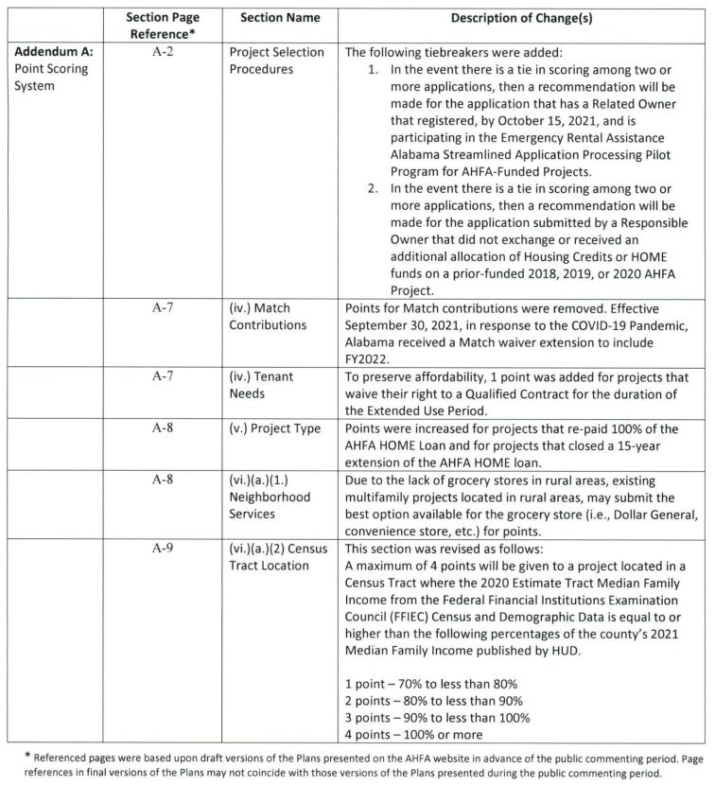

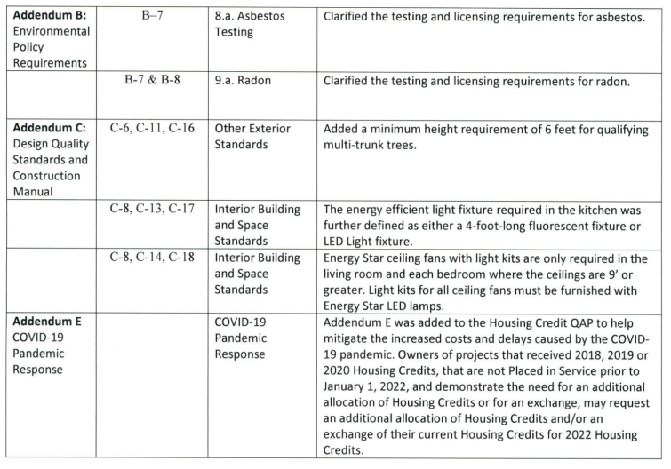

ADDENDUM B

Summary of Proposed Changes to the 2022 HOME Action Plan

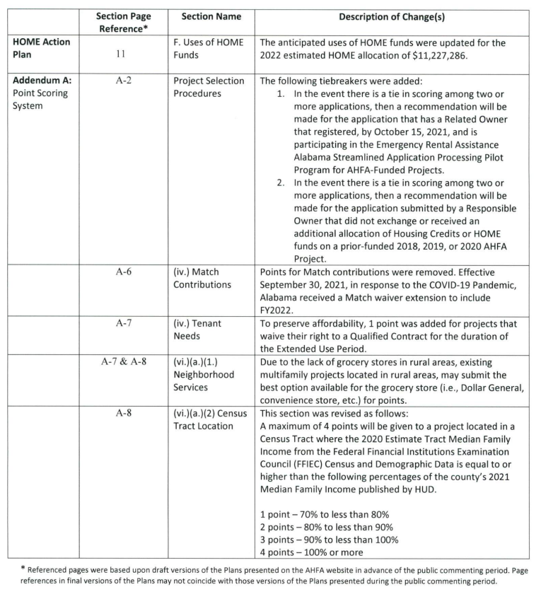

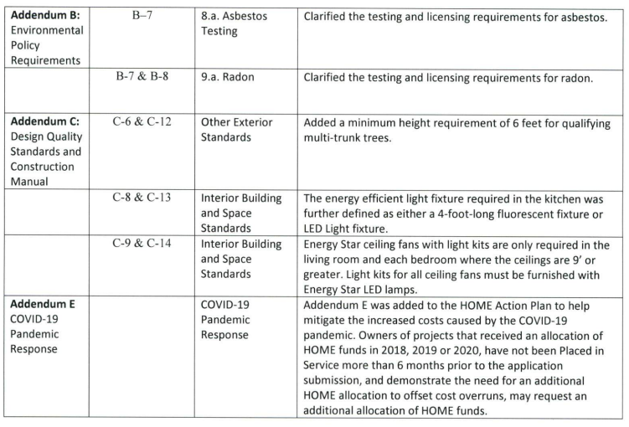

ADDENDUM C

Summary of Proposed Changes to the 2022 National Housing Trust Allocation Plan

