**Alabama Broadband Accessibility Fund**

**2020 Annual Report**

**Presented January 2020**

**Amended May 2020**

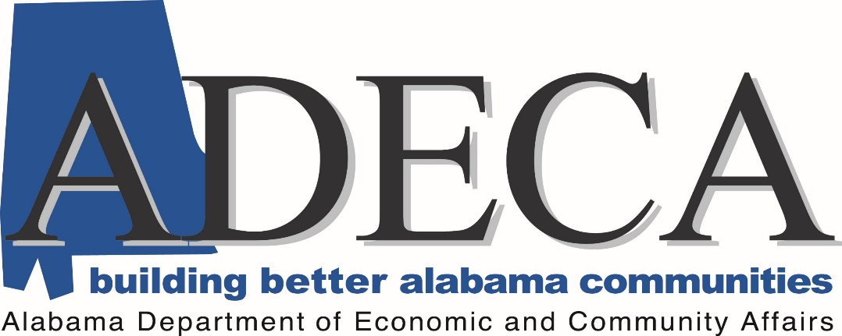

[broadband.fund@adeca.alabama.gov](mailto:broadband.fund@adeca.alabama.gov)

Street Address: 401 Adams Avenue, Suite 560

Montgomery, Alabama 36104-4325

Mailing Address: Post Office Box 5690

Montgomery, Alabama 36103-5690

On March 28, 2018, Governor Kay Ivey signed the Alabama Broadband Accessibility Act. Because the availability of high-speed broadband services in unserved rural Alabama is important for economic development, education, health care, and emergency services, the Alabama Broadband Accessibility Act established the Alabama Broadband Accessibility Fund. On May 30, 2019, Governor Ivey signed Act #2019-327 which provided numerous amendments to the original Act.

**Key Legislative Changes**

|  |  |
| --- | --- |
| **2018-2019** | **2019-2020** |
| * Minimum Speed 10/1 | * Minimum Speed 25/3 |
| * Maximum Grant 20 percent or $1,000,000 | * Maximum Grant 35 percent or $1,500,00 |
| * Priority Areas | * Added Additional Consideration Categories |
| * Application Due Date Established by Legislation (150 days) | * Application Due Date Established by ADECA (90 days) |
| * Limited Documentation of Project Completion | * Specific Documentation of Project Completion |
|  | * Added Definitions |

**New Definitions and Reporting Requirements**

* **End User**: “A residential, business, institutional, or government entity that uses broadband services for its own purposes and does not resell such broadband services to other entities. An internet service provider (ISP) and mobile wireless service provider are not an end user for the purposes of this act.”

* **Middle Mile**: “A broadband infrastructure project that does not provide broadband service to end users or to end-user devices.”
* **Reporting**: “operational testing, when possible, to confirm the level of service proposed in the grant application. Such regulations shall not exceed in degree or differ in kind from testing and reporting requirements imposed on the grant recipient by the Federal Communications Commission, as adjusted for the service specifications in the ADECA grant agreement.”

**Accountability Measures**

* **Reimbursement Program:** Funds are awarded prior to project commencement; however, funds are only disbursed after project completion and verification.
* **Time Requirement:** The Alabama Broadband Accessibility Fund requires projects to be completed within two years of award.

**Funded Projects (as of January 2020)**

|  |  |  |  |  |  |
| --- | --- | --- | --- | --- | --- |
| **Applicant** | **Project Area/Name** | **Project Amount** | **Grant Amount** | **Potential New Services** | **Average Grant Cost Per New Service** |
| Millry Telephone | Choctaw County Project 1 | $4,691,530.52 | $938,306.10 | 760 | $1,234.61 |
| Charter | Eastwood Point | $55,110.00 | $11,022.00 | 40 | $275.55 |
| Charter | Emerald Ridge | $55,316.40 | $11,063.28 | 41 | $269.84 |
| Charter | Glen Ridge | $147,835.00 | $29,567.00 | 94 | $314.54 |
| Charter | Grace Haven | $30,086.00 | $6,017.20 | 29 | $207.49 |
| Farmers Telecommunications | Pea Ridge | $372,932.00 | $74,586.00 | 62 | $1,203.00 |
| Charter | Vickey Lane | $42,076.00 | $8,415.20 | 44 | $191.25 |
| Farmers Telecommunications | Fabius | $443,340.55 | $88,668.11 | 48 | $1,847.25 |
| Roanoke Telephone Company | Five Points Community | $396,198.00 | $79,239.60 | 176 | $450.23 |
| R. M. Greene | Pittsview Area | $21,602.87 | $4,320.57 | 23 | $187.85 |
| Troy Cablevision | SE AL Broadband Accessibility Project #1 | $2,875,576.57 | $575,115.31 | 957 | $600.96 |
| Troy Cablevision | SE AL Broadband Accessibility Project #2 | $1,744,426.85 | $348,885.37 | 440 | $792.92 |
| R. M. Greene | Dixie Area | $253,560.43 | $50,712.09 | 219 | $231.50 |
| Troy Cablevision | SE AL Broadband Accessibility Project #3 | $117773.40 | $23,554.68 | 37 | $636.61 |
| Cyber Broadband | Smith Lake – Sipsey Pines Community | $568,400.00 | $113,680.00 | 200 | $568.40 |

**Applications Funded to Date**

* 22 applications were received during the 2018 application period and 5 applications were received during the 2019 application period
* 13 projects were awarded funding for 2018 and 2 projects were awarded funding for 2019
* Funds awarded total $2,363,152.51 with a matching private investment of $9,452,612.08
* The average grant dollar cost per new service is $745.47

**Unfunded Applications**

* A total of 12 projects did not receive funding
* In most cases, projects that did not receive funding were for areas that were not eligible under the previous legislation
* In a few cases, there were problems with the application, or an applicant chose to rescind the application and resubmit under the new program guidelines
* In all cases, unsuccessful applicants were allowed to resubmit an application during a subsequent funding round (many chose to do so)

**Statewide Broadband Plan Phase 1**

* **Planning Contract:** In July of 2019, ADECA issued a request for proposals for planning and mapping services. Eight responses were received. CTC Technology and Energy received the highest score in the evaluation process. The contract was reviewed and approved by the Contract Review Committee. The amount of the contract is $1.5 million, and the contract period is January 1, 2020 through December 31, 2021. General scope of work items include provide technical expertise for grant program development, identify and develop strategy for leveraging state funds to attract other funding, legislative review and recommendations, identify and convene stakeholders, develop current broadband maps and system for updating maps over time, develop statewide strategic plan, and support and enable regional planning.
* **Next Steps:** Additional planning and mapping requirements will be identified through this process. The scope of work for phase 2 will be determined as a result of phase 1.

**Preview of 2020 Program Year**

**Applications Received Under 2020 Round One Grant Period**

* 61 Applications were received by the deadline
* The 30-day challenge period ended February 12, 2020
* The first 20 successful applications were announced March 31



The average cost per new service was $721. 40. If all projects are completed as proposed, as many as 13,101 new services could be available within two years. These services will include households, businesses and industries, and anchor institutors such as hospitals. The grant investment of $9,451,023.16 will leverage $17,889,275.15 in private investment.

Six projects were rescinded from consideration after submittal. These projects are not included in the table above or below and have been removed from the website.

There are an additional 35 projects under review. These projects represent additional grant requests totaling $17,360,739.36. If funded, these projects could provide as many as 67,277 new services at an average cost of $258.05 per service.

