Alabama Broadband Accessibility Act
2018-2019 Program Year Report

Alabama Department of Economic and Community Affairs
Kenneth W. Boswell, Director

March 28, 2019

Alabama Broadband Accessibility Act

On March 28, 2018, Governor Kay Ivey signed the Alabama Broadband Accessibility Act (Act). The purpose of the Act is to encourage high-speed broadband services in unserved, rural areas of Alabama to promote economic development, to improve education, to enhance health care, and to support emergency services.

Alabama Broadband Accessibility Fund

The Act established the Alabama Broadband Accessibility Fund (Fund).

The Fund establishes a Minimum Service Threshold – “A connection to the Internet that provides capacity for transmission at an average speed per customer of at least 10 megabits per second (Mbps) downstream and at least one Mbps upstream.”

Additionally, Rural Area is defined as – “Any area within this state not included within the boundaries of any incorporated city or town having a population in excess of 25,000 inhabitants, according to the last federal census.

Furthermore, Unserved Area is defined as – “Any rural area in which there is not at least one provider of terrestrial broadband service that is either: (1) offering a connection to the Internet meeting the minimum service threshold; or (2) is required, under the terms of the Federal Universal Service Fund or other federal or state grant, to provide a connection to the internet at speeds meeting the minimum service threshold within five years of the effective date of this act.”

Finally, award requirements include that no more than 20 percent of project costs may come from the Fund. Additionally, the grant ceiling is capped at $750,000 or $1,400,000, based on the broadband speed provided. Furthermore, at least 40 percent of awards will be in unincorporated areas and all funds must be used in rural areas. Lastly, all funds are for current, non-governmental providers.

Program Status and Broadband Availability

As required by the Legislation, the Alabama Department of Economic and Community Affairs (ADECA) is providing the following information regarding program status and broadband availability in the state.

The legislature provided $7.4 million to use for these grants. ADECA has held two application workshops (one for the 2018 program year and one for the 2019 program year). Additionally, ADECA has developed and published on its website an application guide and program information.

Project Name | Total Project | Amount Requested | Provider/Applicant | Primary County | Total Potential Customers
Choctaw County Project 1 | $4,691,530.52 | $938,306.10 | Millry | Choctaw | 760
East Wood Point | $55,110.00 | $11,022.00 | Charter | Lawrence | 40
Emerald Ridge | $55,316.40 | $11,063.28 | Charter | Shelby | 41
Glen Ridge | $147,835.00 | $29,567.00 | Charter | Tuscaloosa | 94
Grace Haven | $30,086.00 | $6,017.20 | Charter | Marshall | 29
Pea Ridge | $372,932.00 | $74,586.00 | FTC | DeKalb | 62
Vickey Lane | $42,076.00 | $8,415.20 | Charter | Etowah | 44
Subtotal | $5,394,885.92 | $1,078,976.78 |  |  | 1,070

Project Name | Total Project | Amount Requested | Provider/Applicant | Primary County | Total Potential Customers
Dixie Area | $273,140.55 | $218,512.44 | R.M. Green | Russell | 238
Fabius | $443,340.55 | $88,668.11 | FTC | Jackson | 48
Fiber to Premise | $165,000.00 | $33,000.00 | Otelco | Morgan | 79
Five Points Community Broadband Project | $396,198.00 | $79,239.60 | Roanoke/TEC/National Telephone | Chambers | 153
Pittsview Area | $21,602.87 | $17,828.30 | R.M. Green | Russell | 23
Southeast Alabama Project 1 | $6,251,457.10 | $1,250,291.42 | Troy | Geneva | 2,272
Southeast Alabama Project 2 | $3,331,633.03 | $666,326.61 | Troy | Pike | 1,189
Subtotal | $10,882,372.10 | $2,353,866.48 |  |  | 4,002

Project Name | Total Project | Amount Requested | Provider/Applicant | Primary County | Total Potential Customers
Padgett Rd. Area | $50,594.65 | $40,475.72 | R.M. Green | Russell | 49
Patterson Rd. Area | $37,110.10 | $29,688.08 | R.M. Green | Russell | 21
Red Rock Community Broadband Project | $447,822.00 | $89,564.40 | Roanoke/TEC/National Telephone | Colbert | 124
Rural Hackleburg | $3,539,443.00 | $707,889.00 | Tombigbee | Marion | 637
Southeast Marion County | $1,646,778.00 | $329,356.00 | Tombigbee | Marion | 432
Tin Shop Community Broadband Project | $749,130.00 | $149,130.00 | Roanoke/TEC/National Telephone | Randolph | 163
Whitehouse Community | $1,128,876.00 | $225,776.00 | Tombigbee | Marion | 404
Paladin Coosa Fixed Wireless Solution | $7,000,000.00 | $1,400,000.00 | Paladin | Coosa | 12,000
Subtotal | $14,599,753.75 | $2,971,879.20 |  |  | 13,830

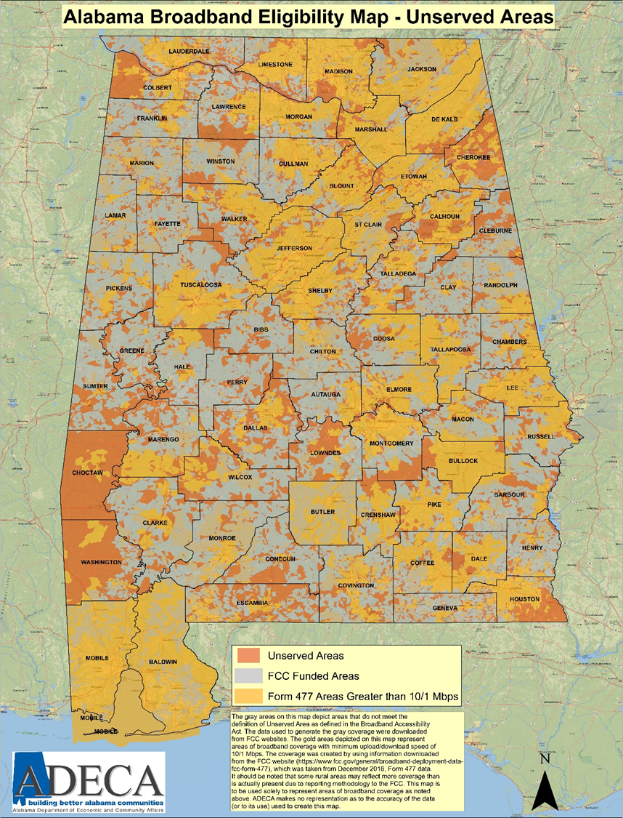

Additional information regarding broadband availability and program status can be found at http://adeca.alabama.gov/Divisions/energy/broadband/Pages/default.aspx

